Water safety 2025 – partner communications pack
We are once again launching our water safety campaign, to make people aware of the dangers of open water and offering advice on what to do if they get into difficulty in the water or see someone else struggling in the water.
The campaign is aimed at young people, particularly teenage boys, who are historically more likely to take unnecessary risks by jumping into open water and swimming in different areas of Greater Manchester. There is also messaging aimed at adults who know a young person, asking them to speak to a young person they know about the dangers of open water and keeping safe.
The 2025 water safety campaign launched on Friday 20 June. This campaign runs alongside the Safe4Summer campaign which shares messages about keeping safe around water, preventing anti-social behaviour and reducing moorland fires.
This year, the water safety campaign’s key messages are:
- 193 people accidentally drowned in the UK in 2024. Don’t become a statistic, stay safe around water.
- Jumping into open water can be fatal. Cold water shock kills and you don’t know what’s lurking beneath the surface.
- If you encourage your mates to go in the water it could be the last time you see them.
- If you get into difficulty in the water, float to live.
- If you see someone in difficulty in the water remember ‘call, tell, throw’ (call 999 and ask for fire if inland or the coastguard if by the sea, tell the struggling person to try to float on their back and throw them something that floats).
Facebook, X and Instagram: @manchesterfire
Hashtags #DrowningPrevention #WaterSafety #RespectTheWater and #BeWaterAware used in social posts.

Key activities
- Sharing messaging on social media – including videos of our staff sharing campaign messages. Please help us share the new content as it’s released.
- Paid social media advertising during particularly warm spells of weather.
- Water safety banners and posters installed at key locations.
- Out of home and targeted online advertising, using the same artwork as the social media assets for campaign consistency.
- GMFRS school visits, giving presentations to students on water safety (alongside other prevention activity).
- Water safety campaign webpage updated: https://www.manchesterfire.gov.uk/your-safety/campaigns/water-safety/
Campaign assets have been updated and are available from the campaign webpage. If you have any issues downloading any assets, please contact hendersonz@manchesterfire.gov.uk.
Partners are encouraged to share content from the digital toolkit as widely as possible across all social channels, as well as link through to our webpage: https://www.manchesterfire.gov.uk/your-safety/campaigns/water-safety/ when sharing any messaging.

Suggested social media posts
Facebook and X
Copy | Image/Alt Text
General campaign messages
As part of the latest @manchesterfire #WaterSafety campaign we are reminding people about the dangers of open water.  If you encourage your mates to go in the water it could be the last time you see them. Cold water shock kills even the strongest swimmers.  #DrowningPrevention | Graphic one: If you encourage your mates to go in the water it could be the last time you see them. Image shows two people sat on a riverbank, looking into the water.  Graphic two: Cold water shock kills even the strongest swimmers. Image shows two people sat on a riverbank, looking into the water.  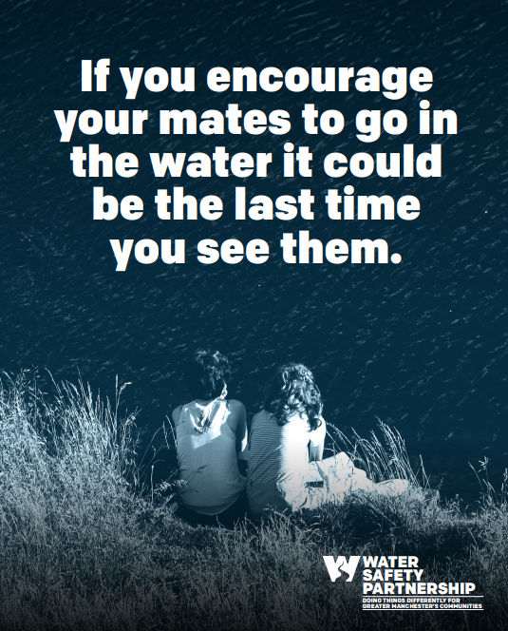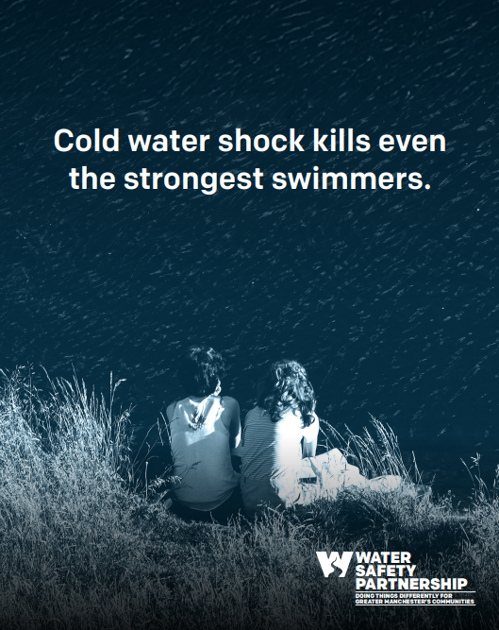
Jumping into open water can be fatal. Cold water shock and under-water currents can kill, and you don’t know what’s lurking beneath the surface.  Don’t become a statistic, stay safe around water.  #WaterSafety #DrowningPrevention #BeWaterAware | Graphic one: Jumping into open water can be fatal. Image shows person underneath the water.  Graphic two: Cold water shock kills and you don’t know what’s beneath the surface. Image shows person underneath the water.  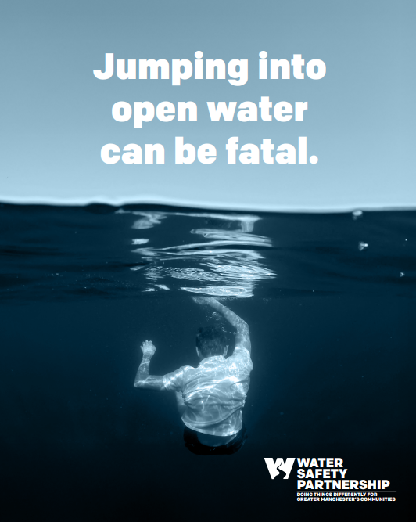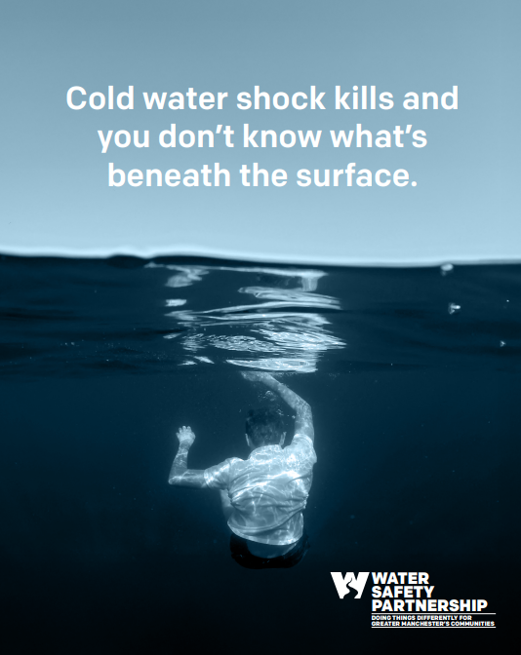
Did you know cold water shock can kill even strong swimmers, and under-water currents can be deadly? Our message is clear: if you encourage your mates to go in the water, it could be the last time you see them.  #WaterSafety #DrowningPrevention #BeWaterAware | Graphic one: If you encourage your mates to go in the water it could be the last time you see them. Image shows two people sat on a riverbank, looking into the water.  Graphic two: Cold water shock kills even the strongest swimmers. Image shows two people sat on a riverbank, looking into the water.
Do you know where your kids go, and what they get up to, when they’re out with their friends? Please speak with them about the dangers of open water – it could save their life  https://www.manchesterfire.gov.uk/your-safety/campaigns/water-safety/  #WaterSafety #BeWaterAware | Graphic one: 193 people accidentally drowned in the UK in 2024. Image shows person underneath the water, with arm stretched up towards the surface.  Graphic two: Don’t become a statistic, stay safe around water. Image shows person underneath the water, with arm stretched up towards the surface.  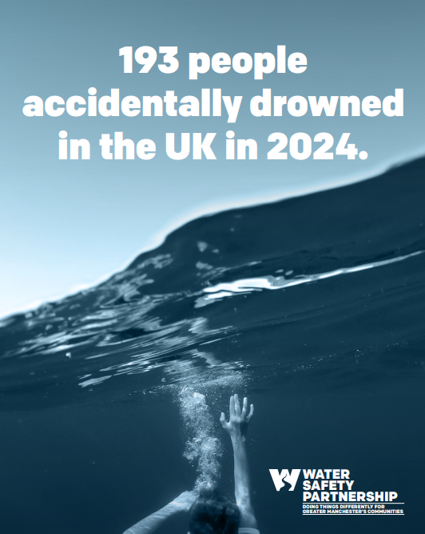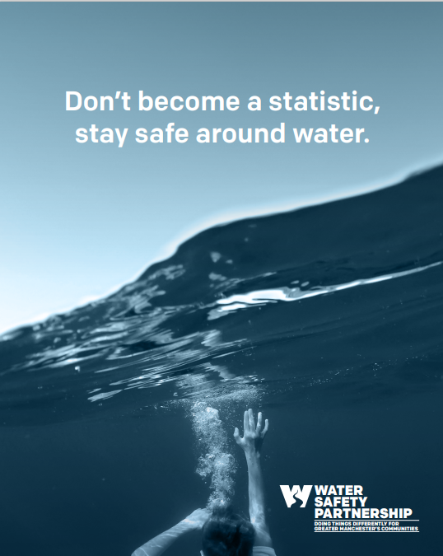
💔 Did you know that 193 people accidentally drowned in the UK in 2024?  Don’t become a statistic, stay safe around water.  #WaterSafety #DrowningPrevention #BeWaterAware | Graphic one: 193 people accidentally drowned in the UK in 2024. Image shows person underneath the water, with arm stretched up towards the surface.  Graphic two: Don’t become a statistic, stay safe around water. Image shows person underneath the water, with arm stretched up towards the surface.
If you get into difficulty in the water, remember #FloatToLive…  - Tilt your head back, ears submerged.  - Relax and try to breathe normally.  - Move your hands and legs to help you stay afloat.  - It's OK if your legs sink, we all float differently.  Practise floating at a supervised location like a swimming pool.  #RespectTheWater | If you get into difficulty in the water, float to live. Image shows person floating on water with arms and legs stretched out.  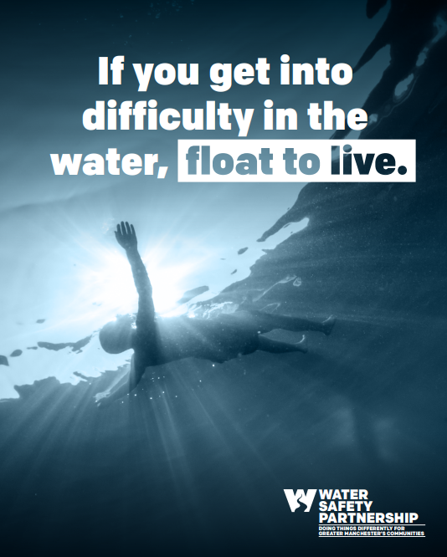
If you see someone in difficulty in the water remember ‘call, tell, throw’:  - Call 999 and ask for fire if inland or the coastguard if by the sea.  - Tell the struggling person to try to float on their back.  - Throw them something that floats.  #WaterSafety #RespectTheWater | If you see someone in difficulty in the water remember ‘call, tell, throw’. Image shows person on their phone looking out at open water.  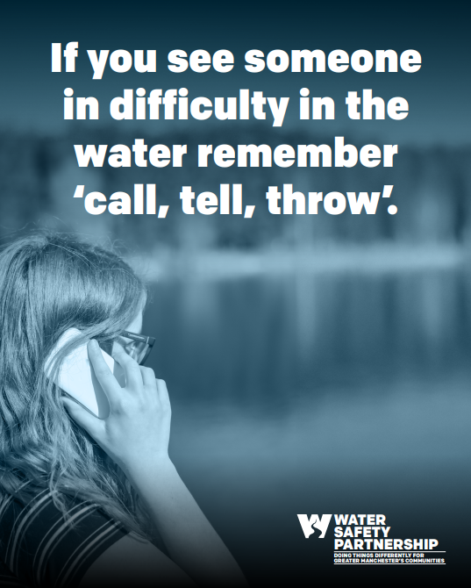
Warm weather proactive messaging
Looks like it will stay warm a bit longer, so why not have a chat with your kids, or other young people you know, about the dangers of open water? It could save their life ❤️  #WaterSafety #DrowningPrevention #BeWaterAware | Graphic one: 193 people accidentally drowned in the UK in 2024. Image shows person underneath the water, with arm stretched up towards the surface.  Graphic two: Don’t become a statistic, stay safe around water. Image shows person underneath the water, with arm stretched up towards the surface.
Enjoying the warmer weather?  Remember - jumping into open water can be fatal. Cold water shock kills and you don’t know what’s lurking beneath the surface.  #WaterSafety #DrowningPrevention #RespectTheWater | Graphic one: Jumping into open water can be fatal. Image shows person underneath the water.  Graphic two: Cold water shock kills and you don’t know what’s beneath the surface. Image shows person underneath the water.
Enjoying the warmer weather?  If you're planning on going for a swim - visit your local pool. If you're at the beach, pick a spot with lifeguards on duty.  If you get into difficulty in the water, #FloatToLive  #WaterSafety #DrowningPrevention #RespectTheWater | If you get into difficulty in the water, float to live. Image shows person floating on water with arms and legs stretched out.
☀ It’s warm in Greater Manchester, so what better time to remind people about @manchesterfire #WaterSafety campaign  Do you know a young person? Chat with them today about the dangers of open water  https://www.manchesterfire.gov.uk/your-safety/campaigns/water-safety/ | Graphic one: 193 people accidentally drowned in the UK in 2024. Image shows person underneath the water, with arm stretched up towards the surface.  Graphic two: Don’t become a statistic, stay safe around water. Image shows person underneath the water, with arm stretched up towards the surface.
Please stay safe around water this summer. If you encourage your mates to go in the water it could be the last time you see them. Cold water shock kills even the strongest swimmers.  #DrowningPrevention | Graphic one: If you encourage your mates to go in the water it could be the last time you see them. Image shows two people sat on a riverbank, looking into the water.  Graphic two: Cold water shock kills even the strongest swimmers. Image shows two people sat on a riverbank, looking into the water.
If you see someone in difficulty in the water remember ‘call, tell, throw’.  - Call 999 and ask for fire if inland or the coastguard if by the sea.  - Tell the struggling person to try to float on their back.  - Throw them something that floats.  #DrowningPrevention #RespectTheWater | If you see someone in difficulty in the water remember ‘call, tell, throw’. Image shows person on their phone looking out at open water.

Instagram
Copy | Image/Alt Text
General campaign messages
As part of the latest @manchesterfire #WaterSafety campaign we are reminding people about the dangers of open water.  If you encourage your mates to go in the water it could be the last time you see them. Cold water shock kills even the strongest swimmers.  #DrowningPrevention | Graphic one: If you encourage your mates to go in the water it could be the last time you see them. Image shows two people sat on a riverbank, looking into the water.  Graphic two: Cold water shock kills even the strongest swimmers. Image shows two people sat on a riverbank, looking into the water.
Jumping into open water can be fatal. Cold water shock and under-water currents can kill, and you don’t know what’s lurking beneath the surface.  Don’t become a statistic, stay safe around water.  #WaterSafety #DrowningPrevention #BeWaterAware | Graphic one: Jumping into open water can be fatal. Image shows person underneath the water.  Graphic two: Cold water shock kills and you don’t know what’s beneath the surface. Image shows person underneath the water.
Did you know cold water shock can kill even strong swimmers, and under-water currents can be deadly? Our message is clear: if you encourage your mates to go in the water, it could be the last time you see them.  #WaterSafety #DrowningPrevention #BeWaterAware | Graphic one: If you encourage your mates to go in the water it could be the last time you see them. Image shows two people sat on a riverbank, looking into the water.  Graphic two: Cold water shock kills even the strongest swimmers. Image shows two people sat on a riverbank, looking into the water.
Do you know where your kids go, and what they get up to, when they’re out with their friends? Please speak with them about the dangers of open water – it could save their life  👉 Search ‘water safety’ on @manchesterfire website  #WaterSafety #BeWaterAware | Graphic one: 193 people accidentally drowned in the UK in 2024. Image shows person underneath the water, with arm stretched up towards the surface.  Graphic two: Don’t become a statistic, stay safe around water. Image shows person underneath the water, with arm stretched up towards the surface.
💔 Did you know that 193 people accidentally drowned in the UK in 2024?  Don’t become a statistic, stay safe around water.  #WaterSafety #DrowningPrevention #BeWaterAware | Graphic one: 193 people accidentally drowned in the UK in 2024. Image shows person underneath the water, with arm stretched up towards the surface.  Graphic two: Don’t become a statistic, stay safe around water. Image shows person underneath the water, with arm stretched up towards the surface.
If you get into difficulty in the water, remember #FloatToLive…  - Tilt your head back, ears submerged.  - Relax and try to breathe normally.  - Move your hands and legs to help you stay afloat.  - It's OK if your legs sink, we all float differently.  Practise floating at a supervised location like a swimming pool.  #RespectTheWater | If you get into difficulty in the water, float to live. Image shows person floating on water with arms and legs stretched out.
If you see someone in difficulty in the water remember ‘call, tell, throw’:  - Call 999 and ask for fire if inland or the coastguard if by the sea.  - Tell the struggling person to try to float on their back.  - Throw them something that floats.  #WaterSafety #RespectTheWater | If you see someone in difficulty in the water remember ‘call, tell, throw’. Image shows person on their phone looking out at open water.
Warm weather proactive messaging
Looks like it will stay warm a bit longer, so why not have a chat with your kids, or other young people you know, about the dangers of open water? It could save their life ❤️  #WaterSafety #DrowningPrevention #BeWaterAware | Graphic one: 193 people accidentally drowned in the UK in 2024. Image shows person underneath the water, with arm stretched up towards the surface.  Graphic two: Don’t become a statistic, stay safe around water. Image shows person underneath the water, with arm stretched up towards the surface.
Enjoying the warmer weather?  Remember - jumping into open water can be fatal. Cold water shock kills and you don’t know what’s lurking beneath the surface.  #WaterSafety #DrowningPrevention #RespectTheWater | Graphic one: Jumping into open water can be fatal. Image shows person underneath the water.  Graphic two: Cold water shock kills and you don’t know what’s beneath the surface. Image shows person underneath the water.
Enjoying the warmer weather?  If you're planning on going for a swim - visit your local pool. If you're at the beach, pick a spot with lifeguards on duty.  If you get into difficulty in the water, #FloatToLive  #WaterSafety #DrowningPrevention #RespectTheWater | If you get into difficulty in the water, float to live. Image shows person floating on water with arms and legs stretched out.
☀ It’s warm in Greater Manchester, so what better time to remind people about @manchesterfire #WaterSafety campaign  Do you know a young person? Chat with them today about the dangers of open water ❤ | Graphic one: 193 people accidentally drowned in the UK in 2024. Image shows person underneath the water, with arm stretched up towards the surface.  Graphic two: Don’t become a statistic, stay safe around water. Image shows person underneath the water, with arm stretched up towards the surface.
Please stay safe around water this summer. If you encourage your mates to go in the water it could be the last time you see them. Cold water shock kills even the strongest swimmers.  #DrowningPrevention | Graphic one: If you encourage your mates to go in the water it could be the last time you see them. Image shows two people sat on a riverbank, looking into the water.  Graphic two: Cold water shock kills even the strongest swimmers. Image shows two people sat on a riverbank, looking into the water.
Quick question for you before you head out to enjoy the weather…  Do you know what to do if you see someone in trouble in the water?  Remember ‘call, tell, throw’:  - Call 999 and ask for fire if inland or the coastguard if by the sea.  - Tell the struggling person to try to float on their back.  - Throw them something that floats.  #WaterSafety #DrowningPrevention #BeWaterAware #RespectTheWater | If you see someone in difficulty in the water remember ‘call, tell, throw’. Image shows person on their phone looking out at open water.

