Smoke alarm testing and escape route planning campaign
Social media pack 2025
Introduction
We are running a campaign focusing on smoke alarm testing and escape route planning.
A working smoke alarm can be the first alert to a fire and can save lives by providing vital extra seconds to escape a fire in the home. Each level should have at least one working alarm and we suggest testing at least monthly to ensure they are working. Knowing what to do if a smoke alarm sounds is also important – prepare an escape plan to help everyone escape smoothly in case of a fire. Also, make sure everyone living in the same household knows about the plan.
To ensure Greater Manchester residents are aware of these important actions and routines we will be sharing social media posts across all relevant channels and we encourage partners to share where possible, allowing for maximum impact and coverage.
Communication objectives
- Encourage people to fit smoke alarms on each level of their home and a heat alarm in their kitchen - test them at least monthly.
- Encourage people to plan escape routes and review them regularly.
- Educate people on what they should do in case of a fire.
Audience
- Residents in all boroughs of Greater Manchester.
Key messages:
- Ensure you have at least one working smoke alarm fitted on every level of your home and a heat alarm in your kitchen. Test your alarms at least monthly.
- Ensure you have an escape plan, in case of fire, which your whole household understands.
- If there is a fire in your home - get out, stay out, call 999.

Assets can be downloaded here: manchesterfire.gov.uk/your-safety/campaigns/smoke-alarm-testing-and-escape-planning/
These posts will be shared with the main hashtags #TestItWhileYouWait and #TestingTesting123 on GMFRS’ various channels including Facebook, X and Instagram (@manchesterfire).
Suggested content | Image/Video | Alt text
Facebook and X
When was the last time you tested your smoke alarms?  @manchesterfire advice is to test them at least monthly, by pressing the test button until the alarm sounds.  #TestItWhileYouWait | Test it while you wait animation | N/A (animation)
Fit a minimum of one working smoke alarm on every level of your home, preferably in a circulation space such as a hallway or landing.  Fit additional alarms in other rooms where there could be a risk of a fire starting.  ✅ Test your smoke alarms at least monthly.  #TestItWhileYouWait | Test it while you wait animation | N/A (animation)
If you are a tenant, your landlord (unless they are excluded) must ensure that at least one smoke alarm is provided on each level of your home, where there is a room used as living accommodation.  ✅ Test your smoke alarms at least monthly.  #TestItWhileYouWait | Test it while you wait animation | N/A (animation)
Waiting for your kettle to boil? Why not test your smoke alarm while you wait?  It only takes a moment and it could save your life.  #TestItWhileYouWait | Kettle – test it while you wait animation | N/A (animation)
Waiting for your washer/dryer to finish?  Why not test your smoke alarm while you wait? It only takes a moment and it could save your life.  #TestItWhileYouWait | Washer dryer – test it while you wait animation | N/A (animation)
Waiting for the adverts to finish on TV?  Why not test your smoke alarm while you wait? It only takes a moment and it could save your life.  #TestItWhileYouWait | TV adverts – test it while you wait animation | N/A (animation)
On the phone and put on hold?  Why not test your smoke alarm while you wait? It only takes a moment and it could save your life.  #TestItWhileYouWait | Phone on hold – test it while you wait animation | N/A (animation)
🤔 Thinking about smoke alarms and fire safety in your home? 🏠 🔥  Watch @manchesterfire short animation to find out more about their Home Fire Safety Assessments 📽 | Home Fire Safety Assessment animation (short) | N/A (animation)
As part of their new campaign, @manchesterfire are reminding you to:  - Make sure you have a working smoke alarm on every level of your home and a heat alarm in your kitchen.  - Test your alarms at least monthly.  - Know what to do if there is a fire – have an escape route planned and get out, stay out, call 999.  #TestingTesting123 | 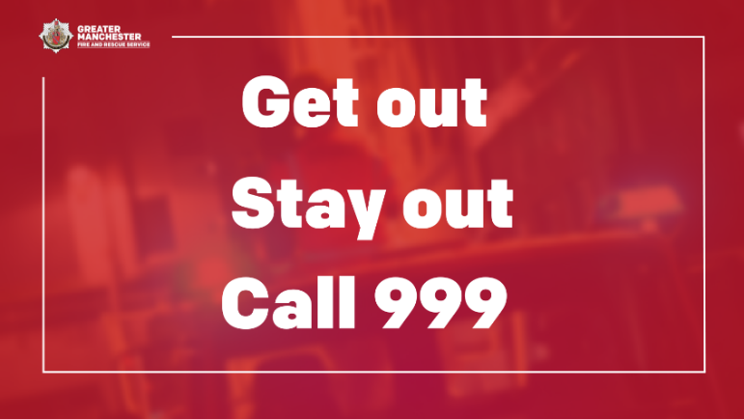 | Firefighter on fire engine with sirens flashing. Graphic text reads ‘Get out. Stay out. Call 999.’
Would you, or your family and friends, know what to do if your smoke or heat alarms go off? Plan ahead and practice an escape route.  Make sure door and window keys are accessible to everyone.  #TestingTesting123 | 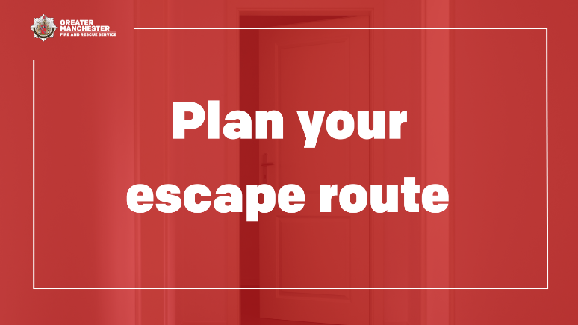 | Door open at the end of a hallway. Graphic text reads ‘Plan your escape route.’
Your normal way out of the house is often your best escape route, so always keep it clear of clutter!  #TestingTesting123 | 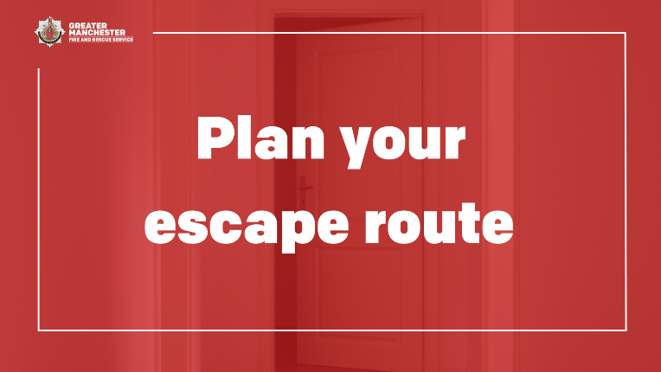 | Door open at the end of a hallway. Graphic text reads ‘Plan your escape route.’
Does your escape plan include a plan B? Plan for a second escape route, in case the first one is blocked. Make sure everyone in your home knows how to escape.  If you encounter a fire, keep calm and act quickly – get out, stay out, call 999.  #TestingTesting123 |  | Firefighter on fire engine with sirens flashing. Graphic text reads ‘Get out. Stay out. Call 999.’
Declutter your home once in a while to keep fire escape routes clear in case of an emergency.  If you’ve had any building work done or any temporary changes to your home, including people living with you, make sure you have updated your escape plan, so everyone knows what to do, if there’s a fire.  Visit @manchesterfire website for more advice and tips. | 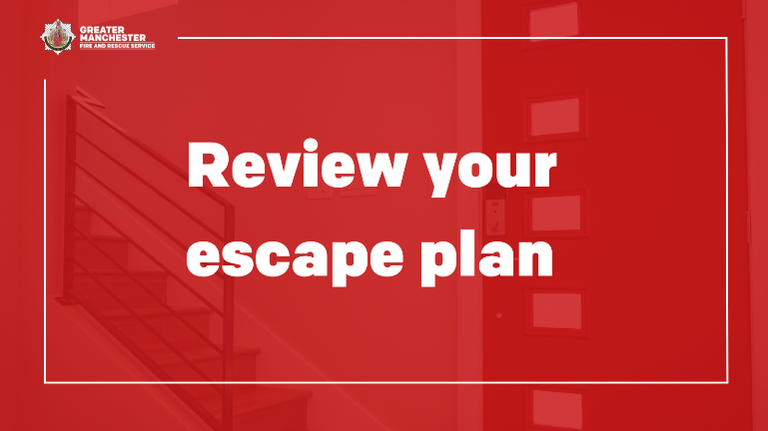 | A staircase inside house next to front door. Graphic text reads ‘Review your escape plan.’
Living in a flat but unsure on how to escape safely, in case of a fire? Contact your housing provider or managing agent for your building about your evacuation strategy.  If there is a fire in your flat, keep calm and act quickly - get out, stay out, call 999.  Find out more manchesterfire.gov.uk/your-safety/fire-safety/flat/what-is-your-building-s-evacuation-strategy/ | 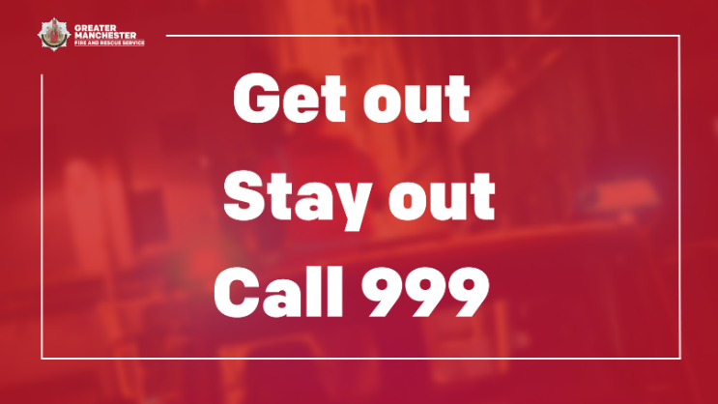 | Firefighter on fire engine with sirens flashing. Graphic text reads ‘Get out. Stay out. Call 999.’
🏠 Complete @manchesterfire free online home fire safety check and get advice on simple changes you can make to reduce the risk of a fire.  manchesterfire.gov.uk/your-safety/hfsa  #TestingTesting123 | 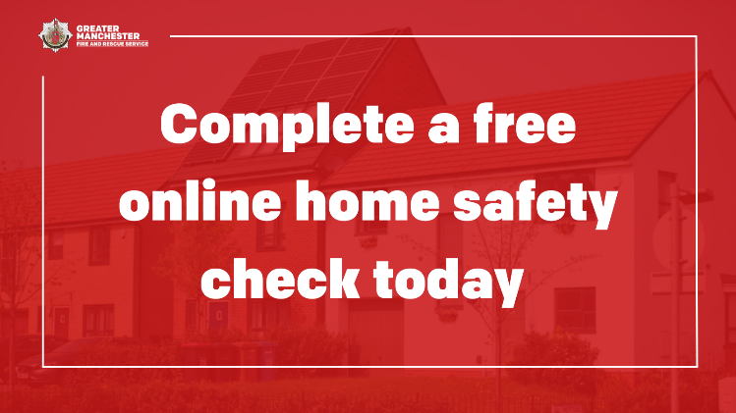  Or use Home Fire Safety Assessment animation (short) | Row of houses on street. Graphic text reads ‘Complete a free online home safety check today.’
If there’s a fire in your home, keep calm and act quickly – get out, stay out, call 999.  If you hear a smoke alarm go off in a neighbour’s property, check it out and call 999 immediately if you suspect a fire. |  | Firefighter on fire engine with sirens flashing. Graphic text reads ‘Get out. Stay out. Call 999.’
Instagram
When was the last time you tested your smoke alarms?  @manchesterfire advice is to test them at least monthly, by pressing the test button until the alarm sounds.  #TestItWhileYouWait | Test it while you wait animation | N/A (animation)
Fit a minimum of one working smoke alarm on every level of your home, preferably in a circulation space such as a hallway or landing.  Fit additional alarms in other rooms where there could be a risk of a fire starting.  ✅ Test your smoke alarms at least monthly.  #TestItWhileYouWait | Test it while you wait animation | N/A (animation)
If you are a tenant, your landlord (unless they are excluded) must ensure that at least one smoke alarm is provided on each level of your home, where there is a room used as living accommodation.  ✅ Test your smoke alarms at least monthly.  #TestItWhileYouWait | Test it while you wait animation | N/A (animation)
Waiting for your kettle to boil? Why not test your smoke alarm while you wait?  It only takes a moment and it could save your life.  #TestItWhileYouWait | Kettle – test it while you wait animation | N/A (animation)
Waiting for your washer/dryer to finish?  Why not test your smoke alarm while you wait? It only takes a moment and it could save your life.  #TestItWhileYouWait | Washer dryer – test it while you wait animation | N/A (animation)
Waiting for the adverts to finish on TV?  Why not test your smoke alarm while you wait? It only takes a moment and it could save your life.  #TestItWhileYouWait | TV adverts – test it while you wait animation | N/A (animation)
On the phone and put on hold?  Why not test your smoke alarm while you wait? It only takes a moment and it could save your life.  #TestItWhileYouWait | Phone on hold – test it while you wait animation | N/A (animation)
🤔 Thinking about smoke alarms and fire safety in your home? 🏠 🔥  Watch @manchesterfire short animation to find out more about their Home Fire Safety Assessments 📽 | Home Fire Safety Assessment animation (short) | N/A (animation)
As part of their new campaign, @manchesterfire are reminding you to:  - Make sure you have a working smoke alarm on every level of your home and a heat alarm in your kitchen.  - Test your alarms at least monthly.  - Know what to do if there is a fire – have an escape route planned and get out, stay out, call 999.  #TestingTesting123 | 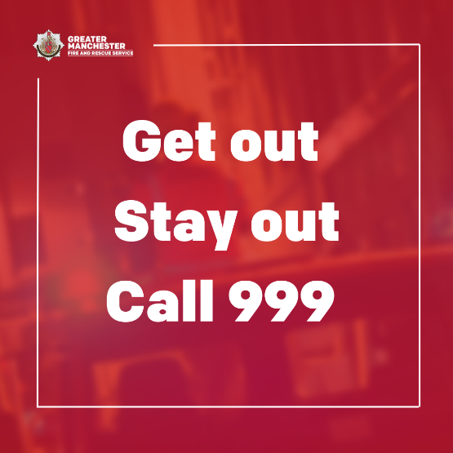 | Firefighter on fire engine with sirens flashing. Graphic text reads ‘Get out. Stay out. Call 999.’
Would you, or your family and friends, know what to do if your smoke or heat alarms go off? Plan ahead and practice an escape route.  Make sure door and window keys are accessible to everyone.  #TestingTesting123 | 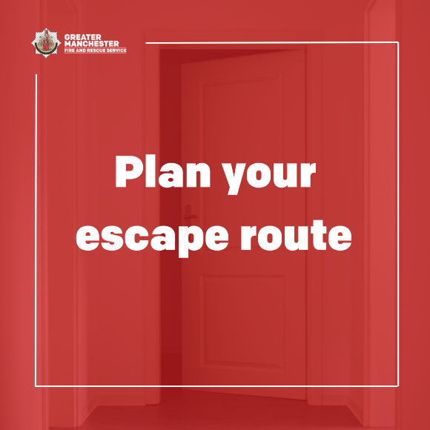 | Door open at the end of a hallway. Graphic text reads ‘Plan your escape route.’
Your normal way out of the house is often your best escape route, so always keep it clear of clutter!  #TestingTesting123 |  | Door open at the end of a hallway. Graphic text reads ‘Plan your escape route.’
Does your escape plan include a plan B? Plan for a second escape route, in case the first one is blocked. Make sure everyone in your home knows how to escape.  If you encounter a fire, keep calm and act quickly – get out, stay out, call 999.  #TestingTesting123 |  | Firefighter on fire engine with sirens flashing. Graphic text reads ‘Get out. Stay out. Call 999.’
Declutter your home once in a while to keep fire escape routes clear in case of an emergency.  If you’ve had any building work done or any temporary changes to your home, including people living with you, make sure you have updated your escape plan, so everyone knows what to do, if there’s a fire.  Visit @manchesterfire website for more advice and tips. | 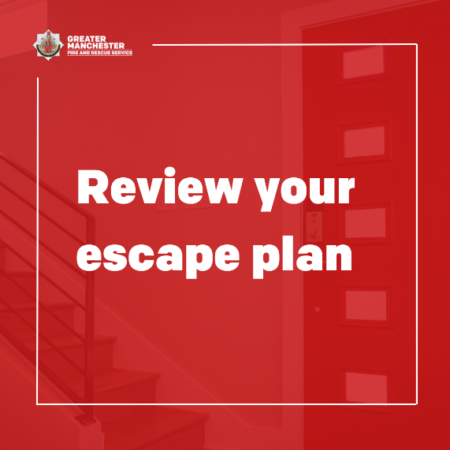 | A staircase inside house next to front door. Graphic text reads ‘Review your escape plan.’
🏠 Complete @manchesterfire free online home fire safety check and get advice on simple changes you can make to reduce the risk of a fire.  #TestingTesting123 | 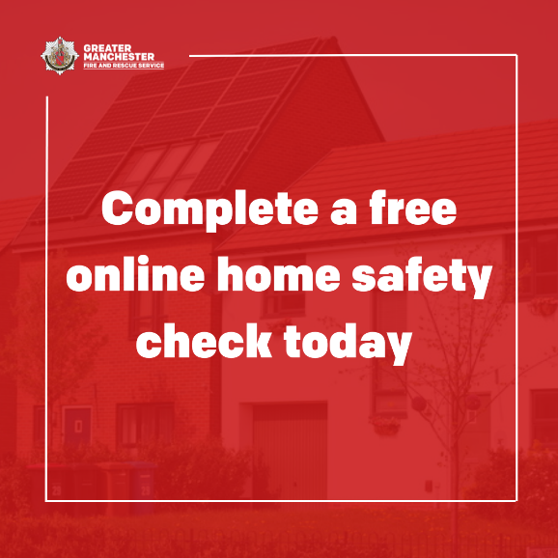 | Row of houses on street. Graphic text reads ‘Complete a free online home safety check today.’
If there’s a fire in your home, keep calm and act quickly – get out, stay out, call 999.  If you hear a smoke alarm go off in a neighbour’s property, check it out and call 999 immediately if you suspect a fire. |  | Firefighter on fire engine with sirens flashing. Graphic text reads ‘Get out. Stay out. Call 999.’

