#ChargeSafe partner toolkit
Communications messaging and assets for our ‘Charge Safe’ campaign. The campaign runs from 3 December 2024 until 31 January 2025, but assets can continue to be used throughout the year.

Below are the key campaign messages, which have been split into two phases for sharing on social media.

Only buy e-bikes, e-scooters and batteries from trusted retailers and manufacturers.

Check for the CE or UKCA safety marking to make sure your battery and charger meet safety standards.

Always follow the manufacturer’s instructions. Don’t attempt to modify or tamper with the battery.

It is recommended that a professional carries out an e-bike conversion.

Don’t leave your device charging unattended or when you’re asleep.

Don’t charge or store your battery in the hallway or where it could block your escape.

Only use the correct charger for your battery.

Images
Assets featured in the suggested posts below can be downloaded from the partner campaign page: https://www.manchesterfire.gov.uk/your-safety/campaigns/e-scooters-e-bikes-and-batteries/

Accessibility
Please ensure that all images posted on social media make use of the 'alt text' function and wording that we have supplied.

Phase one: Pre-Christmas, buying or modifying. To be used from 3 to 24 December 2024.

Suggested copy | Image | Alt text
💭 Thinking of buying an e-bike or e-scooter?  Check for the CE or UKCA safety marking to make sure your battery and charger meet safety standards.  Watch this short animation for more fire safety advice.  #ChargeSafe | N/A – Charge Safe animation | N/A
Only buy e-bikes, e-scooters and batteries from trusted retailers and manufacturers.  Check for the CE or UKCA safety marking to make sure your battery and charger meet safety standards.  #ChargeSafe | 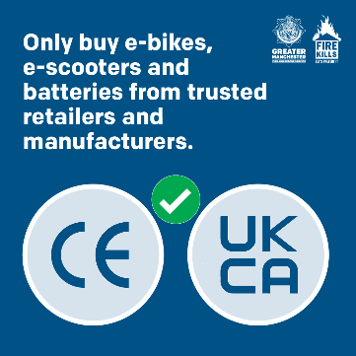 | Only buy e-bikes, e-scooters and batteries from trusted retailers and manufacturers. Graphics of CE and UKCA safety markings with green tick.
Always follow the manufacturer’s instructions for your e-bike or e-scooter.  Don’t attempt to modify or tamper with the battery and always use the correct charger.  #ChargeSafe | 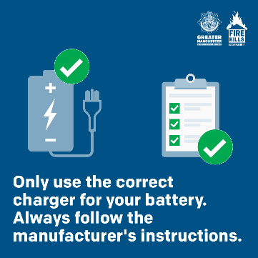 | Only use the correct charger for your battery. Always follow the manufacturer’s instructions. Battery and charger and clipboard with green ticks.
It is recommended that a professional carries out an e-bike conversion.  Visit @manchesterfire for more e-bike/e-scooter fire safety advice.  #ChargeSafe | 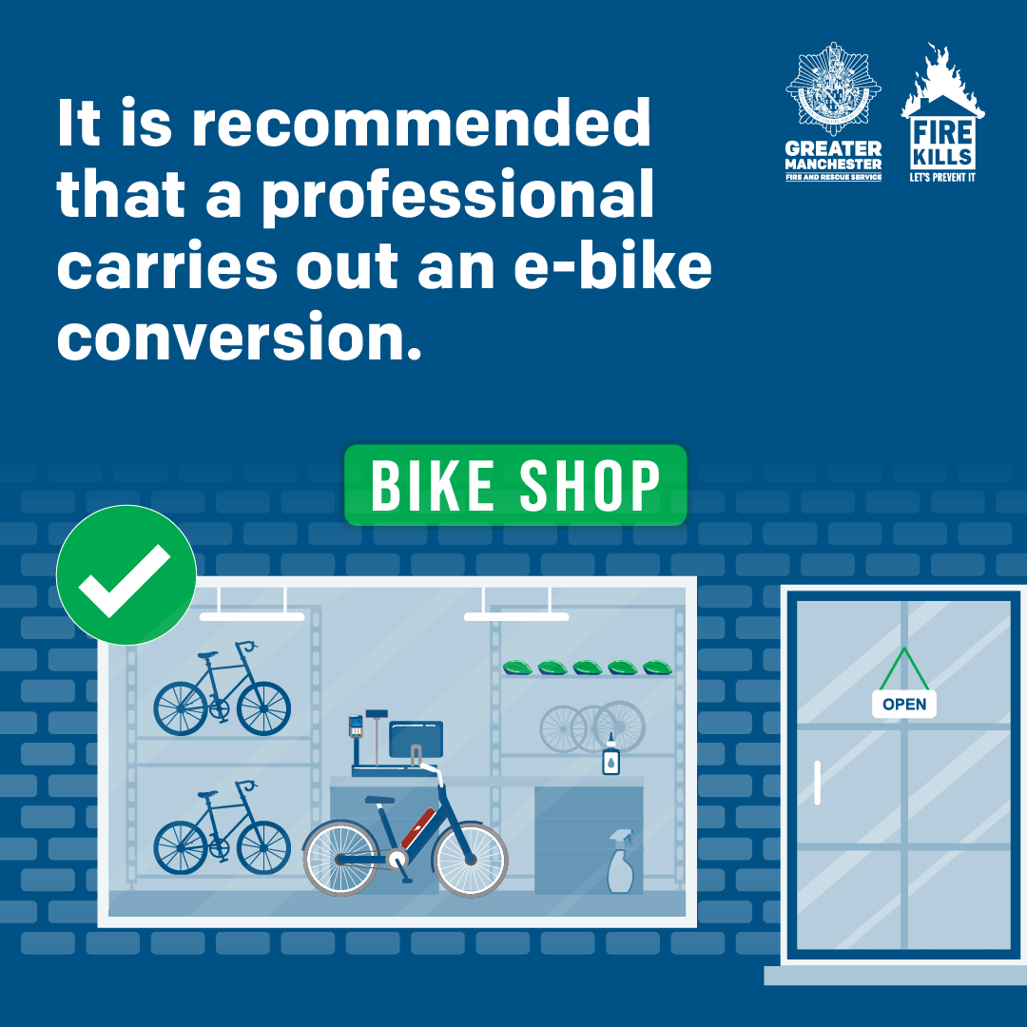  Or  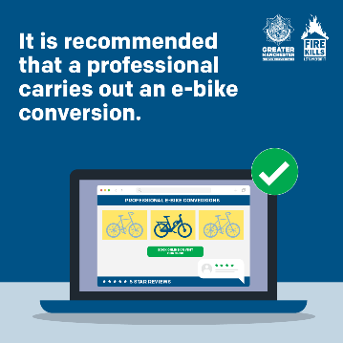 | It is recommended that a professional carries out an e-bike conversion. Green tick next to bike shop.  It is recommended that a professional carries out an e-bike conversion. Green tick next to online bike shop.

Phase two: Post-Christmas, charging safely. To be used from 25 December 2024 to 31 January 2025.

Suggested copy | Image | Alt text
Make sure you charge your e-bike or e-scooter battery safely. Follow these simple steps to reduce the risk of fire.  #ChargeSafe | N/A – Charge Safe animation | N/A
❌Don’t leave your e-bike or e-scooter battery charging unattended or when you’re asleep.  ✅ You should fit a smoke alarm in the room or garage where you charge or store your device, so you’re alerted quickly if there’s a fire.  #ChargeSafe | 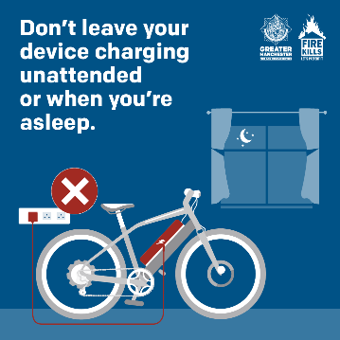 | Don’t leave your device charging unattended or when you’re asleep. Graphic of e-bike on charge on a night, with red cross.
Don’t charge or store your e-bike or e-scooter battery in the hallway or where it could block your escape.  In the event of a fire – get out, stay out, call 999.  #ChargeSafe | 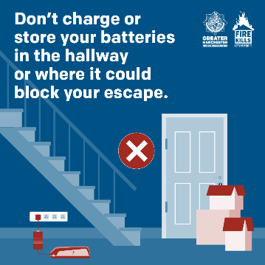 | Don’t charge or store your battery in the hallway or where it could block your escape. Image of door blocked by boxes and battery on charge, with red cross.
🛴 Do you have an e-bike or e-scooter? Our advice is to only use the correct charger for your battery and follow the manufacturer’s instructions to ensure safe charging and storage.  #ChargeSafe |  | Only use the correct charger for your battery. Always follow the manufacturer’s instructions. Battery and charger and clipboard with green ticks.

