Water safety 2024 – partner communications pack
We are once again launching our water safety campaign, working with families who have lost loved ones through accidental drownings, to make people aware of the dangers of open water.
The campaign is aimed at young people, particularly teenage boys, who are historically more likely to take unnecessary risks by jumping into open water and swimming in different areas of Greater Manchester. There is also messaging aimed at adults who know a young person, asking them to speak to a young person they know about the dangers of open water and keeping safe.
The 2024 water safety campaign launched on Friday 31 May. This campaign will run alongside the Safe4Summer campaign which shares messages about keeping safe around water, preventing anti-social behaviour and reducing moorland fires.
This year, the campaign’s key messages are:
- 236 people accidentally drowned in the UK in 2023. Don’t become a statistic, stay safe around water.
- Jumping into open water can be fatal. Cold water shock kills and you don’t know what’s lurking beneath the surface.
- If you encourage your mates to go in the water it could be the last time you see them.
- If you get into difficulty in the water, float to live.
- If you see someone in difficulty in the water remember ‘call, tell, throw’ (call 999 and ask for fire if inland or the coastguard if by the sea, tell the struggling person to try to float on their back and throw them something that floats).
Facebook, X and Instagram: @manchesterfire
Hashtags #DrowningPrevention #WaterSafety #RespectTheWater and #BeWaterAware used in social posts.
WeTransfer link to social media assets and videos: https://we.tl/t-yIWbgThEae

Key activities
- Sharing messaging on social media – including videos from family and friends who have lost loved ones
- Paid social media advertising during particularly warm spells of weather
- Water safety banners and posters installed at key locations
- Out of home and targeted online advertising, using the same artwork as the social media assets for campaign consistency
- GMFRS school visits, giving presentations to students on water safety (alongside other prevention activity)
- Water safety campaign webpage updated: https://www.manchesterfire.gov.uk/your-safety/campaigns/water-safety/
Campaign assets have been updated and are available from the WeTransfer link above. If you have any issues downloading any assets, please contact hendersonz@manchesterfire.gov.uk or katie.gee@greatermanchester-ca.gov.uk.
Partners are encouraged to share content from the digital toolkit as widely as possible across all social channels, as well as link through to our webpage: https://www.manchesterfire.gov.uk/your-safety/campaigns/water-safety/ when sharing any messaging.

Suggested social media posts
Facebook and X
Copy | Image/Alt Text
General campaign messages
As part of the latest @manchesterfire #WaterSafety campaign we are reminding people about the dangers of open water.  If you encourage your mates to go in the water it could be the last time you see them. Cold water shock kills even the strongest swimmers.  #DrowningPrevention | If you encourage your mates to go in the water it could be the last time you see them. Cold water shock kills even the strongest swimmers. Image shows underneath the water when someone has jumped in.  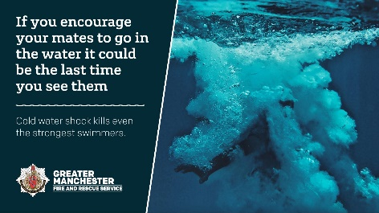
Jumping into open water can be fatal. Cold water shock and under-water currents can kill, and you don’t know what’s lurking beneath the surface.  Don’t become a statistic, stay safe around water.  #WaterSafety #DrowningPrevention #BeWaterAware | Jumping into open water can be fatal. Cold water shock kills and you don’t know what’s lurking beneath the surface. Image shows underneath the water when someone has jumped in.  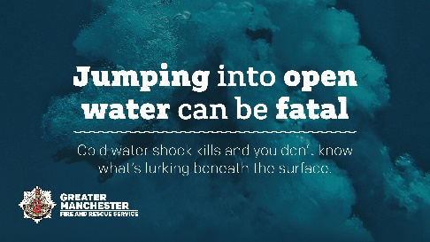
Did you know cold water shock can kill even strong swimmers, and under-water currents can be deadly? Our message is clear: if you encourage your mates to go in the water, it could be the last time you see them.  #WaterSafety #DrowningPrevention #BeWaterAware | If you encourage your mates to go in the water it could be the last time you see them. Cold water shock kills even the strongest swimmers. Image shows underneath the water when someone has jumped in.
Do you know where your kids go, and what they get up to, when they’re out with their friends? Please speak with them about the dangers of open water – it could save their life  https://www.manchesterfire.gov.uk/your-safety/campaigns/water-safety/  #WaterSafety #BeWaterAware | 236 people accidentally drowned in the UK in 2023. Don’t become a statistic, stay safe around water. Image shows underneath the water when someone has jumped in, with 236 people icons on top.  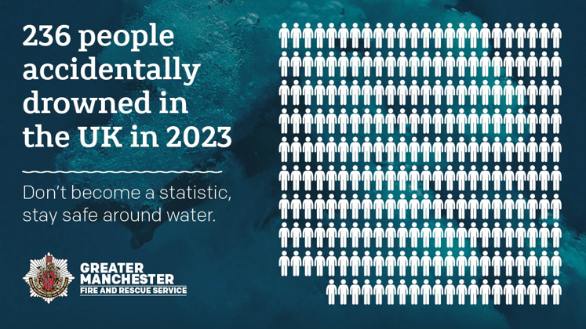
💔 Did you know that 236 people accidentally drowned in the UK in 2023?  Don’t become a statistic, stay safe around water.  #WaterSafety #DrowningPrevention #BeWaterAware | 236 people accidentally drowned in the UK in 2023. Don’t become a statistic, stay safe around water. Image shows underneath the water when someone has jumped in, with 236 people icons on top.
If you get into difficulty in the water, remember #FloatToLive…  - Tilt your head back, ears submerged.  - Relax and try to breathe normally.  - Move your hands to help you stay afloat.  - It's OK if your legs sink, we all float differently.  - Spread your arms and legs to improve stability.  #RespectTheWater | If you get into difficulty in the water, float to live. Image shows underneath the water when someone has jumped in.  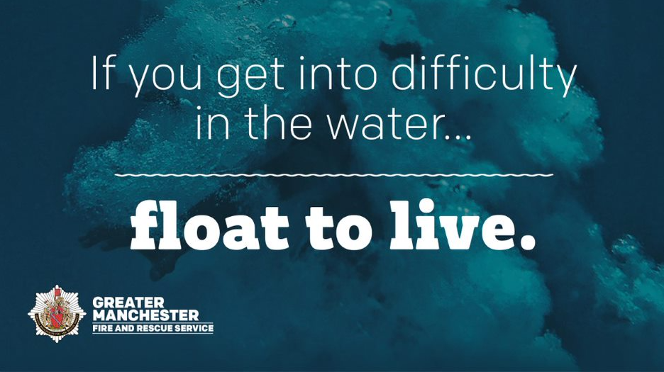
If you see someone in difficulty in the water remember ‘call, tell, throw’:  - Call 999 and ask for fire if inland or the coastguard if by the sea.  - Tell the struggling person to try to float on their back.  - Throw them something that floats.  #WaterSafety #RespectTheWater | If you see someone in difficulty in the water remember ‘call, tell, throw’. Image shows underneath the water when someone has jumped in.  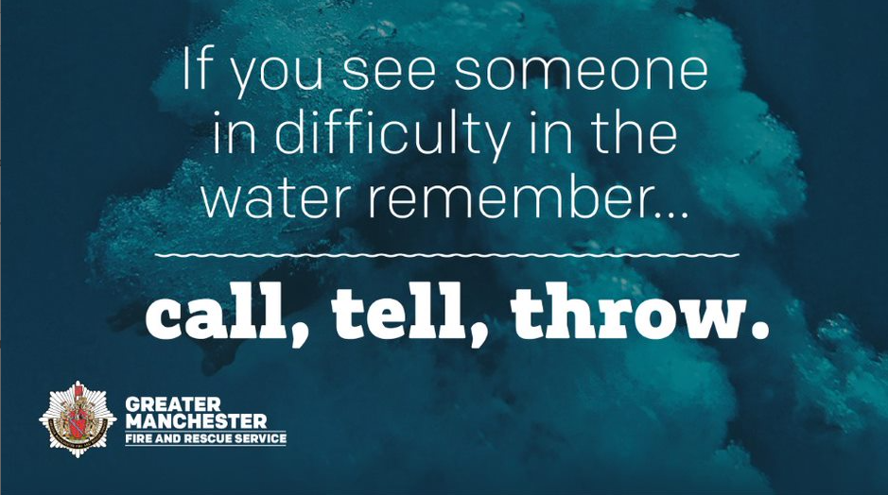
Family videos
Family members who have lost loved ones continue to support @manchesterfire #WaterSafety campaign to protect young people like you.  They share their stories in memory of those who are no longer with us to prevent others experiencing the same heartache as them 💔  #DrowningPrevention | Social media family and friends MP4s
236 people accidentally drowned in the UK in 2023.  Behind every statistic is a grieving family. Family members who have lost loved ones continue to support @manchesterfire #WaterSafety campaign to protect young people, so you don’t have to go through what they’ve been through 💔. | Social media family and friends MP4s
“It’s not worth your family going through the sort of pain that my family’s been through”.  💔 Lauren’s brother Mark drowned in 2018. @manchesterfire have filmed these powerful stories from those who have lost loved ones in accidental drownings, to remind people of the dangers of open water. | Lauren mp4 (Debdale Park, Manchester)
Chris lost his nephew Jack, to drowning. He’s sharing his story to prevent others going through what him and his family have.  “The water doesn’t care if you’re a strong swimmer or not, the water can be vicious, and it can change in an instant”.  #WaterSafety #DrowningPrevention | Chris mp4 (River Etherow, Tameside)
“That’s when I just broke down and I knew that my life had changed forever”.  Natalie shares her story of losing her son, Paul, so others don’t have to experience her heartache.  #WaterSafety #DrowningPrevention | Natalie mp4 (Greenbooth Reservoir, Rochdale)
“Losing him was the hardest thing, and life without him is harder “  💔 Jack Pullen drowned in July 2016 at age 16, in a river. His sister is helping raise awareness of the dangers of open water.  #WaterSafety #DrowningPrevention | Fallon mp4 (River Etherow, Tameside)
Ben and Jordan lost their friend, Paul, to drowning – they share their story to prevent others going through what they have.  Think about your friends and family before going in the water – they will miss you more than you think.  #WaterSafety #DrowningPrevention | Ben and Jordan mp4 (Greenbooth Reservoir, Rochdale)
“So many children, teens, and adults don’t make it home after 20 minutes of swimming.”  Dylan Ramsay drowned in 2011 in a quarry. Dylan’s mum Beckie spoke to us about her heartache.  https://www.youtube.com/watch?v=KTEE15STQss  #WaterSafety #DrowningPrevention | Dylan Ramsay (age 13) youtube video  https://www.youtube.com/watch?v=KTEE15STQss
Warm weather proactive messaging
Looks like it will stay warm a bit longer, so why not have a chat with your kids, or other young people you know, about the dangers of open water? It could save their life ❤️  #WaterSafety #DrowningPrevention #BeWaterAware | 236 people accidentally drowned in the UK in 2023. Don’t become a statistic, stay safe around water. Image shows underneath the water when someone has jumped in, with 236 people icons on top.
Enjoying the warmer weather?  Remember - jumping into open water can be fatal. Cold water shock kills and you don’t know what’s lurking beneath the surface.  https://www.manchesterfire.gov.uk/your-safety/campaigns/water-safety/  #WaterSafety #DrowningPrevention #RespectTheWater | Jumping into open water can be fatal. Cold water shock kills and you don’t know what’s lurking beneath the surface. Image shows underneath the water when someone has jumped in.
Enjoying the warmer weather?  If you're planning on going for a swim - visit your local pool. If you're at the beach, pick a spot with lifeguards on duty.  If you get into difficulty in the water, #FloatToLive  #WaterSafety #DrowningPrevention #RespectTheWater | If you get into difficulty in the water float to live. Image shows underneath the water when someone has jumped in.
☀ It’s warm in Greater Manchester, so what better time to remind people about @manchesterfire #WaterSafety campaign  Do you know a young person? Chat with them today about the dangers of open water  https://www.manchesterfire.gov.uk/your-safety/campaigns/water-safety/ | 236 people accidentally drowned in the UK in 2023. Don’t become a statistic, stay safe around water. Image shows underneath the water when someone has jumped in, with 236 people icons on top.
Please stay safe around water this summer. If you encourage your mates to go in the water it could be the last time you see them. Cold water shock kills even the strongest swimmers.  #DrowningPrevention | If you encourage your mates to go in the water it could be the last time you see them. Cold water shock kills even the strongest swimmers. Image shows underneath the water when someone has jumped in.
If you see someone in difficulty in the water remember ‘call, tell, throw’.  - Call 999 and ask for fire if inland or the coastguard if by the sea.  - Tell the struggling person to try to float on their back.  - Throw them something that floats.  #DrowningPrevention #RespectTheWater | If you see someone in difficulty in the water remember ‘call, tell, throw’. Image shows underneath the water when someone has jumped in.

Instagram
Copy | Image/Alt Text
General campaign messages
As part of the latest @manchesterfire #WaterSafety campaign we are reminding people about the dangers of open water.  If you encourage your mates to go in the water it could be the last time you see them. Cold water shock kills even the strongest swimmers.  #DrowningPrevention | If you encourage your mates to go in the water it could be the last time you see them. Cold water shock kills even the strongest swimmers. Image shows underneath the water when someone has jumped in.  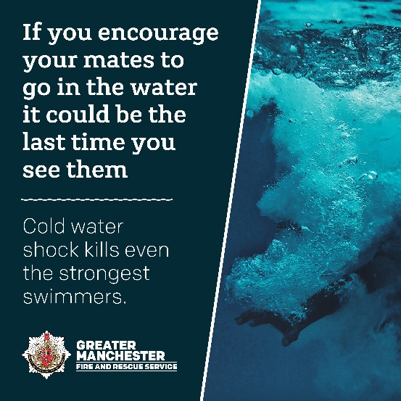
Jumping into open water can be fatal. Cold water shock and under-water currents can kill, and you don’t know what’s lurking beneath the surface.  Don’t become a statistic, stay safe around water.  #WaterSafety #DrowningPrevention #BeWaterAware | Jumping into open water can be fatal. Cold water shock kills and you don’t know what’s lurking beneath the surface. Image shows underneath the water when someone has jumped in.  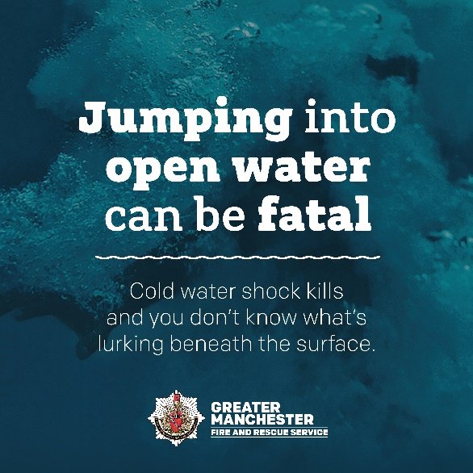
Did you know cold water shock can kill even strong swimmers, and under-water currents can be deadly? Our message is clear: if you encourage your mates to go in the water, it could be the last time you see them.  #WaterSafety #DrowningPrevention #BeWaterAware | If you encourage your mates to go in the water it could be the last time you see them. Cold water shock kills even the strongest swimmers. Image shows underneath the water when someone has jumped in.
Do you know where your kids go, and what they get up to, when they’re out with their friends? Please speak with them about the dangers of open water – it could save their life  Search ‘water safety’ on our website  #WaterSafety #BeWaterAware | 236 people accidentally drowned in the UK in 2023. Don’t become a statistic, stay safe around water. Image shows underneath the water when someone has jumped in.  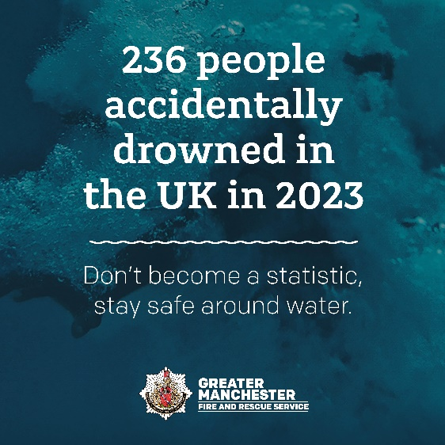
💔 Did you know that 236 people accidentally drowned in the UK in 2023?  Don’t become a statistic, stay safe around water.  #WaterSafety #DrowningPrevention #BeWaterAware | 236 people accidentally drowned in the UK in 2023. Don’t become a statistic, stay safe around water. Image shows underneath the water when someone has jumped in.
If you get into difficulty in the water, remember #FloatToLive…  - Tilt your head back, ears submerged.  - Relax and try to breathe normally.  - Move your hands to help you stay afloat.  - It's OK if your legs sink, we all float differently.  - Spread your arms and legs to improve stability.  #RespectTheWater | If you get into difficulty in the water, float to live. Image shows underneath the water when someone has jumped in.  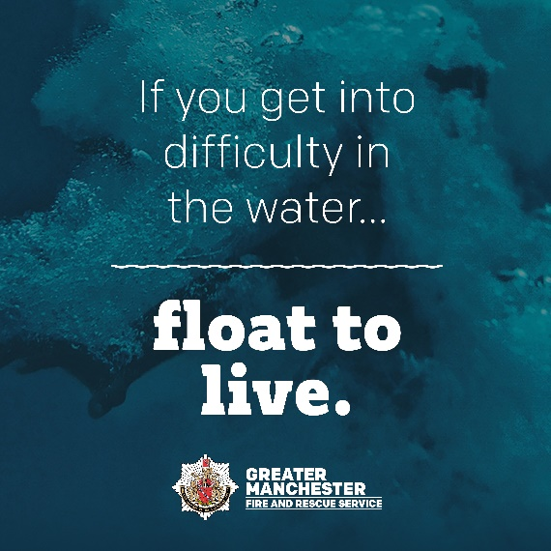
If you see someone in difficulty in the water remember ‘call, tell, throw’:  - Call 999 and ask for fire if inland or the coastguard if by the sea.  - Tell the struggling person to try to float on their back.  - Throw them something that floats.  #WaterSafety #RespectTheWater | If you see someone in difficulty in the water remember ‘call, tell, throw’. Image shows underneath the water when someone has jumped in.  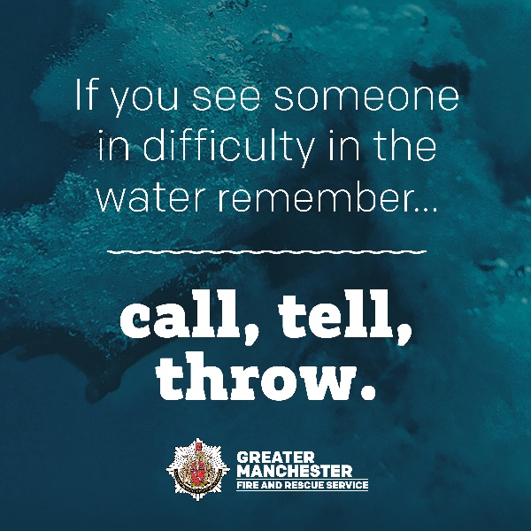
Family videos
Family members who have lost loved ones continue to support @manchesterfire #WaterSafety campaign to protect young people like you.  They share their stories in memory of those who are no longer with us to prevent others experiencing the same heartache as them 💔  #DrowningPrevention | Social media family and friends MP4s
236 people accidentally drowned in the UK in 2023.  Behind every statistic is a grieving family. Family members who have lost loved ones continue to support @manchesterfire #WaterSafety campaign to protect young people, so you don’t have to go through what they’ve been through 💔. | Social media family and friends MP4s
“It’s not worth your family going through the sort of pain that my family’s been through”.  💔 Lauren’s brother Mark drowned in 2018. @manchesterfire have filmed these powerful stories from those who have lost loved ones in accidental drownings, to remind people of the dangers of open water.  It’s not worth dying for a dip.  #DrowningPrevention | Lauren mp4 (Debdale Park, Manchester)
Chris lost his nephew Jack, to drowning. He’s sharing his story to prevent others going through what him and his family have.  “The water doesn’t care if you’re a strong swimmer or not, the water can be vicious, and it can change in an instant”.  #WaterSafety #DrowningPrevention | Chris mp4 (River Etherow, Tameside)
“That’s when I just broke down and I knew that my life had changed forever”.  Natalie shares her story of losing her son, Paul, so others don’t have to experience her heartache.  #WaterSafety #DrowningPrevention | Natalie mp4 (Greenbooth Reservoir, Rochdale)
“Losing him was the hardest thing, and life without him is harder “  💔 Jack Pullen drowned in July 2016 at age 16, in a river. His sister is helping raise awareness of the dangers of open water.  #WaterSafety #DrowningPrevention | Fallon mp4 (River Etherow, Tameside)
Ben and Jordan lost their friend, Paul, to drowning – they share their story to prevent others going through what they have.  Think about your friends and family before going in the water – they will miss you more than you think.  #WaterSafety #DrowningPrevention | Ben and Jordan mp4 (Greenbooth Reservoir, Rochdale)
“So many children, teens, and adults don’t make it home after 20 minutes of swimming.”  Dylan Ramsay drowned in 2011 in a quarry. Dylan’s mum Beckie spoke to us about her heartache.  https://www.youtube.com/watch?v=KTEE15STQss  #WaterSafety #DrowningPrevention | Dylan Ramsay (age 13) youtube video  https://www.youtube.com/watch?v=KTEE15STQss
Warm weather proactive messaging
Looks like it will stay warm a bit longer, so why not have a chat with your kids, or other young people you know, about the dangers of open water? It could save their life ❤️  #WaterSafety #DrowningPrevention #BeWaterAware | 236 people accidentally drowned in the UK in 2023. Don’t become a statistic, stay safe around water. Image shows underneath the water when someone has jumped in.
Enjoying the warmer weather?  Remember - jumping into open water can be fatal. Cold water shock kills and you don’t know what’s lurking beneath the surface.  #WaterSafety #DrowningPrevention #RespectTheWater | Jumping into open water can be fatal. Cold water shock kills and you don’t know what’s lurking beneath the surface. Image shows underneath the water when someone has jumped in.
Enjoying the warmer weather?  If you're planning on going for a swim - visit your local pool. If you're at the beach, pick a spot with lifeguards on duty.  If you get into difficulty in the water, #FloatToLive  #WaterSafety #DrowningPrevention #RespectTheWater | If you get into difficulty in the water float to live. Image shows underneath the water when someone has jumped in.
☀ It’s warm in Greater Manchester, so what better time to remind people about @manchesterfire #WaterSafety campaign  Do you know a young person? Chat with them today about the dangers of open water  Search ‘water safety’ on our website | 236 people accidentally drowned in the UK in 2023. Don’t become a statistic, stay safe around water. Image shows underneath the water when someone has jumped in.
Please stay safe around water this summer. If you encourage your mates to go in the water it could be the last time you see them. Cold water shock kills even the strongest swimmers.  #DrowningPrevention | If you encourage your mates to go in the water it could be the last time you see them. Cold water shock kills even the strongest swimmers. Image shows underneath the water when someone has jumped in.
Quick question for you before you head out to enjoy the weather…  Did you know what to do if you see someone in trouble in the water?  Remember ‘call, tell, throw’:  - Call 999 and ask for fire if inland or the coastguard if by the sea.  - Tell the struggling person to try to float on their back.  - Throw them something that floats.  #WaterSafety #DrowningPrevention #BeWaterAware #RespectTheWater | If you see someone in difficulty in the water remember ‘call, tell, throw’. Image shows underneath the water when someone has jumped in.

