Home Fire Safety Assessments

Partner Toolkit

Background
On 5 January 2022, we launched Home Fire Safety Assessments (HFSA), targeted home fire safety interventions which replaced the previous Safe and Well offer.
To support HFSA an Online Home Fire Safety Check (OHFSC) tool is available, which households can use to help identify fire hazards in their home. The tool also suggests changes that can be easily made to reduce the risk of a fire. Residents of Greater Manchester can access the online tool via a link on our website.
Completing the online check assesses whether the householder is eligible for a HFSA and presents the user with a referral form if they are eligible. Submitting the completed form transfers referral information to our contact centre, who then telephone the householder or representative to arrange an appointment for a face-to-face visit.
Partner agencies across Greater Manchester can also use the tool to make a third-party referral to us and training is available to partners to explain the process and how to use the online tool.

How you can help – seven simple steps
This toolkit has been developed to encourage partners to support the promotion of our Online Home Fire Safety Check, the Home Fire Safety Assessment process and signpost to the fire safety advice on our website.
We are asking you, our trusted partner, to help promote Home Fire Safety Assessments and our referral pathway to your staff and service users by taking seven simple steps:
- Provide a link to our HFSA webpage on your website
- Provide a link to our HFSA partner webpage on your intranet
- Promote HFSAs on social media as widely as possible, across all relevant channels
- Distribute our HFSA promotional leaflets and display our posters
- Attend our HFSA training and encourage your colleagues to attend
- Include fire safety in your service user assessments
- Sign up to our Home Fire Safety Partnership Bulletin and encourage your colleagues to sign up

Step one: Provide a link to our HFSA webpage on your website
Below is some suggested copy to include on your website. You could also include it in your external communications, such as a newsletter or resident publication. Please feel free to amend for your requirements. Accompanying images are provided in this WeTransfer link - https://we.tl/t-PiKLZROUlh

Home Fire Safety
You can get personalised advice to keep your home safe from fire by using an Online Home Fire Safety Check tool. This can be accessed on the Greater Manchester Fire and Rescue Service (GMFRS) website, and you can complete an Online Home Fire Safety Check to help identify fire hazards in your home and get advice on simple changes that can reduce the risk of a fire. The free online check takes up to 15 minutes to complete.
If you would like a free, face-to-face Home Fire Safety Assessment, delivered by trained GMFRS staff, complete the online check to find out if you are eligible. If you are eligible, you will be presented with an online referral form for completing and submitting to GMFRS’ contact centre, who will then be in touch to arrange the visit. If you do not have online access, you can telephone GMFRS’ contact centre on 0800 555 815 to find out if you are eligible for a Home Fire Safety Assessment.
manchesterfire.gov.uk/your-safety/hfsa

Step two: Provide a link to our HFSA partner webpage on your intranet
Below is some suggested copy to include on your intranet or internal communications. This is to make your staff aware of the process for referring service users for a HFSA and encourage them to use the online tool. Please feel free to amend for your requirements. Accompanying images are provided in this WeTransfer link - https://we.tl/t-PiKLZROUlh
Home Fire Safety
Greater Manchester Fire and Rescue Service (GMFRS) has an online tool that gives local people personalised home fire safety advice. The Online Home Fire Safety Check tool also assesses if someone needs a Home Fire Safety Assessment (HFSA), a targeted home fire safety intervention that has replaced the previous Safe and Well offer.
The offer is part of GMFRS’ targeted approach to fire prevention across Greater Manchester, to ensure vulnerable residents are protected and get the support they need to stay safe from fire. Partner agencies across Greater Manchester, such as ours, are being encouraged to use the tool to make a third party referral to GMFRS.
During the online check, if the person you are referring is eligible for a HFSA you will be presented with an online referral form for completing and submitting to GMFRS’ contact centre. The contact centre will then get in touch with the householder (or third party) to arrange the visit. If you do not have online access, you can telephone GMFRS’ contact centre on 0800 555 815 to find out if your service user is eligible for a Home Fire Safety Assessment.
Training is being rolled out to partners to explain the HFSA referral process, the Online Home Fire Safety Check and make sure they are aware of how to make a referral on behalf of a resident. Visit GMFRS’ website for details of future training sessions and book your place.
More information for partners, including how to sign up for the Home Fire Safety Partnership Bulletin, is available on the GMFRS website - manchesterfire.gov.uk/your-safety/partner-information

Step three: Promote HFSAs on social media as widely as possible, across all relevant channels
Social media assets can be downloaded on this WeTransfer link - https://we.tl/t-PiKLZROUlh
Social media posts:
Post | Graphic and alt text
Use @manchesterfire Online Home Fire Safety Check to keep your home safe from fire.  Complete the online check to help identify fire hazards in your home.  🔥 Get personalised advice on simple changes you can make to reduce the risk of a fire.  manchesterfire.gov.uk/your-safety/hfsa/ | 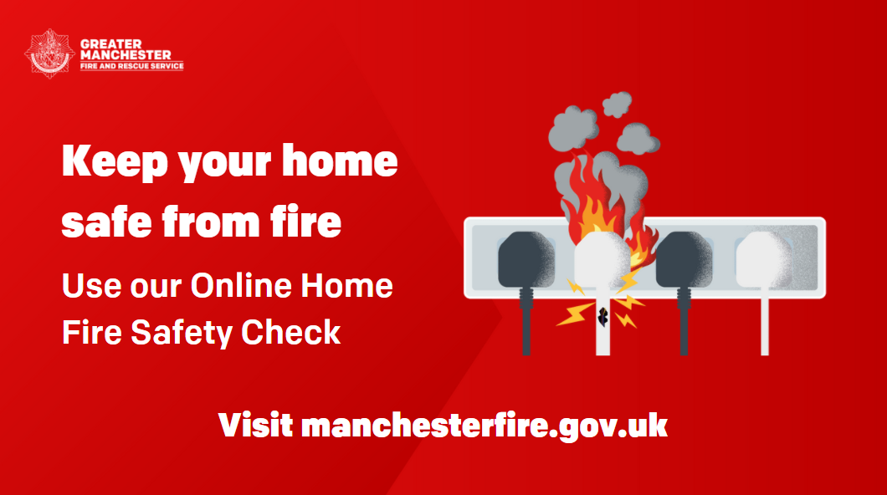  Cartoon image of an overloaded plug socket, with one plug in flames. GMFRS logo and text reads: Keep your home safe from fire. Use our Online Home Fire Safety Check. Visit manchesterfire.gov.uk
Use @manchesterfire Online Home Fire Safety Check to keep your home safe from fire.  🏠 Complete the online check to help identify fire hazards in your home.  Get personalised advice on simple changes you can make to reduce the risk of a fire.  manchesterfire.gov.uk/your-safety/hfsa/ | 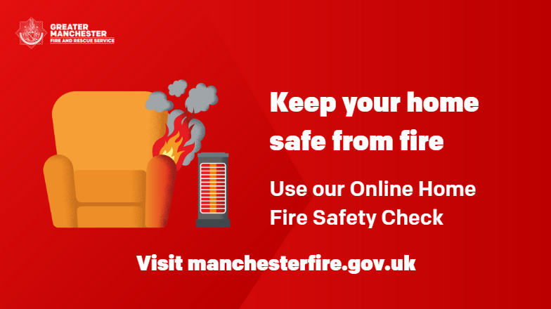  Cartoon image of a chair too close to a heater, with the arm of the chair in flames. GMFRS logo and text reads: Keep your home safe from fire. Use our Online Home Fire Safety Check. Visit manchesterfire.gov.uk  OR  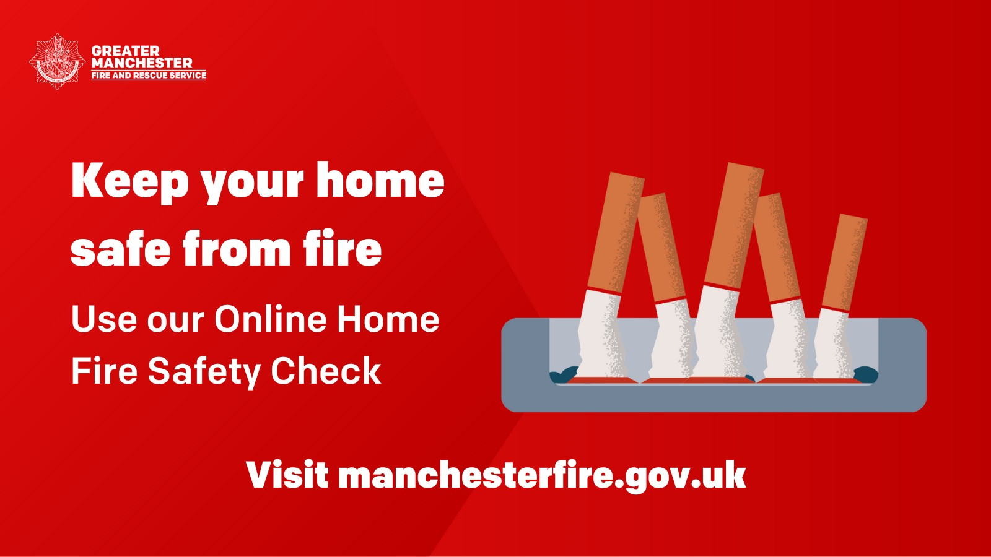  Cartoon image of cigarettes stubbed out in an ashtray. GMFRS logo and text reads: Keep your home safe from fire. Use our Online Home Fire Safety Check. Visit manchesterfire.gov.uk
🔥 Half of fires that result in deaths are in homes with no working smoke alarm.  🏠 Complete @manchesterfire free Online Home Fire Safety Check and get advice on simple changes you can make to reduce the risk of a fire.  manchesterfire.gov.uk/your-safety/hfsa/ | 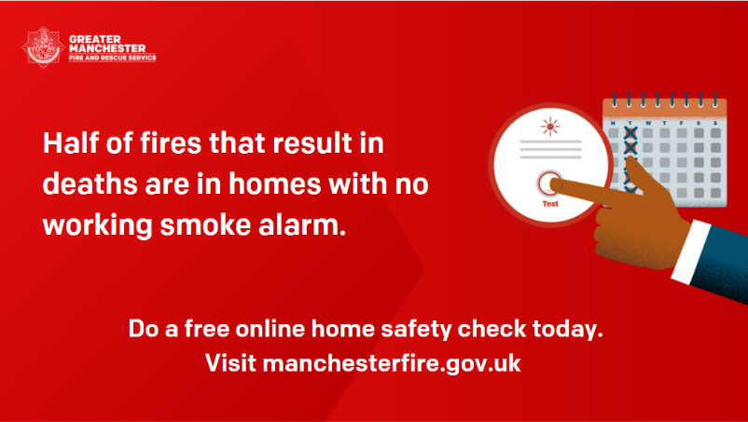  Cartoon image of a finger testing a smoke alarm, with a calendar in the background. GMFRS logo and text reads: Half of fires that result in deaths are in homes with no working smoke alarm. Do a free online home safety check today. Visit manchesterfire.gov.uk
🚬 Most house fire deaths are caused by smoking.  Get personalised home fire safety advice from @manchesterfire to keep you and your loved ones safe from fire.  manchesterfire.gov.uk/your-safety/hfsa/ | 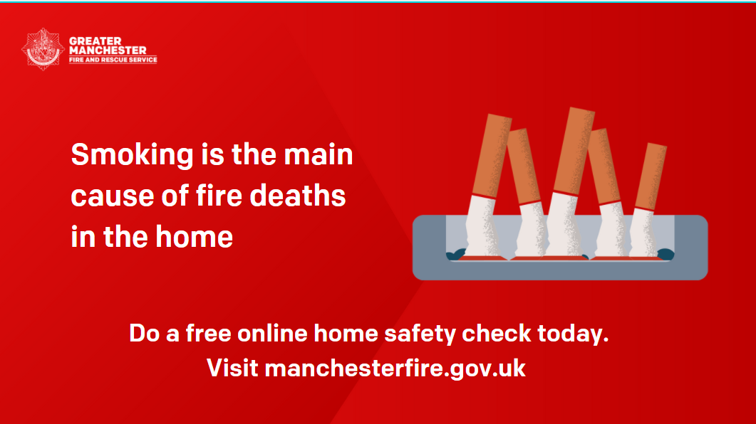  Cartoon image of cigarettes stubbed out in an ashtray. GMFRS logo and text reads: Smoking is the main cause of fire deaths in the home. Do a free online home fire safety check today. Visit manchesterfire.gov.uk
⏰ Take 15 minutes to protect your home and loved ones from fire.  🏠 Use @manchesterfire online tool to get personalised advice or find out if you’re eligible for a Home Fire Safety Assessment.  manchesterfire.gov.uk/your-safety/hfsa/ | 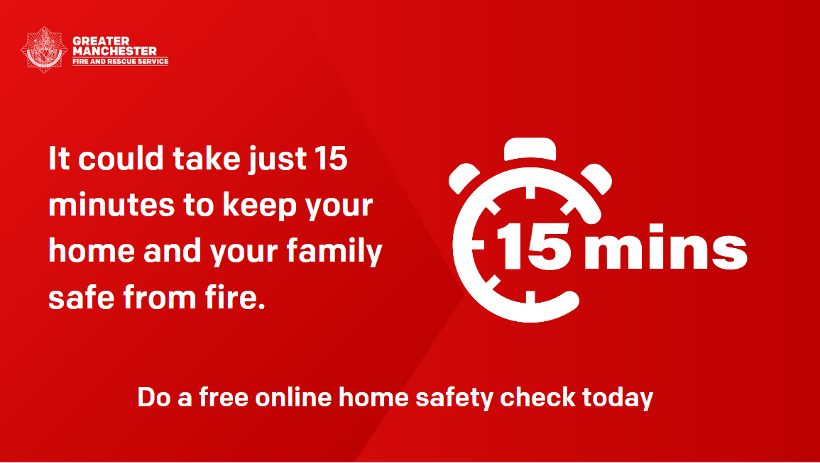  Cartoon image of a stop watch with ’15 mins’ written. GMFRS logo and text reads: It could take just 15 minutes to keep your home and your family safe from fire. Do a free online home safety check today.
🍳 Most house fires are caused by cooking.  Get personalised home fire safety advice from @manchesterfire to keep you and your loved ones safe from fire.  manchesterfire.gov.uk/your-safety/hfsa/ | 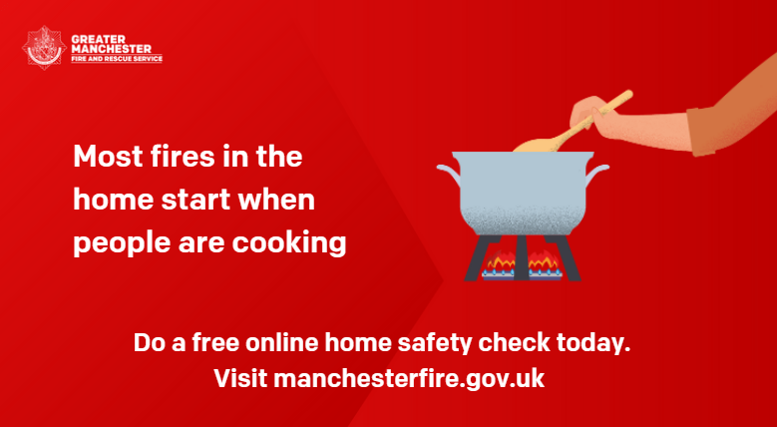  Cartoon image of a pan cooking, with a person stirring the pot. GMFRS logo and text reads: Most fires in the home start when people are cooking. Do a free online home safety check today. Visit manchesterfire.gov.uk
🏠 Want to find out more about Home Fire Safety Assessments?  Watch @manchesterfire short animation 👇 | Short animation (59 seconds) - with subtitles  WeTransfer link - https://we.tl/t-PiKLZROUlh  or youtube (Home Fire Safety Assessment animation (short version) - YouTube)
🤔 Thinking about fire safety in your home? 🏠 🔥  Watch @manchesterfire short animation to find out more about their Home Fire Safety Assessments 📽 | Short animation (59 seconds) - with subtitles  WeTransfer link - https://we.tl/t-PiKLZROUlh  or youtube (Home Fire Safety Assessment animation (short version) - YouTube)
👀 Watch @manchesterfire short animation to find out more about their Online Home Fire Safety Check.  Then head over to manchesterfire.gov.uk/your-safety/hfsa/ to find out if you’re eligible for a Home Fire Safety Assessment. | Short animation (59 seconds) - with subtitles  WeTransfer link - https://we.tl/t-PiKLZROUlh  or youtube (Home Fire Safety Assessment animation (short version) - YouTube)
If you care for or support someone in Greater Manchester, they might be eligible for one of @manchesterfire home visits, where fire staff provide important fire safety advice.  Watch their short animation to find out more 👇 | Short animation (59 seconds) - with subtitles  WeTransfer link - https://we.tl/t-PiKLZROUlh  or youtube (Home Fire Safety Assessment animation (short version) - YouTube)

Step four: Distribute our HFSA promotional leaflets and display our posters
We provide a range of fire safety and other leaflets which you can download for distribution to the people you work with. This includes a promotional HFSA leaflet and our Advice to Households booklet - manchesterfire.gov.uk/your-safety/partner-information/fire-safety-literature/
To order free physical copies of the HFSA leaflet and poster, please email preventioneducation@manchesterfire.gov.uk

Step five: Attend our HFSA training and encourage your colleagues to attend
We currently offer two options for home fire safety training to partner organisations.
Option one is a 90-minute online option delivered on Microsoft Teams to equip partners to identify people at increased risk of fire, amongst their service users, and refer them for a Home Fire Safety Assessment (HFSA). HFSAs are home visits to assess and reduce the risk of fire in the home.

Option two is a half-day session delivered at our Training and Safety Centre in Bury. It provides the same learning as option one but also provides learners with an immersive input on fire safety in the home, including the five main causes of fire, bedtime routines and escape planning. This is delivered in a mock home environment.

To view the available training dates and book a place on a session, visit manchesterfire.gov.uk/your-safety/partner-information/fire-safety-in-the-home-training/
If your staff are unable to attend training, an alternative way to provide them with some information about HFSAs and how to make a referral is our short (under 5 minutes) animation. Distributing this across your staff network will help us to raise awareness at scale. You can watch the animation on our website here: manchesterfire.gov.uk/your-safety/partner-information/home-fire-safety-assessments-partners/

Step six: Include fire safety in your service user assessments
An effective and systematic way to build fire safety into the care you provide to your service users is to include a relevant question in your initial assessments or client reviews. For example, adding, ‘Do you have a working smoke alarm on each floor of your home?’ or ‘Have you had a Home Fire Safety Assessment from Greater Manchester Fire and Rescue Service?’ will enable you to record a Yes/No response and open up a conversation about home fire safety and/or referring or signposting the person to our Online Home Fire Safety Check and referral pathway.

Step seven: Sign up to our Home Fire Safety Partnership Bulletin and encourage your colleagues to sign up
We have a quarterly bulletin for our partners, to keep you up to date on current campaigns and other fire safety information. If you are not already subscribed, please sign up at http://eepurl.com/hQa-if, and help share this information through your networks.

Contacts
Prevention Development Manager: Sarah Hardman - sarah.hardman@manchesterfire.gov.uk, 07968 143 678
Prevention Manager, Manchester: Melanie Kearney - kearneym@manchesterfire.gov.uk, 07734 275 703
Prevention Manager, Salford: Andy Pownall - pownalla@manchesterfire.gov.uk, 07977 410 605
Prevention Manager, Bolton and Wigan: Derek Dempster - dempsterd@manchesterfire.gov.uk, 07734 275 762
Prevention Manager, Oldham and Tameside: Andy Williams - williamsa@manchesterfire.gov.uk, 07812 207 297
Prevention Manager, Stockport and Trafford: Louise Atkinson - atkinsonl@manchesterfire.gov.uk, 07772 210 774
Prevention Manager, Bury and Rochdale: Liz Hinchcliffe - elizabeth.hinchcliffe@manchesterfire.gov.uk, 07580 698 644
Senior Communications Manager, GMFRS and GMCA Communications and Engagement Team: Katie Gee - katie.gee@greatermanchester-ca.gov.uk, 07976 702 346

