#StayFireSafe partner social media toolkit
Communications messaging and assets for our stay fire safe (cost of living) campaign. For use from 4 December and throughout winter.
The main aim of the stay fire safe campaign is to provide fire safety information for residents as the cost of living rises. Key messages include:
- Fitting a smoke alarm on every level of your home and a heat alarm in your kitchen
- Checking if you are eligible for a Home Fire Safety Assessment: manchesterfire.gov.uk/your-safety/hfsa/
- Visiting the GMFRS stay fire safe webpage: manchesterfire.gov.uk/your-safety/stay-fire-safe/
- Heating and fire safety​
- Cooking and fire safety
- Electrical fire safety

Social media copy
You will find suggested social content and images in the table below. Please remove any website links for use on Instagram.

Images
Assets featured in the suggested posts below can be downloaded from: Stay Fire Safe for partners - Greater Manchester Fire Rescue Service
They are grouped by size for X, Facebook, and Instagram.

Social media posts and assets
General
Image preview | Copy | Image title
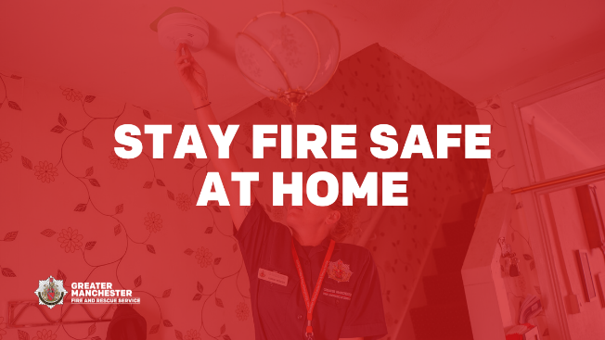  Alt text: Stay fire safe at home. Image of someone testing a smoke alarm. | We are all looking at ways to reduce our energy bills. Make sure you #StayFireSafe and don’t put yourself at risk of fire in your home.  See @manchesterfire advice for keeping safe here: manchesterfire.gov.uk/your-safety/stay-fire-safe/ | Stay fire safe at home
Alt text: Stay fire safe at home. Image of someone testing a smoke alarm. | Visit @manchesterfire website to complete some quick questions to help identify fire hazards in your home and get advice on simple changes you can make to reduce the risk of a fire.  #StayFireSafe | Stay fire safe at home
Alt text: Stay fire safe at home. Image of someone testing a smoke alarm. | How are your loved ones keeping warm this winter?  Please check on family and friends who might be struggling to heat their home.  You can complete @manchesterfire online home fire safety check here: manchesterfire.gov.uk/your-safety/hfsa/  #StayFireSafe | Stay fire safe at home
HFSA animation (MP4 file) | 🤔 Thinking about fire safety in your home? 🏠 🔥  Watch @manchesterfire short animation to find out more about their Home Fire Safety Assessments 📽  #StayFireSafe | Home Fire Safety Assessment animation (short)
HFSA animation (MP4 file) | 👀 Watch @manchesterfire short animation to find out more about their Online Home Fire Safety Check.  Then head over to manchesterfire.gov.uk/your-safety/hfsa/ to find out if you’re eligible for a Home Fire Safety Assessment.  #StayFireSafe | Home Fire Safety Assessment animation (short)
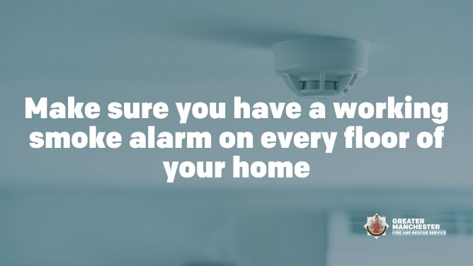  Alt text: Make sure you have a working smoke alarm on every floor of your home. Image of a smoke alarm. | There are some simple steps you can take to help keep you safe from fire.  Make sure you have a working smoke alarm on every floor of your home and a heat alarm in the kitchen, so you’re alerted quickly if there’s a fire.  #StayFireSafe | Smoke alarms
Heat your home safely
Image preview | Copy | Image title
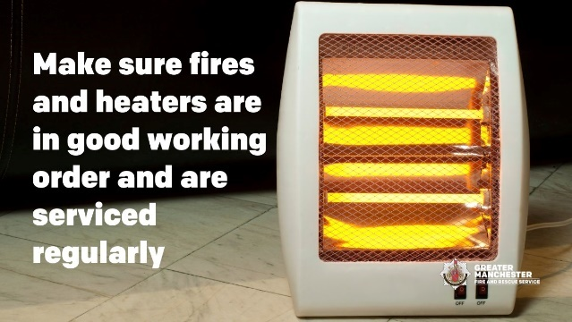  Alt text: Make sure fires and heaters are in good working order and are serviced regularly. Image of an electric heater. | If you're using portable heaters, make sure they are in good working order and check they are not on any product recall lists.  Visit @manchesterfire for more home fire safety advice.  #StayFireSafe | Heaters in good working order
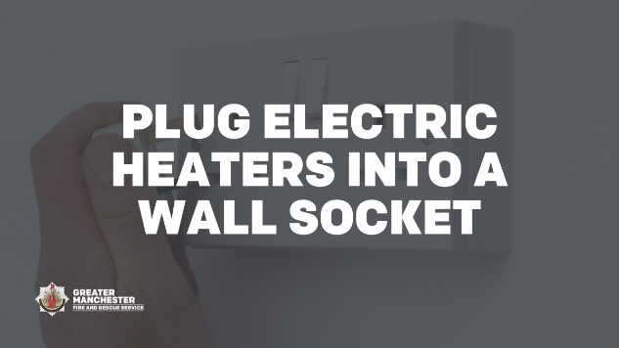  Alt text: Plug electric heaters into a wall socket. Image of a plug being plugged into a wall socket. | Electric heaters should be plugged into a wall socket – do not use extension leads as they can easily be overloaded and cause a fire.  Find more advice to keep yourself safe at home 👉 manchesterfire.gov.uk/your-safety/stay-fire-safe/  #StayFireSafe | Plug electric heaters into a wall socket
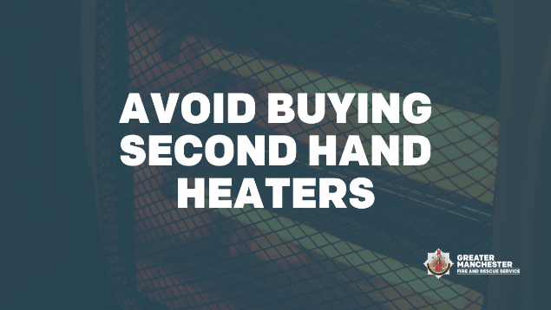  Alt text: Avoid buying second hand heaters. Image of a heater. | Avoid buying second-hand heaters, but if you need to buy one check it closely for damage - if in doubt avoid it.  Visit @manchesterfire for more home fire safety advice.  #StayFireSafe | Avoid buying second hand heaters
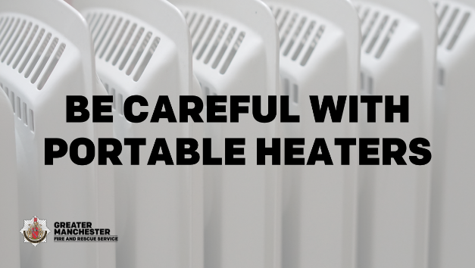  Alt text: Be careful with portable heaters. Image of portable heaters. | Portable heaters should only be moved when they have been switched off and cooled down.  Visit @manchesterfire for more home fire safety advice.  #StayFireSafe | Be careful with portable heaters
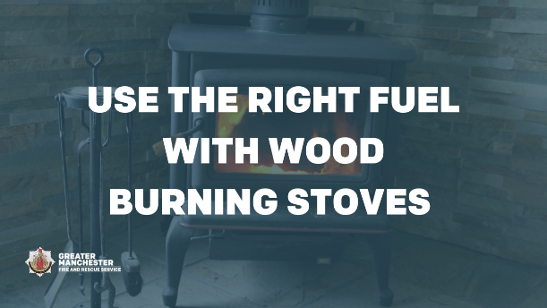  Alt text: Use the right fuel with wood burning stoves. Image of a wood burning stove. | Open fires and wood burning stoves may be a cosy way to keep warm but please use the right fuel to avoid fire risk and toxic fumes.  Make sure you've had your chimney swept to keep yourself safe.  Visit @manchesterfire for more home fire safety advice.  #StayFireSafe | Use the right fuel with wood burning stoves
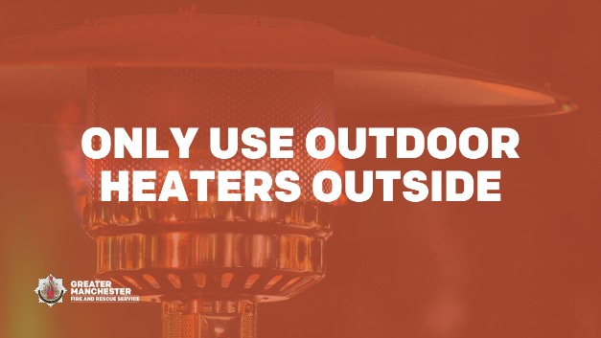  Alt text: Only use outdoor heaters outside. Image of an outdoor heater. | Only use outdoor heaters outside.  Using outdoor heaters inside is a fire risk and they also produce carbon monoxide which can be fatal.  Visit @manchesterfire for more home fire safety advice.  #StayFireSafe | Only use outdoor heaters outside
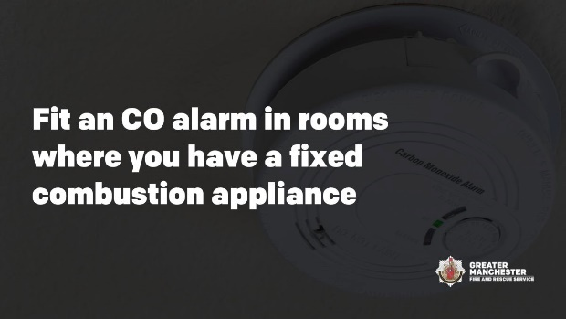  Alt text: Fit a CO alarm in rooms where you have a fixed combustion appliance. Image of a CO alarm. | Ensure you have a working carbon monoxide (CO) alarm in the same room as any heating appliance which does not run off electricity.  Remember to switch off heaters and extinguish fires before sleeping, to reduce your risk of fire or carbon monoxide poisoning.  #StayFireSafe | CO alarms
Electrical fire safety
Image preview | Copy | Image title
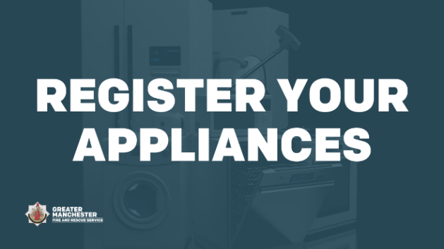  Alt text: Register your appliances. Image of fridge, freezer, washing machine, cooker, hoover and dishwasher. | To help keep yourself safe from fire, register your electrical products online: registermyappliance.org.uk  You will be informed if there is a problem.  This doesn’t just apply to new items; you can register older or second-hand appliances too.  #StayFireSafe | Register your appliances
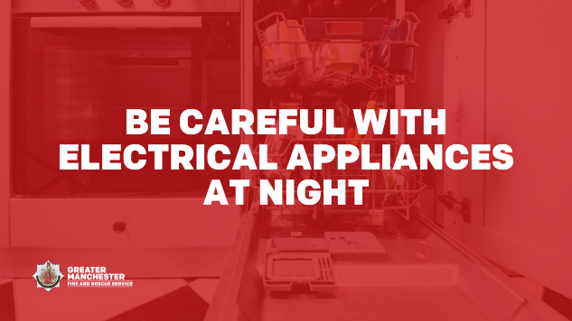  Alt text: Be careful with electrical appliances at night. Image of cooker and open dishwasher. | Electricity costs the same no matter what time of day or night you use it - unless you have a time of use tariff.  Don’t run white goods or charge items if you are asleep thinking you will save money. If a fire happens you will have less time to react and escape.  #StayFireSafe | Be careful with electrical appliances at night
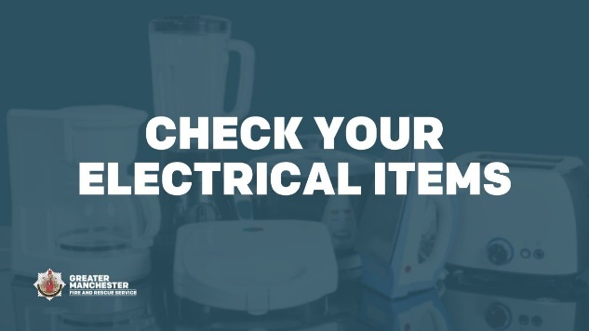  Alt text: Check your electrical items. Image of coffee machine, iron, toaster, toastie machine, slow cooker and blender. | Check cables and plugs for signs of wear and tear and don’t overload your plug sockets.  If you think there is a problem, unplug it and contact the retailer or manufacturer.  Find out more 👉 manchesterfire.gov.uk/your-safety/stay-fire-safe/  #StayFireSafe | Check your electrical items
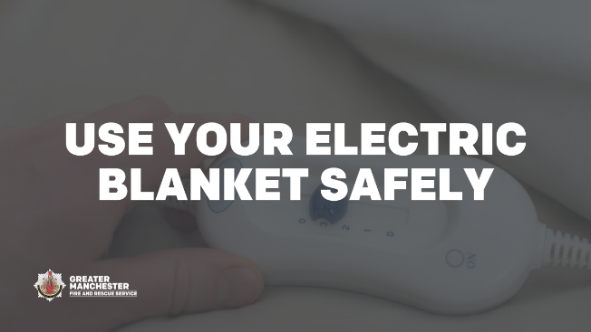  Alt text: Use your electric blanket safely. Image of the control on an electric blanket. | If you use an electric blanket always follow the manufacturer's instructions before use and store correctly.  Examine your blanket, plug and cord for signs of wear or damage.  Visit @manchesterfire for more home fire safety advice.  #StayFireSafe | Use your electric blanket safely
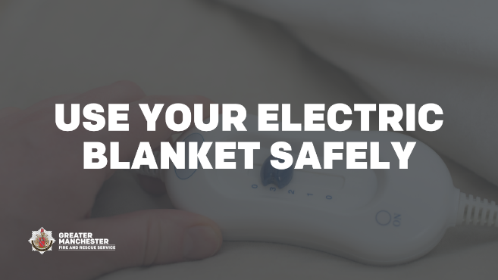  Alt text: Use your electric blanket safely. Image of the control on an electric blanket. | Don’t have drinks or use a hot water bottle when using your electric blanket. Liquids and electricity don’t mix.  Visit @manchesterfire for more home fire safety advice.  #StayFireSafe | Use your electric blanket safely
Bypassing electric and gas meters
Image preview | Copy | Image title
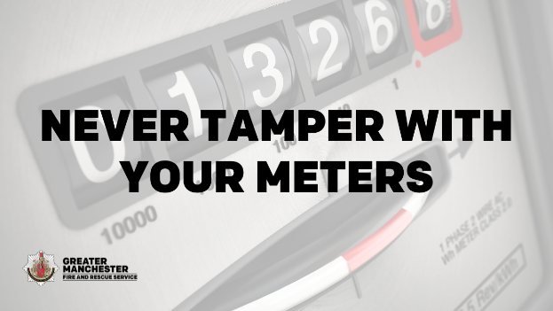  Alt text: Never tamper with your meters. Image of a meter. | Energy theft is not a victimless crime.  The potential dangers of meter tampering include sparks, fires, damage to property, explosions and, tragically, sometimes death.  #StayFireSafe | Never tamper with your meters
Cooking fire safety
Image preview | Copy | Image title
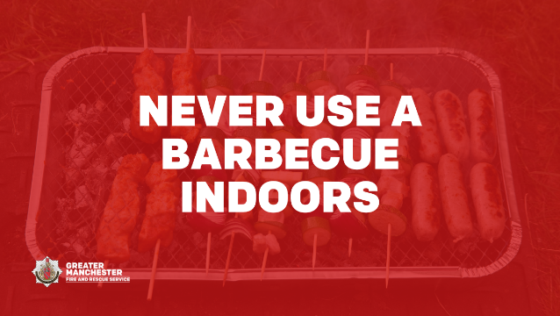  Alt text: Never use a barbecue indoors. Image of a barbecue cooking food. | Whether you have a gas or charcoal barbecue, remember they must never be used indoors.  Protect yourself from fire and carbon monoxide poisoning.  #StayFireSafe | Never use a barbecue indoors
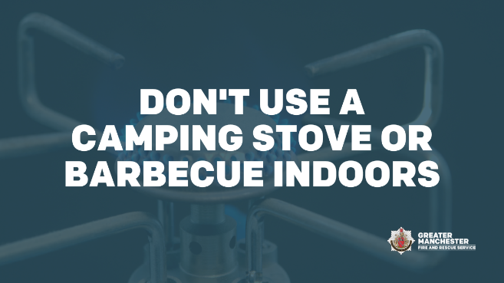  Alt text: Don’t use a camping stove or barbecue indoors. Image of a camping stove. | It might be tempting to use a camping stove or barbecue indoors, but remember these products must only be used outdoors.  Indoors they are a carbon monoxide and fire risk.  #StayFireSafe | Don't use a camping stove or barbecue indoors
Candle fire safety
Image preview | Copy | Image title
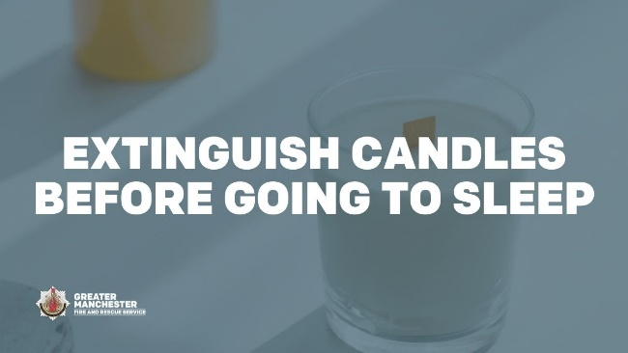  Alt text: Extinguish candles before going to sleep. Image of a candle. | When using candles don’t forget how many you have lit.  Never leave lit candles unattended and make sure they are all out completely at night or when you go out.  #StayFireSafe | Extinguish candles before going to sleep
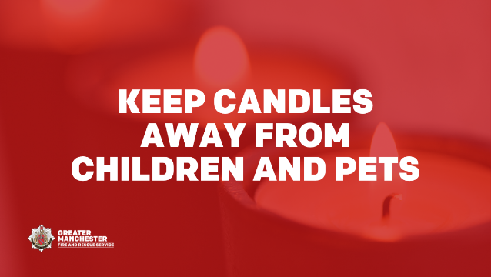  Alt text: Keep candles away from children and pets. Image of candles. | Place lit candles out of reach of children and pets.  Also remember to keep lighters and matches somewhere safe, away from children.  #StayFireSafe | Keep candles away from children and pets
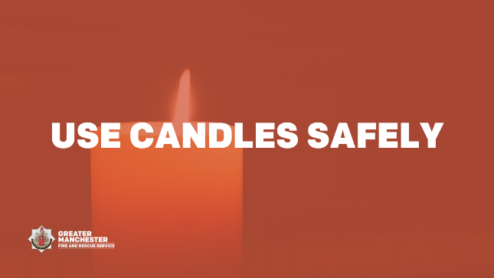  Alt text: Use candles safely. Image of a candle. | Don’t move or carry lit candles.  It’s much safer to use an LED candle or torch to light your way.  #StayFireSafe | Use candles safely
Gas safety
Image preview | Copy | Image title
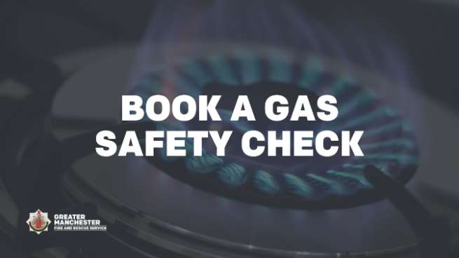  Alt text: Book a gas safety check. Image of flames on a gas hob. | Book a gas safety check to keep you safe at home.  If you own your home, check with your energy provider to see if you can get a free annual check through their Priority Services Register.  If you are a tenant, your landlord must arrange an annual gas safety check.  #StayFireSafe | Book a gas safety check
Help in Greater Manchester
Image preview | Copy | Image title
[Link through to helping hand webpages] | Are you worried about the rise in the cost of living?  @greatermcr have a lot of useful information that can provide you with a helping hand, including how to stay fire safe at home.  Find out more here: greatermanchester-ca.gov.uk/helping-hand/
Smoking safety
Image preview | Copy | Image title
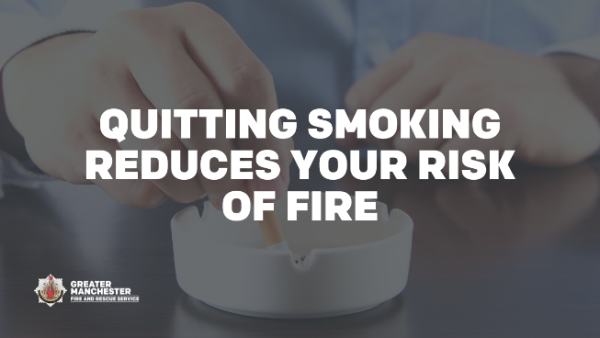  Alt text: Quitting smoking reduces your risk of fire. Image of a hand stubbing out a cigarette in an ashtray. | The best way to prevent smoking related fires is to quit smoking.  But if you’re not ready yet, follow @manchesterfire safety advice to reduce your risk of fire  manchesterfire.gov.uk/your-safety/fire-safety/house-maisonette-or-bungalow/smoking/  #StayFireSafe | Quitting smoking reduces your risk of fire
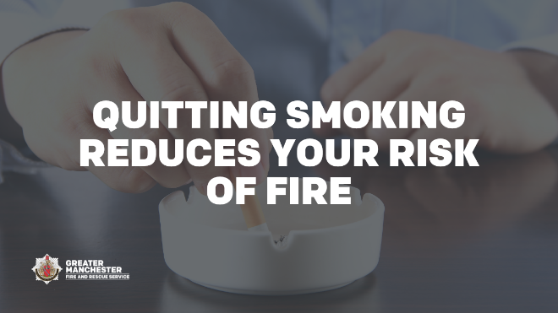  Alt text: Quitting smoking reduces your risk of fire. Image of a hand stubbing out a cigarette in an ashtray. | Smoking is the number one cause of accidental fire deaths in the UK.  If you smoke at home it’s safer to smoke outside if you can.  Find out more on how to stay fire safe at home: manchesterfire.gov.uk/your-safety/stay-fire-safe/  #StayFireSafe | Quitting smoking reduces your risk of fire
Home reconfiguration or part use
Image preview | Copy | Image title
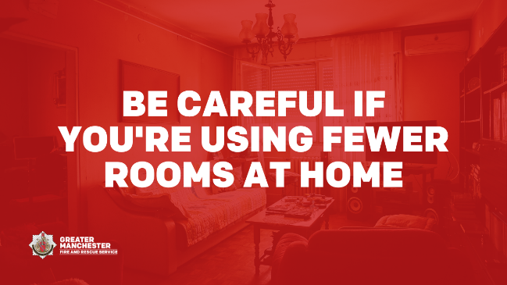  Alt text: Be careful if you’re using fewer rooms at home. Image of a front room. | If you are spending more time in just a couple of rooms in your home to save on heating, make sure you have working smoke alarms in or near the rooms you use most.  Find out more on how to stay fire safe at home: manchesterfire.gov.uk/your-safety/stay-fire-safe/  #StayFireSafe | Be careful if you're using fewer rooms at home
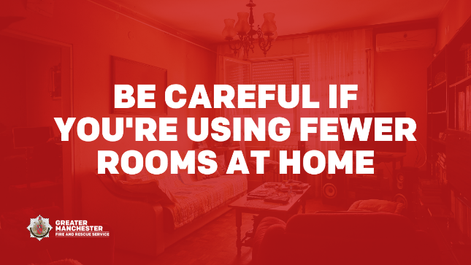  Alt text: Be careful if you’re using fewer rooms at home. Image of a front room. | If you are using fewer rooms to save on heating make sure there’s space around heaters, open fires and candles to reduce the risk of a fire in your home.  Visit @manchesterfire for more home fire safety advice.  #StayFireSafe | Be careful if you're using fewer rooms at home

