Stay Focused Drive Safe campaign social toolkit
• Communications messaging and assets for GMFRS’s Stay Focused Drive Safe campaign 2023 for use from 19 July – September 10
Our firefighters attend Road Traffic Collisions (RTCs) whenever someone is trapped in a vehicle or requires help to make an area safe or put out a vehicle fire. We now rescue more people from RTCs than we do from fires - so we see it as vitally important to raise awareness about the dangers of driving and encourage safe practice.
Between 2020 and 2022 there were 122 road casualties across our motorway network in Greater Manchester. This data was taken from the Transport for Greater Manchester Data Base Collision Records supplied by Greater Manchester Police and validated by the Surveys Research and Analysis Department.
The majority of traffic across Greater Manchester is seen on the city-region’s motorway network. Therefore, it is imperative that we continually educate and raise awareness about motorway safety and the dangers involved.
We’re supporting the campaign with a social media toolkit that will be shared with partner Heads of Comms. Our News and Media Team will also work with partner agencies such as Highways to provide updates on major incidents affecting Greater Manchester’s motorway network.
Furthermore, there will be continued coverage of our new virtual reality equipment across our website and social channels. The virtual reality experiences are being used to engage with our communities and teach them about road safety.
Key messages for Greater Manchester Fire and Rescue Service (GMFRS) include:
- Stay focused while driving and avoid distractions
- Don't hold or use a phone, sat nav, or any device while driving
- Don't drink and drive
- Always wear a seatbelt when driving and ensure all passengers do too
- Keep to the speed limit and be alert when driving on a smart motorway
- Remember the 2 second rule
- Raise awareness about the potential impacts of dangerous motorway driving
- #StayFocusedDriveSafe
Audiences
- Commuters
- Young drivers
- Learner drivers
- Driving instructors
- Older drivers
Channels
- GMFRS Facebook and Instagram
- Twitter - @manchesterfire, @buryfireteam, @firebolton, @mancfireteam, @oldhamfireteam, @rochdalefire, @salfordfireteam, @stockportfire, @tamesidefire, @traffordfire, @wiganfire
Social media copy
You will find suggested social content and example assets in the table below. You can also download the assets sized for Twitter/Facebook and Instagram via this link on our website.
Please use the following hashtag on your social posts: #StayFocusedDriveSafe
If you are using your own social media content, please tag us so we can support you by sharing your messaging across our channels.
Accessibility
Please make sure all images posted on social media make use of the ‘alt text’ function. Any words that appear in a graphic should be duplicated in the ‘alt text’. This will allow those using screen readers to access the content. The imagery in the graphic should also be described. You will find suggested alt text in the table below.

Asset | Content | Suggested times
Twitter
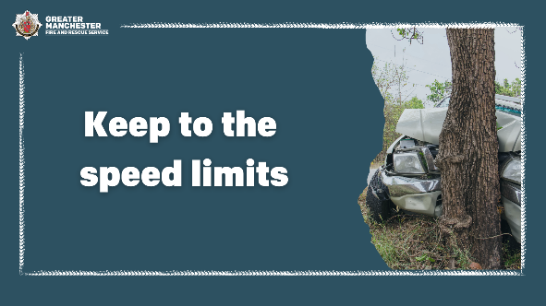  Alt text: A car that has crashed into a tree. Graphic text reads, ‘Keep to the speed limits.’ | 🚗 In Greater Manchester, 122 people were killed or seriously injured on motorways between 2020 and 2022.  Keep to the speed limit and remember the speed limit is not a target.  🛣 In some road conditions, even driving at the speed limit is too fast.  #StayFocusedDriveSafe | Tues-Thurs  7am-9am or 4pm-7pm
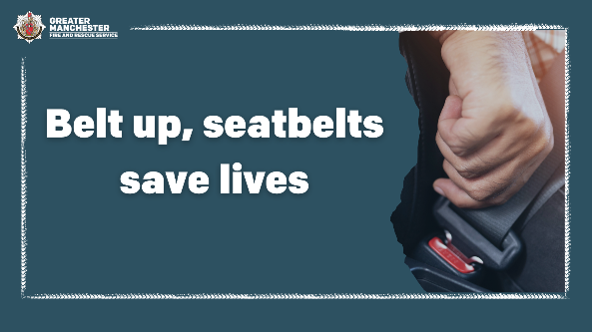  Alt text: Hand securing seatbelt. Graphic text reads, ‘Belt up, seatbelts save lives.’ | ❗ Your seatbelt is there to protect you.  It is a legal requirement to fasten your seatbelt whether you’re driving or a passenger in a vehicle.  If caught, you could be fined up to £500.  For more advice 👉 manchesterfire.gov.uk/your-safety/road-safety/staying-safe-on-motorways/  #StayFocusedDriveSafe | Tues-Thurs  6am-9am or 4pm-7pm
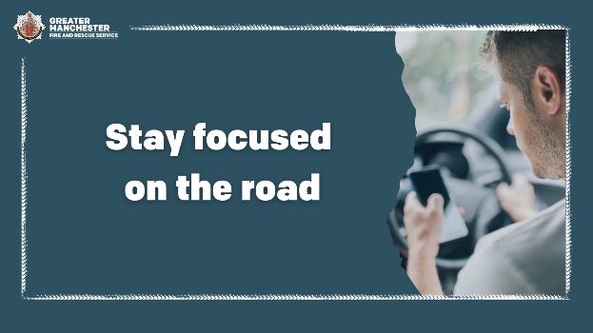  Alt text: Man texting while driving. Graphic text reads, ‘Stay focused on the road.’ | 📱 It’s illegal to hold and use a phone, sat nav, or any device while driving.  Stay focused and keep your eyes on the road at all times.  For more tips when driving 👉 manchesterfire.gov.uk/your-safety/road-safety/staying-safe-on-motorways/  #StayFocusedDriveSafe | Tues-Thurs  6am-9am or 4pm-7pm
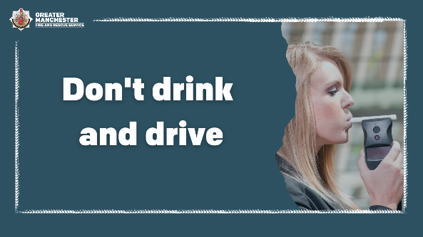  Alt text: Woman blowing into a breathalyser. Graphic text reads, ‘Don’t drink and drive.’ | ❌ Don’t drink and drive.  If you’ve been drinking the night before, remember you could still be over the limit the next day.  For more advice 👉 manchesterfire.gov.uk/your-safety/road-safety/staying-safe-on-motorways/  #StayFocusedDriveSafe | Thursday-Sunday
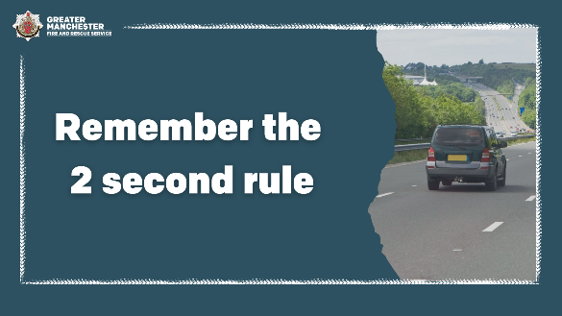  Alt text: Car in middle lane of a motorway. Graphic text reads, ‘Remember the 2 second rule.’ | ⏳ Use the 2 second rule when driving.  Make sure there is always 2 seconds between your own car and the vehicle in front.  For more tips 👉  manchesterfire.gov.uk/your-safety/road-safety/staying-safe-on-motorways/  #StayFocusedDriveSafe | Tuesday-Thursday 6am-9am or  4pm-7pm
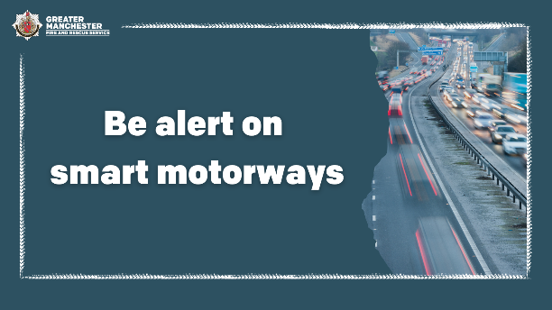  Alt text: Blurry picture of a motorway with many cars on it. Graphic text reads, ‘Be alert on smart motorways.’ | A ❌ signals when a lane is closed on a smart motorway and drivers should move into another lane.  If your vehicle experiences difficulties, exit the smart motorway immediately and find a safe place to stop.  For more info 👉 manchesterfire.gov.uk/your-safety/road-safety/staying-safe-on-motorways/  #StayFocusedDriveSafe | Tuesday-Thursday 6am-9am or  4pm-7pm
Facebook
Alt text: A car that has crashed into a tree. Graphic text reads, ‘Keep to the speed limits.’ | 🚗 In Greater Manchester, 122 people were killed or seriously injured on motorways between 2020 and 2022.  Keep to the speed limit and remember the speed limit is not a target.  🛣 In some road conditions, even driving at the speed limit is too fast.  #StayFocusedDriveSafe | Tues-Thurs  6am-9am or 4pm-7pm
Alt text: Hand securing seatbelt. Graphic text reads, ‘Belt up, seatbelts save lives.’ | ❗ Your seatbelt is there to protect you.  It is a legal requirement to fasten your seatbelt whether you’re driving or a passenger in a vehicle.  If caught, you can be fined up to £500.  The driver is also responsible for children aged up to 14 and could be fined for each child passenger without a belt.  #StayFocusedDriveSafe | Tues-Thurs  6am-9am or 4pm-7pm
Alt text: Man texting while driving. Graphic text reads, ‘Stay focused on the road.’ | 📱 It’s illegal to hold and use a phone, sat nav, or any device while driving.  The law still applies when you’re stopped at traffic lights or queuing in traffic.  Stay focused and keep your eyes on the road at all times.  #StayFocusedDriveSafe | Tues-Thurs  6am-9am or 4pm-7pm
Alt text: Woman blowing into a breathalyser. Graphic text reads, ‘Don’t drink and drive.’ | ❌ Don’t drink and drive.  If you’ve been drinking the night before, remember you could still be over the limit the next day.  You could be imprisoned, banned from driving and face a fine if you’re found guilty of drink-driving.  #StayFocusedDriveSafe | Thursday-Sunday
Alt text: Car in middle lane of a motorway. Graphic text reads, ‘Remember the 2 second rule.’ | ⏳ Use the 2 second rule when driving.  Make sure there is always 2 seconds between your own car and the vehicle in front.  ❄ If the weather is poor, you should leave an even bigger gap.  #StayFocusedDriveSafe | Tuesday-Thursday 6am-9am or  4pm-7pm
Alt text: Blurry picture of a motorway with many cars on it. Graphic text reads, ‘Be alert on smart motorways.’ | Keep to the speed limit shown on the gantries when driving on smart motorways.  A ❌ signals when a lane is closed on a smart motorway and drivers should move into another lane.  If your vehicle experiences difficulties, exit the smart motorway immediately and find a safe place to stop.  #StayFocusedDriveSafe | Tuesday-Thursday 6am-9am or  4pm-7pm
Instagram
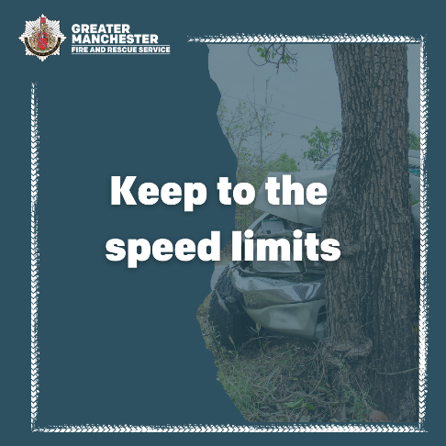  Alt text: A car crashed into a tree. Graphic text reads, ‘Keep to the speed limits. | 🚗 In Greater Manchester, 122 people were killed or seriously injured on motorways between 2020 and 2022.  Keep to the speed limit and remember the speed limit is not a target.  🛣 In some road conditions, even driving at the speed limit is too fast.  #StayFocusedDriveSafe | Tues-Thurs  6am-9am or 4pm-7pm
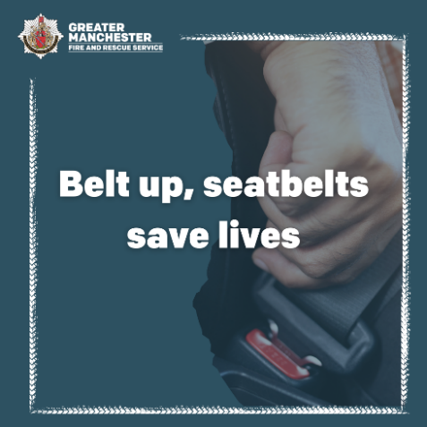  Alt text: Hand securing seatbelt. Graphic text reads, ‘Belt up, seatbelts save lives.’ | ❗ Your seatbelt is there to protect you.  It is a legal requirement to fasten your seatbelt whether you’re driving or a passenger in a vehicle.  If caught, you can be fined up to £500.  The driver is also responsible for children aged up to 14 and could be fined for each child passenger without a belt.  #StayFocusedDriveSafe | Tues-Thurs  6am-9am or 4pm-7pm
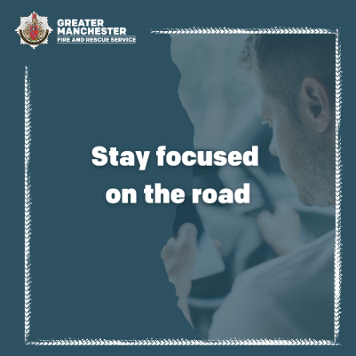  Alt text: Man texting while driving. Graphic text reads, ‘Stay focused on the road.’ | 📱 It’s illegal to hold and use a phone, sat nav, or any device while driving.  The law still applies when you’re stopped at traffic lights or queuing in traffic.  Stay focused and keep your eyes on the road at all times.  #StayFocusedDriveSafe | Tues-Thurs  6am-9am or 4pm-7pm
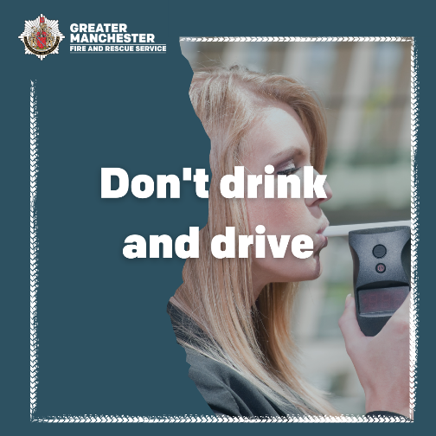  Alt text: Woman blowing into a breathalyser. Graphic text reads, ‘Don’t drink and drive.’ | ❌ Don’t drink and drive.  If you’ve been drinking the night before, remember you could still be over the limit the next day.  You could be imprisoned, banned from driving and face a fine if you’re found guilty of drink-driving.  #StayFocusedDriveSafe | Thursday-Sunday
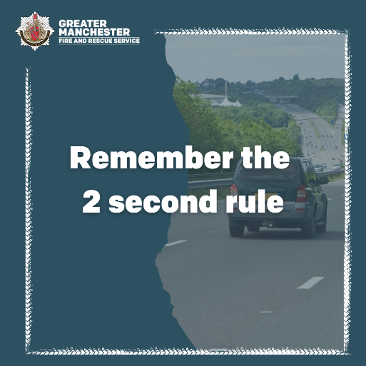  Alt text: Car in middle lane of a motorway. Graphic text reads, ‘Remember the 2 second rule.’ | ⏳ Use the 2 second rule when driving.  Make sure there is always 2 seconds between your own car and the vehicle in front.  ❄ If the weather is poor, you should leave an even bigger gap.  #StayFocusedDriveSafe | Tuesday-Thursday 6am-9am or  4pm-7pm
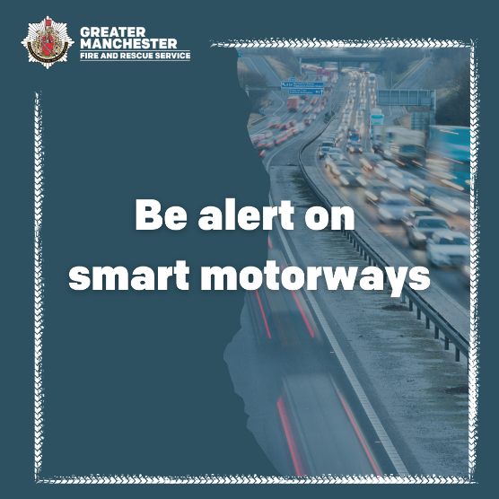  Alt text: Blurry picture of a motorway with many cars on it. Graphic text reads, ‘Be alert on smart motorways.’ | Keep to the speed limit shown on the gantries when driving on smart motorways.  A ❌ signals when a lane is closed and drivers should move into another lane.  If your vehicle experiences difficulties, exit the smart motorway immediately and find a safe place to stop.  #StayFocusedDriveSafe | Tuesday-Thursday 6am-9am or  4pm-7pm

