#CookSafeGM Partner Toolkit
Communications messaging and assets for Greater Manchester Fire and Rescue Service (GMFRS) Cook Safe campaign. For use from 28 April until the end of June 2023.
The main aim of the Cook Safe campaign is to provide information about cooking and kitchen fire safety for residents, focusing on five key messages:
- Never leave your cooking unattended
- It’s easy to get distracted while cooking
- Take care when frying - hot oil or fat can easily catch fire​
- Try oven chips or use a thermostat controlled fryer instead of a chip pan
- Never cook if you’ve been drinking alcohol

Images
Assets featured in the suggested posts below can be downloaded from:
Website: GMFRS Cook Safe
They are grouped by size for Twitter, Facebook, and Instagram.

Accessibility
Please ensure that all images posted on social media make use of the 'alt text' function and wording that we have supplied.
You can find further guidance and how to do this for different platforms below and for further advice on writing image descriptions, see here: https://www.rnib.org.uk/rnibconnect/technology/making-your-social-media-accessible

Image preview | Copy | Image Title
Facebook
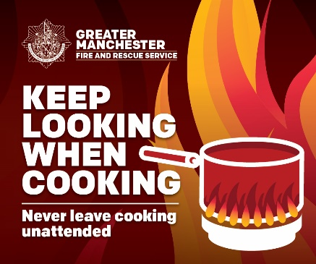  ALT text – Keep looking when cooking. Never leave cooking unattended. Artist image of a pan in flames. | We all need to take care when cooking  🥘 Never leave cooking unattended  📺 Don’t get distracted while cooking  🍳Take care when frying - hot oil or fat can easily catch fire  🍟Don’t use a chip pan  Find out more cooking safety tips from @manchesterfire  manchesterfire.gov.uk/your-safety/fire-safety/your-home-safety/house-maisonette-or-bungalow/cooking-and-kitchen-safety/  #CookSafeGM | Keep looking unattended
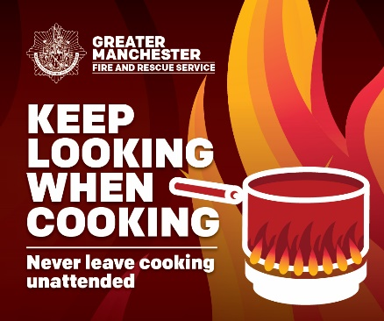  ALT text – Keep looking when cooking. Never leave cooking unattended. Artist image of a pan in flames. | Most accidental fires start in the kitchen so keep looking when cooking & never leave cooking unattended 🍳  🔥If your pan does catch fire - don't panic! Leave the kitchen, close the door behind you, get everyone out & call 999  More advice from @manchesterfire 👇  manchesterfire.gov.uk/your-safety/fire-safety/your-home-safety/house-maisonette-or-bungalow/cooking-and-kitchen-safety/  #CookSafeGM | Keep looking unattended
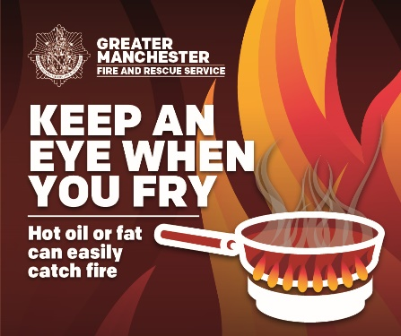  ALT text – Keep an eye when you fry. Hot oil or fat can easily catch fire. Artistic image of a frying pan in flames. | Keep an eye when you fry  ⚠️Never fill a pan more than one-third full of fat or oil  ✅Ensure food is dry before putting it in hot oil so it doesn’t splash  ⚠️If the oil starts to smoke, it’s too hot – turn off the heat and let it cool  👀 👉 manchesterfire.gov.uk/your-safety/fire-safety/your-home-safety/house-maisonette-or-bungalow/cooking-and-kitchen-safety/deep-frying-with-oil/  #CookSafeGM | Keep an eye
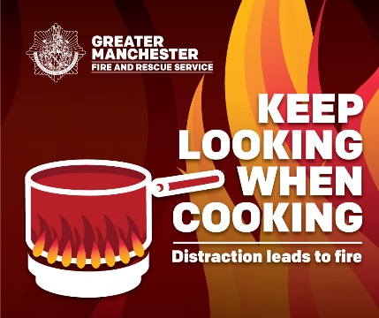  ALT text – Keep looking when cooking. Distraction leads to fire. Artist image of a pan in flames. | Cooking a delicious meal? Keep looking when cooking:  ❌Don’t let yourself get distracted by your phone, TV or someone at the door  ❌Don't leave your cooking unattended  Read more cooking safety tips on @manchesterfire website manchesterfire.gov.uk/your-safety/fire-safety/your-home-safety/house-maisonette-or-bungalow/cooking-and-kitchen-safety/  #CookSafeGM | Keep looking distraction
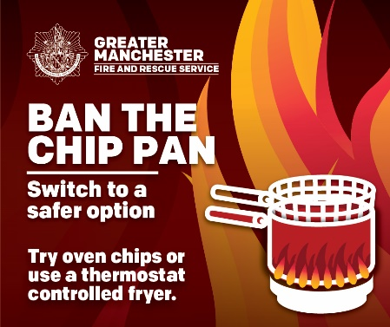  Alt text – Ban the chip pan. Switch to a safer option. Try oven chips or use a thermostat controlled fryer. Artistic image of a chip pan in flames. | Chip pan fires can kill 🔥  We recommend you try oven alternatives or use a thermostat-controlled fryer  Thermostatically controlled deep fat fryers that plug into the wall are much safer to use  Read more cooking safety tips visit @manchesterfire  manchesterfire.gov.uk/your-safety/fire-safety/your-home-safety/house-maisonette-or-bungalow/cooking-and-kitchen-safety/deep-frying-with-oil/  #CookSafeGM | Ban the chip pan
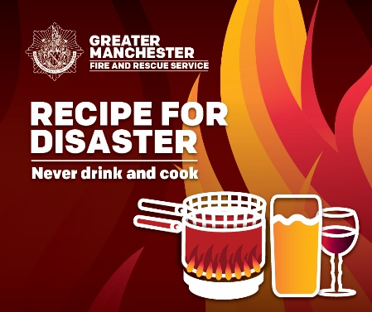  Alt text – Recipe for disaster. Never drink and cook. Artistic image of a chip pan, a pint and a glass of wine in flames. | 🍺🍷Drinking and cooking is a recipe for disaster 🔥  Don’t cook if you've had a drink – prepare something beforehand or order a takeaway instead  Read more cooking safety tips visit manchesterfire.gov.uk/your-safety/fire-safety/your-home-safety/house-maisonette-or-bungalow/cooking-and-kitchen-safety/  #CookSafeGM | Recipe for disaster
Instagram
ALT text – Keep looking when cooking. Never leave cooking unattended. Artist image of a pan in flames. | We all need to take care when cooking  🥘 Never leave cooking unattended  📺 Don’t get distracted while cooking  🍳Take care when frying - hot oil or fat can easily catch fire  🍟Don’t use a chip pan  #CookSafeGM  @manchesterfire | Keep looking unattended
ALT text – Keep looking when cooking. Never leave cooking unattended. Artist image of a pan in flames. | Most accidental fires start in the kitchen so keep looking when cooking & never leave cooking unattended 🍳  🔥If your pan does catch fire - don't panic! Leave the kitchen, close the door behind you, get everyone out & call 999  #CookSafeGM  @manchesterfire | Keep looking unattended
ALT text – Keep an eye when you fry. Hot oil or fat can easily catch fire. Artistic image of a frying pan in flames. | Keep an eye when you fry  ⚠️Never fill a pan more than one-third full of fat or oil  ✅Ensure food is dry before putting it in hot oil so it doesn’t splash  ⚠️If the oil starts to smoke, it’s too hot – turn off the heat and let it cool  #CookSafeGM  @manchesterfire | Keep an eye

ALT text – Keep looking when cooking. Distraction leads to fire. Artist image of a pan in flames. | Cooking a delicious meal? Keep looking when cooking:  ❌Don’t let yourself get distracted by your phone, TV or someone at the door  ❌Don't leave your cooking unattended  #CookSafeGM  @manchesterfire | Keep looking distraction
Alt text – Ban the chip pan. Switch to a safer option. Try oven chips or use a thermostat controlled fryer. Artistic image of a chip pan in flames. | Chip pan fires can kill 🔥  We recommend you try oven alternatives or use a thermostat-controlled fryer  Thermostatically controlled deep fat fryers that plug into the wall are much safer to use  #CookSafeGM  @manchesterfire | Ban the chip pan
Alt text – Recipe for disaster. Never drink and cook. Artistic image of a chip pan, a pint and a glass of wine in flames. | 🍺🍷Drinking and cooking is a recipe for disaster 🔥  Don’t cook if you've had a drink – prepare something beforehand or order a takeaway instead  #CookSafeGM  @manchesterfire | Recipe for disaster
Twitter
ALT text – Keep looking when cooking. Never leave cooking unattended. Artist image of a pan in flames. | We all need to take care when cooking  🥘Never leave cooking unattended  📺Don’t get distracted  🍳Take care when frying - hot oil/fat can easily catch fire  🍟Don’t use a chip pan  Find out more cooking safety tips from @manchesterfire  👉 manchesterfire.gov.uk/your-safety/fire-safety/your-home-safety/house-maisonette-or-bungalow/cooking-and-kitchen-safety/  #CookSafeGM | Keep looking unattended
ALT text – Keep looking when cooking. Never leave cooking unattended. Artist image of a pan in flames. | Most accidental fires start in the kitchen so keep looking when cooking & never leave it unattended🍳  🔥 If your pan does catch fire don't panic! Leave the kitchen, close the door, get everyone out & call 999  More advice from  @manchesterfire  manchesterfire.gov.uk/your-safety/fire-safety/house-maisonette-or-bungalow/cooking-and-kitchen-safety/  #CookSafeGM | Keep looking unattended
ALT text – Keep an eye when you fry. Hot oil or fat can easily catch fire. Artistic image of a frying pan in flames. | Keep an eye when you fry  ⚠️Never fill a pan more than one-third full of fat or oil  ✅ Ensure food is dry before putting it in hot oil so it doesn’t splash  ♨ If the oil starts to smoke, it’s too hot – turn off the heat and let it cool  👀👉 manchesterfire.gov.uk/your-safety/fire-safety/your-home-safety/house-maisonette-or-bungalow/cooking-and-kitchen-safety/deep-frying-with-oil/  #CookSafeGM | Keep an eye
ALT text – Keep looking when cooking. Distraction leads to fire. Artist image of a pan in flames. | Cooking a delicious meal? Keep looking when cooking:  ❌Don’t let yourself get distracted by your phone, TV or someone at the door  ❌Don't leave your cooking unattended  Read more cooking safety tips visit @manchester fire  manchesterfire.gov.uk/your-safety/fire-safety/your-home-safety/house-maisonette-or-bungalow/cooking-and-kitchen-safety/  #CookSafeGM | Keep looking distraction
Alt text – Ban the chip pan. Switch to a safer option. Try oven chips or use a thermostat controlled fryer. Artistic image of a chip pan in flames. | Chip pan fires can kill 🔥  We recommend you try oven alternatives or use a thermostat-controlled fryer  Thermostatically controlled deep fat fryers that plug into the wall are much safer to use  Read more cooking safety tips visit @manchesterfire  manchesterfire.gov.uk/your-safety/fire-safety/your-home-safety/house-maisonette-or-bungalow/cooking-and-kitchen-safety/deep-frying-with-oil/  #CookSafeGM | Ban the chip pan
Alt text – Recipe for disaster. Never drink and cook. Artistic image of a chip pan, a pint and a glass of wine in flames. | 🍺🍷Drinking and cooking is a recipe for disaster 🔥  Don’t cook if you've had a drink – prepare something beforehand or order a takeaway instead  Read more cooking safety tips visit @manchesterfire  manchesterfire.gov.uk/your-safety/fire-safety/your-home-safety/house-maisonette-or-bungalow/cooking-and-kitchen-safety/  #CookSafeGM | Recipe for disaster

