E-scooter, E-bike and Battery social toolkit
Communications messaging and assets for Great Manchester Fire and Rescue Service (GMFRS) in relation to battery fires following a rise in related incidents over the past six months.
Communication objectives
- Encourage proper and safe disposal of lithium-ion batteries
- Raise awareness about dangers of battery fires
- Encourage buying of e-bikes and e-scooters from reputable retailers
- Encourage safe charging and storage
- Promote smoke alarm safety
Audience
- Residents who use e-bikes or e-scooters
- Residents in all boroughs of Greater Manchester
- Residents of all ages
Key messages
- Dispose of batteries safely at recycling and waste centres
- Follow manufacturers guidance for charging and storing
- Always buy from reputable retailers
- Fit smoke alarm in garage or room where you charge e-bike/scooter
The tweets will be re-shared from borough accounts. This will help to spread key fire safety messages to relevant areas.
Social media copy
You will find suggested social content and images in the table below.
Accessibility
Please make sure all images posted on social media make use of the ‘alt text’ function. Any words that appear in a graphic should be duplicated in the ‘alt text’. This will allow those using screen readers to access the content. The imagery in the graphic should also be described.

Graphic | Content |  | Alt text
Twitter and Facebook

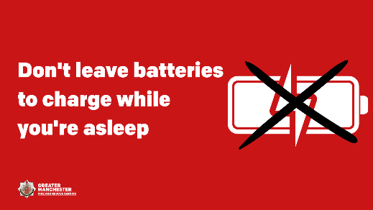 | ❗ We're attending an increasing number of fires started by e-bikes, e-scooters and laptops.  To stay safe, follow our advice:  ❌ Don’t leave batteries to charge while you're asleep  ❌ Don't charge items on escape routes  Find out more 👉 manchesterfire.gov.uk/your-safety/fire-safety/house-maisonette-or-bungalow/electrical/e-bikes-and-e-scooters/ |  | Alt text: White battery with black cross through it. Graphic text reads, ‘Don’t leave batteries to charge while you’re asleep.’
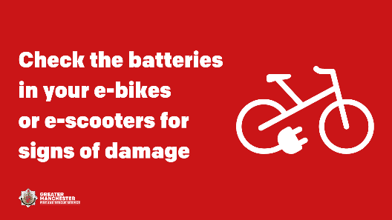 | 🔎 Check the battery in your e-bikes or e-scooters regularly for signs of damage. If you suspect it’s been damaged it should be replaced immediately.  🔥 When a battery is damaged, it can overheat and catch fire without warning.  For more advice 👉 manchesterfire.gov.uk/your-safety/fire-safety/house-maisonette-or-bungalow/electrical/e-bikes-and-e-scooters/ |  | Alt text: White electric bike. Graphic text reads, ‘Check the batteries in your e-bikes or e-scooters for signs of damage.’
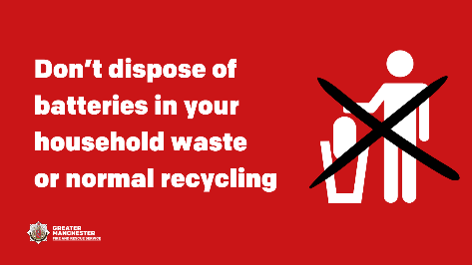 | ❌ If you need to dispose of a damaged or end-of-life battery, don’t dispose of it in your household waste or normal recycling.  These batteries can cause fires in bin lorries, recycling and waste centres.  Take it to your local tip or use a battery recycling service. |  | Alt text: Black cross over person putting large object into bin. Graphic text reads, ‘Don’t dispose of batteries in your household waste or normal recycling.’
 | 🛴 Do you have an electric bike or scooter? Our advice is to follow the manufacturer’s instructions to ensure safe charging and storage.  An increasing number of fires are caused by lithium-ion batteries in e-bikes and e-scooters.  For more advice 👉 manchesterfire.gov.uk/your-safety/fire-safety/house-maisonette-or-bungalow/electrical/e-bikes-and-e-scooters/ |  | Alt text: Open information leaflet with picture of scooter on. Graphic text reads, ‘Always follow manufacturer’s instructions.’
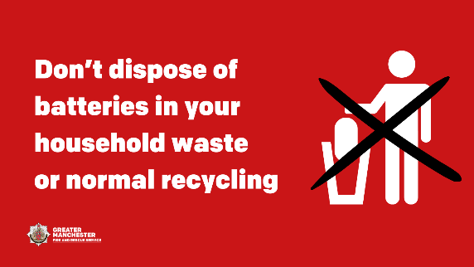 | ♻ Need to dispose of a damaged or end-of-life battery? Don’t dispose of it in your household waste or normal recycling.  Your electric bike or scooter manufacturer may offer a recycling service. Or, you can take it to your local tip.  For more advice 👉 manchesterfire.gov.uk/your-safety/fire-safety/house-maisonette-or-bungalow/electrical/e-bikes-and-e-scooters/ |  | Alt text: Black cross over person putting large object into bin. Graphic text reads, ‘Don’t dispose of batteries in your household waste or normal recycling.’
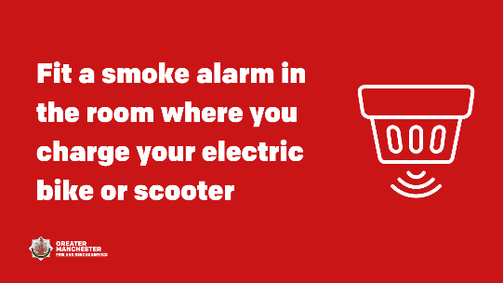 | ❌ Never charge batteries or store your electric bike or scooter near combustible or flammable materials.  You should also fit a smoke alarm in the room or garage where you charge or store your electric bike or scooter.  For more advice and information 👉 manchesterfire.gov.uk/your-safety/fire-safety/house-maisonette-or-bungalow/electrical/e-bikes-and-e-scooters/ |  | Alt text: White smoke alarm. Graphic text reads, ‘Fit a smoke alarm in the room where you charge your electric bike or scooter.’
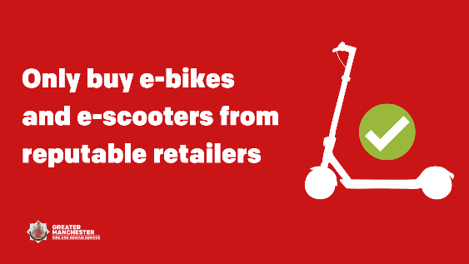 | Only buy e-bikes, e-scooters, chargers and batteries from reputable retailers.  Items that don’t meet British or European standards pose a fire risk.  For safety, register your appliances on 👉 registermyappliance.org.uk/ |  | Alt text: White scooter with green tick above it. Graphic text reads, ‘Only buy e-bikes and e-scooters from reputable retailers.’
Modified e-bike fire video:  https://youtu.be/py8b0rc3lgk | 💭 Thinking of buying an e-bike, e-scooter, or conversion kit?  Always buy from a reputable retailer and follow their guidance to ensure safe charging and storage.  This video shows the impact of a fire involving modified e-bikes.  Read more 👉  manchesterfire.gov.uk/news/video-shows-impact-of-modified-electric-bike-battery-fire/ |  | N/A
Instagram

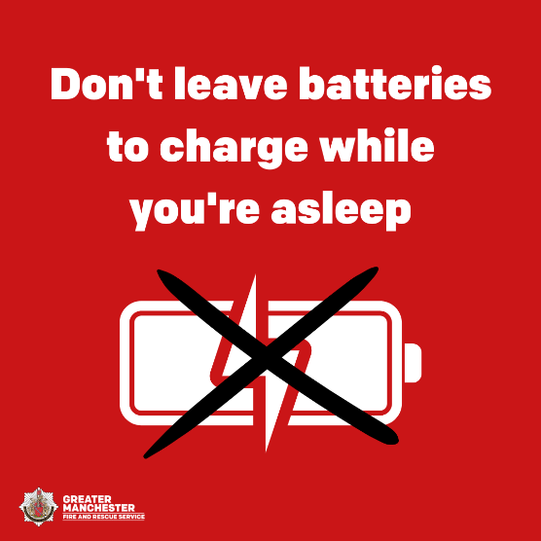 |  | ❗ We're attending an increasing number of fires started by e-bikes, e-scooters and laptops.  To stay safe, follow our advice:  ❌ Don’t leave batteries to charge while you're asleep  ❌ Don't charge items on escape routes  To find out more search ‘bikes’ or ‘scooters’ on the GMFRS website. |  | Alt text: White battery with black cross through it. Graphic text reads, ‘Don’t leave batteries to charge while you’re asleep.
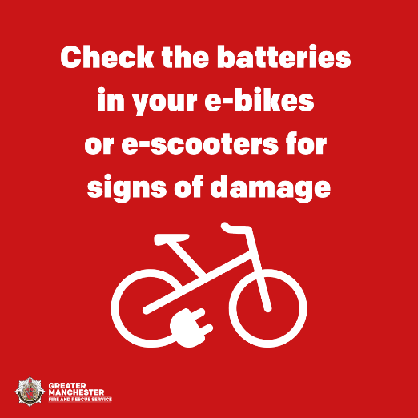 |  | 🔎 Check the battery in your e-bikes or e-scooters regularly for signs of damage. If you suspect it’s been damaged it should be replaced immediately.  🔥 When a battery is damaged, it can overheat and catch fire without warning.  To find out more search ‘bikes’ or ‘scooters’ on the GMFRS website. |  | Alt text: White electric bike. Graphic text reads, ‘Check the batteries in your e-bikes or e-scooters for signs of damage.’
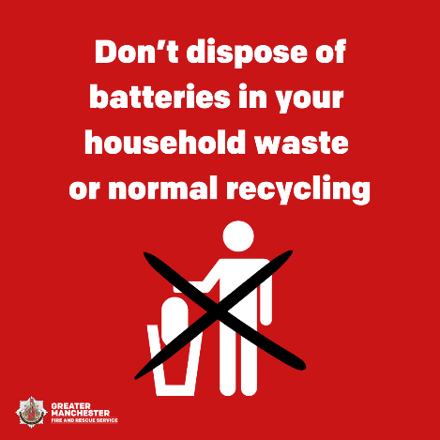 |  | ❌ If you need to dispose of a damaged or end-of-life battery, don’t dispose of it in your household waste or normal recycling.  These batteries can cause fires in bin lorries, recycling and waste centres.  Take it to your local tip or use a battery recycling service. |  | Alt text: Black cross over person putting large object into bin. Graphic text reads, ‘Don’t dispose of batteries in your household waste or normal recycling.’
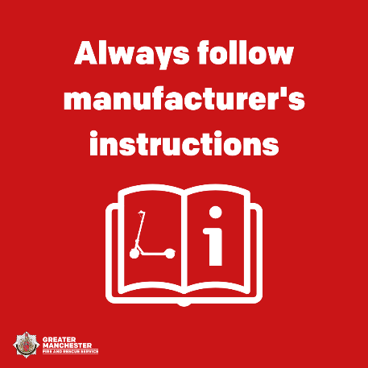 |  | 🛴 Do you have an electric bike or scooter? Our advice is to follow the manufacturer’s instructions to ensure safe charging and storage.  An increasing number of fires are caused by lithium-ion batteries in e-bikes and e-scooters.  To find out more search ‘bikes’ or ‘scooters’ on the GMFRS website. |  | Alt text: Open information leaflet with picture of scooter on. Graphic text reads, ‘Always follow manufacturer’s instructions.’
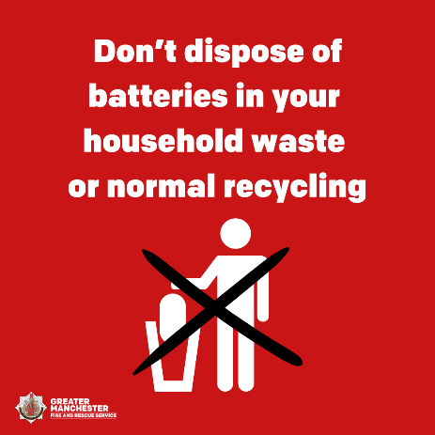 |  | ♻ Need to dispose of a damaged or end-of-life battery? Don’t dispose of it in your household waste or normal recycling.  Your electric bike or scooter manufacturer may offer a recycling service. Or, you can take it to your local tip.  To find out more search ‘battery’ on the GMFRS website. |  | Alt text: Black cross over person putting large object into bin. Graphic text reads, ‘Don’t dispose of batteries in your household waste or normal recycling.’
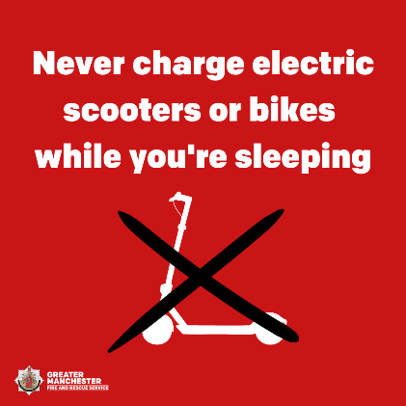 |  | ❌ Never charge batteries or store your electric bike or scooter near combustible or flammable materials.  You should also fit a smoke alarm in the room or garage where you charge or store your electric bike or scooter.  To find out more search ‘bikes’ or ‘scooters’ on the GMFRS website. |  | Alt text: White smoke alarm. Graphic text reads, ‘Fit a smoke alarm in the room where you charge your electric bike or scooter.’
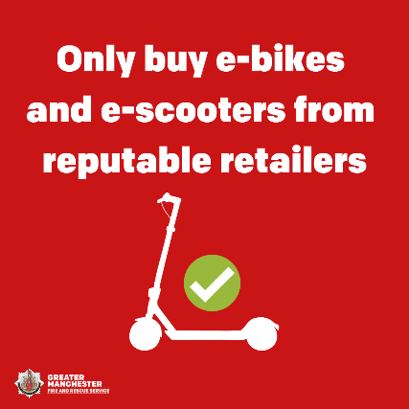 |  | Only buy e-bikes, e-scooters, chargers and batteries from reputable retailers.  Items that don’t meet British or European standards pose a fire risk.  For safety, register your appliances on AMDEA’s website. |  | Alt text: White scooter with green tick above it. Graphic text reads, ‘Only buy e-bikes and e-scooters from reputable retailers.’
Modified e-bike fire video: (MP4 file in ‘Assets’ folder) |  | 💭 Thinking of buying an e-bike, e-scooter, or conversion kit?  Always buy from a reputable retailer and follow their guidance to ensure safe charging and storage.  This video shows the impact of a fire involving modified e-bikes.  To find out more visit the GMFRS website. |  | N/A

