GMFRS smoke alarm testing and escape route planning
Social media pack 2023
Introduction
Greater Manchester and Rescue Service (GMFRS) is running a campaign focusing on smoke alarm testing and escape route planning.
In the last three years the number of incidents we have attended with a smoke alarm present has been on average 82%, whilst in 2021-22, 93% of households in England had at least one working smoke alarm.
In addition, according to the data from our home visits, the percentages of Greater Manchester residents having a working smoke alarm on each floor of their home and testing their smoke alarms weekly have decreased over the past three years.
Greater Manchester residents' data
 | 2019/2020 | 2020/2021 | 2021/2022
Having a working smoke alarm on each floor | 63.20% | 50.01% | 46.25%
Test smoke alarms every week | 85.90% | 66.45% | 56.74%

A working smoke alarm can be the first alert to a fire and can save lives by providing vital extra seconds to escape a fire in the home. Each level should have at least one working alarm and we suggest testing once a week to ensure they are working. Knowing what to do if a smoke alarm sounds is also important – prepare an escape plan to help everyone escape smoothly in case of a fire. Also, make sure everyone living in the same household knows about the plan.
To ensure Greater Manchester residents are aware of these important actions and routines we will be sharing social media posts across all relevant channels and we encourage partners to share where possible, allowing for maximum impact and coverage.
Communication objectives
- Encourage people to fit smoke alarms on each level of their home and test them once a week
- Encourage people to plan escape routes and review them regularly
- Educate people on what they should do in case of a fire
Audience
- Residents living in a house, maisonette, flat or bungalow
- Residents living in a high-rise building
- Residents in all boroughs of Greater Manchester
- Landlords – legal duty to fit smoke alarms (tenants to test them)
Key messages:
- Fit smoke alarms on each level of your home.
- Test the batteries in your smoke alarm every week.
- A smoke alarm should wake you up and give you vital extra time to escape.
- Plan an escape route and make sure everyone knows how to get out.
- Keep door and window keys accessible.
- The best route is usually the normal way in and out of your home, so always keep it clear of clutter.
- Plan a second escape route, in case the first one is blocked.
- Review your escape route regularly to take into account any changes in your home.
- If a fire starts, keep calm and act quickly – get out, stay out and call 999.
Assets can be downloaded here: https://www.manchesterfire.gov.uk/your-safety/campaigns/smoke-alarm-testing-and-escape-planning/
These posts will be shared with the main hashtag #TestingTesting123 on GMFRS’ various channels including Twitter, Facebook and Instagram.

Suggested content | Image | Alt text
Facebook
How often do you test your smoke alarm? @manchesterfire advice is to test it weekly by pressing the test button until the alarm sounds.  Learn more 👉 manchesterfire.gov.uk/your-safety/fire-safety/your-home-safety/house-maisonette-or-bungalow/smoke-alarms/  #TestingTesting123 | 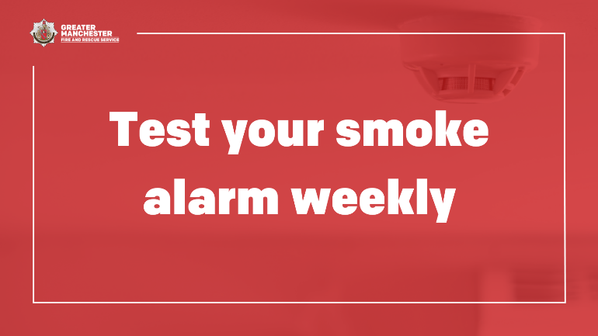 | Smoke alarm on ceiling. Graphic text reads, ‘Test your smoke alarm weekly.’
Would you know what to do if your smoke alarms go off? Plan ahead and practise an escape route.  Make sure door and window keys are accessible to everyone.  More tips and advice 👉 manchesterfire.gov.uk/your-safety/fire-safety/your-home-safety/house-maisonette-or-bungalow/planning-an-escape-route/  #TestingTesting123 | 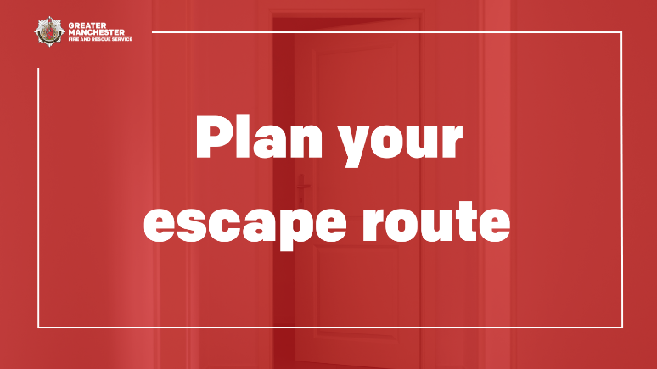 | Door open at the end of a hallway. Graphic text reads, ‘Plan your escape route.’
A smoke alarm would fail to work if the fire is outside of its range.  Make sure you fit at least one working alarm on every level of your home.  🏠 Check if you’re eligible for a free Home Fire Safety Assessment from @manchesterfire by visiting their website 👉 manchesterfire.gov.uk/your-safety/hfsa/  #TestingTesting123 | 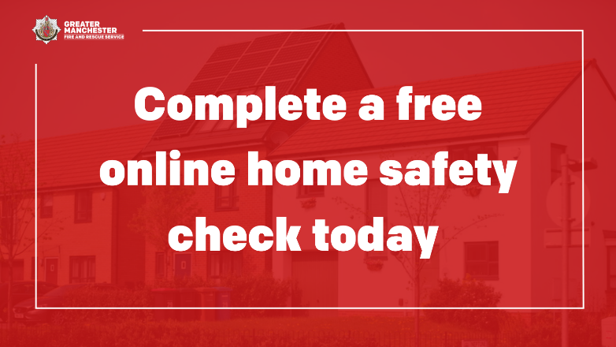 | Row of houses on street. Graphic text reads, ‘Complete a free online home safety check today.’
🔥 It’s hard to notice a fire at the earliest stages when you’re sleeping – that's why you need a working smoke alarm to give you vital extra seconds to escape.  ✅ Test your smoke alarm weekly  Learn more 👉 manchesterfire.gov.uk/your-safety/fire-safety/your-home-safety/house-maisonette-or-bungalow/smoke-alarms/  #TestingTesting123 | 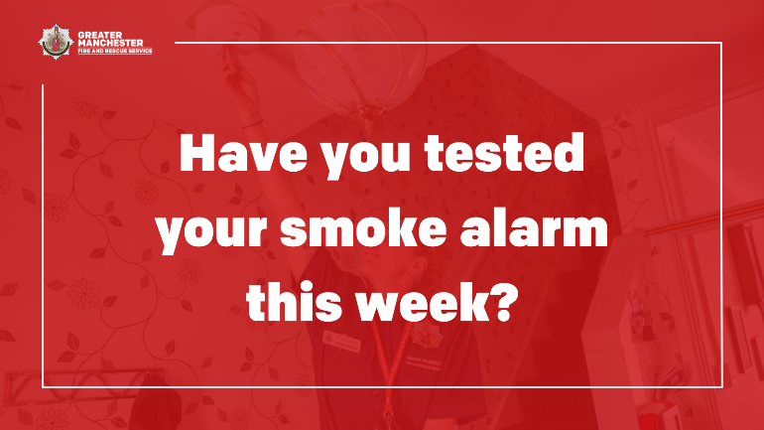 | Woman in fire service uniform testing smoke alarm in living room of house. Graphic text reads, ‘Have you tested your smoke alarm this week?’
You need to be prepared and have an escape plan, in case there’s a fire - one day it could just save your life!  Everyone who lives with you should know how to escape too.  Learn more 👉 manchesterfire.gov.uk/your-safety/fire-safety/your-home-safety/house-maisonette-or-bungalow/planning-an-escape-route/  #TestingTesting123 | 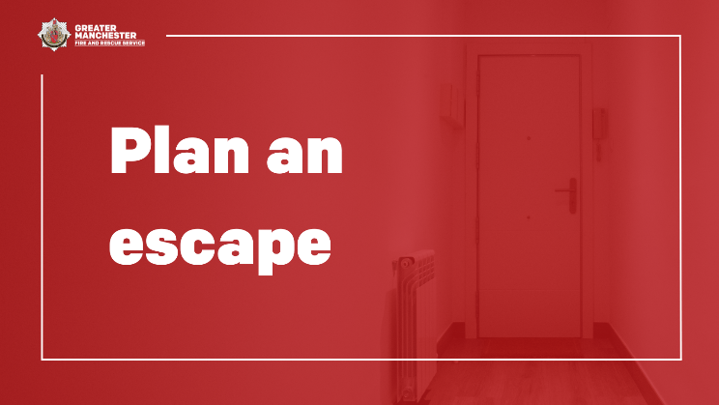 | Front door at the end of hallway with radiator. Graphic text reads, ‘Plan an escape.’
🔥 Half of fires that result in deaths are in homes with no working smoke alarm.  🏠 Complete @manchesterfire free online Home Fire Safety Check and get advice on simple changes you can make to reduce the risk of a fire.  manchesterfire.gov.uk/your-safety/hfsa/  #TestingTesting123 | 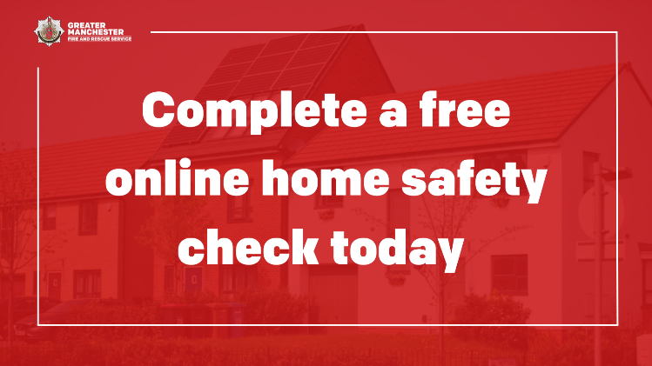 | Row of houses on street. Graphic text reads, ‘Complete a free online home safety check today.’
Time to learn how to test your smoke alarms!  ✅ Press the test button until the alarm sounds  ✅ Test them once a week  Learn more about smoke alarms 👉 manchesterfire.gov.uk/your-safety/fire-safety/your-home-safety/house-maisonette-or-bungalow/smoke-alarms/  #TestingTesting123 | 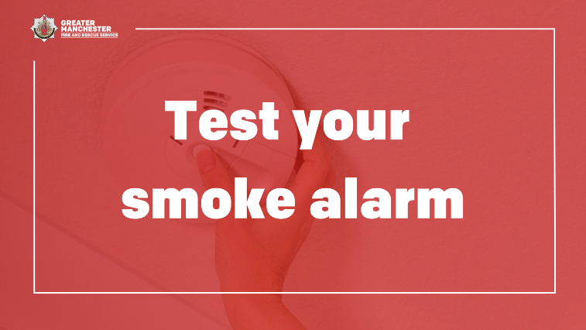 | Hand pressing the test button on a smoke alarm. Graphic text reads, ‘Test your smoke alarm’
Your normal way out of the house is often your best escape route, so always keep it clear of clutter!  More tips and advice 👉 manchesterfire.gov.uk/your-safety/fire-safety/your-home-safety/house-maisonette-or-bungalow/planning-an-escape-route/  #TestingTesting123 | 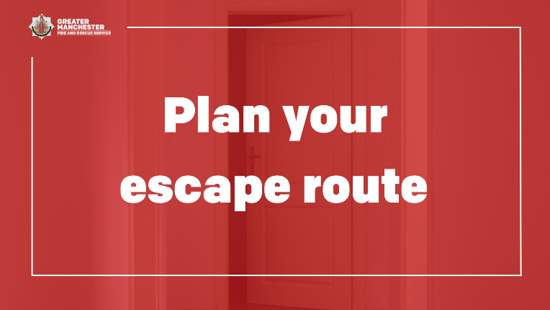 | Door open at the end of a hallway. Graphic text reads, ‘Plan your escape route.’
Does your escape plan include a plan B? Plan for a second escape route, in case the first one is blocked.  If you encounter a fire, keep calm and act quickly – get out, stay out, call 999.  More advice and tips 👉 manchesterfire.gov.uk/your-safety/fire-safety/your-home-safety/house-maisonette-or-bungalow/planning-an-escape-route/  #TestingTesting123 | 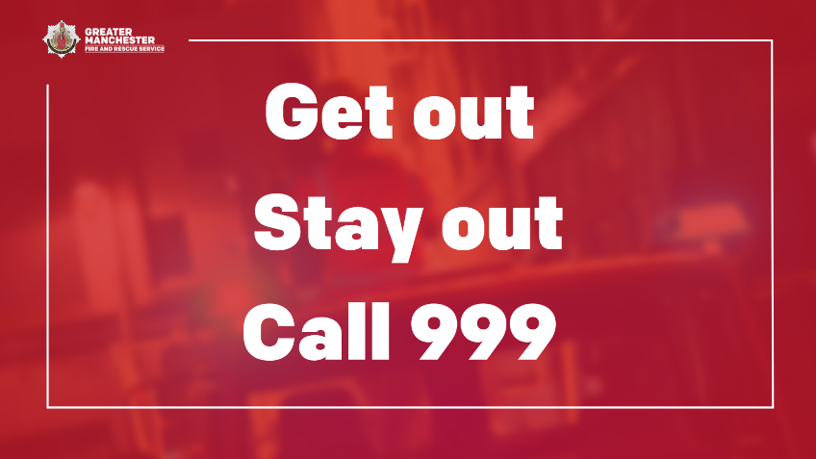 | Firefighter on fire engine with sirens flashing. Graphic text reads, ‘Get out. Stay out. Call 999.’
A working smoke alarm gives you vital extra time to escape if a fire does occur in your home - it’s important to have at least one on each level at home.  ✅ Remember to test them once a week  More tips and advice 👉 manchesterfire.gov.uk/your-safety/fire-safety/your-home-safety/house-maisonette-or-bungalow/smoke-alarms/  #TestingTesting123 | 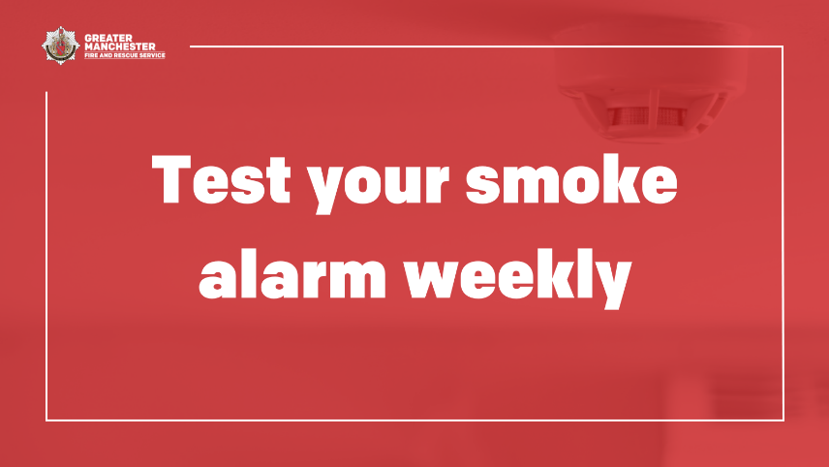 | Smoke alarm on ceiling. Graphic text reads, ‘Test your smoke alarm weekly.’
Declutter your home once in a while to keep fire escape routes clear in case of an emergency.  If you’ve made changes to your home, remember to review your escape plan.  More advice and tips 👉 manchesterfire.gov.uk/your-safety/fire-safety/your-home-safety/house-maisonette-or-bungalow/planning-an-escape-route/  #TestingTesting123 | 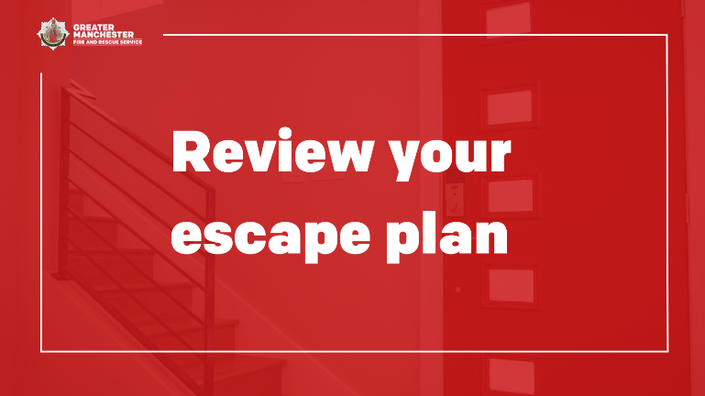 | A staircase inside house next to front door. Graphic text reads, ‘Review your escape plan.’
If you encounter a fire, keep calm and act quickly – get out, stay out, call 999.  Always use the stairs to get out if you’re escaping from a block of flats.  Learn what to do in a fire 👉 manchesterfire.gov.uk/your-safety/fire-safety/your-home-safety/flat/what-to-do-if-a-fire-is-in-your-building/  #TestingTesting123 | 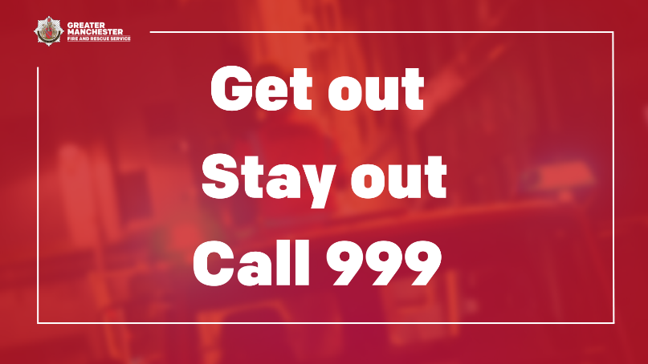 | Firefighter on fire engine with sirens flashing. Graphic text reads, ‘Get out. Stay out. Call 999.’
Instagram
How often do you test your smoke alarm? @manchesterfire advice is to test it weekly by pressing the test button until the alarm sounds.  👉 Search ‘smoke alarm’ on our website to learn more.  #TestingTesting123 | 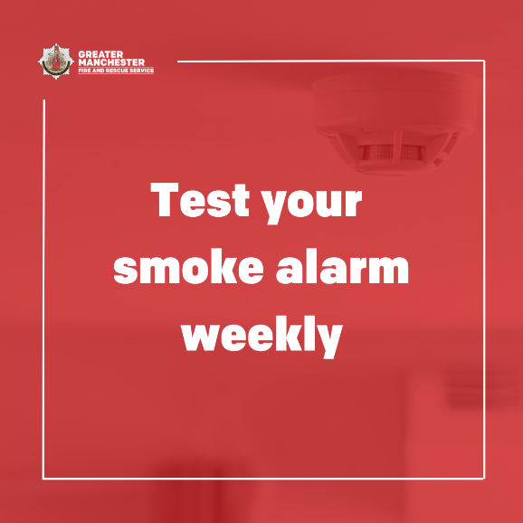 | Smoke alarm on ceiling. Graphic text reads, ‘Test your smoke alarm weekly.’
Would you know what to do if your smoke alarms go off? Plan ahead and practise an escape route.  Make sure door and window keys are accessible to everyone.  👉 More tips and advice by searching ‘planning an escape route’ on @manchesterfire website.  #TestingTesting123 | 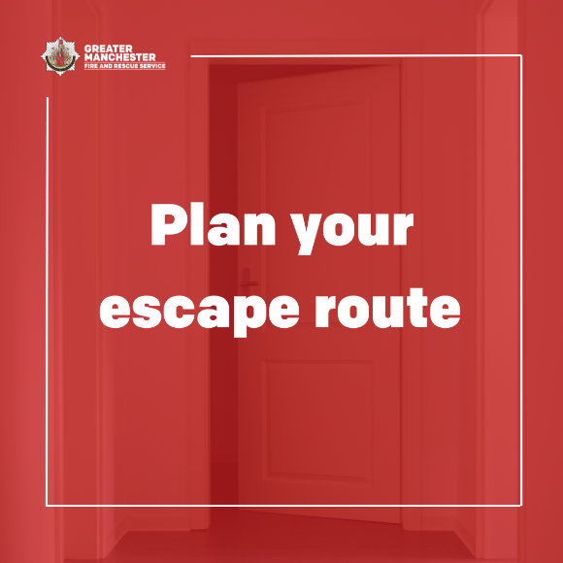 | Door open at the end of a hallway. Graphic text reads, ‘Plan your escape route.’
A smoke alarm would fail to work if the fire is outside of its range.  Make sure you fit at least one working alarm on every level of your home.  🏠 Check if you’re eligible for a free Home Fire Safety Assessment visit from @manchesterfire on their website.  #TestingTesting123 | 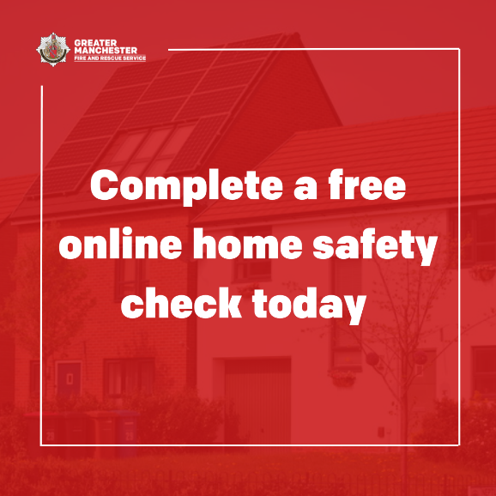 | Row of houses on street. Graphic text reads, ‘Complete a free online home safety check today.’
🔥 It’s hard to notice a fire at the earliest stages when you’re sleeping – that's why you need a working smoke alarm to give you vital extra seconds to escape.  ✅ Test your smoke alarm weekly  👉 Search ‘smoke alarm’ on @manchesterfire website to learn more.  #TestingTesting123 | 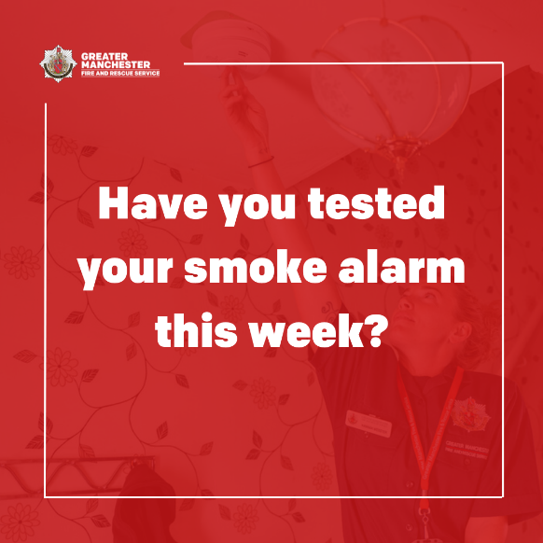 | Woman in fire service uniform testing smoke alarm in living room of house. Graphic text reads, ‘Have you tested your smoke alarm this week?’
You need to be prepared and have an escape plan, in case there’s a fire - one day it could just save your life!  Everyone who lives with you should know how to escape too.  Learn more 👉 search ‘planning an escape route’ on @manchesterfire website.  #TestingTesting123 | 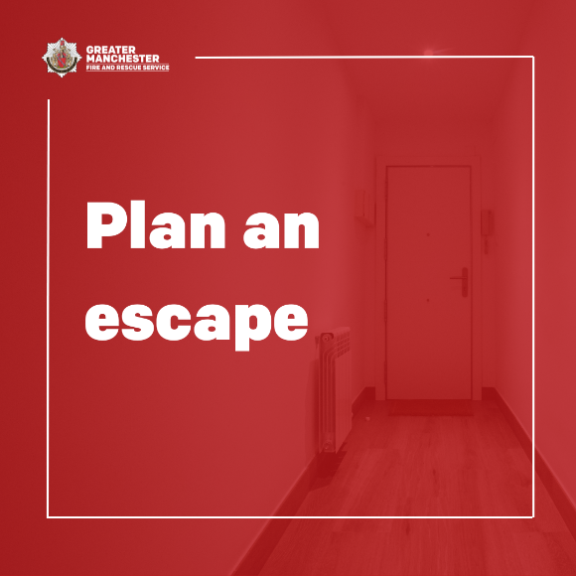 | Front door at the end of hallway with radiator. Graphic text reads, ‘Plan an escape.’
🔥 Half of fires that result in deaths are in homes with no working smoke alarm.  🏠 Complete @manchesterfire free online Home Fire Safety Check and get advice on simple changes you can make to reduce the risk of a fire.  Search ‘HFSA’ on their website to learn more.  #TestingTesting123 |  | Row of houses on street. Graphic text reads, ‘Complete a free online home safety check today.’
Time to learn how to test your smoke alarms!  ✅ Press the test button until the alarm sounds  ✅ Test them once a week  Learn more about smoke alarms 👉 search ‘smoke alarm’ on @manchesterfire website.  #TestingTesting123 | 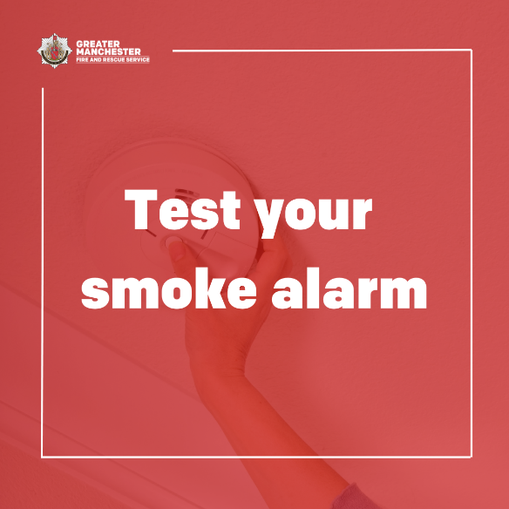 | Hand pressing the test button on a smoke alarm. Graphic text reads, ‘Test your smoke alarm’
Your normal way out of the house is often your best escape route, so always keep it clear of clutter!  👉 Look for ‘planning an escape route’ on @manchesterfire website for more tips and advice  #TestingTesting123 | 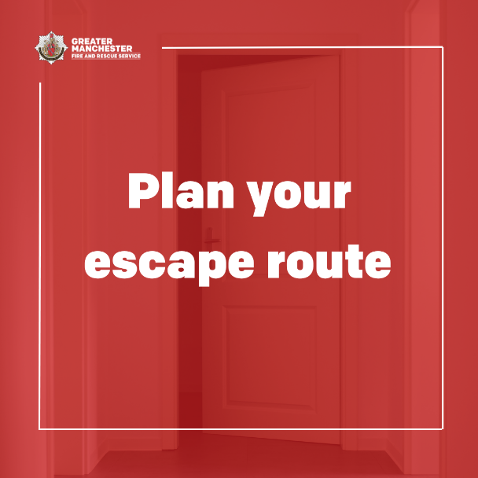 | Door open at the end of a hallway. Graphic text reads, ‘Plan your escape route.’
Does your escape plan include a plan B? Plan for a second escape route, in case the first one is blocked.  If you encounter a fire, keep calm and act quickly – get out, stay out, call 999.  More advice and tips 👉 head to @manchesterfire website and search ‘planning an escape route’.  #TestingTesting123 | 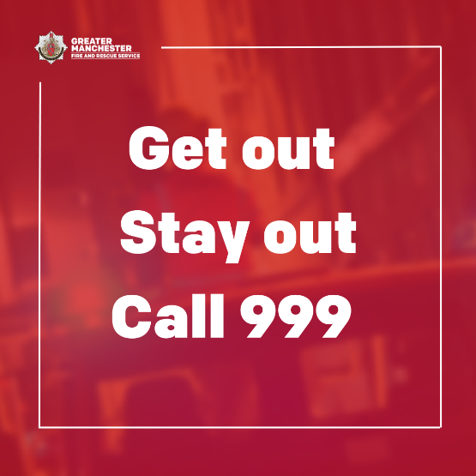 | Firefighter on fire engine with sirens flashing. Graphic text reads, ‘Get out. Stay out. Call 999.’
A working smoke alarm gives you vital extra time to escape if a fire does occur in your home - it’s important to have at least one on each level at home.  ✅ Remember to test them once a week  More tips and advice 👉 look up ‘smoke alarm’ on @manchesterfire website for more advice.  #TestingTesting123 |  | Smoke alarm on ceiling. Graphic text reads, ‘Test your smoke alarm weekly.’
Declutter your home once in a while to keep fire escape routes clear in case of an emergency.  If you’ve made changes to your home, remember to review your escape plan.  More advice and tips 👉 head to @manchesterfire website and search ‘planning an escape route’.  #TestingTesting123 | 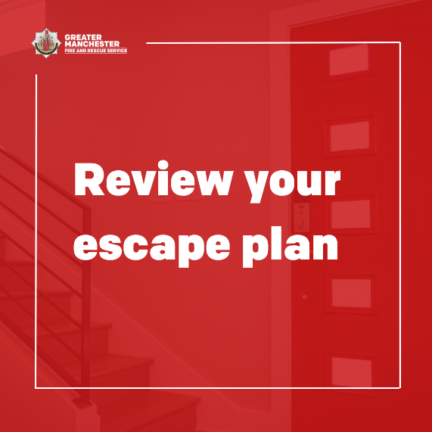 | A staircase inside house next to front door. Graphic text reads, ‘Review your escape plan.’
If you encounter a fire, keep calm and act quickly – get out, stay out, call 999.  Always use the stairs to get out if you’re escaping from a block of flats.  Learn what to do in a fire 👉 search ‘planning an escape route’ on @manchesterfire website to learn more.  #TestingTesting123 |  | Firefighter on fire engine with sirens flashing. Graphic text reads, ‘Get out. Stay out. Call 999.’
Twitter
How often do you test your smoke alarm? @manchesterfire advice is to test it weekly by pressing the test button until the alarm sounds.  Learn more 👉 manchesterfire.gov.uk/your-safety/fire-safety/your-home-safety/house-maisonette-or-bungalow/smoke-alarms/  #TestingTesting123 |  | Smoke alarm on ceiling. Graphic text reads, ‘Test your smoke alarm weekly.’
Would you know what to do if your smoke alarms go off? Plan ahead and practise an escape route.  Make sure door and window keys are accessible to everyone.  More tips and advice 👉 manchesterfire.gov.uk/your-safety/fire-safety/your-home-safety/house-maisonette-or-bungalow/planning-an-escape-route/  #TestingTesting123 |  | Door open at the end of a hallway. Graphic text reads, ‘Plan your escape route.’
A smoke alarm won’t work if the fire is outside of its range.  Make sure you fit at least one working alarm on every level of your home.  🏠 Check if you’re eligible for a free Home Fire Safety Assessment from @manchesterfire  👉 manchesterfire.gov.uk/your-safety/hfsa/  #TestingTesting123 |  | Row of houses on street. Graphic text reads, ‘Complete a free online home safety check today.’
🔥 It’s hard to notice a fire at the earliest stages when you’re sleeping – that's why you need a working smoke alarm to give you vital extra seconds to escape.  ✅ Test your smoke alarm weekly  Learn more 👉 manchesterfire.gov.uk/your-safety/fire-safety/your-home-safety/house-maisonette-or-bungalow/smoke-alarms/  #TestingTesting123 | 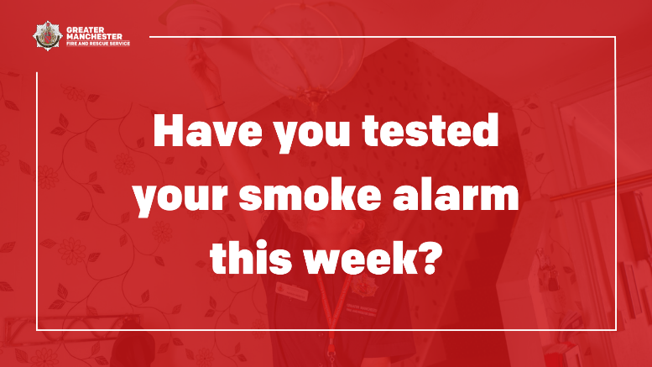 | Woman in fire service uniform testing smoke alarm in living room of house. Graphic text reads, ‘Have you tested your smoke alarm this week?’
In the event of a fire you need to be prepared and have an escape plan - it could just save your life!  Everyone who lives with you should know how to escape too.  Learn more 👉 manchesterfire.gov.uk/your-safety/fire-safety/your-home-safety/house-maisonette-or-bungalow/planning-an-escape-route/  #TestingTesting123 |  | Front door at the end of hallway with radiator. Graphic text reads, ‘Plan an escape.’
🔥 Half of fires that result in deaths are in homes with no working smoke alarm.  🏠 Complete @manchesterfire free Online Home Fire Safety Check and get advice on simple changes you can make to reduce the risk of a fire.  manchesterfire.gov.uk/your-safety/hfsa/  #TestingTesting123 |  | Row of houses on street. Graphic text reads, ‘Complete a free online home safety check today.’
Time to learn how to test your smoke alarms!  ✅ Press the test button until the alarm sounds  ✅ Test them once a week  Learn more about smoke alarms 👉 manchesterfire.gov.uk/your-safety/fire-safety/your-home-safety/house-maisonette-or-bungalow/smoke-alarms/  #TestingTesting123 |  | Hand pressing the test button on a smoke alarm. Graphic text reads, ‘Test your smoke alarm’
Your normal way out of the house is often your best escape route, so always keep it clear of clutter!  More tips and advice 👉 manchesterfire.gov.uk/your-safety/fire-safety/your-home-safety/house-maisonette-or-bungalow/planning-an-escape-route/  #TestingTesting123 |  | Door open at the end of a hallway. Graphic text reads, ‘Plan your escape route.’
In the event of a fire does your escape plan include a plan B? Plan for a second escape route, in case the first one is blocked.  Keep calm and act quickly – get out, stay out, call 999.  More advice and tips 👉 manchesterfire.gov.uk/your-safety/fire-safety/your-home-safety/house-maisonette-or-bungalow/planning-an-escape-route/  #TestingTesting123 |  | Firefighter on fire engine with sirens flashing. Graphic text reads, ‘Get out. Stay out. Call 999.’
A working smoke alarm gives you vital extra time to escape if a fire does occur in your home - it’s important to have at least one on each level at home.  ✅ Remember to test them once a week  More tips and advice 👉 manchesterfire.gov.uk/your-safety/fire-safety/your-home-safety/house-maisonette-or-bungalow/smoke-alarms/  #TestingTesting123 |  | Smoke alarm on ceiling. Graphic text reads, ‘Test your smoke alarm weekly.’
Declutter your home once in a while to keep fire escape routes clear in case of an emergency.  If you’ve made changes to your home, remember to review your escape plan.  More advice and tips 👉 manchesterfire.gov.uk/your-safety/fire-safety/your-home-safety/house-maisonette-or-bungalow/planning-an-escape-route/  #TestingTesting123 |  | A staircase inside house next to front door. Graphic text reads, ‘Review your escape plan.’
If you encounter a fire, keep calm and act quickly – get out, stay out, call 999.  Always use the stairs to get out if you’re escaping from a block of flats.  👉 manchesterfire.gov.uk/your-safety/fire-safety/your-home-safety/flat/what-to-do-if-a-fire-is-in-your-building/  #TestingTesting123 |  | Firefighter on fire engine with sirens flashing. Graphic text reads, ‘Get out. Stay out. Call 999.’
LinkedIn
Landlords – you must put a smoke alarm on every floor of a property you rent out.  You must check they work at the start of a new tenancy.  It’s the tenant’s responsibility to test the batteries regularly when they’re living there.  More info on Fire Safety Regs on Greater Manchester Fire and Rescue Service website - Advice for Landlords - Greater Manchester Fire Rescue Service |  | Hand pressing the test button on a smoke alarm. Graphic text reads, ‘Test your smoke alarm’

Test it Tuesday
Suggested content | Image | Alt text
Facebook
🚨 A smoke alarm could save your life in the event of a fire.  Fit a minimum of one working smoke alarm on every level of your home.  Watch this short video for more advice and information 👇  #TestItTuesday | Smoke alarm asleep (video animation) | N/A
🚨 90 people die every year because their smoke alarm is not working.  📽 Watch this short video for advice and information on how to make sure yours is working.  To find out more 👉 manchesterfire.gov.uk/your-safety/fire-safety/house-maisonette-or-bungalow/smoke-alarms/  #TestItTuesday | Smoke alarm 10-year (video animation) | N/A
Instagram
🚨 A smoke alarm could save your life in the event of a fire.  Fit a minimum of one working smoke alarm on every level of your home.  Watch this short video for more advice and information 👇  #TestItTuesday | Smoke alarm asleep (video animation) | N/A
🚨 90 people die every year because their smoke alarm is not working.  📽 Watch this short video for advice and information on how to make sure yours is working.  For more advice and tips 👉 search ‘smoke alarm’ on our website. | Smoke alarm 10-year (video animation) | N/A
Twitter
🚨 A smoke alarm could save your life in the event of a fire.  Fit a minimum of one working smoke alarm on every level of your home.  Watch this short video for more advice and information 👇  #TestItTuesday | Smoke alarm asleep (video animation) | N/A
🚨 90 people die every year because their smoke alarm is not working.  📽 Watch this short video for advice and information on how to make sure yours is working.  To find out more 👉 manchesterfire.gov.uk/your-safety/fire-safety/house-maisonette-or-bungalow/smoke-alarms/  #TestItTuesday | Smoke alarm 10-year (video animation) | N/A

Key contacts:
- Greater Manchester Fire and Rescue Service – Prevention Development Officer (Digital and Campaigns), Zoe Henderson, hendersonz@manchesterfire.gov.uk 07971 972 280
- Greater Manchester Fire and Rescue Service / Greater Manchester Combined Authority – Senior Communications Manager, Katie Gee, katie.gee@greatermanchester-ca.gov.uk, 07976 702 346

