Road Safety Speeding Session Plan

Session Plan
Session  Road safety – Topic – Speeding. | Length  20 Minutes. | Facilities Required  Parking, access and egress.  Computer.  Projector & screen.  Internet access.
Content Slides 1 – 12.

Aims  This presentation is aimed to look at how drivers can improve their driving, to be safer on the roads, whilst analysing some risks of speeding.  Warning that some viewers may find the presentation upsetting.  Content and Videos aimed at 16 +  Please use discretion when showing videos to anyone younger than this.  Subtitles can be switched on/off  Transcript is available at the bottom of this lesson plan | Objectives (delivery Staff)  - Explain that Speed Limits Are Not Targets.  - Explain the dangers of speeding on rural roads.  - Talk through stopping distances.  - Remind the audience of the two second rule.  - Explain that driving at safe speeds saves lives.  - Talk about Speeding Drivers and why they should expect to be caught.  - Speak about speeding penalties.

Time | Topic & Activity | Resources
1 minutes. | Slide 1. Introduce yourself and briefly explain the topic you are going to talk about.  One in four crashes in the UK involves someone who was driving too fast! | PowerPoint.
2 minutes. | Slide 2. Play the film Mistakes’ – Speeding (Film).  (Some viewers may find this distressing). | PowerPoint.  Embedded into the presentation.  Subtitles can be turned on/off  Transcript Available
2 minutes. | Slide 3. Explain that Speed Limits Are Not Targets.  Speed limits are limits, not targets. They are set as the top speed for any particular road, and should never be exceeded, a safe speed is often far below the posted limit.  When a car crashes, it’s the amount of kinetic energy that the car has which determines the force of impact. Kinetic energy is the energy of motion. Small increases in speed lead to much higher increases in kinetic energy.  When you’re driving, it’s hard to perceive that a slight increase in speed is really so damaging. It’s easy to let speed creep up. But a crash at 30mph involves twice as much energy and destructive potential as a crash at 20mph.  Crashes at higher speeds cause more severe injuries and deaths. | PowerPoint.
2 minutes. | Slide 4. State ‘Rural Roads Are Not Racetracks’.  Narrow, bendy roads often lack pavements or cycle paths and are unsuited to high speeds.  Rural roads pose high risks, accounting for well over half of all fatal crashes. Cyclists, motorcyclists and car drivers are more than three times as likely to be killed per mile travelled on a rural road than an urban road.  Speed is often a major factor in rural road crashes. A study of single-carriageway rural roads estimated that a 10% increase in average speed results in a 30% increase in fatal and serious crashes.  The most common crash types on rural roads are collisions at intersections, head-on collisions and running off the road. | PowerPoint.
2 minutes. | Slide 5. Talk through stopping distances.  A vehicle travelling at 20mph would stop in time to avoid a child running out three car-lengths in front. The same vehicle travelling at 25mph would not be able to stop in time and would hit the child at 18mph. This is roughly the same impact as a child falling from an upstairs window.  Driving is unpredictable and if something unexpected happens on the road ahead, such as a child stepping out from between parked cars, it is a driver’s speed that will determine whether they can stop in time and, if they can’t stop, how hard they will hit.  In adverse weather, such as icy roads stopping distance increases by up to 10 times. | PowerPoint.
2 minutes. | Slide 6. Tell them about the two second rule.  The two-second rule is a rule of thumb by which a driver may maintain a safe trailing distance at any speed. The rule is that a driver should ideally stay at least two seconds behind any vehicle that is directly in front of his or her vehicle.  Allow at least a two-second gap between you and the vehicle in front on roads carrying faster-moving traffic and in tunnels where visibility is reduced.  The gap should be at least doubled on wet roads and increased still further on icy roads. | PowerPoint.
2 minutes. | - Slide 7. Briefly discuss stopping distances.  - 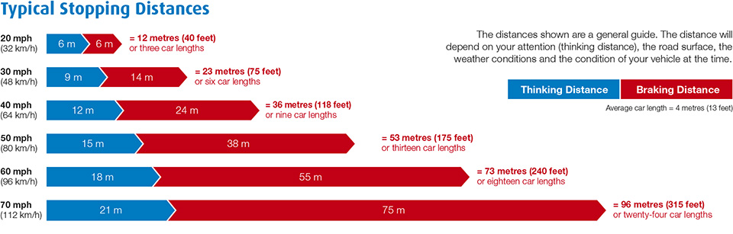 | PowerPoint.
2 minutes. | Slide 8. Explain that driving at safe speeds saves lives.  Driving at a safe speed reduces the risk of road death and injury and enables more people to make safe and healthy journeys on foot and by bike.  A pedestrian hit at 30mph has a 1 in 5 chance of being killed.  Every day, road crashes cause devastation to individuals, families and communities across the UK and the globe. Vehicle speed is always a factor in the severity of the incident.  With someone injured on a UK road every four minutes, and vehicle speed playing a part in every crash, it’s time to come together to say that there is no need to speed.  Research has found that many young men who have been driving for a while are overconfident in their driving ability and believe they can safely take risks when at the wheel. This includes driving too fast, especially when in a hurry or on roads they think they know well and being more likely to use a handheld mobile at the wheel. | PowerPoint.
2 minutes. | Slide 9. Clarify why slower driving is safer.  The faster a vehicle is travelling, the longer it takes to stop. At higher speeds, a driver has less time to react and stop in time in an emergency.  The faster we drive, the greater our risk of crashing, and the harder we hit if we crash. A crash at 30mph has twice the energy and destructive potential of a crash at 20mph.  The greater the impact speed, the greater the chance of death. A pedestrian hit at 30mph has a very significant (one in five) chance of being killed. This rises significantly to a one in three chance if they are hit at 35mph. Even small increases in speed can lead to an increase in impact severity.  Where traffic is slow, more people choose to walk or cycle. 20mph is an appropriate maximum speed in places where people live.  Fast moving traffic also creates unpleasant noise and air pollution, making our communities less safe and deterring people from walking and cycling. | PowerPoint.
1 minutes. | Slide 10. Talk about Speeding Drivers and why they should expect to be caught.  Safe road users comply with road rules and share responsibility for the safety of everyone who uses roads.  Most road deaths and injuries are caused by unsafe driver behaviour, often because drivers are going too fast for road conditions.  Investment in roads policing and a comprehensive speed enforcement programme is essential to catch speeding drivers and deter people from speeding. | PowerPoint.
2 minutes. | Slide 11. Explain about speeding penalties.  The minimum penalty for speeding is a £100 fine and 3 penalty points added to your licence.  You could be disqualified from driving if you build up 12 or more penalty points within a period of 3 years.  New drivers, still within 2 years of passing their driving test, will have their diving licence revoked (withdrawn) if they build up 6 or more penalty points. | PowerPoint.
 | Slide 12. Thank you and Any Questions? | PowerPoint.

Slide 2. Play the film Mistakes’ – Speeding (Film).
(Some viewers may find this distressing).
Transcript
[Car with father and son on the back seat comes to a junction, looks left and right and turns right into an oncoming car]
[Vehicle is approaching from the right at speed]
[Both cars stop]
Uh
Mate
I’m so sorry i thought there was time
he just pulled out
i don't have time to stop well come on

mate man
it was a simple mistake
i don't know if i was going a bit slower
[Car starts to drive towards the other vehicle with the young boy in the back seat]
please
I’ve got my boy in the back
I’ll go too fast
I’m sorry
[Father puts his hands on his head and return to the car, looking over his should at his son]
[The car and driver crash into the Father and Son’s car]
Other people make mistakes, slow down
End of Transcript

