#StayFireSafe Partner Social Media Toolkit
Communications messaging and assets for Greater Manchester Fire and Rescue Service (GMFRS) Stay Fire Safe cost of living campaign. For use from 14 November and throughout winter.
The main aim of the Stay Fire Safe campaign is to provide fire safety information for residents as the cost of living rises. Key messages include:
- Fitting smoke alarms on all levels of your home
- Checking if you are eligible for a Home Fire Safety Assessment: https://www.manchesterfire.gov.uk/your-safety/hfsa/
- Visiting the GMFRS Stay Fire Safe webpage: https://www.manchesterfire.gov.uk/your-safety/stay-fire-safe/
- Heating safely​
- Cooking safely
- Electrical safety

Social media copy
You will find suggested social content and images in the table below.
(Please remove links in suggested content for Instagram as they will not work. You can replace with: ‘Search for Stay Fire Safe on the Greater Manchester Fire and Rescue Service Website to find out more’).

Images
Assets featured in the suggested posts below can be downloaded from:
Stay Fire Safe for partners - Greater Manchester Fire Rescue Service
They are grouped by size for Twitter, Facebook, and Instagram

Accessibility
Please ensure that all images posted on social media make use of the 'alt text' function and duplicate any words that appear in a graphic so the same information is accessible to those using screen readers. You should also describe any imagery that appears within this description.
You can find further guidance and how to do this for different platforms below and for further advice on writing image descriptions, see here: https://www.rnib.org.uk/rnibconnect/technology/making-your-social-media-accessible

Social media posts and assets
General
Image preview | Copy | Image Title
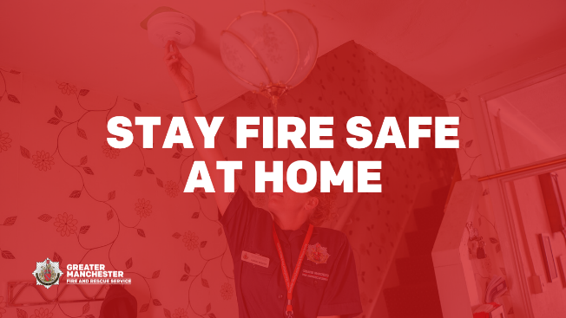  Alt text: ‘Stay fire safe at home’ | We are all looking at ways to reduce our energy bills. Make sure you #StayFireSafe and don’t put yourself at risk of fire in your home  See Greater Manchester Fire and Rescue Service’s advice for keeping safe here: https://www.manchesterfire.gov.uk/your-safety/stay-fire-safe/ | Stay Fire Safe at Home
[Link through to webpage] | GMFRS offers a free online Home Fire Safety Check tool, where you can complete some quick questions to help identify fire hazards in your home and get advice on simple changes you can make to reduce the risk of a fire  Find out more here: https://www.manchesterfire.gov.uk/your-safety/hfsa/  #StayFireSafe
[Link through to webpage] | How are your loved ones keeping warm this winter?  Please check on family and friends who might be struggling to heat their home  You can complete a home fire safety check online here: https://www.manchesterfire.gov.uk/your-safety/hfsa/  You can find more home fire safety advice here 👇  https://www.manchesterfire.gov.uk/your-safety/stay-fire-safe/  #StayFireSafe
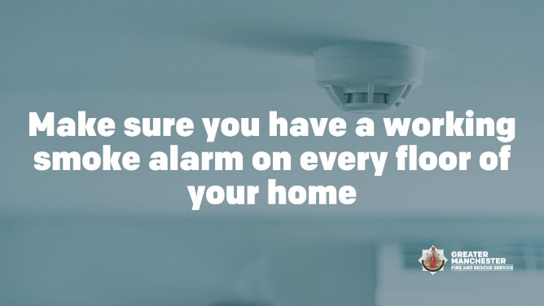  Alt text: ‘Make sure you have a working smoke alarm on every floor of your home’ | There are some simple steps you can take to help keep you safe from fire  Make sure you have a working smoke alarm on every floor of your home, so you’re alerted quickly if there’s a fire  Find out more here: https://www.manchesterfire.gov.uk/your-safety/stay-fire-safe/  #StayFireSafe | Smoke alarms
Heat your home safely
Image preview | Copy | Image Title
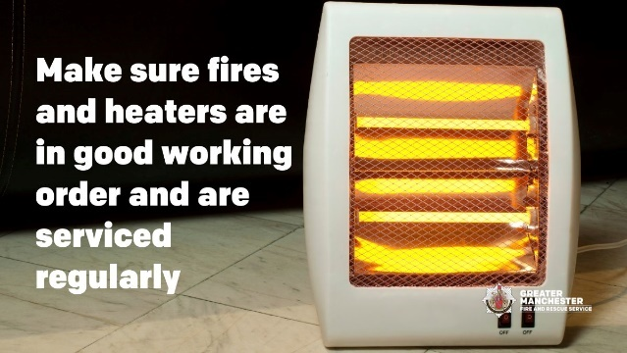  Alt text: ‘Make sure fire and heaters are in good working order and are serviced regularly’ | If you're using portable heaters, make sure they are in good working order  You can check for any product recalls here: https://www.gov.uk/guidance/product-recalls-and-alerts  You can find more home fire safety advice here 👇  https://www.manchesterfire.gov.uk/your-safety/stay-fire-safe/  #StayFireSafe | Heaters in good working order
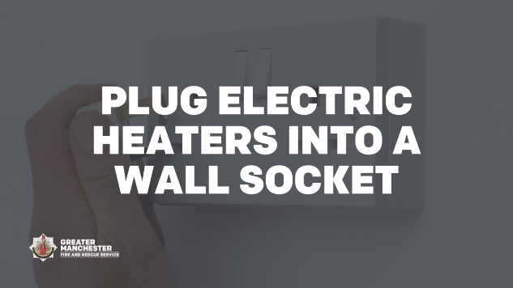  Alt text: ‘Plug electric heaters into a wall socket’ | Electric heaters should be plugged into a wall socket – do not use extension leads as they can easily be overloaded and cause a fire  Find more advice to keep yourself safe at home 👉 https://www.manchesterfire.gov.uk/your-safety/stay-fire-safe/  #StayFireSafe | Plug Electric heaters into a wall socket
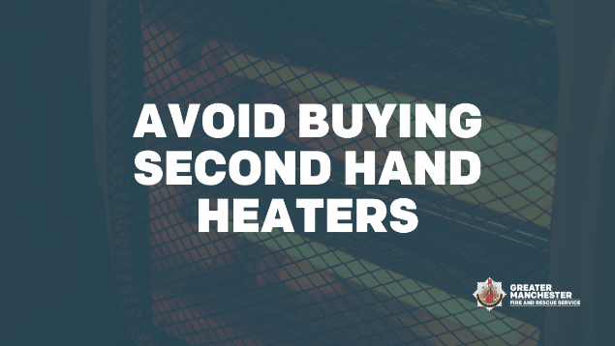  Alt text: ‘Avoid buying second hand heaters’ | Avoid buying second hand heaters  Many online marketplaces do not have to adhere to the same safety standard as high street retailers  Buy from websites of brands you trust  You can find more home fire safety advice here 👇  https://www.manchesterfire.gov.uk/your-safety/stay-fire-safe/  #StayFireSafe | Avoid buying second hand heaters
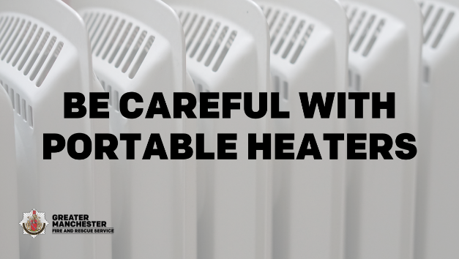  Alt text: ‘Be careful with portable heaters’ | Portable heaters should only be moved when they have been switched off and cooled down  You can find more home fire safety advice here 👇  https://www.manchesterfire.gov.uk/your-safety/stay-fire-safe/  #StayFireSafe | Be careful with portable heaters
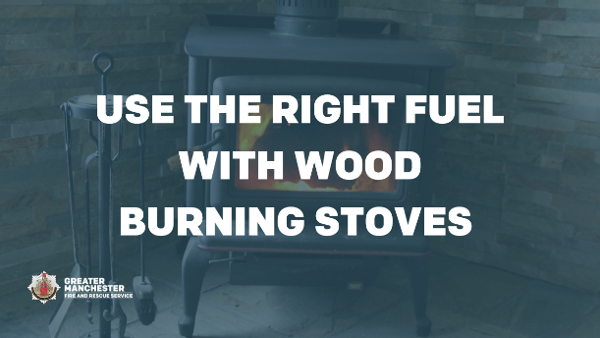  Alt text: ‘Use the right fuel with wood burning stoves’ | Open fires and wood burning stoves may be a cosy way to keep warm but please use the right fuel to avoid fire risk and toxic fumes  Make sure you've had your chimney swept to keep yourself safe  Find more home fire safety advice online👇  https://www.manchesterfire.gov.uk/your-safety/stay-fire-safe/  #StayFireSafe | Use the right fuel with wood burning stoves
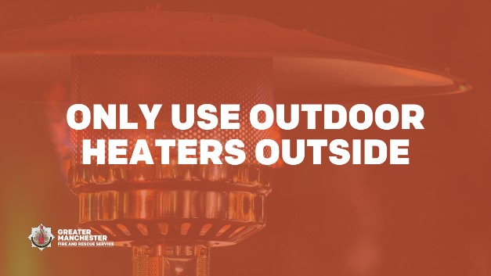  Alt text: ‘Only use outdoor heaters outside’ | Only use outdoor heaters outside  Using outdoor heaters inside is a fire risk and they also produce carbon monoxide which can be fatal  Find more home fire safety advice online👇  https://www.manchesterfire.gov.uk/your-safety/stay-fire-safe/  #StayFireSafe | Only use outdoor heaters outside
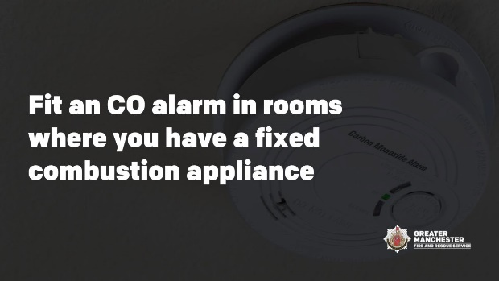  Alt text: ‘Fit a CO alarm in rooms where you have a fixed combustion appliance’ | Ensure you have a working carbon monoxide (CO) alarm in the same room as any heating appliance which does not run off electricity  Remember to switch off heaters and extinguish fires before sleeping to reduce your risk of fire or carbon monoxide poisoning  #StayFireSafe | CO alarms
Electrical fire safety
Image preview | Copy | Image Title
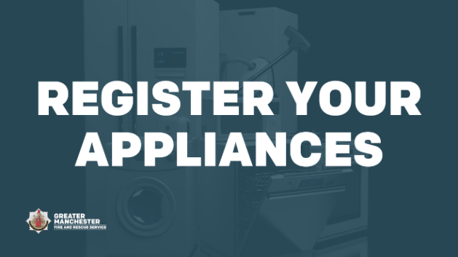  Alt text: ‘Register your appliances’ | To help keep yourself safe from fire, register your electrical products online: www.registermyappliance.org.uk  You will be informed if there is a problem  This doesn’t just apply to new items; you can register older or second-hand appliances too  #StayFireSafe | Register your appliances
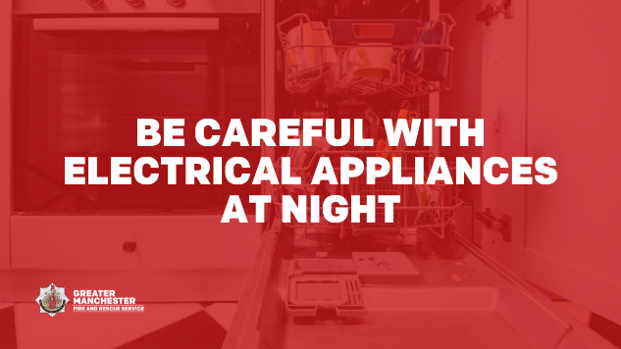  Alt text: ‘Be careful with electrical appliances at night’ | Electricity costs the same no matter what time of day or night you use it - unless you have a time of use tariff  Don’t run white goods or charge items if you are asleep thinking you will save money. If a fire happens you will have less time to react and escape  #StayFireSafe | Be careful with electrical appliances at night
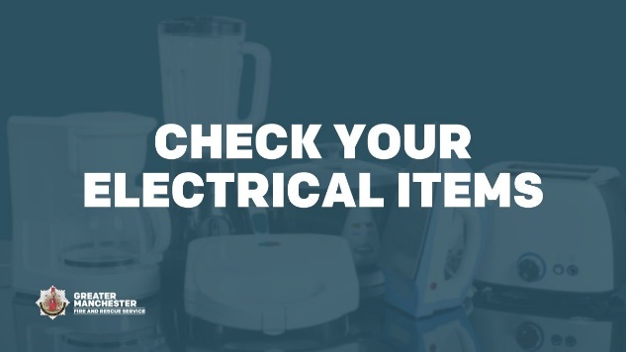  Alt text: ‘Check your electrical items’ | If you have to run an electrical appliance at night don’t overload your plug sockets and check cables and plugs for signs of wear and tear  If you think there is a problem, unplug it and contact the retailer or manufacturer  Find out more 👉 https://www.manchesterfire.gov.uk/your-safety/stay-fire-safe/  #StayFireSafe | Check your electrical items
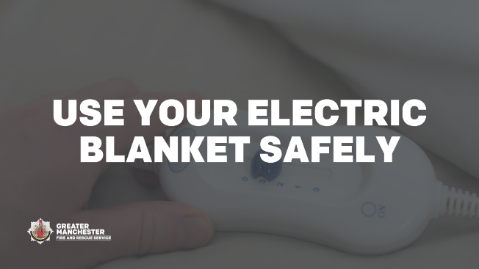  Alt text: ‘Use your electric blanket safely’ | If you use an electric blanket always follow the manufacturer's instructions before use and store correctly  Examine your blanket, plug and cord for signs of wear or damage  Find more safety advice here: https://www.manchesterfire.gov.uk/your-safety/stay-fire-safe/  #StayFireSafe | Use your electric blanket safely
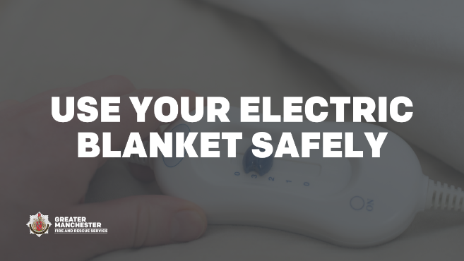  Alt text: ‘Use your electric blanket safely’ | Don’t have drinks or use a hot water bottle when using your electric blanket  Liquids and electricity don’t mix  Find more advice on the Greater Manchester Fire and Rescue Service website: https://www.manchesterfire.gov.uk/your-safety/stay-fire-safe/  #StayFireSafe | Use your electric blanket safely
Bypassing electric and gas meters
Image preview | Copy | Image Title
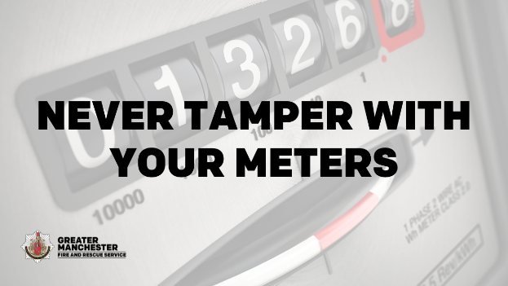  Alt text: ‘Never tamer with your meters’ | Energy theft is not a victimless crime  The potential dangers of meter tampering include sparks, fires, damage to property, explosions and, tragically, sometimes death  #StayFireSafe | Never tamper with your meters
Cooking fire safety
Image preview | Copy | Image Title
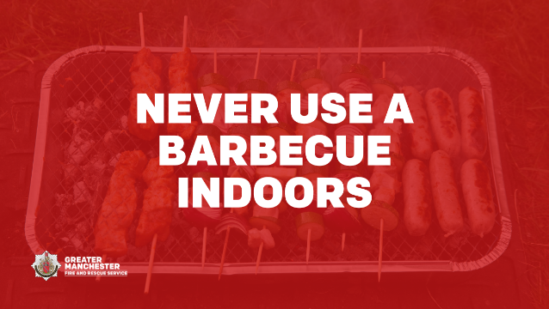  Alt text: ‘Never use a barbecue indoors’ | Whether you have a gas or charcoal barbecue remember they must never be used indoors  Protect yourself from fire and carbon monoxide poisoning  Find out more https://www.manchesterfire.gov.uk/your-safety/stay-fire-safe/  #StayFireSafe | Never use a barbecue indoors
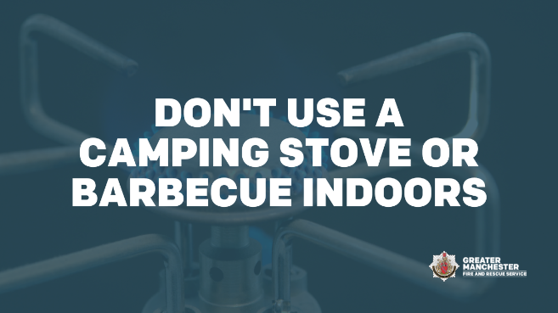  Alt text: ‘Don’t use a camping stove or barbecue indoors’ | It might be tempting to use a camping stove or barbecue indoors but remember these products must only be used outdoors  Indoors they are a carbon monoxide and fire risk  Find out more https://www.manchesterfire.gov.uk/your-safety/stay-fire-safe/  #StayFireSafe | Don't use a camping stove or barbecue indoors
Candle fire safety
Image preview | Copy | Image Title
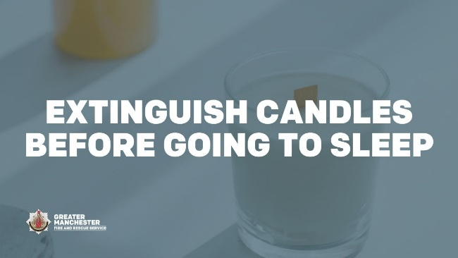  Alt text: ‘Extinguish candles before going to sleep’ | When using candles don’t forget how many you have lit  Never leave lit candles unattended and make sure they are all out completely at night or when you go out  Find out more https://www.manchesterfire.gov.uk/your-safety/stay-fire-safe/  #StayFireSafe | Extinguish candles before going to sleep
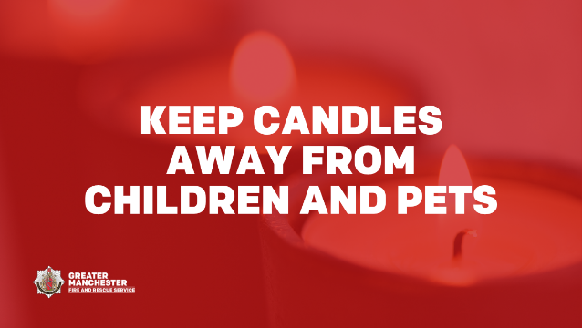  Alt text: ‘Keep candles away from children and pets’ | Place lit candles out of reach of children and pets  Also remember to keep lighters and matches somewhere safe, away from children  Find out more https://www.manchesterfire.gov.uk/your-safety/stay-fire-safe/  #StayFireSafe | Keep Candles away from children and pets
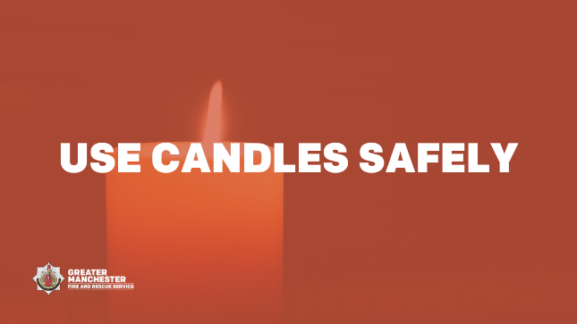  Alt text: ‘Use candles safely’ | Don’t move or carry lit candles  It’s much safer to use an LED candle or torch to light your way  Find out more https://www.manchesterfire.gov.uk/your-safety/stay-fire-safe/  #StayFireSafe | Use candles safely
Gas safety
Image preview | Copy | Image Title
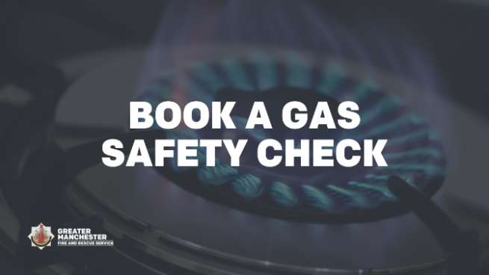  Alt text: ‘Book a gas safety check’ | Book a gas safety check to keep you safe at home  If you own your home, check with your energy provider to see if you can get a free annual check through their Priority Services Register  If you are a tenant, your landlord must arrange an annual gas safety check  #StayFireSafe | Book a gas safety check
Help in Greater Manchester
Image preview | Copy | Image Title
[Link through to Helping Hand webpages] | Are you worried about the rise in the cost of living?  @greatermcr have a lot of useful information that can provide you with a helping hand, including how to stay fire safe at home  Find out more here: https://www.greatermanchester-ca.gov.uk/helping-hand/
Smoking safety
Image preview | Copy | Image Title
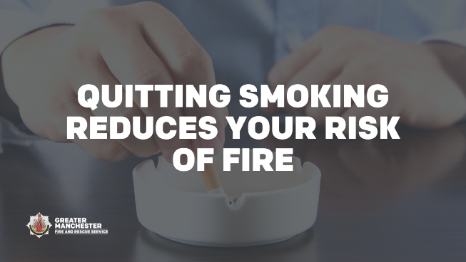  Alt text: ‘Quitting smoking reduces your risk of fire’ | The best way to prevent smoking related fires is to quit smoking  But if you’re not ready yet, follow our safety advice to reduce your risk of fire  https://manchesterfire.gov.uk/your-safety/fire-safety/house-maisonette-or-bungalow/smoking/  #StayFireSafe | Quitting smoking reduces your risk of fire
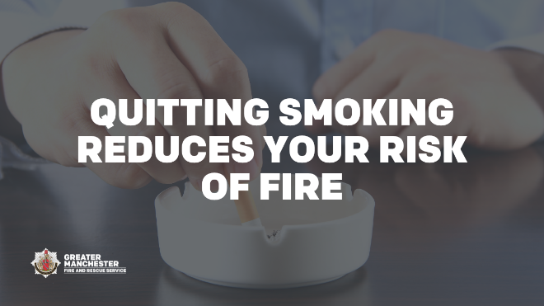  Alt text: ‘Quitting smoking reduces your risk of fire’ | Smoking is the number one cause of accidental fire deaths in the UK  If you smoke at home it’s safer to smoke outside if you can  Find out more on how to stay fire safe at home: https://www.manchesterfire.gov.uk/your-safety/stay-fire-safe/  #StayFireSafe | Quitting smoking reduces your risk of fire
Home reconfiguration or part use
Image preview | Copy | Image Title
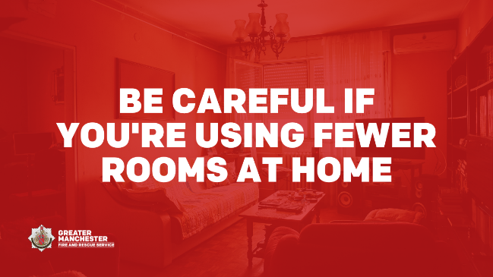  Alt text: ‘Be careful if you’re using fewer rooms at home’ | If you are spending more time in just a couple of rooms in your home to save on heating, make sure you have working smoke alarms in or near the rooms you use most  Find out more on how to stay fire safe at home: https://www.manchesterfire.gov.uk/your-safety/stay-fire-safe/  #StayFireSafe | Be careful if you're using fewer rooms at home
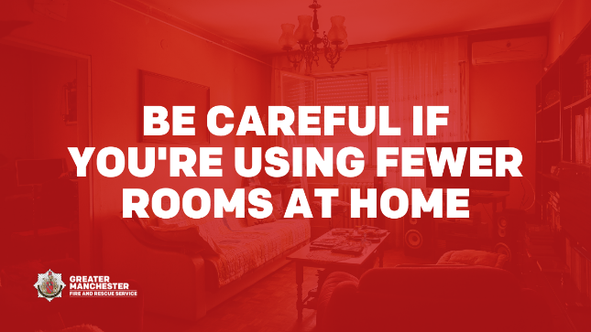  Alt text: ‘Be careful if you’re using fewer rooms at home’ | If you are using fewer rooms to save on heating make sure there’s space around heaters, open fires and candles to reduce the risk of a fire in your home  Find out more on how to stay fire safe at home: https://www.manchesterfire.gov.uk/your-safety/stay-fire-safe/  #StayFireSafe | Be careful if you're using fewer rooms at home

