GMFRS Smoke alarm testing and escape route planning
Social media pack 2022
Introduction
Greater Manchester and Rescue Service (GMFRS) is running a campaign focusing on smoke alarm testing and escape route planning.
In the last three years the number of incidents we have attended with a smoke alarm present has been on average 82%, whilst the UK average for having at least one working smoke alarm in 2020/21 was 94%.
In addition, according to the data from our home visits, the percentages of Greater Manchester residents having a working smoke alarm on each floor of their home and testing their smoke alarms weekly have decreased over the past three years.
Greater Manchester residents' data
 | 2019/2020 | 2020/2021 | 2021/2022
Having a working smoke alarm on each floor | 63.20% | 50.01% | 46.25%
Test smoke alarms every week | 85.90% | 66.45% | 56.74%

A working smoke alarm can be the first alert to a fire and can save lives by providing vital extra seconds to escape a fire in the home. Each level should have at least one working alarm and we suggest testing once a week to ensure they are working. Knowing what to do if a smoke alarm sounds is also important – prepare an escape plan to help everyone escape smoothly in case of a fire. Also, make sure everyone living in the same household knows about the plan.
To ensure Greater Manchester residents are aware of these important actions and routines, as well as to support Home Fire Safety Week (13-19 June) led by the National Fire Chiefs Council (NFCC), we will be sharing social media posts across all relevant channels and we encourage partners to share where possible, allowing for maximum impact and coverage.

Communication objectives
- Encourage people to fit smoke alarms on each level of their home and test them once a week
- Encourage people to plan escape routes and review them regularly
- Educate people on what they should do in case of a fire
Audience
- Residents living in a house, maisonette or bungalow
- Residents living in a high-rise building
- Residents in all boroughs of Greater Manchester
Key messages:
- Fit smoke alarms on each level of your home.
- Test the batteries in your smoke alarm every week.
- A smoke alarm should wake you up and give you vital extra time to escape.
- Plan an escape route and make sure everyone knows how to get out.
- Keep door and window keys accessible.
- The best route is usually the normal way in and out of your home, so always keep it clear of clutter.
- Plan a second escape route, in case the first one is blocked.
- Review your escape route regularly to take into account any changes in your home.
- If a fire starts, keep calm and act quickly – get out, stay out and call 999.
Assets can be downloaded here: https://www.manchesterfire.gov.uk/your-safety/campaigns/smoke-alarm-testing-and-escape-planning/
These posts will be shared with the main hashtag #TestingTesting123 on GMFRS’ various channels including Twitter, Facebook and Instagram. Additional hashtag #HFSW22 will be used to support NFCC’s Home Fire Safety Week during 13-19 June.

Suggested content | Image | Alt text
How often do you test your smoke alarm? Our advice is to test it weekly by pressing the test button until the alarm sounds.  Learn more 👉 https://www.manchesterfire.gov.uk/your-safety/fire-safety/your-home-safety/house-maisonette-or-bungalow/smoke-alarms/  #TestItTuesday #TestingTesting123 #HFSW22 | 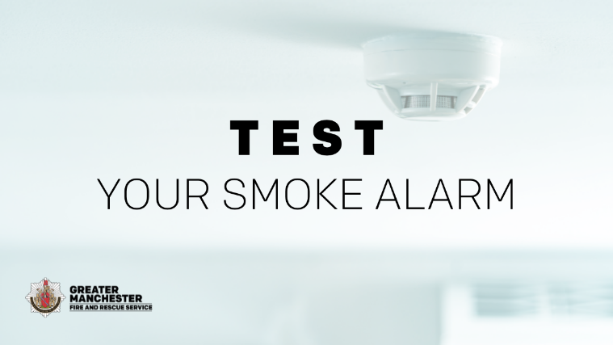 | Test your smoke alarm
Would you know what to do if your smoke alarms go off? Plan ahead and practise an escape route.  Make sure door and window keys are accessible to everyone.  More tips and advice 👉 https://www.manchesterfire.gov.uk/your-safety/fire-safety/your-home-safety/house-maisonette-or-bungalow/planning-an-escape-route/  #TestingTesting123 #HFSW22 | 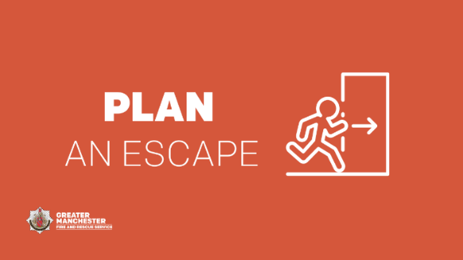 | Plan an escape
A smoke alarm would fail to work if the fire is outside of its range.  Make sure you fit at least one working alarm on every level of your home.  🏠 Check if you’re eligible for a free Home Fire Safety Assessment visit👉 https://manchesterfire.gov.uk/your-safety/hfsa/  #TestingTesting123 #HFSW22 | 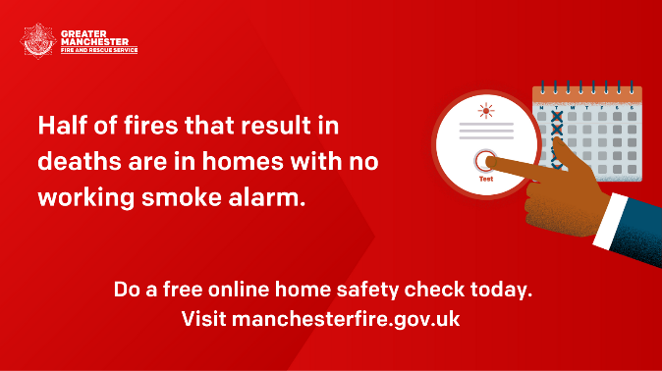 | Do a free home safety check today. Visit GMFRS website.
🔥 It’s hard to notice a fire at the earliest stages when you’re sleeping – that's why you need a working smoke alarm to give you vital extra seconds to escape.  ✅ Test your smoke alarm weekly  Learn more 👉 https://www.manchesterfire.gov.uk/your-safety/fire-safety/your-home-safety/house-maisonette-or-bungalow/smoke-alarms/  #TestingTesting123 #HFSW22 | 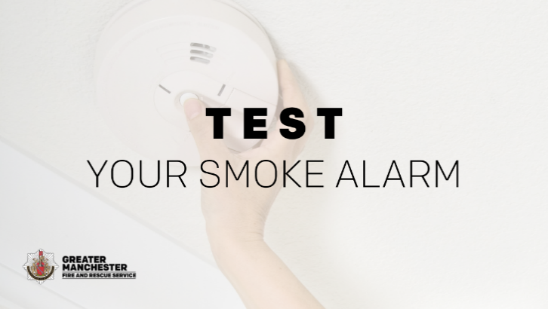 | Test your smoke alarm
You need to be prepared and have an escape plan - one day it could just save your life!  Everyone who lives with you should know how to escape too.  Learn more 👉 https://www.manchesterfire.gov.uk/your-safety/fire-safety/your-home-safety/house-maisonette-or-bungalow/planning-an-escape-route/  #TestingTesting123 #HFSW22 | 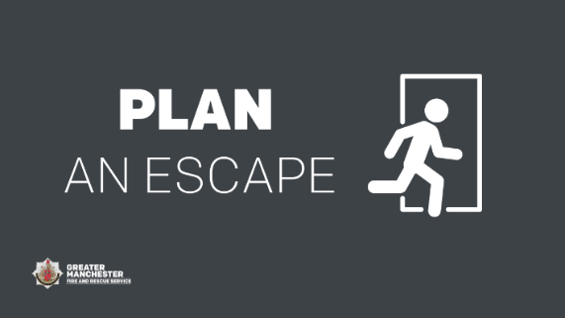 | Plan an escape
🔥 Half of fires that result in deaths are in homes with no working smoke alarm.  🏠 Complete our free Online Home Fire Safety Check and get advice on simple changes you can make to reduce the risk of a fire.  manchesterfire.gov.uk/your-safety/hfsa/  #TestingTesting123 #HFSW22 |  | Do a free home safety check today. Visit GMFRS website.
Time to learn how to test your smoke alarms!  ✅ Press the test button until the alarm sounds  ✅ Test them once a week  Learn more about smoke alarms 👉 https://www.manchesterfire.gov.uk/your-safety/fire-safety/your-home-safety/house-maisonette-or-bungalow/smoke-alarms/  #TestItTuesday #TestingTesting123 | 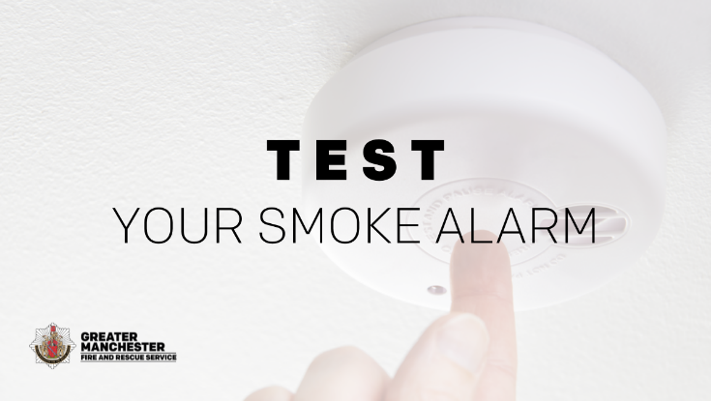 | Test your smoke alarm
Your normal way out of the house is often your best escape route, so always keep it clear of clutter!  More tips and advice 👉 https://www.manchesterfire.gov.uk/your-safety/fire-safety/your-home-safety/house-maisonette-or-bungalow/planning-an-escape-route/  #TestingTesting123 | 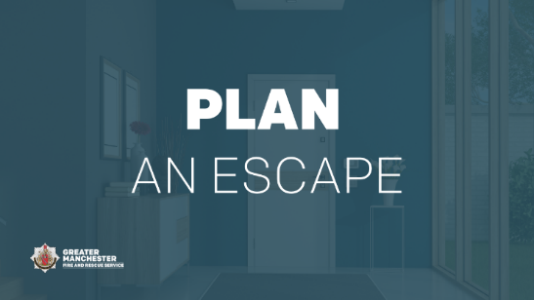 | Plan an escape
Does your escape plan include a plan B? Plan for a second escape route, in case the first one is blocked.  If you encounter a fire, keep calm and act quickly – get out, stay out, call 999.  More advice and tips 👉 https://www.manchesterfire.gov.uk/your-safety/fire-safety/your-home-safety/house-maisonette-or-bungalow/planning-an-escape-route/  #TestingTesting123 | 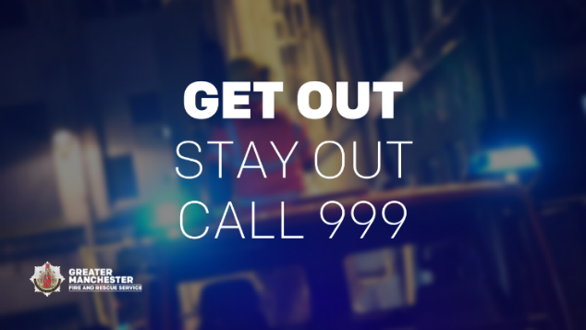 | Get out, stay out, call 999
A working smoke alarm gives you vital extra time to escape if a fire does occur in your home - it’s important to have at least one on each level at home.  ✅ Remember to test them once a week  More tips and advice 👉 https://www.manchesterfire.gov.uk/your-safety/fire-safety/your-home-safety/house-maisonette-or-bungalow/smoke-alarms/  #TestItTuesday #TestingTesting123 | 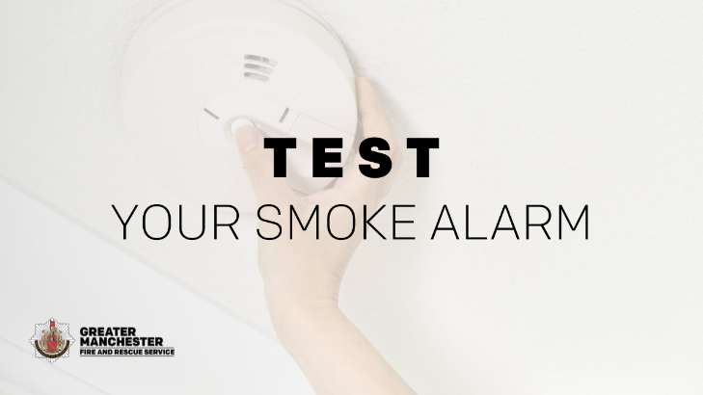 | Test your smoke alarm
Declutter your home once in a while to keep fire escape routes clear in case of an emergency.  If you’ve made changes to your home, remember to review your escape plan.  More advice and tips 👉 https://www.manchesterfire.gov.uk/your-safety/fire-safety/your-home-safety/house-maisonette-or-bungalow/planning-an-escape-route/  #TestingTesting123 |  | Review your escape plan
If you encounter a fire, keep calm and act quickly – get out, stay out, call 999.  Always use the stairs to get out if you’re escaping from a block of flats.  Learn what to do in a fire 👉 https://www.manchesterfire.gov.uk/your-safety/fire-safety/your-home-safety/flat/what-to-do-if-a-fire-is-in-your-building/  #TestingTesting123 |  | Get out, stay out, call 999

Key contacts:
- Greater Manchester Fire and Rescue Service – Prevention Development Officer (Digital and Campaigns), Zoe Henderson, hendersonz@manchesterfire.gov.uk 07971972280
- Greater Manchester Fire and Rescue Service / Greater Manchester Combined Authority – Assistant Communications Officer, Lucia Tang, lucia.tang@greatermanchester-ca.gov.uk, 07598551679

