Lesson Plan – Bonfire, Firework and Halloween Safety for Primary School

Session Summary
To introduce the children to key messages which include advice on staying safe around bonfire night, firework events and Halloween.
Objectives
- To be able to highlight the dangers of fireworks and bonfires
- To know & understand how to stay safe when out and about during the bonfire and Halloween period
- To identify safe clothing when attending a Halloween, Bonfire or firework event
- To know what to do if clothing catches fire

The session is designed to present the dangers of bonfire night whilst providing time for a facilitated conversation with the audience around key topics.

This method of engagement provides the audience with the opportunity to engage and explore the subject of bonfire and Halloween safety.

This lesson plan is a guideline on how to deliver the session. It contains guidelines on how to facilitate the session and the key information that should be discussed. **Please feel free to use your knowledge and expertise to adapt and include further information, this is just a guidance document**

Lesson Plan

Presentation | Guidance notes
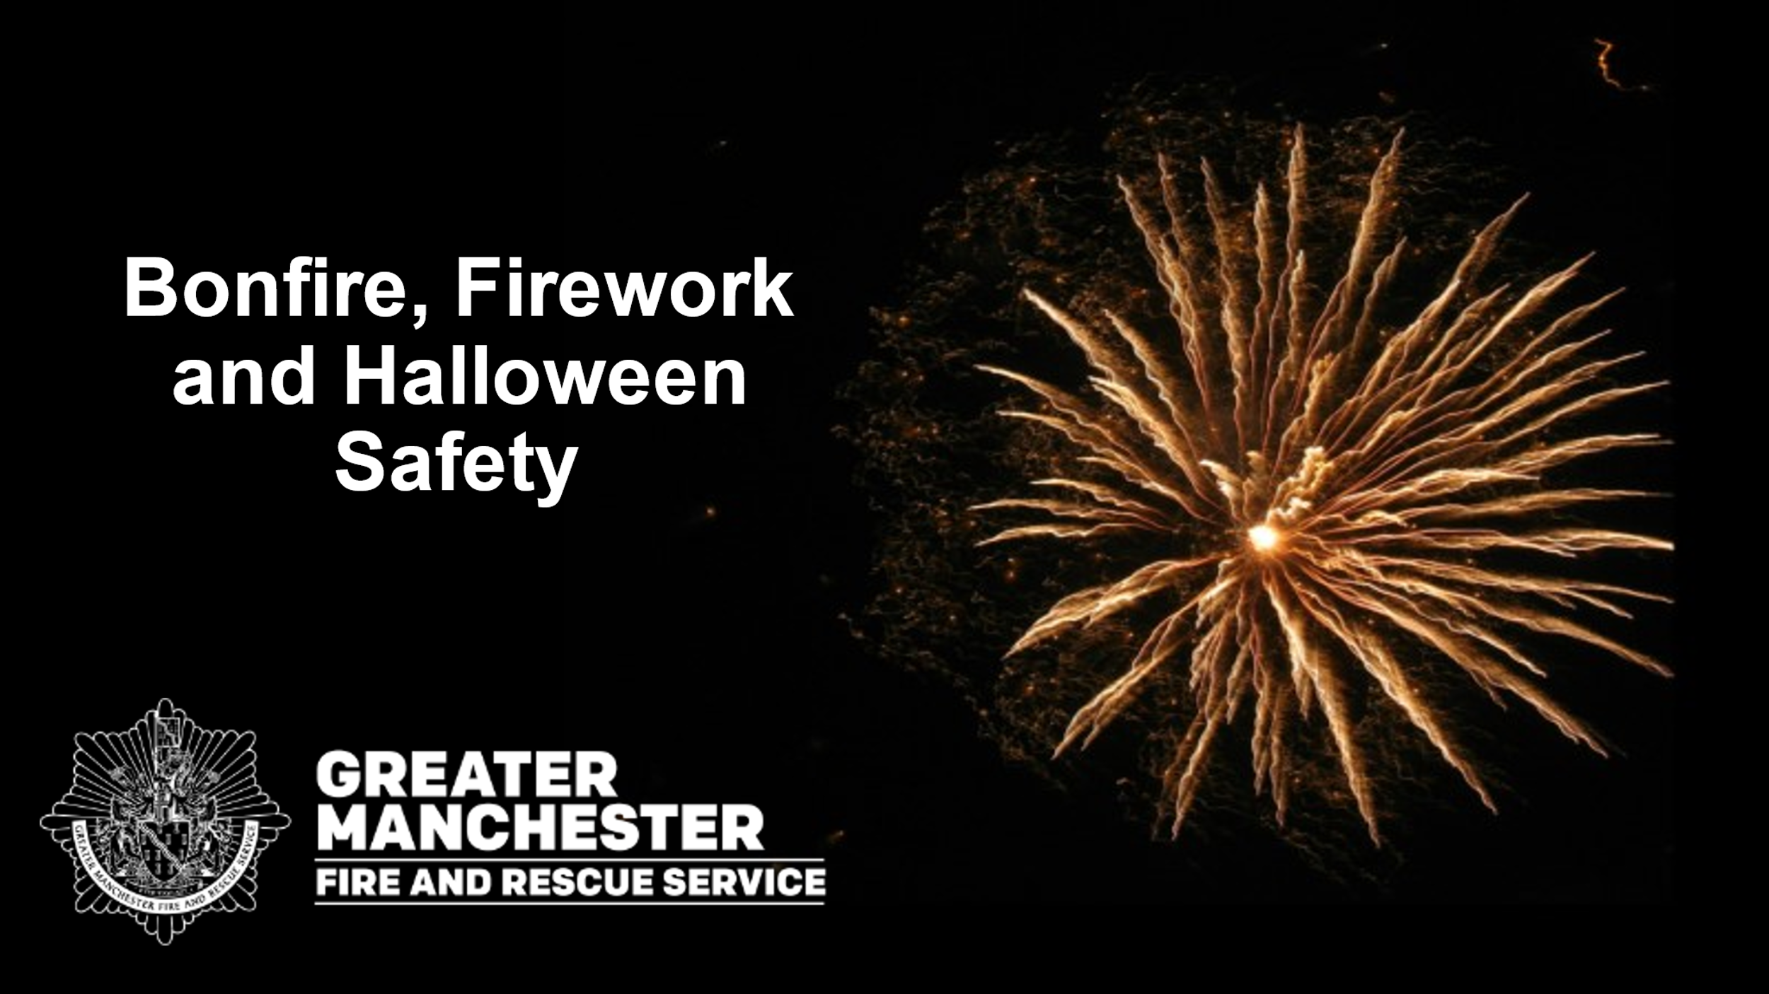  Slide 1  1 minute | This section is to provide the audience with an introduction on what will be discussed during the session -  We will talk about:  - The dangers of bonfires and fireworks  - How to stay safe during the bonfire and Halloween period  - Stop, drop and roll if your clothes catch fire
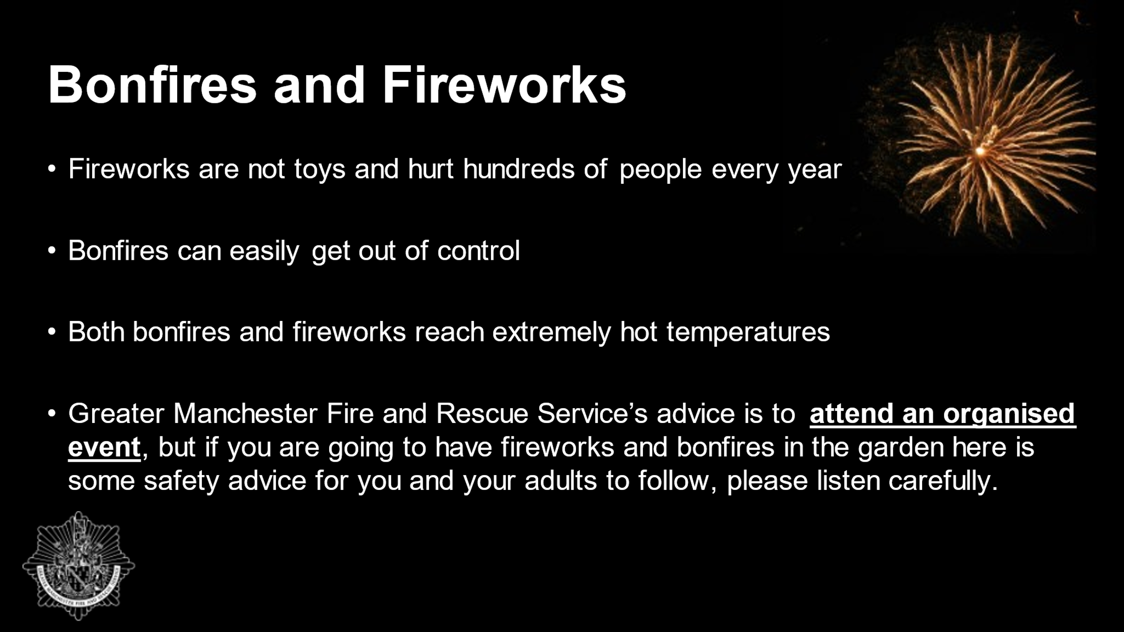  Slide 2  1 minute | Explain to the audience that bonfires and fireworks are very dangerous.  Q: Ask the audience to give you some reasons why they think bonfire and fireworks are dangerous?  Praise correct answers and then go through the slide.  Remind the audience that:  - Fireworks are not toys and hurt hundreds of people every year - Lots of people injured by fireworks are children aged 14 years and younger, the same age as you and your friends. Many of the injuries take place at home in gardens.  - Bonfires can easily get out of control  - Both bonfires and fireworks reach extremely hot temperatures  - Organised public displays are safer and have more amazing and exciting displays. Greater Manchester Fire and Rescue Service’s advice is to attend an organised event, but if you are going to have fireworks and bonfires in the garden here is some safety advice for you and your adults to follow, please listen carefully.
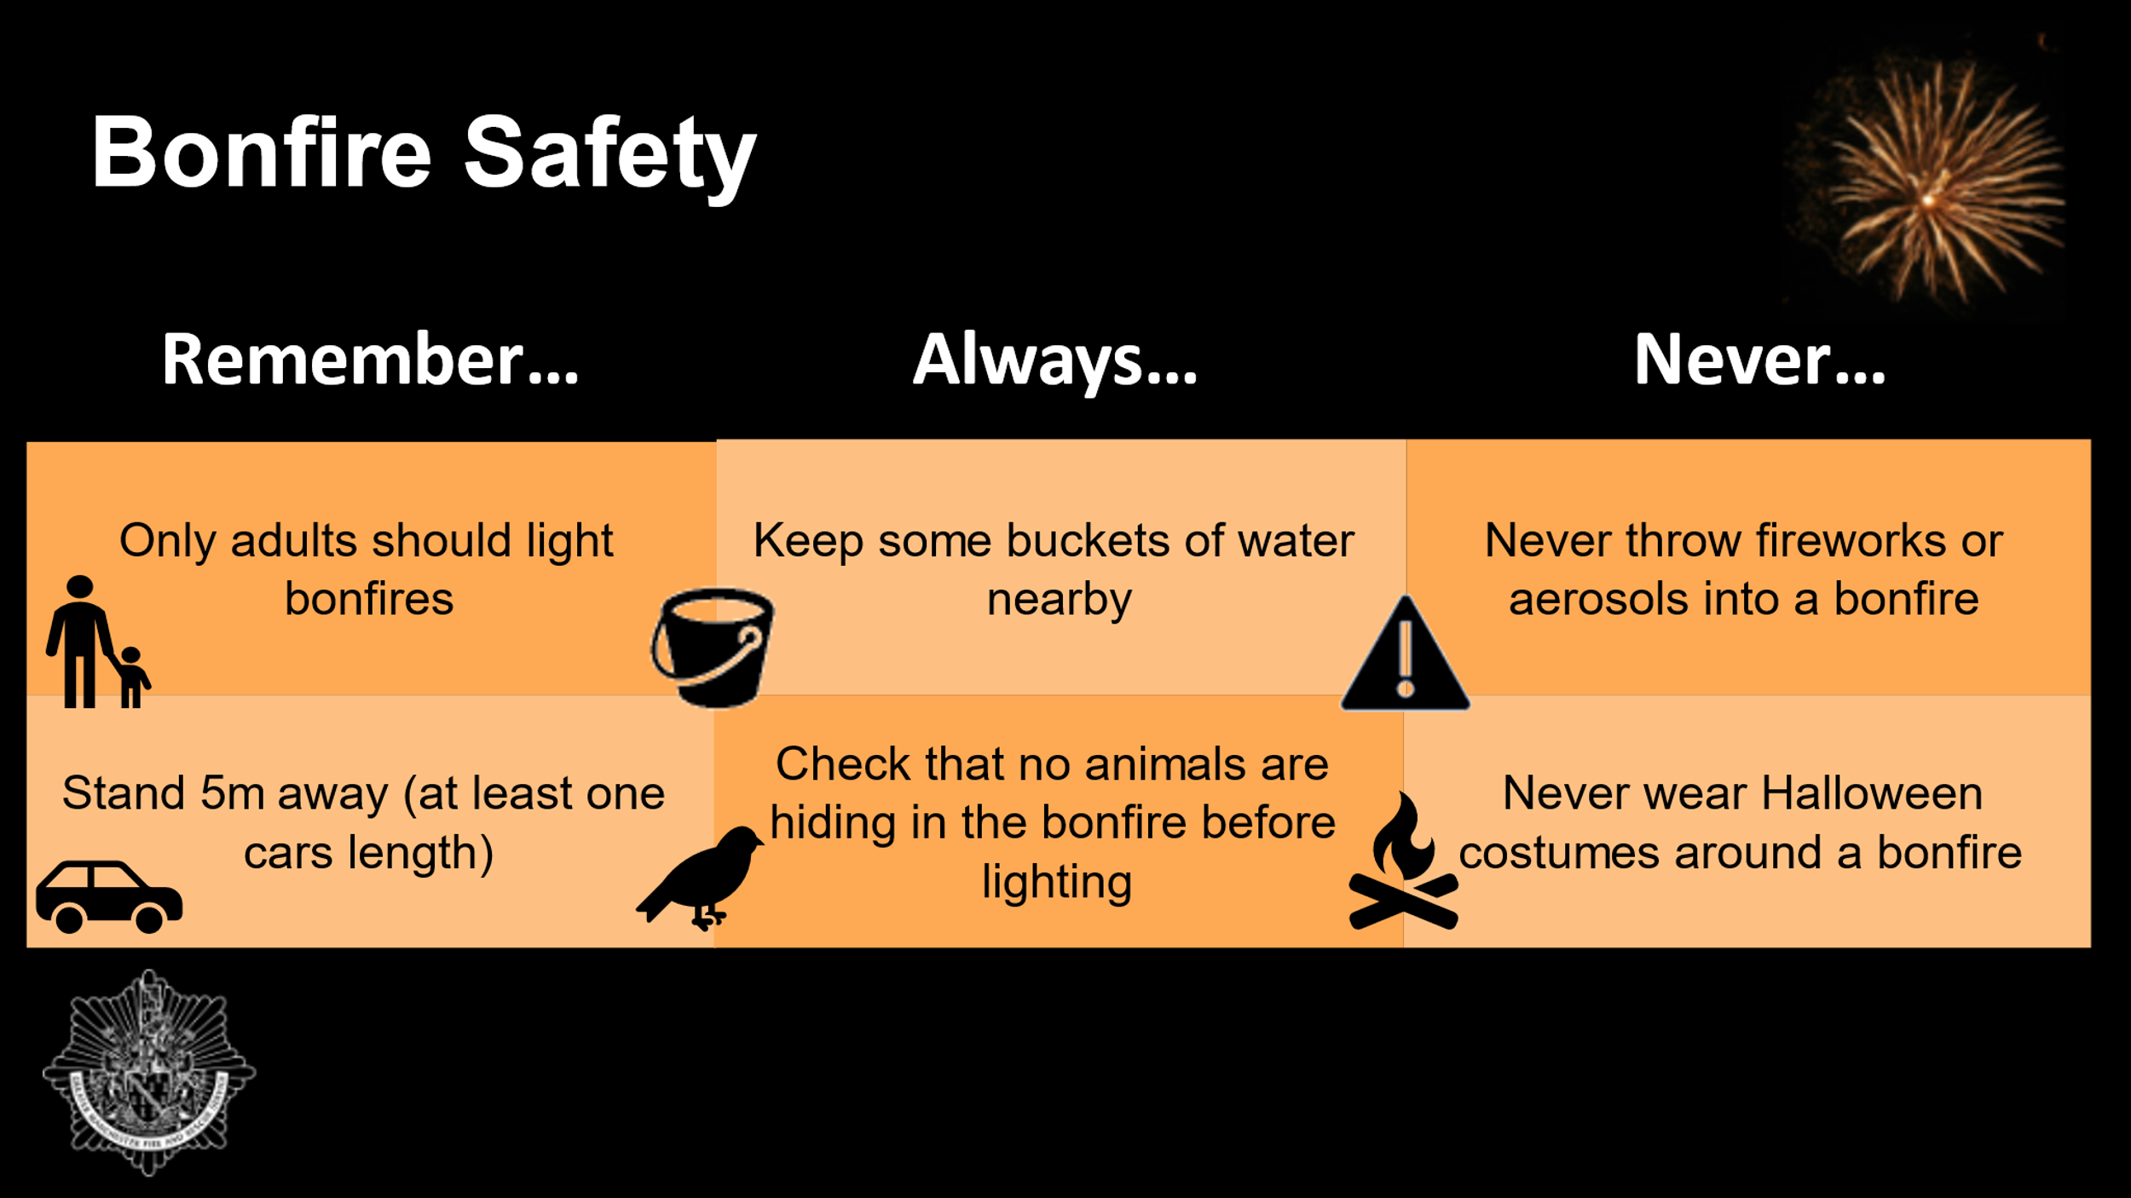  Slide 3  2 minutes | We are going to go through bonfire safety first.  During the bonfire season we want you to:  Remember….Only adults should light bonfires  Remember to…Stand 5m away (at least one car’s length)  Always… Keep some buckets of water nearby  Always… Check that no animals are hiding in the bonfire before lighting it  Never throw fireworks or aerosols into a bonfire  Never wear Halloween costumes around a bonfire  *Depending on time you can ask the audience to repeat each section back to you as a group e.g. Now let’s say it together, what should you remember this bonfire season… children would answer with remember only adults should light bonfires and repeat the process with always and never.*
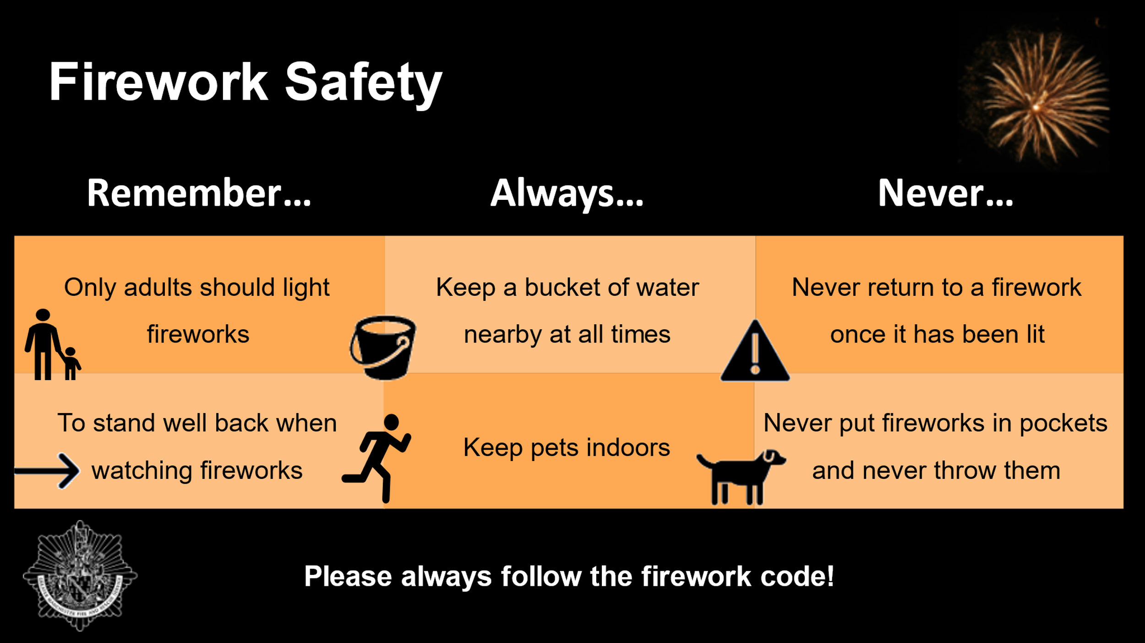  Slide 4  2 minutes | Next we are going to go through firework safety with you.  During the firework season we want you to:  Remember… Only adults should light fireworks  Remember… To stand well back when watching fireworks  Always…Keep a bucket of water nearby at all times  Always… Keep pets indoors (fireworks are loud and scary for a lot of animals).  Never return to a firework once it has been lit  Never put fireworks in pockets and never throw them  Please always follow the firework code and tell your adults at home to read and follow the firework code too. It can be found on our website and you can get it from your teacher as well.
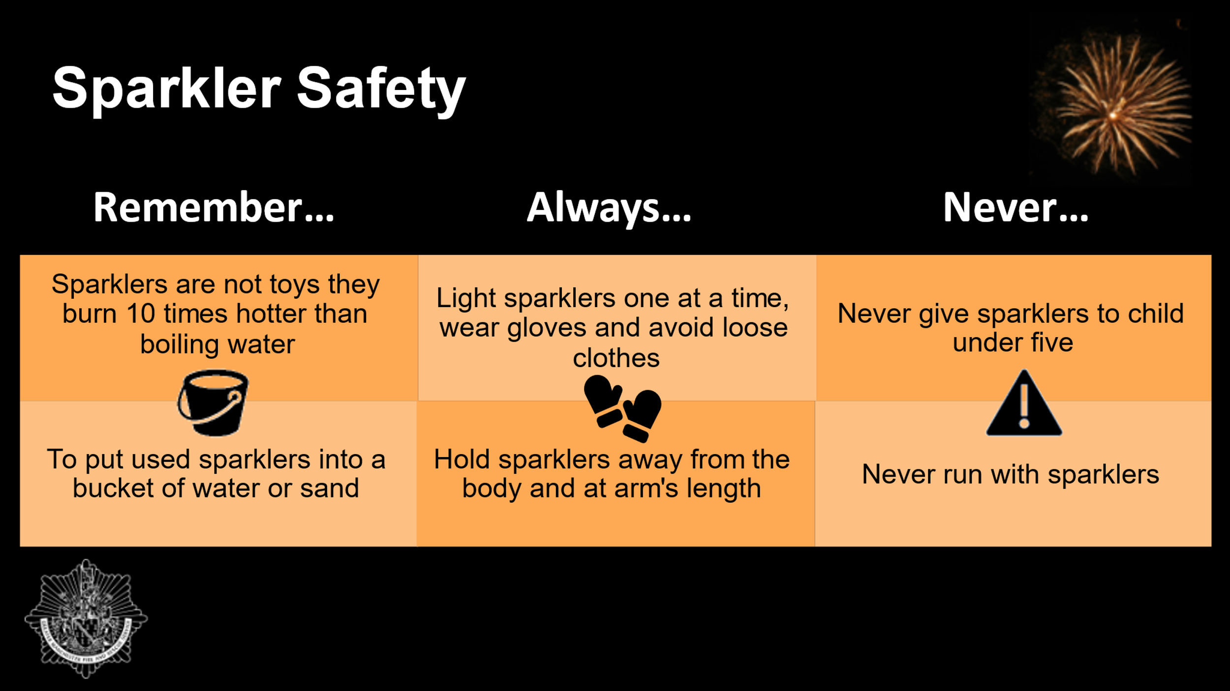  Slide 5  2 minutes | Now, we are going to go through sparkler safety with you.  During the firework season we want you to:  Remember…Sparklers are not toys; they burn 10 times hotter than boiling water  Remember…To put used sparklers into a bucket of water or sand  Always…Light sparklers one at a time, wear gloves and avoid loose clothes  Always…Hold sparklers away from the body and at arm's length  Never give sparklers to child under five  Never run with sparklers  *Depending on time you can ask the audience to repeat each section back to you as a group e.g. Now lets say it together what should you remember this bonfire season… children would answer with remember only adults should light bonfires and repeat the process with always and never.*
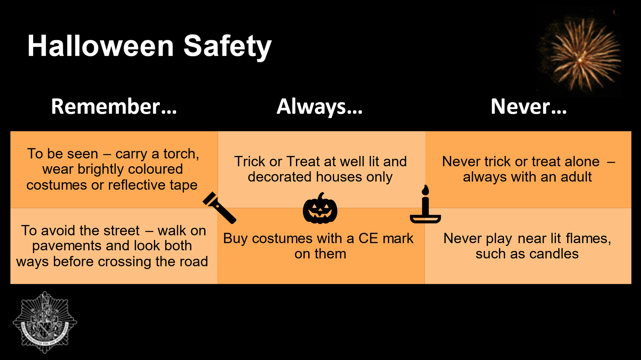  Slide 6  2 minutes | Finally, we are going to go through Halloween safety with you. Ask the audience, who loves trick or treating, do they know what their costumes are going to be yet… etc? Explain that we want them to have an enjoyable time this Halloween but there is some information we want them to remember to keep themselves safe this Halloween.  *Dependent on time you can ask the audience can they think of ways to keep safe during Halloween?  Praise correct answers.*  Remember… To be seen – carry a torch, wear brightly coloured costumes or reflective tape  Remember…. To avoid the street – walk on pavements and look both ways before crossing the road  Always… Trick or Treat at well lit and decorated houses only (some people for example, older people may struggle to come to the door during this night, so we need to be respectful of this).  Always…Look for and buy costumes with a CE mark on them (they are safer)  Never trick or treat alone – always with an adult  Never play near lit flames, such as candles
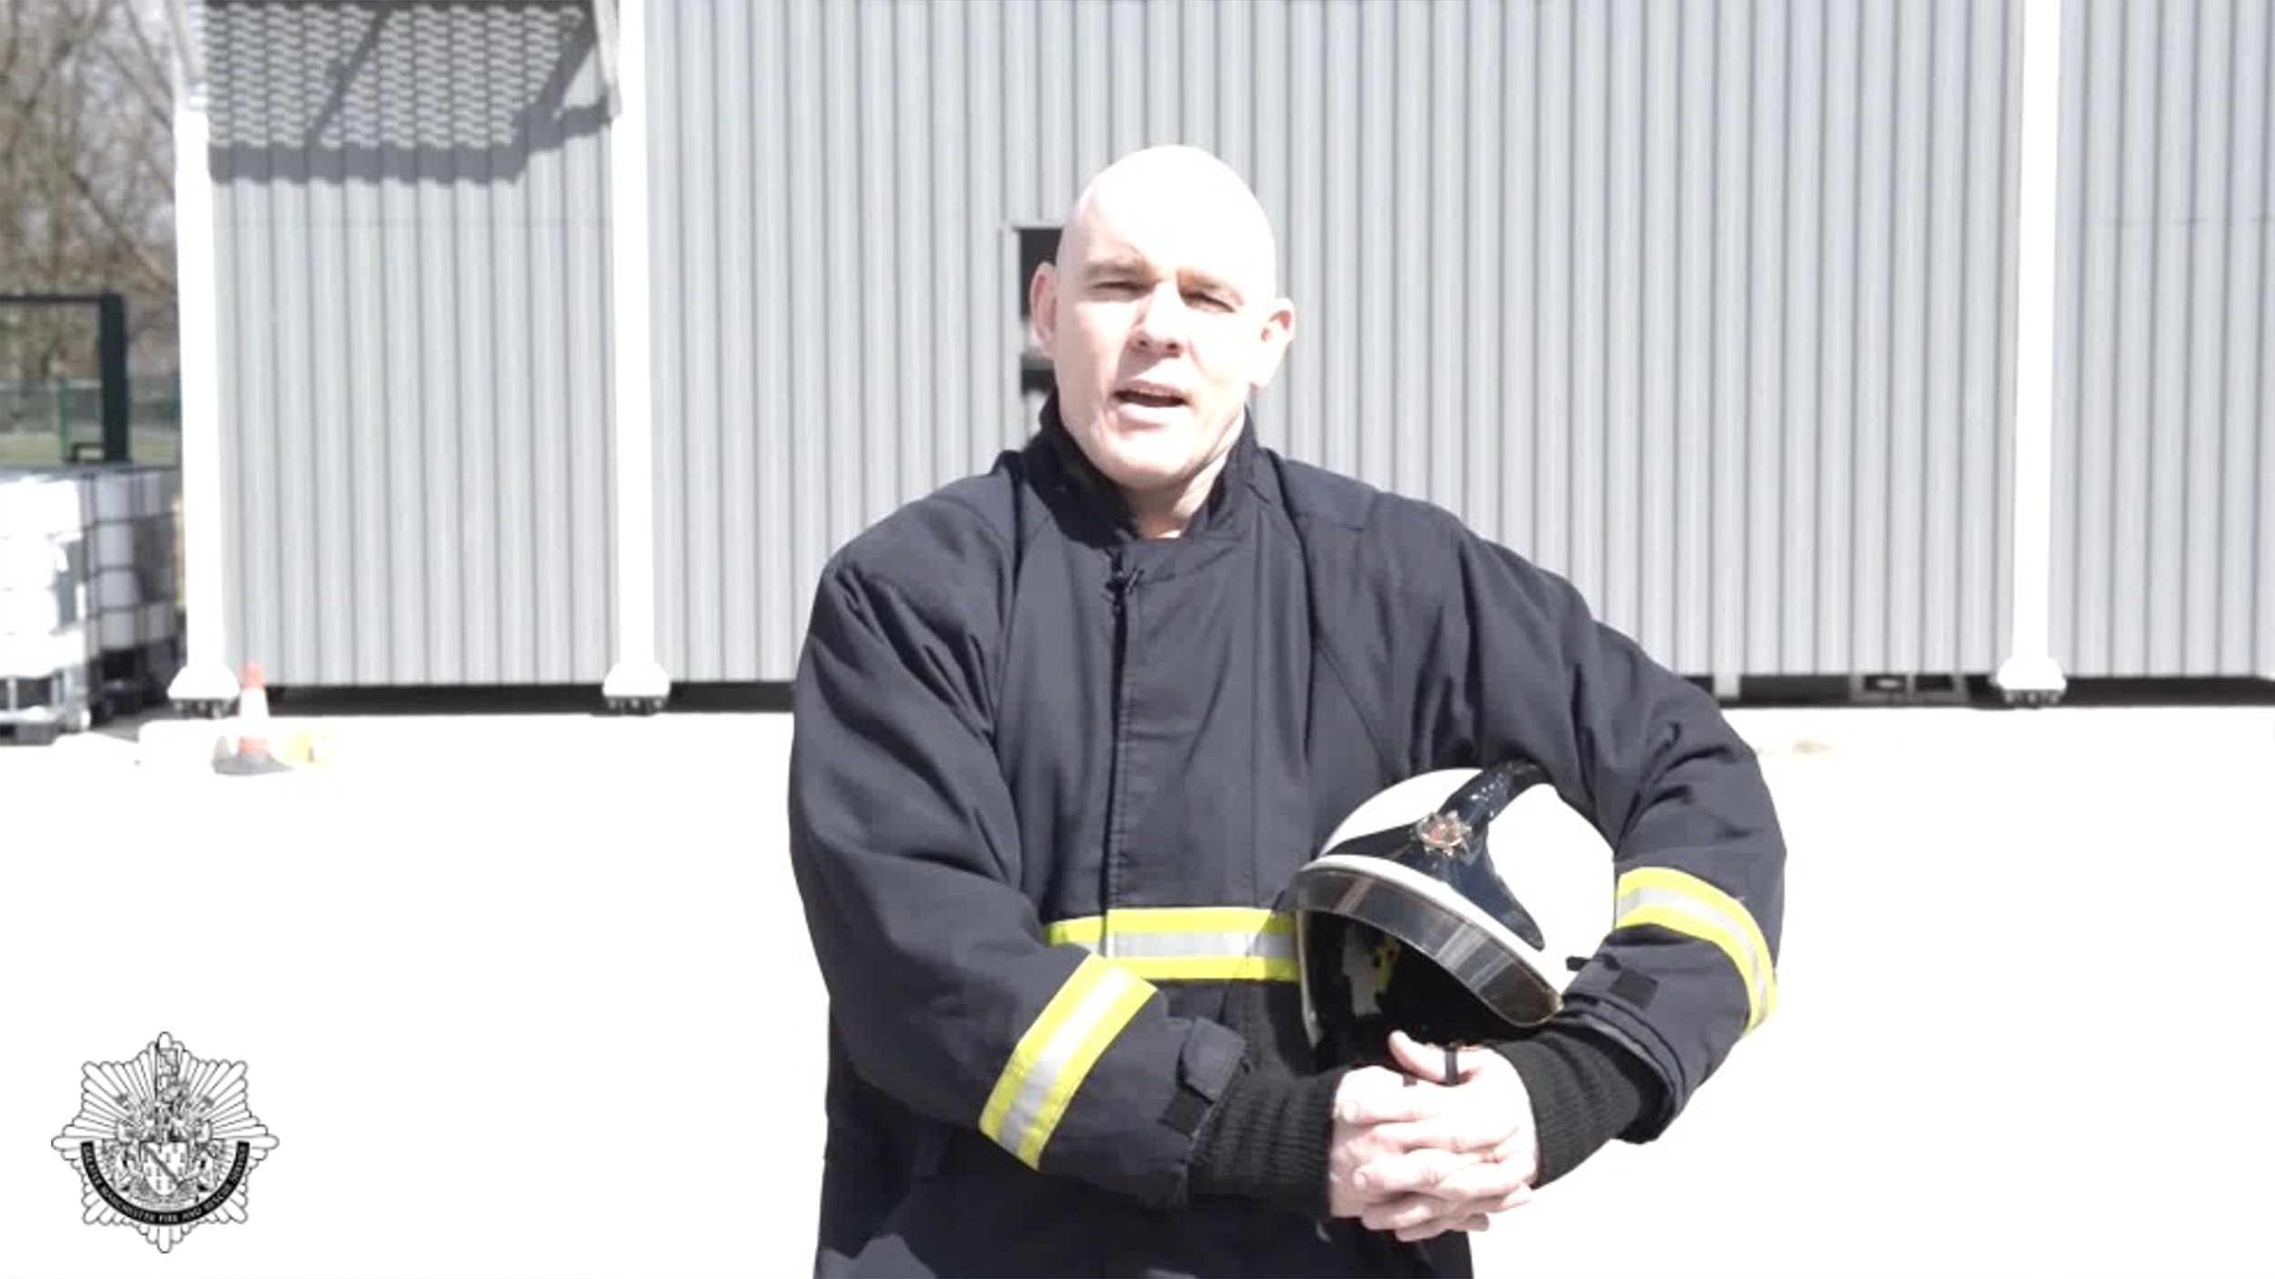  Slide 7  3 minutes | Explain to the audience that this video describes what to do if your clothing catches fire.  To play the video: Hover over the image and a play bar will appear. Click the play button.  You may also want to demonstrate to the group yourself, choose a volunteer from the audience or perform as an entire group – remember children learn best from seeing and then trying it themselves.  If demonstrated you might need a gym mat on the floor.  *Take care, no injuries please!*  STOP – stop what you’re doing and stay very still.  DROP – drop to the floor.  ROLL – roll backwards and forwards until the flames are out.  *If time is short, the three point message is all learners need to remember.*
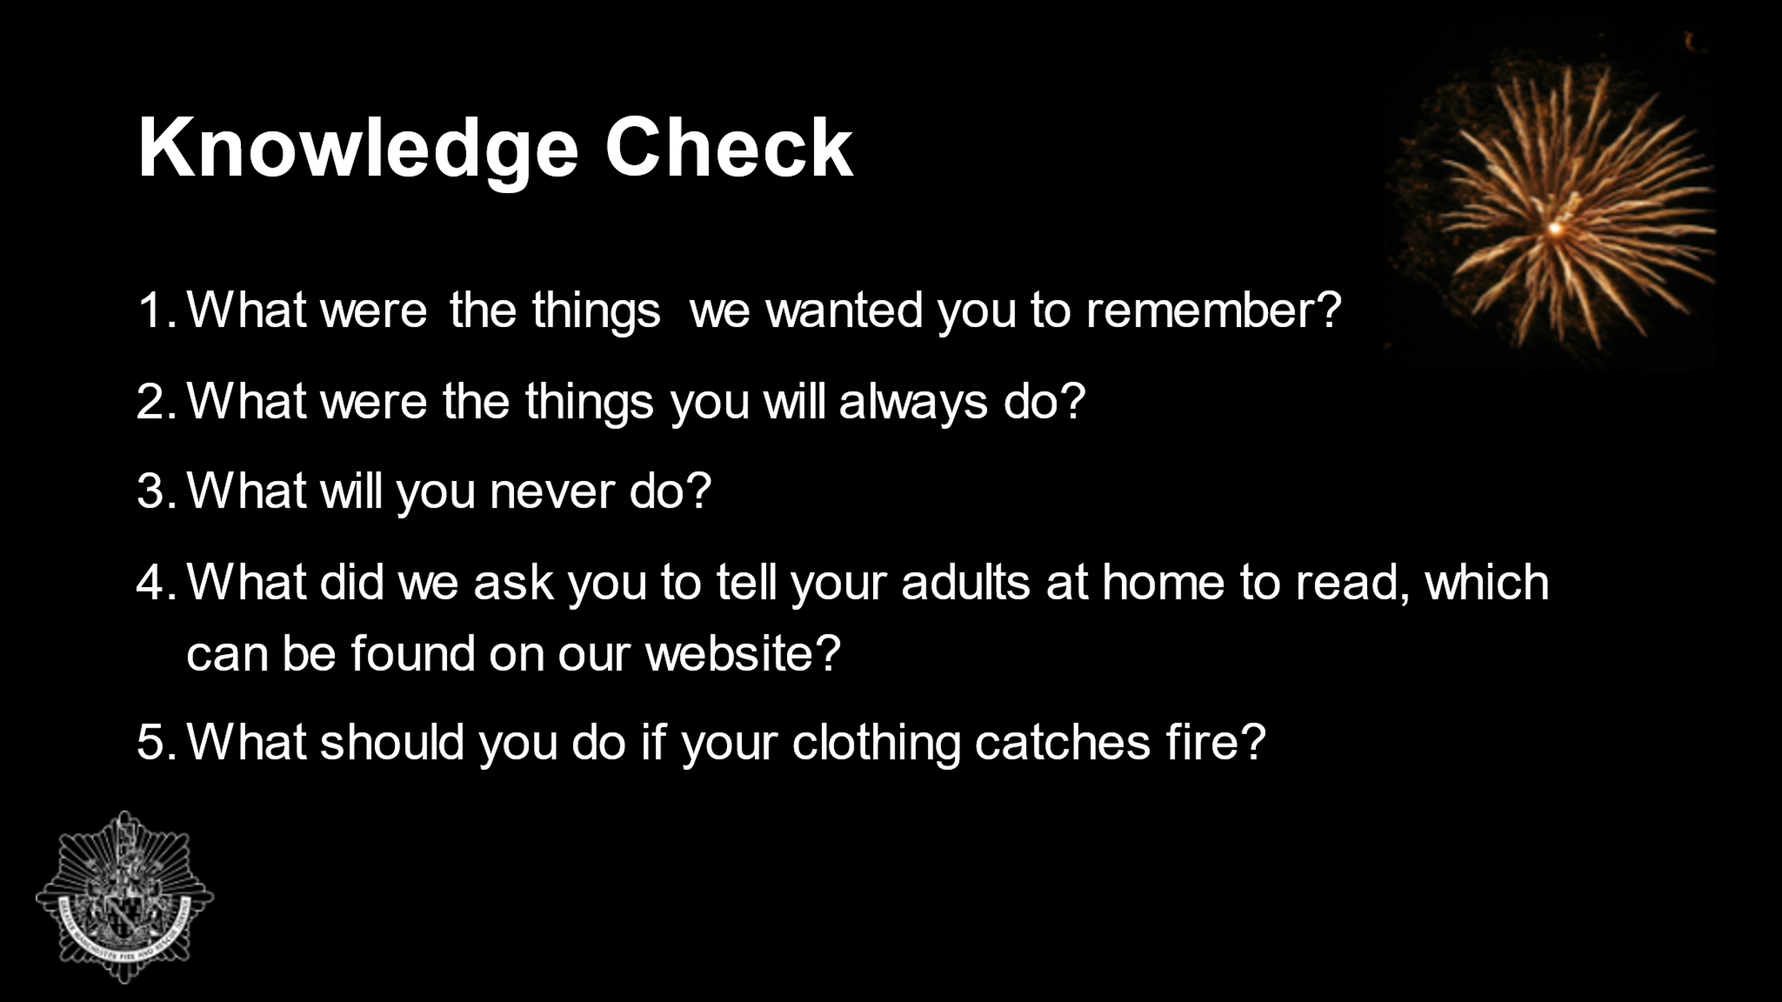  Slide 8 | Dependent on time you can do a little quiz/question and answer to check learning with the audience.  From today’s session:  - What were the things we wanted you to remember?  - What were the things you will always do?  - What will you never do?  - What did we ask you to tell your adults at home to read, which can be found on our website?  - What should you do if your clothing catches fire?  Praise correct answers!*
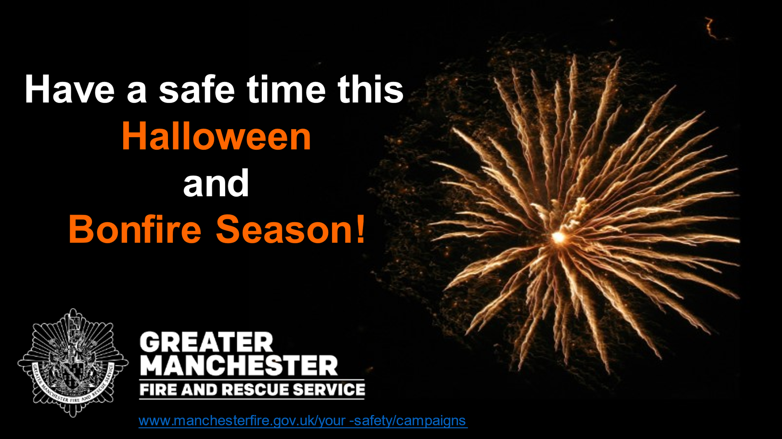  Slide 9  2 minutes | Encourage learners to have a safe time during Halloween and Bonfire season.  Direct the audience to the website – www.manchesterfire.gov.uk/your-safety/campaigns  for more information and where to find their nearest organised event.  Discuss any final thoughts with the audience and ask if they have any questions about what has been discussed.  Thank the children for taking part in the session.

Total Time: 15 minutes

Presenter to inform teachers of our Bury Safety Centre training site, if they are not already aware. To find out more and to book a visit share the website for Bury Safety Centre: https://safetycentre.manchesterfire.gov.uk/

