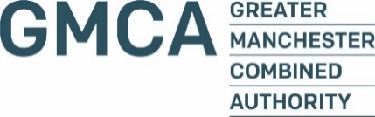

Application for a storage licensed premises to supply adult fireworks all year round in accordance with Regulation 9 of the Firework Regulations 2004
Please complete and return this form to fireworks@manchesterfire.gov.uk or post to:
Greater Manchester Fire and Rescue Service HQ
Fireworks Administration
146 Bolton Road
Swinton
Manchester
M27 8US

Applicant details
Applicant name:
Email address:
Phone number:
Applicants home address:
Applicants registered address (if applying as a limited company)
Shop name:
Shop address:
Post Code:
Trading name and address if different from shop:
Have your or your company been convicted of any offence/s under Health & Safety Legislation or in relation to the sale / supply of fireworks?
If yes, please give details:
Have your or your company been convicted of any offence/s under the Explosives Act 1875 or in relation to the manufacture, sale / supply of gunpowder?
If yes, please give details:

Explosives Storage Licence
You must have a storage licence in place before applying to sell all year round
Storage licence number:
Storage licence expiry date:
Current All Year Licence number (if a renewal):
All Year Licence Expiry date:

Payment Details
The Licence fee is £500, you can make the payment two ways

BACS
Greater Manchester Combined Authority, Barclays Bank Plc, 51 Mosley Street, Manchester, M2 3HQ
Sort code: 20 55 58
Account: 50718718
Please put your shop name and ‘AYF’ as the reference

Worldpay
If you wish to pay by card then please confirm the email address you wish to us to send the link to below

New applications
Any new applicants must wait until the application has been processed and approved. We will then contact you to ask for payment.
BACS receipt No:
This is a new application, so payment is not yet required:
Please confirm email address you wish the card payment link to be sent to:
Signature:
Date:

