#CookSafe Partner Toolkit
Communications messaging and assets for Greater Manchester Fire and Rescue Service (GMFRS) CookSafe campaign. For use from February 2021 to June 2021.
The main aim of the Cook Safe campaign is to provide information about cooking and kitchen fire safety for residents, focusing on four key messages:
- Never leave cooking unattended
- Keep electrical leads, tea towels and cloths away from the cooker
- Any type of pan can catch fire
- More than half of accidental fires in the home start in the kitchen

Images
Assets featured in the suggested posts below can be downloaded from:
Website: https://www.manchesterfire/what-we-do/cooksafe
They are grouped by size for Twitter, Facebook, and Instagram.

Accessibility
Please ensure that all images posted on social media make use of the 'alt text' function and duplicate any words that appear in a graphic so the same information is accessible to those using screen readers. You should also describe any imagery that appears within this description.
You can find further guidance and how to do this for different platforms below and for further advice on writing image descriptions, see here: https://www.rnib.org.uk/rnibconnect/technology/making-your-social-media-accessible

Image preview | Copy | Image Title
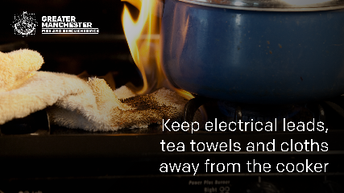 | We all need to take care when cooking  🥘 Never leave cooking unattended  🎛 Try to keep any loose clothing like scarves and sleeves tied back  ✅Keep electrical leads, tea towels and cloths away from the cooker  Find out more cooking safety tips👉https://bit.ly/3cNYQES  #CookSafe | Fabric_Fire
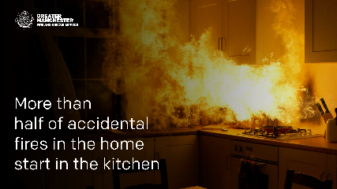 | Most accidental fires start in the kitchen, so take care & never leave cooking unattended  🔥If your pan does catch fire -don't panic! Leave the kitchen, close the door behind you, get everyone out of the house &call 999  For more advice visit https://bit.ly/3cNYQES  #CookSafe | Kitchen_Fire
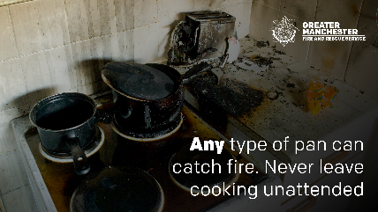 | Any type of pan can catch fire  ⚠️Never fill a pan to more than one-third full of fat or oil  ✅Ensure food is dry before putting it in hot oil so it doesn’t splash  ⚠️If the oil starts to smoke –Turn off the heat and leave it to cool  Learn more👉https://bit.ly/3cNYQES #CookSafe | Pan_Fire
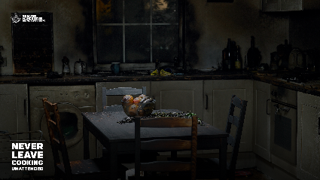 | Getting ready to cook up a delicious meal? #CookSafe  🥘 Never leave cooking unattended  🎛 Never leave children alone near cooking  🍳 Keep saucepan handles out of reach  Read more cooking safety tips visit https://bit.ly/3cNYQES | Burnt_Kitchen

