Overview of the Safe4Winter Secondary School PowerPoint Presentation and how to use it

There are several options for using this presentation. Ideally you would have up to one hour with the students and can do the full session looking at the main Safe4Winter message of educating and warning people of the dangers of ice and open water during winter. However you may have less time than this and the school may only allow you a presentation in a short assembly. Therefore you may wish to tailor the presentation to suit the issues linked with the school and local area.

Limited time at the school……… how to decide on which sections to present

If you have limited time with the students you should look into local issues and see if one of the key Safe4Winter themes is more of an issue than another.
Here are the timings for the presentation which will help your planning:-
- Home safety / seasonal messages: 20 mins
- Ice safety and cold water shock: 20 mins
- Ice safety film: 5 mins
- Ice safety film discussion: 15 mins

How to tailor the session

You can ‘hide slide’ on the PowerPoint when the PowerPoint presentation is in ‘Normal’ view. Right mouse click on the slide you want to hide and choose ‘hide slide’. Hiding slides is a good option instead of clicking through slides saying ‘we won’t cover this today’ which might make the students or teachers feel they are missing out. It looks professional also.

Presenter aim of this session
In this session delegates will:

- Gain an understanding of fire dangers within the home and seasonal fire safety
- Gain an understanding of the dangers of playing on open water in winter months
- Gain an understanding of what cold water shock is
- Be aware of what they can do to check in on older relatives or friends

Course Preparation
Test/check
Check that PowerPoint slides and embedded or hyperlinked videos are working before you go to deliver the training.

Bring with you
Download the entire presentation onto the desktop on your GETAC tablet (or on a pen drive, though many schools no longer allow this), as this will be used offline and you will not have access to the GMFRS network. The school resources are also available to download from the toolkit page on www.safe4winter.com

Optional = Photocopies for delegates of: Slideshow handout. Photocopies for presenter: trainer notes
(Laptop, screen, projector and speakers possibly – check with venue).

Time | Trainer Notes | Resources
Slide 1  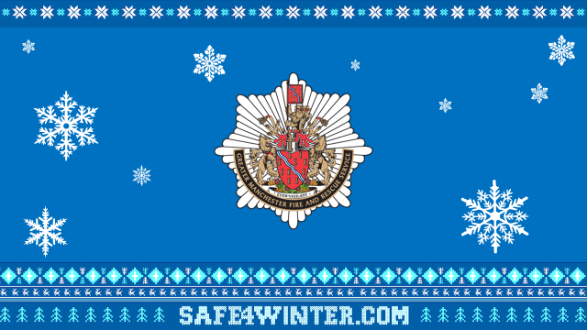 | Presenter to introduce themselves and their role, where they work. | PowerPoint
Slide 2  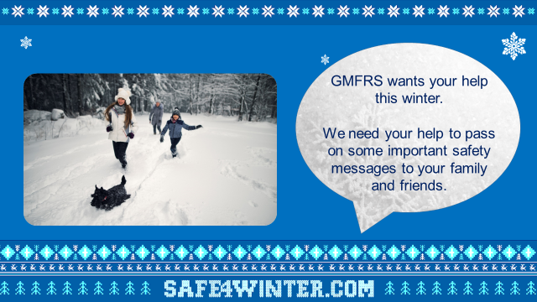 | Greater Manchester Fire & Rescue Service wants your help this winter.  We need your help to pass on some important safety messages to your family and friends.  Today you will:  - Gain an understanding of fire dangers within the home and seasonal fire safety  - Gain an understanding of the dangers of playing on open water in winter months  - Gain an understanding of what cold water shock is  - Be aware of what they can do to check in on older relatives or friends
Slide 3  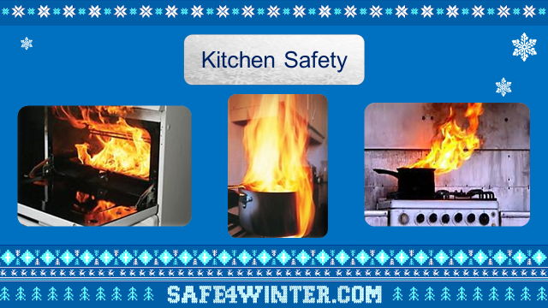 | Kitchen Safety  Most fires start in the kitchen. Never leave cooking unattended.  - Keep electrical leads, tea towels and cloths away from your cooker  - Keep your oven, hob and grill clean. A build up of fat and grease can easily catch fire  - Don't put anything metallic, such as cutlery or tin cans inside the microwave  - Never put a sponge or dishcloth in the microwave  - Keep electrical leads and appliances away from water  - Check the toaster is clean and away from curtains and kitchen rolls, pull out when using if under kitchen cupboards.  - Turn off electrical appliances when they are not being used  - Never fill a pan more than one-third full of oil. If the oil starts to smoke, it's too hot - turn off the heat and leave it to cool down  - Swap your chip pan for an electric deep fat fryer - thermostatically controlled electrical deep fat fryers that plug into the wall are much safer to use  If a fire starts in the kitchen:  - Don’t panic and don't take risks  - Don't move the pan and don’t tackle the fire yourself  - Never throw water or use a water fire extinguisher on a hot fat fire  - Leave the kitchen, close the door behind you, tell everyone else in the home to get out and don't go back inside for any reason  - Call 999
Slide 4  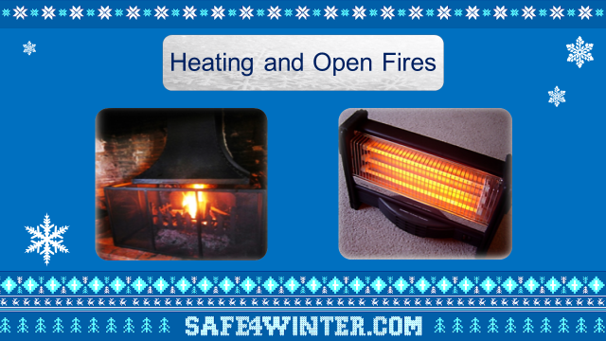 | Heating & Open Fires  - Be careful when using open fires to keep warm.  - Always use a fireguard when using open fires, to protect from flying sparks and hot embers.  - Always unplug electric heaters when you go out or go to bed and make sure that fires are out.  - Do not sit too close to fires or heaters- your clothing or hair could catch fire. 1 metre (3 feet) away at least (may need to demonstrate the distance of this).  - Keep heaters away from curtains and furniture.  - Don’t place wet or dry clothing over or too close to any heater or fire.  Question: Ask the learners do they know what to do if their clothing or hair catches fire?  Answer: Stop, Drop and Roll – demonstrate for learners.
Slide 5 | Electrical Safety  Ask learners do they already know some electrical fire safety?  Built on their answers and go through the following points.  - Make sure mobile phones are fully charge when going to bed but never leave them on charge overnight.  - When charging mobile phones make sure they are on an appropriate surface such as a side table not bed linens for example under a pillow.  - Don’t use mobile phones whilst on charge.  - Use the correct chargers in line with the manufacturer’s guidance.  - Don’t use any damaged or faulty electrical wires and/or devices.  - Never leave other appliances, such as laptops, games consoles and TVs, on charge or standby while at asleep or at school as left for a long period of time, they can overheat and cause a fire.  - When using laptops make sure them are placed on an appropriate surface such as a desk or table and not on furniture or bedding and that the vents are not covered.  - Every plug has an amp usage on it, never exceed (go over) 13 amps when using extension leads.  - Only use the long straight extension leads not cube adaptors.  - Never turn light switches on or off with wet hands.  - Never leave hair straighteners, hair dryers or curling tongs switched on and unattended.  - Never wrap cables around warm appliances such as hair straighteners.  - Make sure hair straighteners, hair dryers and curling tongs are placed on appropriate surfaces or heat mats and not bed linens.  - Don’t place drinks or liquids close to electrical appliances.
Slide 6  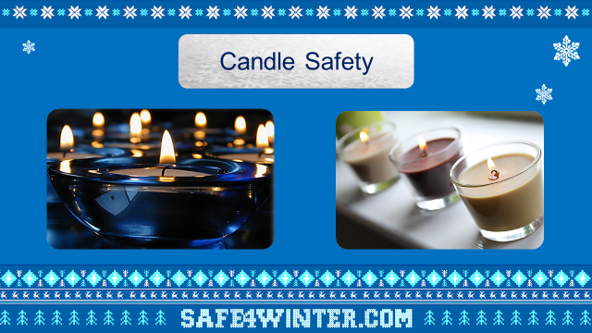 | Candle Safety  - Always keep a burning candle within sight and put them out before you leave the room, go to bed or leave the house.  - Keep candles away from anything that could catch fire, such as curtains and other materials that can easily catch fire.  - Don’t let your clothing come into contact with naked flames. People have been badly injured by loose clothing catching fire.  - Burn candles out of reach from young children and pets.  - Always make sure candles are in a suitable/proper candle holder.
Slide 7  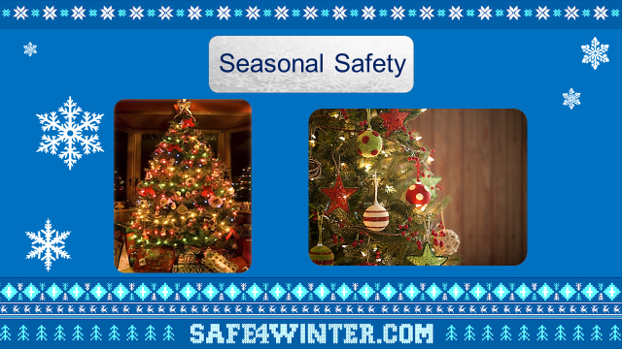 | Seasonal Safety (to be used during December at relevant secondary schools only)  - Check your seasonal electrical decorations, including lights, are in good condition and have a British Safety Standard sign.  - Christmas trees, decorations or materials can burn easily so keep them away from fires, heaters and candles that can catch light.  - Never overload electrical sockets (13 amp rule, do not exceed 13 amps per extension lead – each plug will have an amp usage on it).  - Always switch Christmas lights off and unplug them before you go to bed or leave the house.  - Dispose of wrapping paper and boxes safely and don’t put them near to a naked flame, such as a fire or candle.  Christmas is going to be a bit different this time so take time to check on any elderly relatives and neighbours this Christmas, as they are at greater risk from fire but make sure you do this safely following the government guidelines.
Slide 8  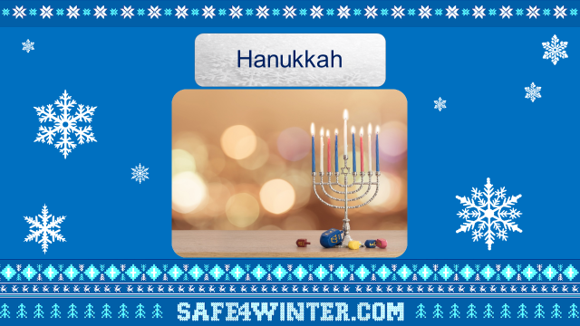 | (To be used in appropriate Jewish Schools only) - can hide the slide by right clicking on it and selecting hide slide option.  Hanukkah  If you are celebrating Hanukkah this year there are a few simple steps that you can take to keep you and your family safe:  - Ensure candles and oils are placed firmly in the menorah on a flat, heat resistant surface.  - Keep the menorah away from flammable material including curtains and furniture.  - Ensure there is at least three feet between the menorah and any surface above it.  - Never move the menorah when lit and don’t leave it unattended.  - Keep the menorah out of reach of young children.  - Ensure you have a working smoke alarm on each level of your home.  - Only use suitable glass or metal containers to burn candles or oil in.
Slide 9  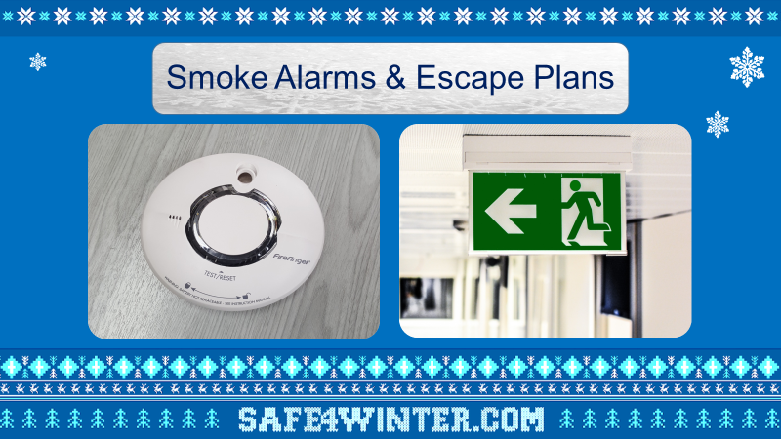 | Smoke Alarms & Escape plans  Today we would also like to remind you to check you have working smoke alarms.  Smoke alarms are very important and every home should have them. They detect smoke and alert you if there is a fire in your home so you can escape safely.  You can use questions to engage the learners interest, such as asking who has a smoke alarm and how often do they think they should test it?  Always test your smoke alarms weekly!  You can do this by pressing the button, if they are working, they will make a loud bleeping noise.  If you can’t reach, ask an adult to do it or you can use other household items such as a brush to reach and press the button.  Leave contact cards with the teacher to hand out to the learners at the end of the session, and let the learners know that if they don’t have smoke alarms at home or their family hasn’t made an escape plan they should give the card to their parents or carers.  You should also discuss what the learners think they should do if there was a fire in the home?  Explain that is important that families stick together if there is a fire and that they leave the home through their nearest exist.  Remember not to block escape routes with Christmas trees, presents or rubbish and everyone should know where the door keys are.  Explain once you get outside, you should never go back in and that it is from outside (or somewhere safe) that you should call 999.  This is an opportunity to discuss some of the reasons that people think that they might go back inside, so that you can highlight how important it is that they don’t (e.g. to rescue pets) let the learners know how quickly fire can spread throughout the home so the importance of getting out quickly and safely. However, you should also reassure learners of our response times and how quickly that a fire engine will get to a fire.  You can further emphasise how much training, experience and equipment you all have along with why is it not safe to go back inside.  Discuss making sure your family and visitors know how to escape in an emergency.  Remember test the batteries in your smoke alarm every week. Never remove them.  Re-empathise: Get Out, Stay Out, Call 999.  Dependent on time: Discuss why you should crawl if there is smoke in a room, asking questions to help the learners to understand e.g. which direction does smoke travel in?  Explain how to check whether it is safe to go through a closed door – highlight the importance of closing doors before bed or even when everybody goes out.  Discuss what to do if you can’t get to your usual exit: stay together, get to a safe room (one with window), close the door and block the gaps around the door, get to the window, and shout for fire help as well as calling 999 – reassure learners of our response times.**
Slide 10  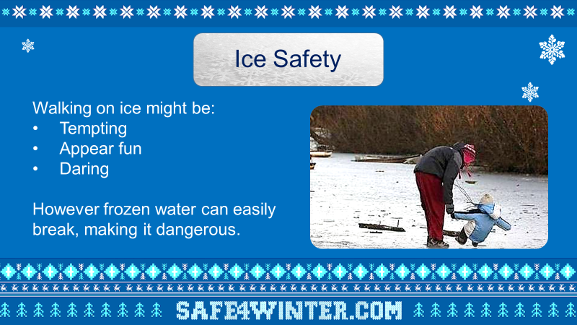 | Ice safety  Question: Ask the learners why some people might try to walk on frozen water?  Some answers may include:  - Tempting  - Appear fun  - Daring (might feel pressurised by friends)  After the group have fed back, close by revealing the last sentence on the slide:  However, frozen water can easily break, making it dangerous.
Slide 11  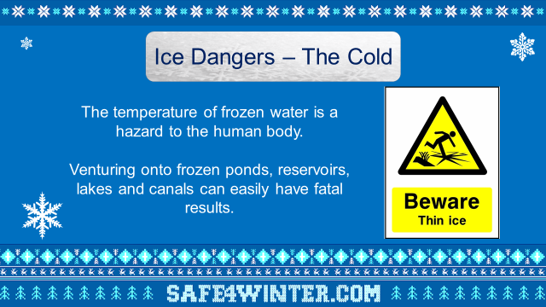 | Ice dangers – the cold  Explain to learners that if they fall into frozen or extremely cold water the temperature is a hazard to the human body.  Question: Where would you find water near to your home that in winter could freeze and turn to ice?  Answer: (canals, rivers, reservoirs, lakes even ponds).  Venturing onto frozen ponds, reservoirs, lakes and canals can easily have fatal results, which means sometimes people die.
Slide 12  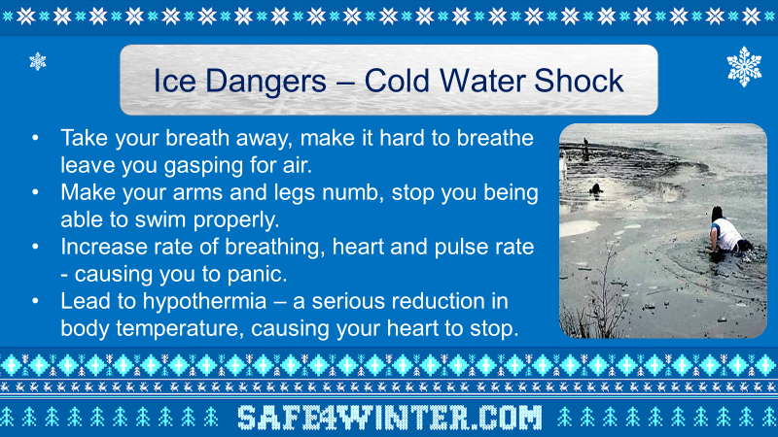 | Ice dangers – cold water shock  I want you to imagine now placing your hands into a bucket of icy water, what would that feel like?  Gather some answers and then explain that immersion or sudden exposure of your head and body to cold water can cause a number of involuntary (not in your control) body reactions.  Question: Ask the learners what they think cold water shock may do to their body.  Answers:  - take your breath away, making it hard to breathe and leave you gasping for air.  - make your arms and legs numb, which means you cannot control them or swim properly.  - Increase your rate of breathing and increase your heart rate and pulse – causing you to panic.  - lead to hyperthermia – this is a serious reduction in body temperature where it drops too low, which can be fatal as it can cause your heart to stop.
Slide 13  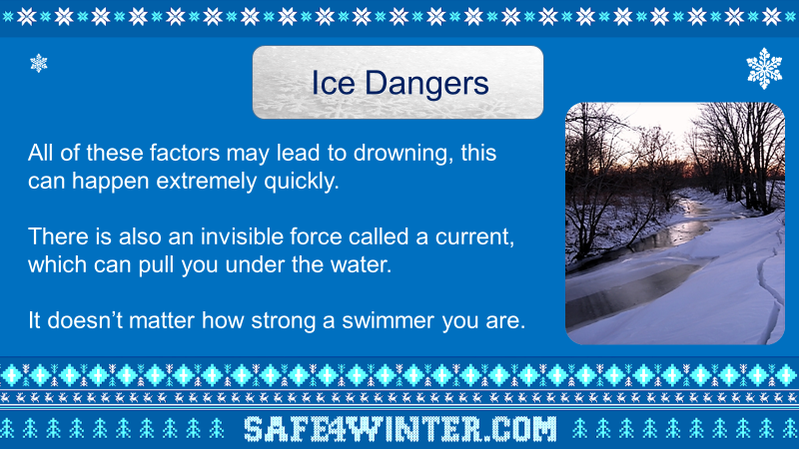 | All the factors above may lead to drowning and this can happen extremely quickly.  There is also an invisible force which can pull you under the water, it is called a Current. It doesn’t matter how strong a swimmer you are; these currents can be very strong, even stronger than you!  So remember if you go on ice and it breaks, these currents can pull you under the water and you can drown.  It is very important to stay Safe whilst outdoors during the winter.
Slide 14  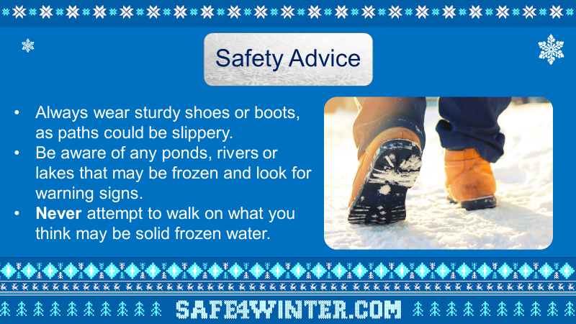 | Safety advice  This slide offers some safety advice for learners who are out and about during the winter months.  - Always wear sturdy shoes or boots as paths could be slippery.  - Be aware of any ponds, rivers or lakes that may be frozen and look out for warning signs for frozen water.  - NEVER attempt to walk on what you think may be frozen water.
Slide 15  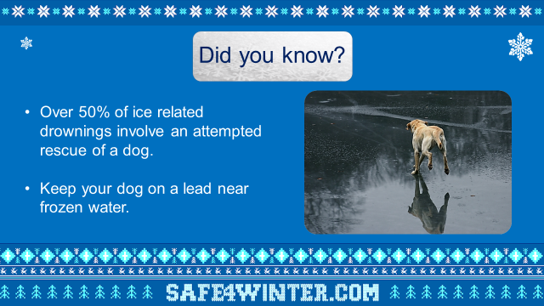 | Did you know? – (Ice facts)  About 50% of ice related drownings involves an attempted rescue of a dog.  It must be very upsetting to see your dog in trouble, but it is really important not to put yourself in danger. Keep your dog on a lead near frozen water.  Just because the ice is strong enough the hold the weight of your dog doesn’t mean it will be strong enough to hold you.
Slide 16  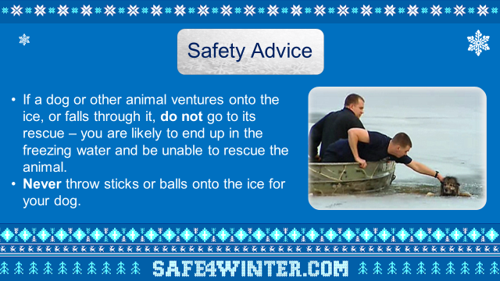 | Safety advice  If a dog or other animal ventures onto the ice, or falls through it, do NOT go to its rescue – you are likely to end up in the freezing water and unable to rescue the animal.  If your dog does get into trouble on the ice call 999 and stay on the bank, wait for the emergency services. Dogs often manage to rescue themselves.  NEVER throw sticks or balls onto the ice for your dog
Slide 17  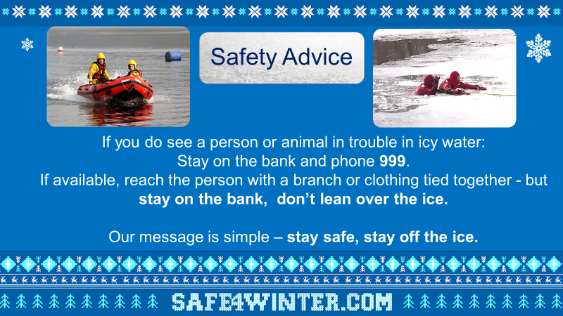 | Safety advice  If you do see a person in trouble in icy water:  - Stay on the bank and phone 999  - If available, reach the person with a branch or clothing tied together but STAY ON THE BANK and don’t lean over the ice.  The Fire Service has special equipment to make sure they can keep themselves safe and rescue a person or animal in trouble in a safe way.  It is important you stay off the ice and ring the Fire Service on 999 immediately - We have 2 specialist water rescue units in Greater Manchester which will come out to you.  Our message is simple - Stay safe, stay off the ice!
Slide 18  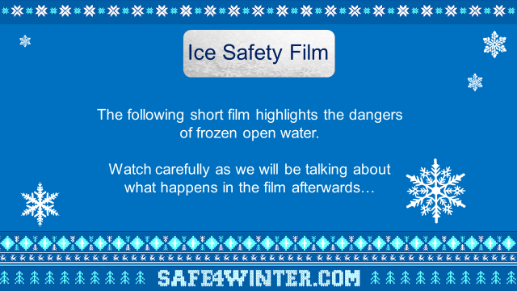 | Ice Safety Film  The following film highlights the dangers of frozen open water.  Watch carefully as we will be talking about what happens in the film afterwards…  Prior to showing the film please state the following:  “The film you are about to see shows just how lethal venturing onto ice can be. Some of you may find the film quite shocking or upsetting. We will talk about the film afterwards, and you should speak to your teacher later if you feel the need to”
Slide 19 | Discussion Guide for “Icebreaker”  • Show the film - 5 mins  • Discussion - 15 mins  Pre-video ask the following questions (for audience to think about whilst watching the film.)  • What effect did Jasmine’s snowball have on Dean?  • Think about all the character actions after this  • Are there any positive actions in this short film?  Discussion  Why did Jasmine go on the ice?  • To retrieve her handbag that Dean had thrown  Why did Dean throw Jasmine’s bag?  • Flirting  • Adrenalin  • Reaction to snowball  • Showing off  What could Dean have done differently?  • Held her back  • Warned of the danger  • Not run away  • Phoned 999  • Thrown a snowball and not the handbag  Jasmine – what would you have liked to say to her to stop her taking the fatal risk she did?  Dean – what would you have liked to say to him to change what happened?  Lydia – is there anything she could have done to keep her friend safe?  What are the dangers and consequences of going into frozen waters?  - Coldness of the water means the body can’t function normally. In very cold water our blood flow changes in an attempt to keep our vital organs (heart, lungs, kidneys, brain, liver etc.) warm.  - This can cause cramp in our muscles and result in heart problems in seconds. As a result panic causes the body to inhale water, flooding the lungs. At this point even strong swimmers are in serious danger of drowning.  - Underwater currents may drag you away from the broken surface ice above. You may then become unable to resurface above the water.  - You may puncture your body or become trapped in discarded debris in the water that people have dumped i.e. a shopping trolley, bicycle etc.  “As you saw in the film, these reactions happen in just a few seconds.”  “You can never judge whether ice can hold your weight”  The following are all factors that can affect the thickness of Ice. Are you an expert able to assess this?  • Type of water  • The depth of the water  • Size of the body of water  • Currents or water flow  • Chemicals  • Logs, rocks, surface debris  • Change in air temperature  After watching the film – is there a message you would give to your friends about staying safe around ice?  To reaffirm:  Never walk on the ice for any reason, whether it be for personal belongings, pets, a dare or any other reason.
Slide 20  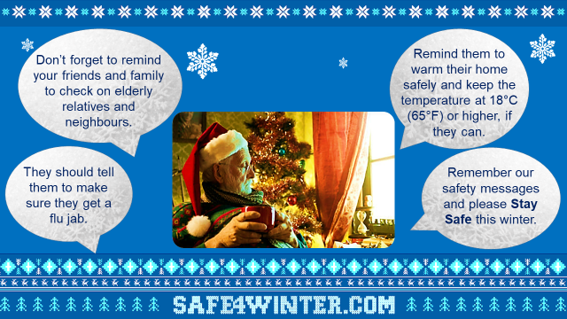 | Don’t forget to pass on these key messages to your family and friends this winter. This might be more difficult to do this year, you can pass on these messages face to face with people in your bubble, otherwise make sure you are following the government guidelines for social distancing 2 metres away or you can do this over the telephone to anyone who is not in your bubble such as elderly relatives or neighbours that might be self-isolating.  They should tell them to make sure they get a flu jab.  They should also remind them to warm their home safely and keep the temperature at 18®C (65®F) or higher if they can.  Please pass on these messages adhering to government guidelines.
Slide 21 | Direct learners to our safe4winter website for more information.  https://manchesterfire.gov.uk/staying-safe/safe4winter/  Direct learners to our Facebook and Twitter page.  Please take care and stay safe this winter.

*Presenter to inform teachers of our Bury Safety Centre training site, if they are not already aware. To find out more and to book a visit share the website for Bury Safety Centre: https://safetycentre.manchesterfire.gov.uk/*
*Please note Bury Safety Centre are not currently taking school visits due to COVID-19 but please still pass on the information for teachers and schools to consider a visit in the hopeful near future*

