Overview of the Safe4Winter Primary School PowerPoint Presentation and how to use it

This presentation is designed to be delivered as an additional resource to the universal GMFRS Key Stage 2 presentation. Ideally you would have 20 minutes available with the students in order to deliver this presentation allowing you to fully address the main Safe4Winter message of educating and warning children and young people of the dangers of ice and open water during winter. However you may have less time than this depending upon the limitations of each Primary school. Therefore you may wish to tailor the presentation to suit the issues linked with the school and local area.

How to tailor the session

You can ‘hide slide’ on the PowerPoint when the PowerPoint presentation is in ‘Normal’ view. Right mouse click on the slide you want to hide and choose ‘hide slide’. Hiding slides is a good option instead of clicking through slides saying ‘we won’t cover this today’ which might make the students or teachers feel they are missing out. It looks professional also.

Presenter aim of this session

In this session delegates will:

- Be encouraged to help pass on important safety messages to friends and family
- Gain an understanding of the dangers of playing around open water in winter months
- The consequences of playing on ice/open water

Course Preparation
Test/check
Check that PowerPoint slides and embedded or hyperlinked videos are working before you go to deliver the training.

Bring with you

Download the entire presentation onto the desktop on your GETAC tablet (or on a pen drive, though many schools no longer allow this), as this will be used offline and you will not have access to the GMFRS network. The school resources are also available to download from the toolkit page on www.safe4winter.com

Optional = Photocopies for delegates of: Slideshow handout. Photocopies for presenter: trainer notes
(Laptop, screen, projector and speakers possibly – check with venue).

Time | Trainer Notes | Resources
Slide 1  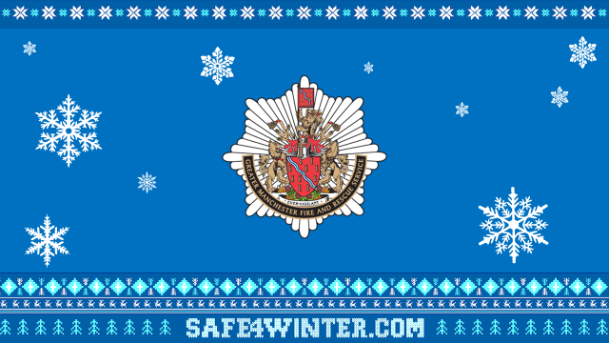 | Presenter to introduce themselves and their role, where they work. | PowerPoint
Slide 2  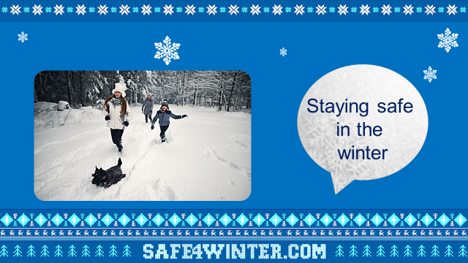 | We will today talk about Staying Safe in the Winter.  - You will gain an understanding of the dangers of playing around open water in winter months.  - The consequences of playing on ice/open water.  - The dangers of sitting too close to fires and heaters and what to do if your clothing catches fire.  - Be encouraged to test your smoke alarms weekly and to help pass on important safety messages to friends and family. | PowerPoint
Slide 3  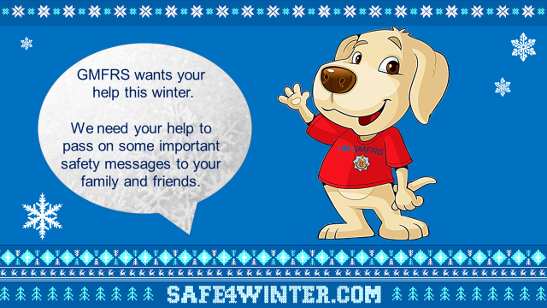 | Greater Manchester Fire & Rescue Service wants your help this winter.  We need your help to pass on some important safety messages to your friends and family, so please listen carefully.  This might be more difficult to do this year, you can pass on these messages face to face with people in your bubble, otherwise make sure you are following the government guidelines for social distancing 2 metres away or you can do this over the telephone to anyone who is not in your bubble. | PowerPoint
Slide 4  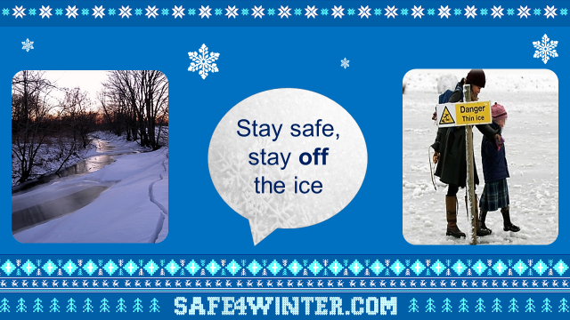 | Swimming in open water is dangerous and this time of year the water can freeze. You may think it is ok to play or walk on frozen water but the ice can easily break- Never go in to open water or on frozen water.  Question: Has anyone seen cartoons or films of people skating on frozen water?  Reply: Remember it is not real; it is not safe and it is very dangerous! We will tell you why shortly.  Question: What is wrong with the picture of the mum and daughter out walking?  Answer: They have either ignored or not noticed the sign to warn them of the dangers of thin ice – always take the time to read any signs and take in your surroundings when walking this is very important.  Question: What might happen walking on the ice?  Answer: Your weight may make it break when walking on the ice and you will fall into the cold water.  Question: Where would you find water near to your home that in winter could freeze and turn to ice? (think walks with your family or in back gardens as well).  Answer: (canals, rivers, reservoirs, lakes even ponds).  Even if the ice appears thick, it becomes thinner in places and your weight may make it break.  The coldness can make your legs and arms numb meaning you cannot swim and if your body temperature drops too low this will cause your heart to stop.  The coldness will also take your breath away which will lead you to panic and drown.  There is an invisible force which can pull you under the water, it is called a Current. It doesn’t matter how strong a swimmer you are; these currents can be very strong, even stronger than you!  So remember if you go on ice and it breaks, these currents can pull you under the water and you can drown.  It is very important to stay Safe whilst outdoors during the winter. | PowerPoint
Slide 5  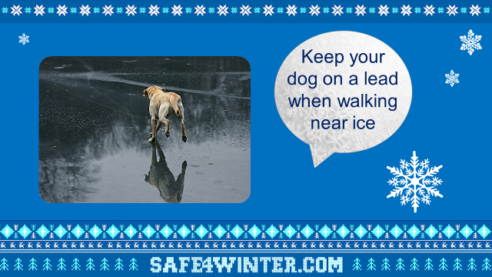 | If a dog or other animal walks onto the ice or falls through it, Never try to rescue the animal - you may end up in the freezing water as well and unable to help. Animals are often able to self-rescue.  Never throw sticks or balls onto the ice or cold open water for your dog.  If you are out with an adult walking a dog near frozen water, tell them to keep the dog on a lead!  Always wear shoes or boots that stop you from slipping.  Never try and walk on what you think is frozen water. | PowerPoint
Slide 6  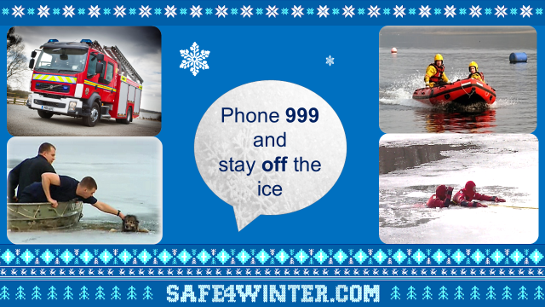 | If you do see a person or animal in trouble in icy water, stay on the bank and phone 999 or shout for help and ask an adult to ring 999.  Do not attempt to rescue them; you are more than likely to end up falling into the frozen water too.  The Fire Service has special equipment to make sure they can keep themselves safe and rescue a person or animal in trouble in a safe way.  It is important you stay off the ice and ring the Fire Service on 999 immediately - We have 2 specialist water rescue units in Greater Manchester which will come out to you. | PowerPoint
Slide 7  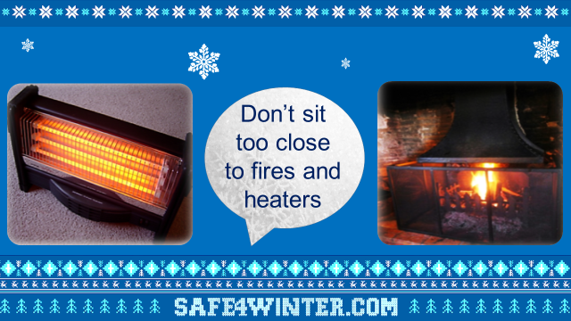 | Something else we would like to talk to you today is fires and heaters.  During the winter months it can get very cold but please don’t sit too close to fires or heaters - your clothing or hair could catch fire.  Sit at least 1 metre (3 feet) away (show the children this distance).  Use a fireguard, particularly in homes with open fires.  Make sure that fires are out or switched off before going  to bed or leaving your home.  Keep heaters away from curtains and furniture.  Never use heaters for drying clothes.  **If time allows you can also briefly mention other ways to keep the home safe from fire during the winter months such as, turning any Christmas tree or festive lights off before going to bed or leaving the house, blowing candles out properly and not placing them near Christmas tree or other materials that could easily catch fire.** | PowerPoint
Slide 8  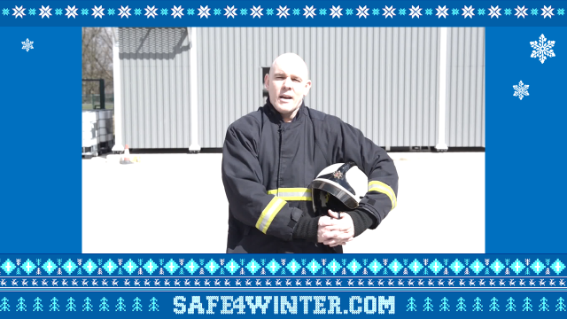 | This section describes what to do should your clothing catch fire.  To play the video: Hover over the image and a play bar will appear. Click the play button.  You may also want to demonstrate to the group yourself, choose someone from the audience or perform as an entire group.  If demonstrated you might need a gym mat on the floor.  *Take care, no injuries please and remember you may need to do this 2m apart!*  STOP – stop what you’re doing and stay very still.  DROP – drop to the floor.  ROLL – roll backwards and forwards until the flames are out.  If time is short, the three point message is all learners need to remember. | PowerPoint
Slide 9  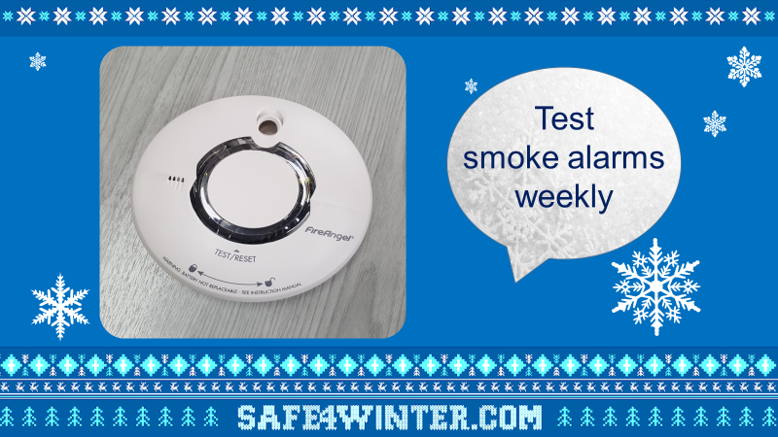 | Today we would also like to remind you to check you have working smoke alarms.  Smoke alarms are very important and every home should have them. They detect smoke and alert you if there is a fire in your home so you can escape safely.  You can use questions to engage the children’s interest, such as asking who has a smoke alarm and how often do they think they should test it?  Always test your smoke alarms weekly!  You can do this by pressing the button, if they are working, they will make a loud bleeping noise.  If you can’t reach, ask an adult to do it or you can use other household items such as a brush to reach and press the button.  Leave contact cards with the teacher to hand out to the children at the end of the session, and let the children know that if they don’t have smoke alarms at home or their family hasn’t made an escape plan they should give the card to their parents or carers.  **If time allows you can discuss what the children think they should do if there was a fire in the home.  Explain that is important that families stick together if there is a fire, that the children don’t try to hide and leave the home through their nearest exist.  Remember not to block escape routes with Christmas trees, presents or rubbish and everyone should know where the door keys are.  Explain once you get outside, you should never go back in and that it is from outside (or somewhere safe) that you should call 999.  This is an opportunity to discuss some of the reasons that people think that they might go back inside, so that you can highlight how important it is that they don’t (e.g. to rescue pets) let the children know how quickly a fire engine will get to a fire and emphasise how much training and experience you all have along with why is it not safe to go back inside.  Re-empathise: Get Out, Stay Out, Call 999.  Dependent on time: Discuss why you should crawl if there is smoke in a room, asking questions to help the children understand e.g. which direction does smoke travel in?  Explain how to check whether it is safe to go through a closed door – highlight the importance of closing doors before bed or even when everybody goes out.  Discuss what to do if you can’t get to your usual exit: stay together, get to a safe room (one with window), close the door and block the gaps around the door, get to the window, and shout for fire help as well as calling 999 – reassure children of our response times.** | PowerPoint  Contact cards
Slide 10  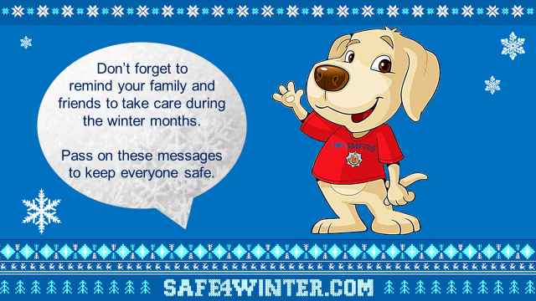 | Don’t forget to remind your family and friends to take care during the winter months, as well as to the take the time to telephone to check on any elderly relatives and neighbours this winter or do this following the government guidelines for social distancing keeping 2 metres apart.  Pass on these messages to keep everyone safe. | PowerPoint
Slide 11 | Direct children to our safe4winter website for more information.  https://manchesterfire.gov.uk/staying-safe/safe4winter/  Please take care and stay safe this winter. | PowerPoint

*Presenter to inform teachers of our Bury Safety Centre training site, if they are not already aware. To find out more and to book a visit share the website for Bury Safety Centre: https://safetycentre.manchesterfire.gov.uk/*
*Please note Bury Safety Centre are not currently taking school visits due to COVID-19 but please still pass on the information for teachers and schools to consider a visit in the hopeful near future*

