Lesson Plan
Session  Key Stage 1 (Year 2) | Length  1 hour | Facilities Required  Parking, access and egress  Computer  Projector & screen  Internet access.
Content

- Stay Fire Safe at Home
- Alarms and Escape
- Calling 999
- Understand the dangers and consequences of playing with fire and setting deliberate fires

Aims  - To understand why it is important to keep their homes safe from fire.  - To understand what an effective escape plan and bedtime check is.  - To know what a smoke alarm looks and sounds like and how to respond to an alarm.  - To understand how and when to dial 999 and how to alert an adult.  - To explain and demonstrate – ‘Stop, Drop n Roll’. | Objectives (delivery Staff)  - Explain why it is important to keep homes safe from fire.  - Describe a smoke alarm and explain how they work and why they are important.  - Discuss electrical safety, charging phones safely and switching off non-essential electricity appliances when not in use.  - Explain how to complete a nighttime routine with their family.  - Use questions and answers (Q&A) to discuss why the audience thinks it is important to close doors at night and when they leave their home?  - Describe and discuss the dangers of playing with matches and lighters.  - Make clear how quickly fire can spread.  - Demonstrate and practice Stop, drop, and roll if clothing catches on fire.  - Give details about burns and what to do if you suffer a burn. Better still, do not play with fire!  - Give an explanation as to why some fires are good while some are dangerous  - Tell the group what the five main causes of fire are in the home.
Curriculum links: English, Maths, Science, Design and technology, History, Geography (the area in which they live). Art and design, Physical education, Computing (accessing online resources GMFRS website for example).
Please check the content is suitable for individuals within the audience prior to delivery.

Time | Topic & Activity | Resources
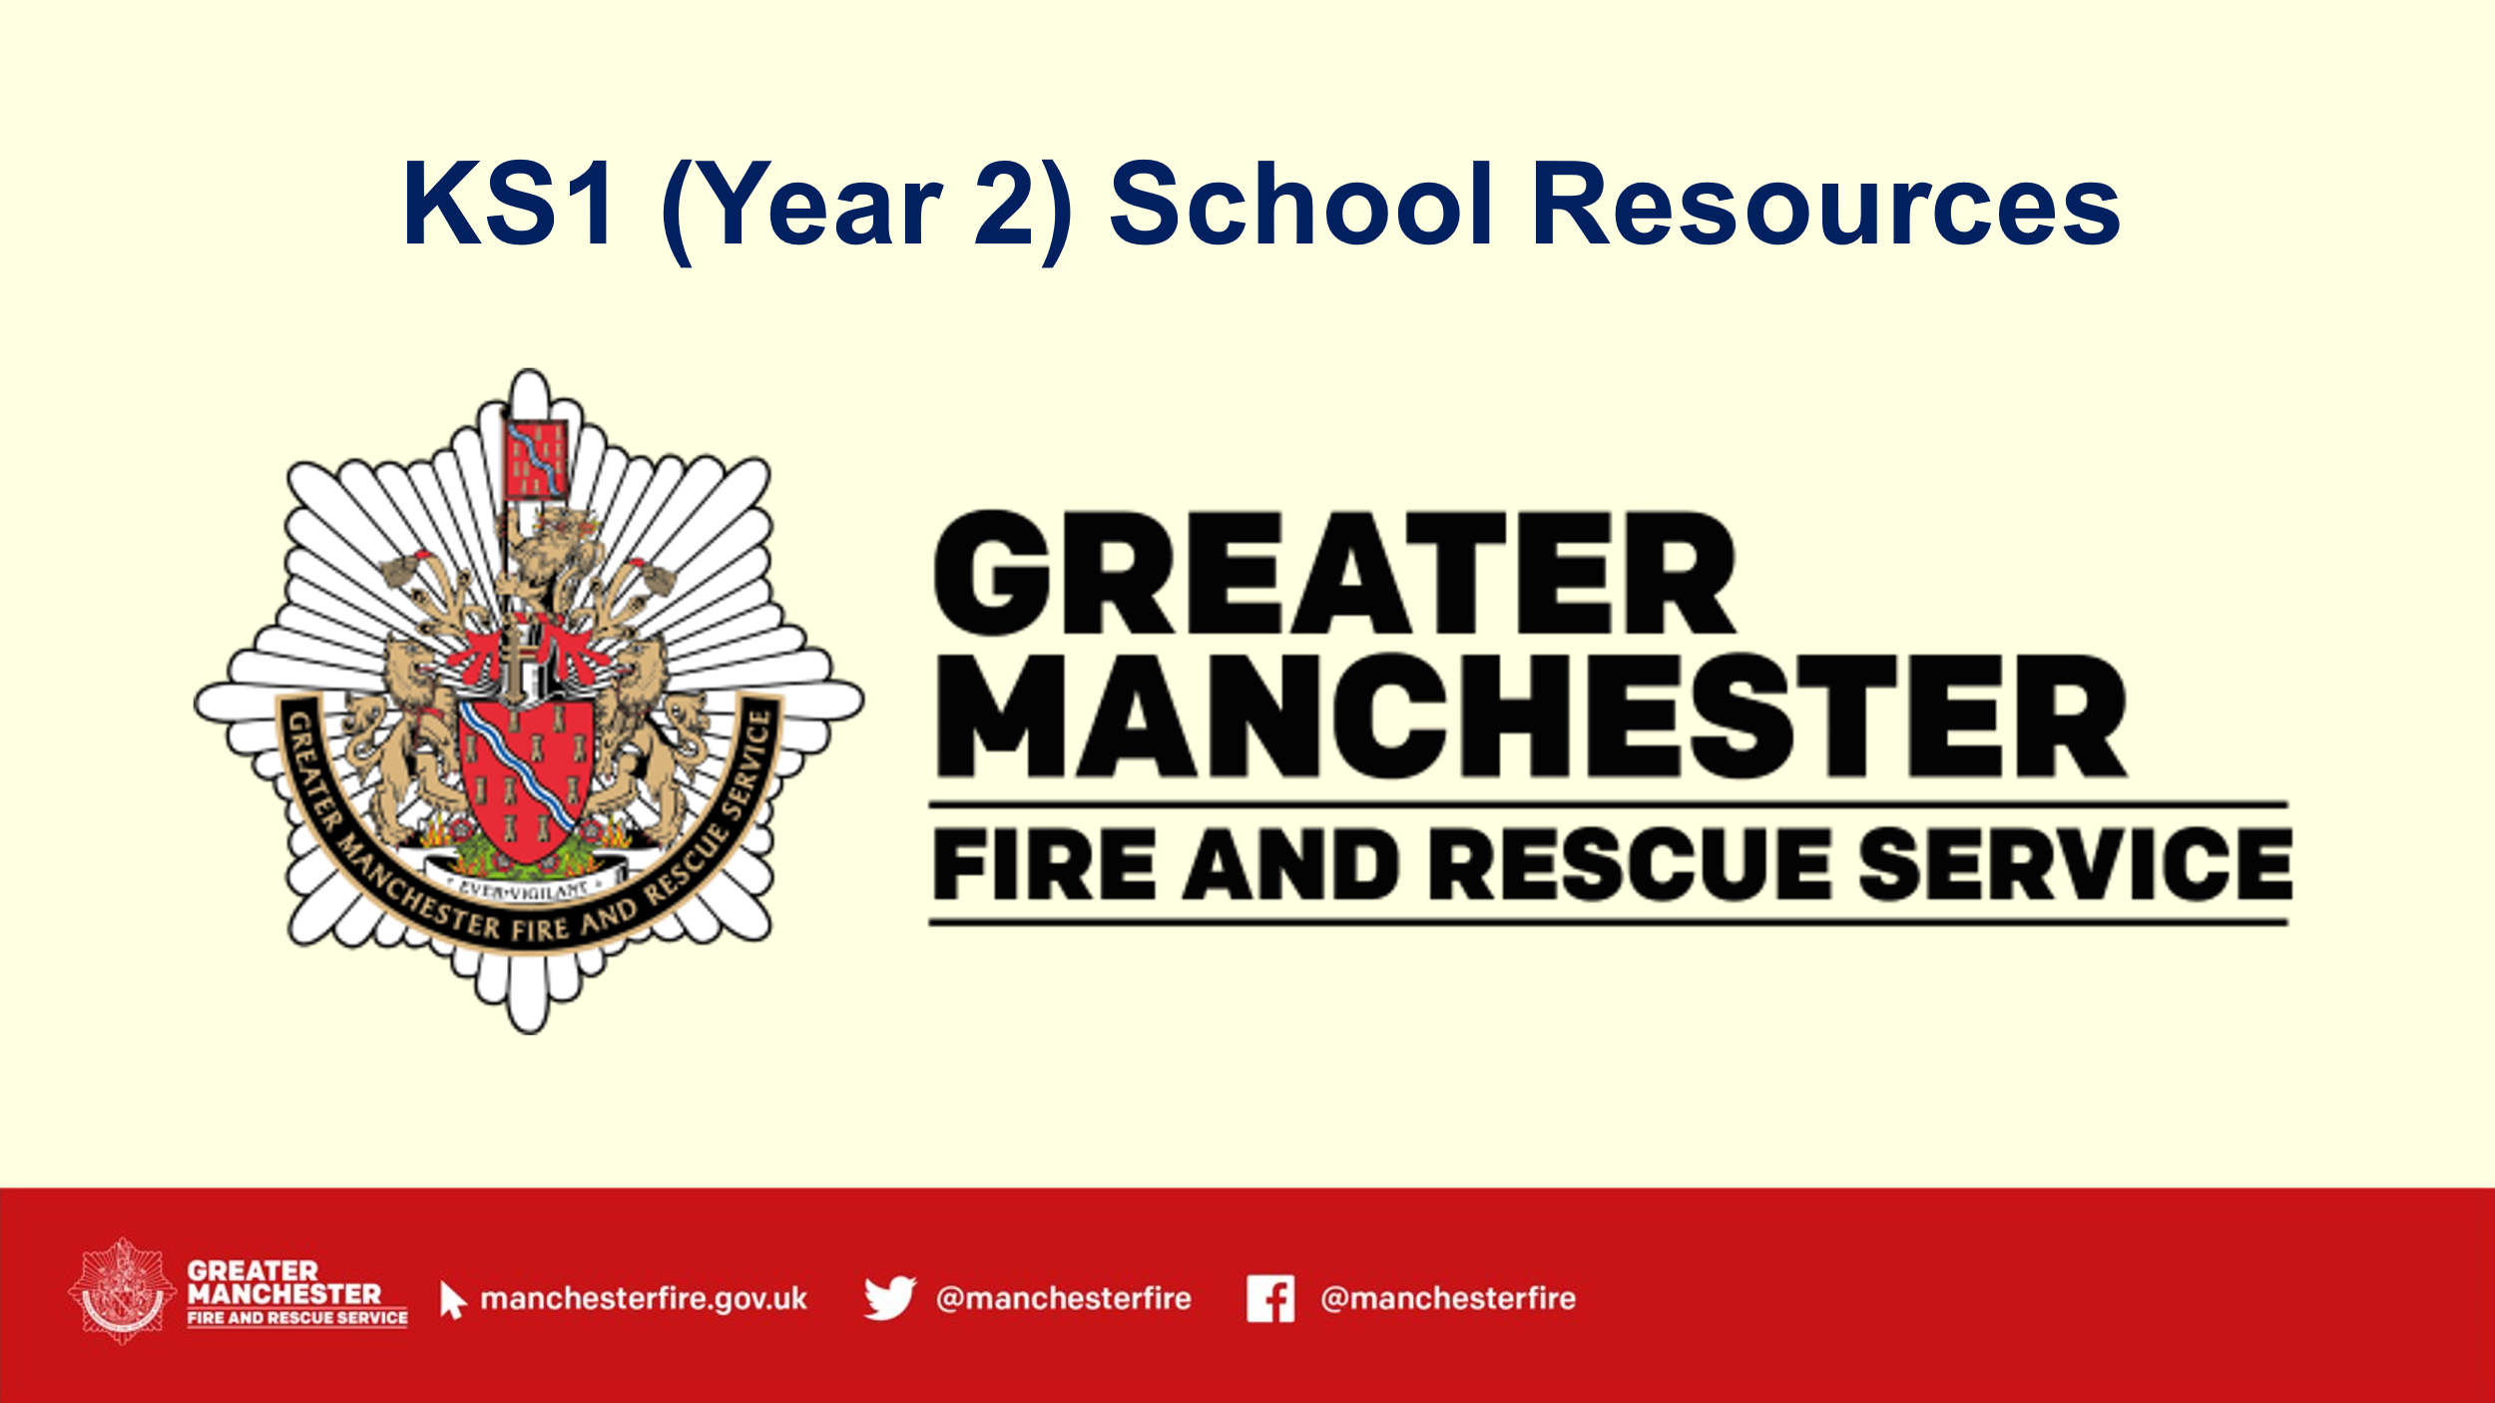 | Slide 1 – Title slide
5 Mins  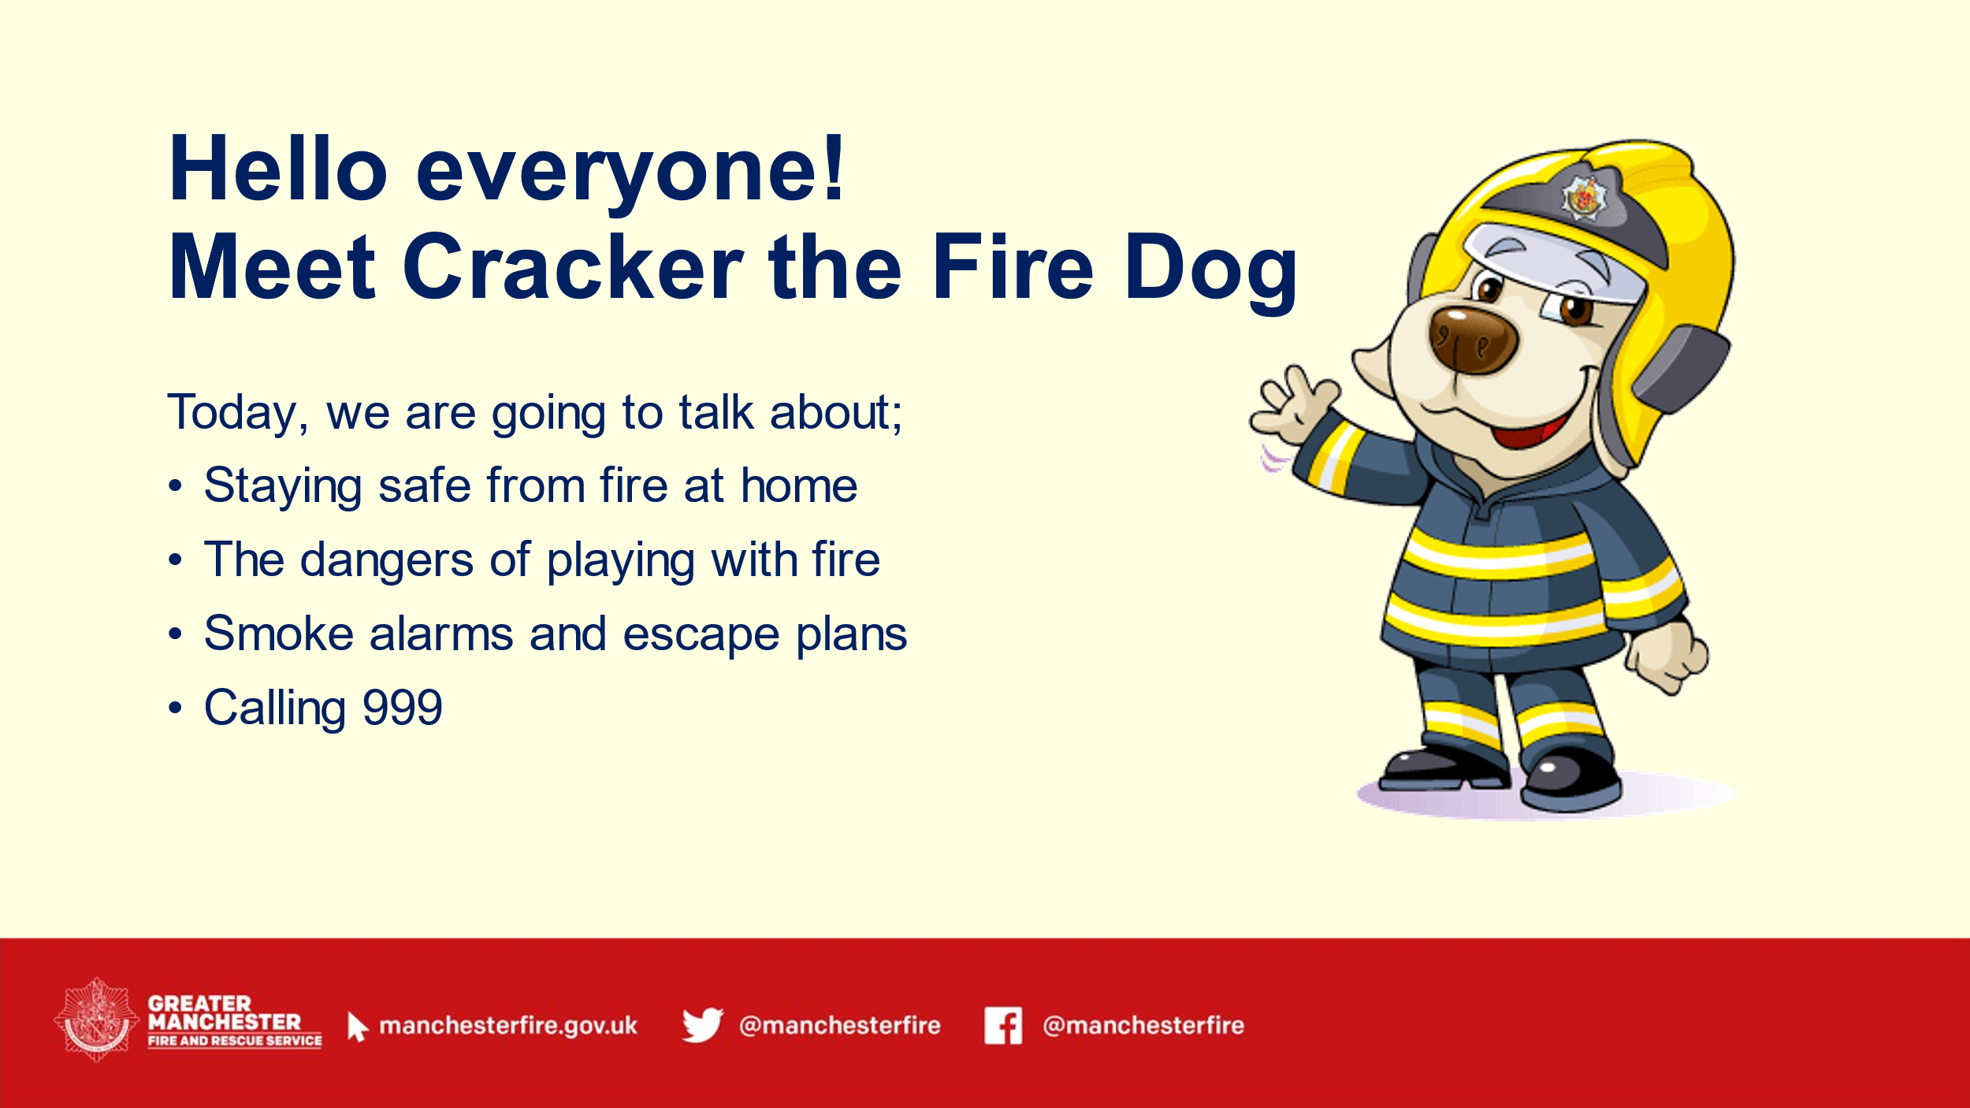 | Slide 2 – Introduction  - Introduce yourself and the topics you will be discussing throughout the session (Staying safe from fire at home, the dangers of playing with fire, smoke alarms and escape plans and calling 999) | PowerPoint
5 mins  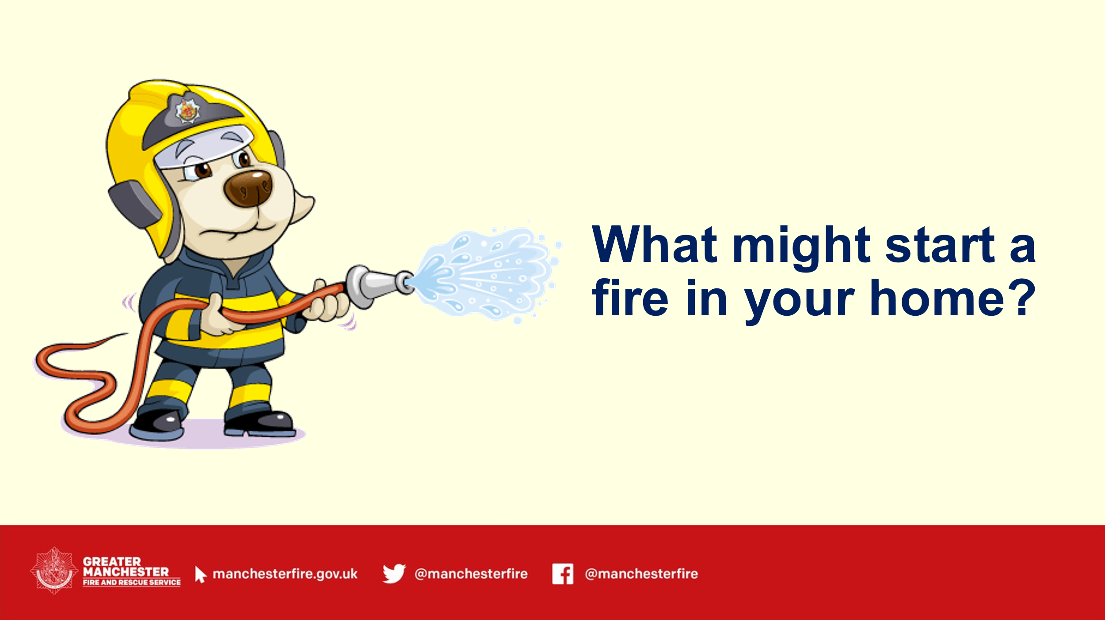 | Slide 3 - Opening question:  - ‘What might start a fire in your home?’  Discuss some of the answers given and discuss the main causes of fire in the home.  - Grown-ups smoking, electrical fires, candles, cooking, matches and lighters). | PowerPoint
10 mins  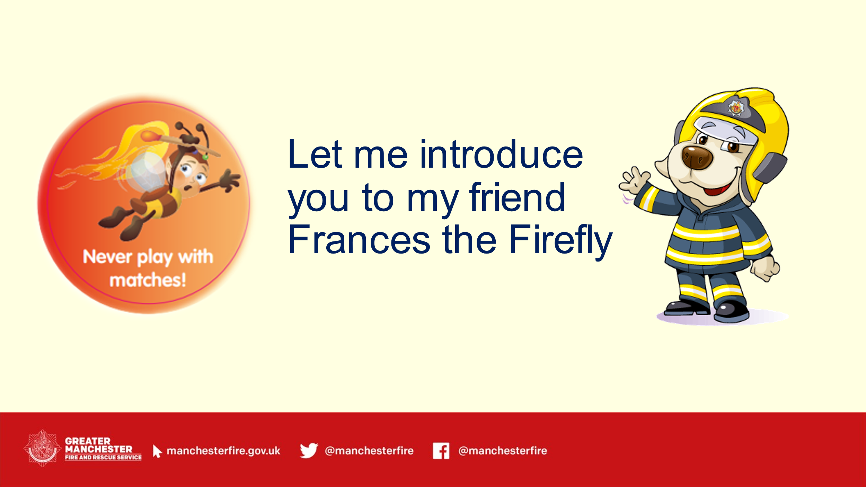  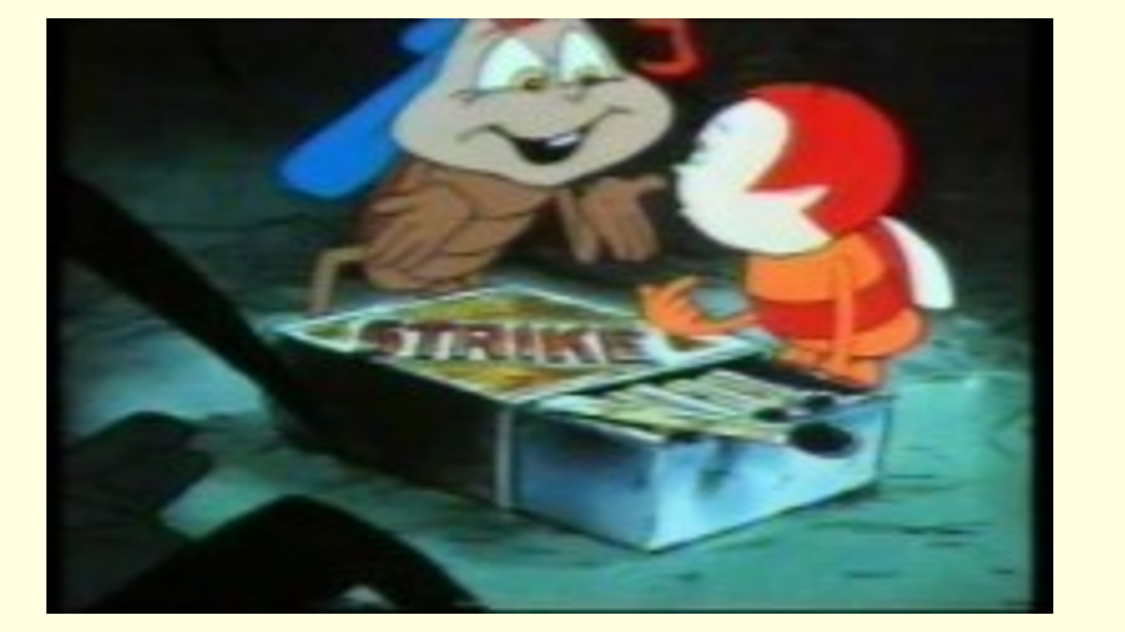  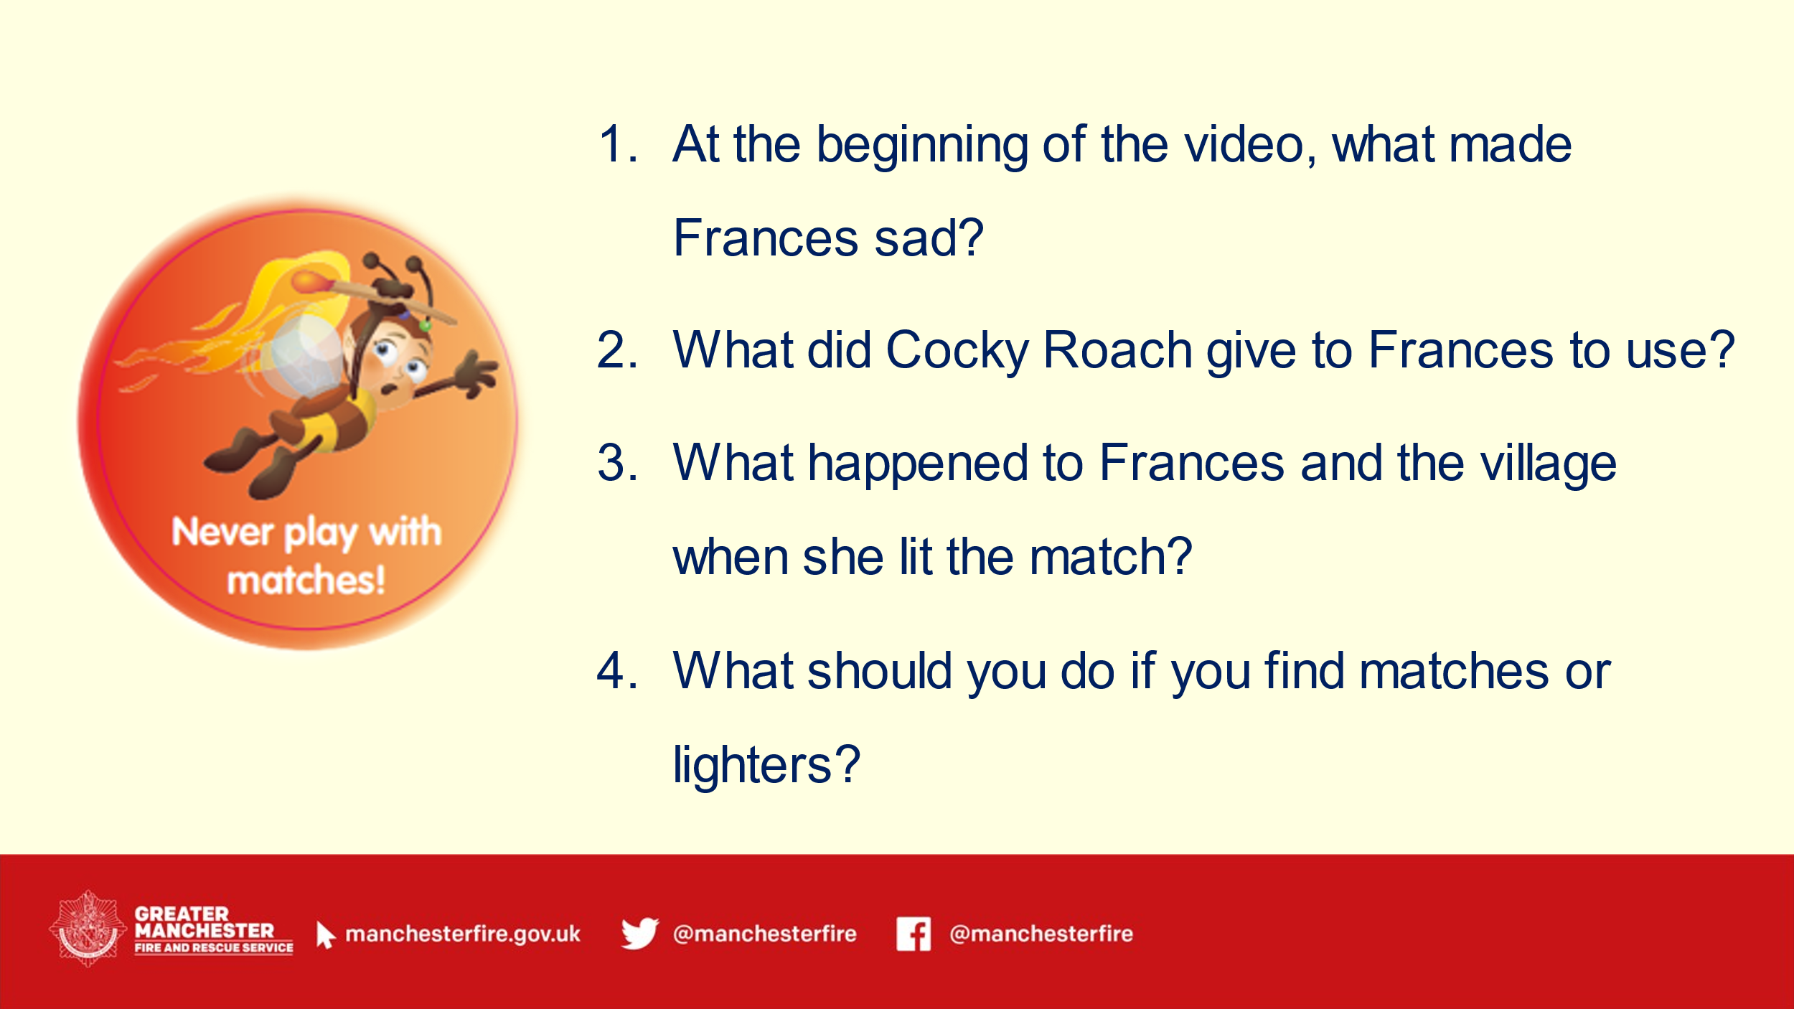 | Slide 4 – Introduce Frances the Firefly  - Following on from the answer ‘matches and lighters’ explain you are going to introduce Frances the Firefly and show the video.  - Ask the children to watch carefully because you are going to ask some questions at the end.  Slide 5 – Play Frances video  Slide 6 – Frances questions  - At the beginning of the video what made Frances sad? (She couldn’t help the other insects because her tail didn’t shine brightly enough)  - What did Cocky Roach give to Frances to use? (Box of matches)  - What happened to Frances and the village when she lit the match? (Frances burnt herself/hurt herself and the village was destroyed)  - What should you do if you find matches or lighters? (Tell a grown up, don’t pick them up or play with them) | PowerPoint, ‘Frances the Firefly video’,  Francis firefly full version - YouTube
5 mins  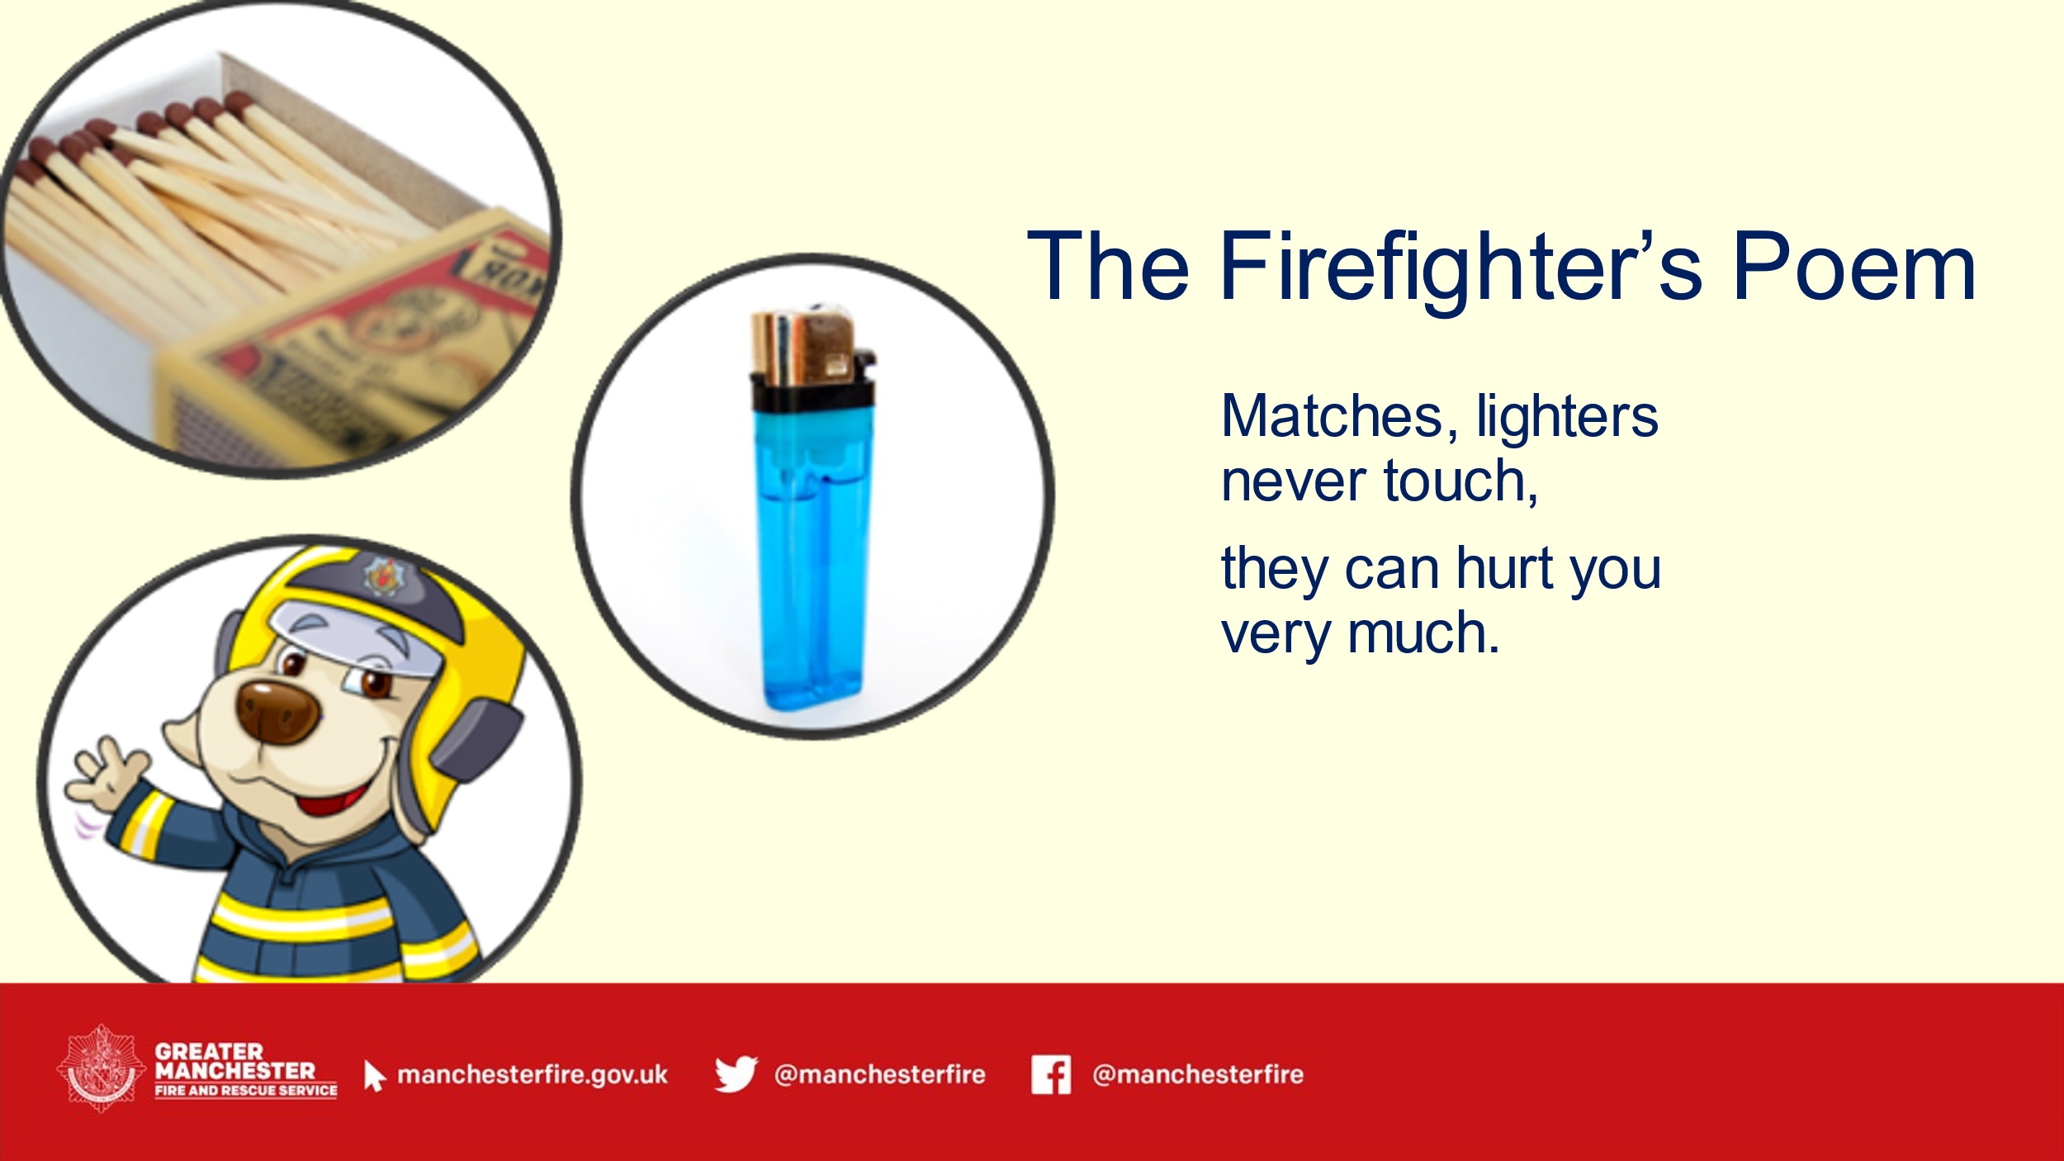 | Slide 7 – Firefighter’s poem  - Introduce the Fire-fighter poem.  - Go through with children and ask them to repeat | PowerPoint, Fire fighter poem  “Matches, Lighters never touch, they can hurt you very much”.
5 mins  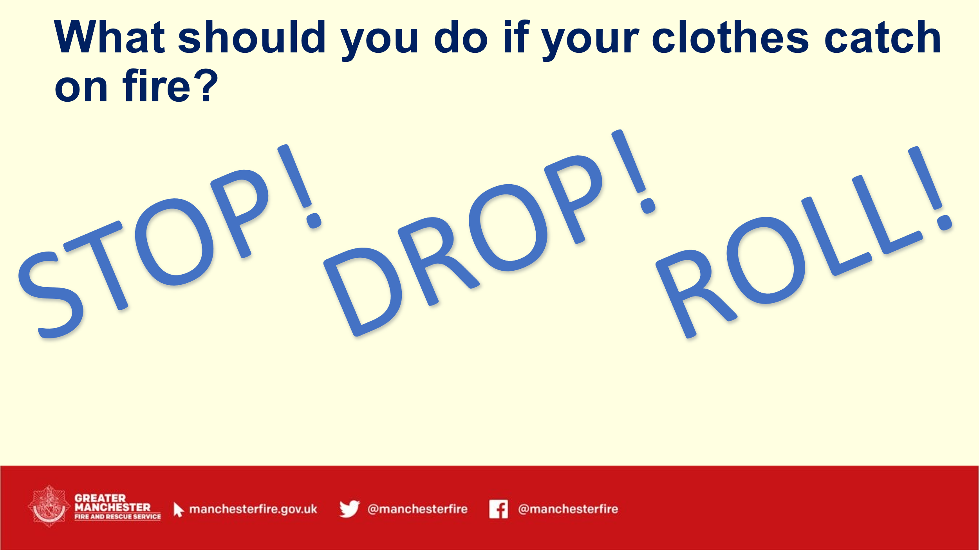  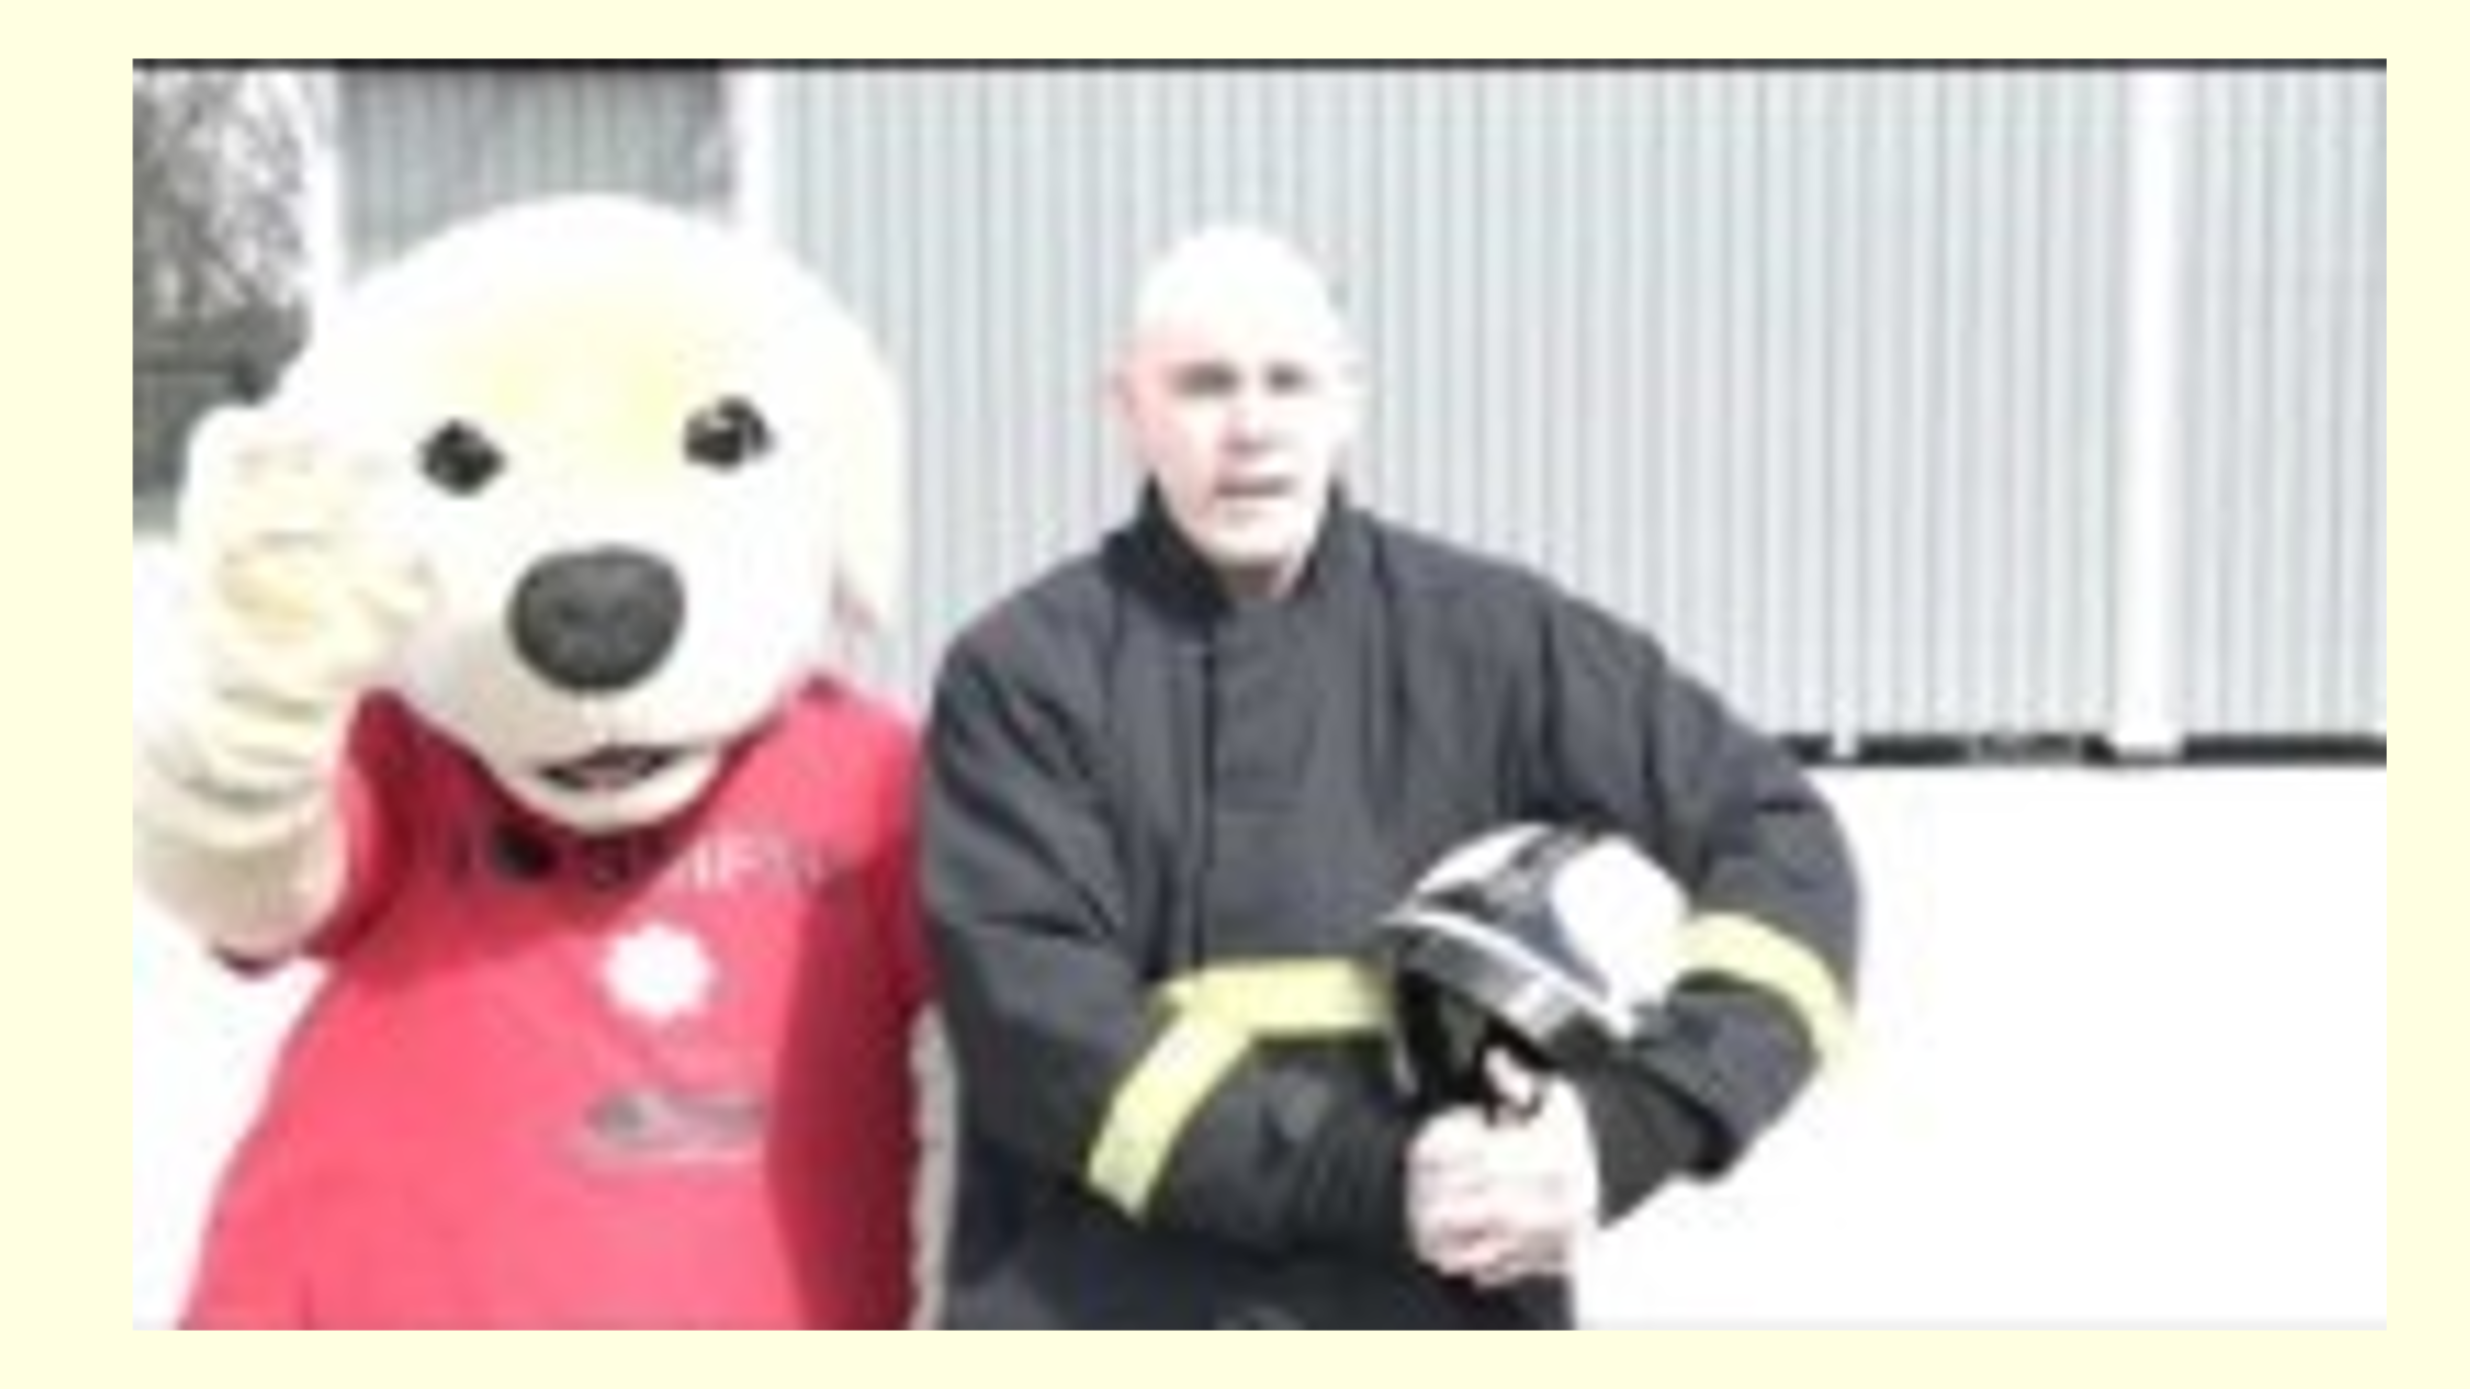 | Slide 8 – Stop, drop and roll  - Ask children ‘what should you do if your clothes catch fire?  - Introduce STOP (don’t run around, even though it might be very difficult not to panic, running will make the flames burn faster).  - DROP (this makes it harder for the flames to spread).  - ROLL (rolling around stops the flames and puts them out).  Slide 9 – Stop, drop and roll video  - Show video  - Group activity to practice (if space allows, if not then select children to come to the front and demonstrate) | PowerPoint, ‘Stop Drop Roll video’.  Stop Drop and Roll! - YouTube
5 mins  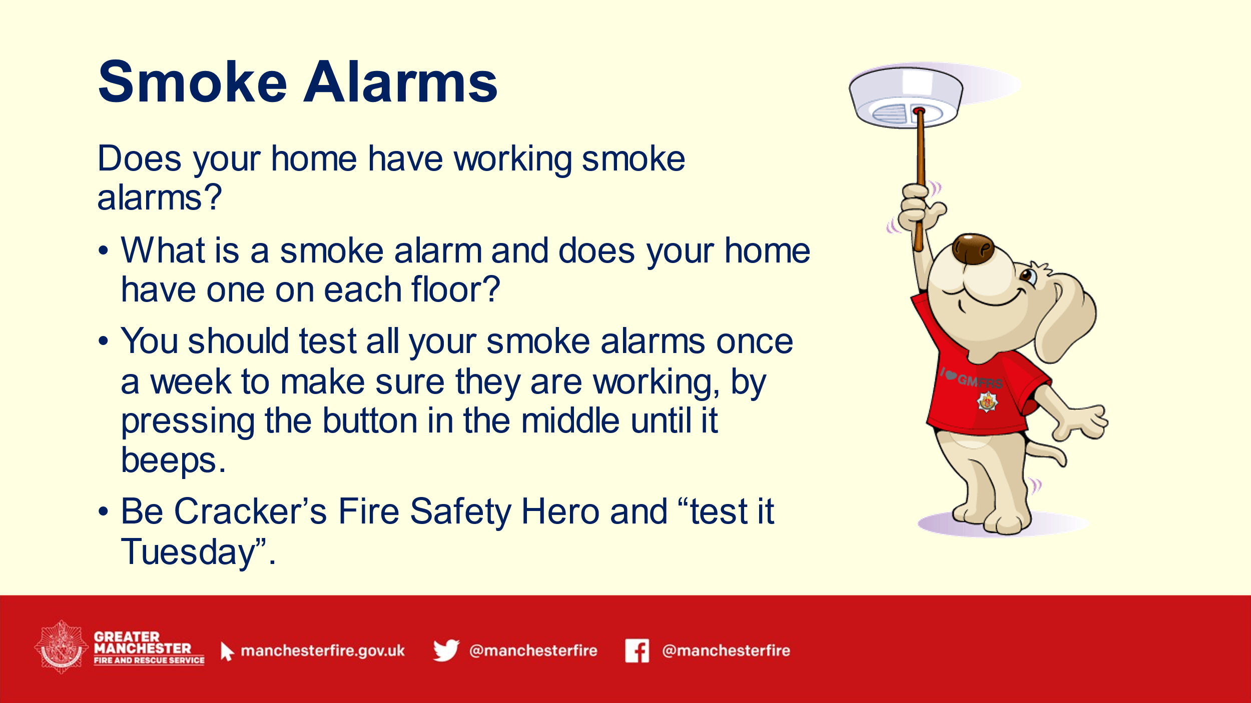 | Slide 10 – Smoke alarms  - Introduce smoke alarm and ask if anyone knows what it is and have they seen them in their home? Explain there should be one smoke alarm on each floor (upstairs and downstairs).  - Ask who knows what a smoke alarms sounds like? Then warn children and test. Ask why they think it needs to be so loud?  - Explain you should test all your smoke alarms once a week to make sure they are working, by pressing the button in the middle until it beeps.  - Cracker tests his smoke alarms on Tuesdays with a broom, test yours when you get home with an adult! “Be Cracker’s Fire Safety Hero and test it Tuesday”. | PowerPoint, smoke alarm
5 mins  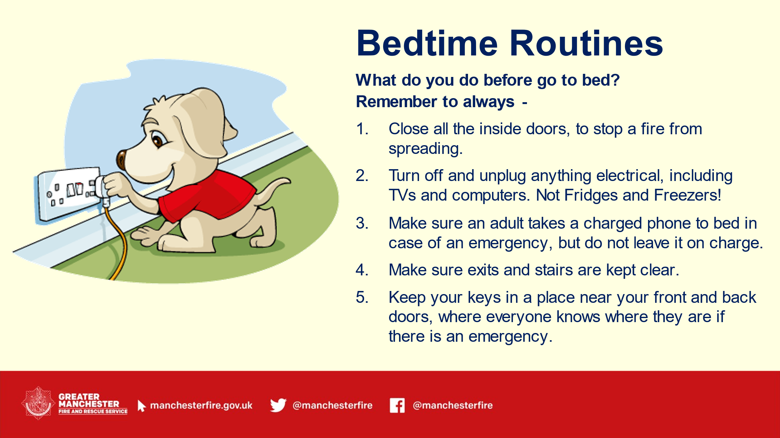 | Slide 11 – bedtime routines  - Ask the children ‘what do they do before they go to bed?’ Some examples may be: clean teeth, read story etc.  - Then tell children it is important to do these next things with their grown-ups before they go to bed as well – to help keep them safe from fire.  - Closing doors (stops the fire spreading and gives you more time to escape).  - Know where keys are (grown up will have keys – tell them to keep them somewhere everyone can get them so they can escape if there is a fire).  - Turn off and unplug electrics (unless they are meant to be left on like fridges and freezers).  - Tidy toys away from stairs/doors etc (if there is a fire everyone can get out quickly and safely). | PowerPoint
5 mins  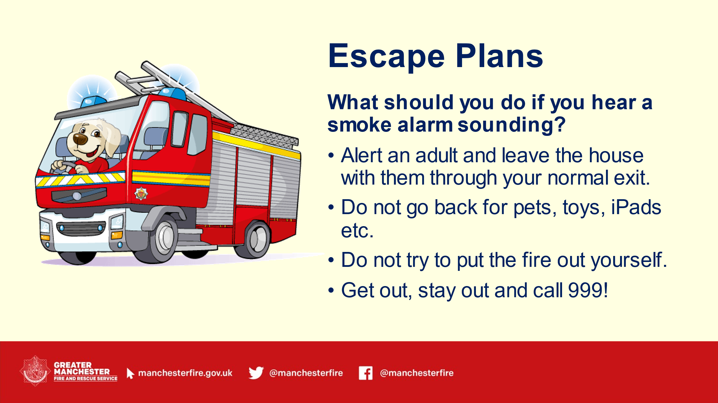 | Slide 12 – Escape Plans  - Ask children what should you do if they hear the smoke alarm?  - Alert their adult/grown-up and leave the house with them.  - Do not go back for pets, toys, ipads etc.  - Do not try to put the fire out yourself.  - Get out and stay out. Then call 999. | PowerPoint
3 mins  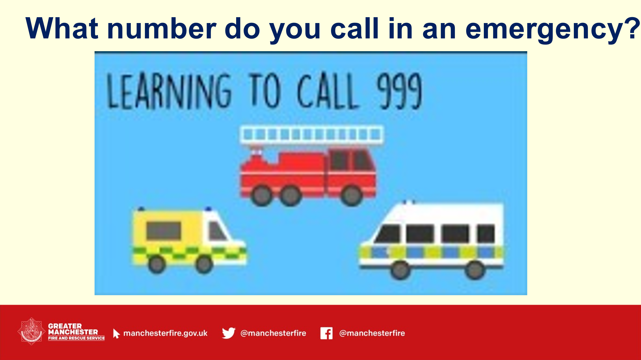 | Slide 13 – What number do you call in an emergency  - Briefly recap escape plan and explain that once outside they should ring the fire service.  - Ask the question: who knows what number to call in an emergency?  - Show video. | PowerPoint  Teaching Children to Call 999 video  Teaching Children to Call 999 - YouTube
1 min  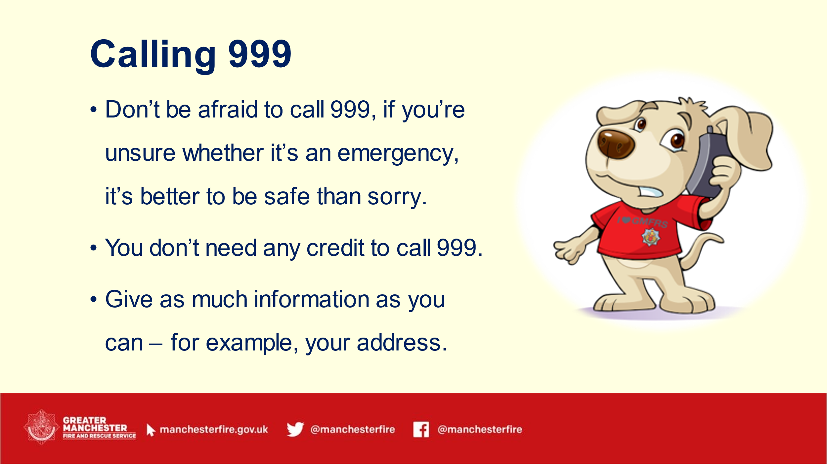 | Slide 14 – Calling 999  Discuss that children shouldn’t be afraid to call 999 if there is an emergency, but they should never do it for fun.  - You can use a phone even if it doesn’t have any credit.  - When you call 999 ask for the fire service. If the fire is at their house they should tell the person their address.  - Make a point if children don’t know their address – ask them to ask who they live with and learn it | PowerPoint
6 mins  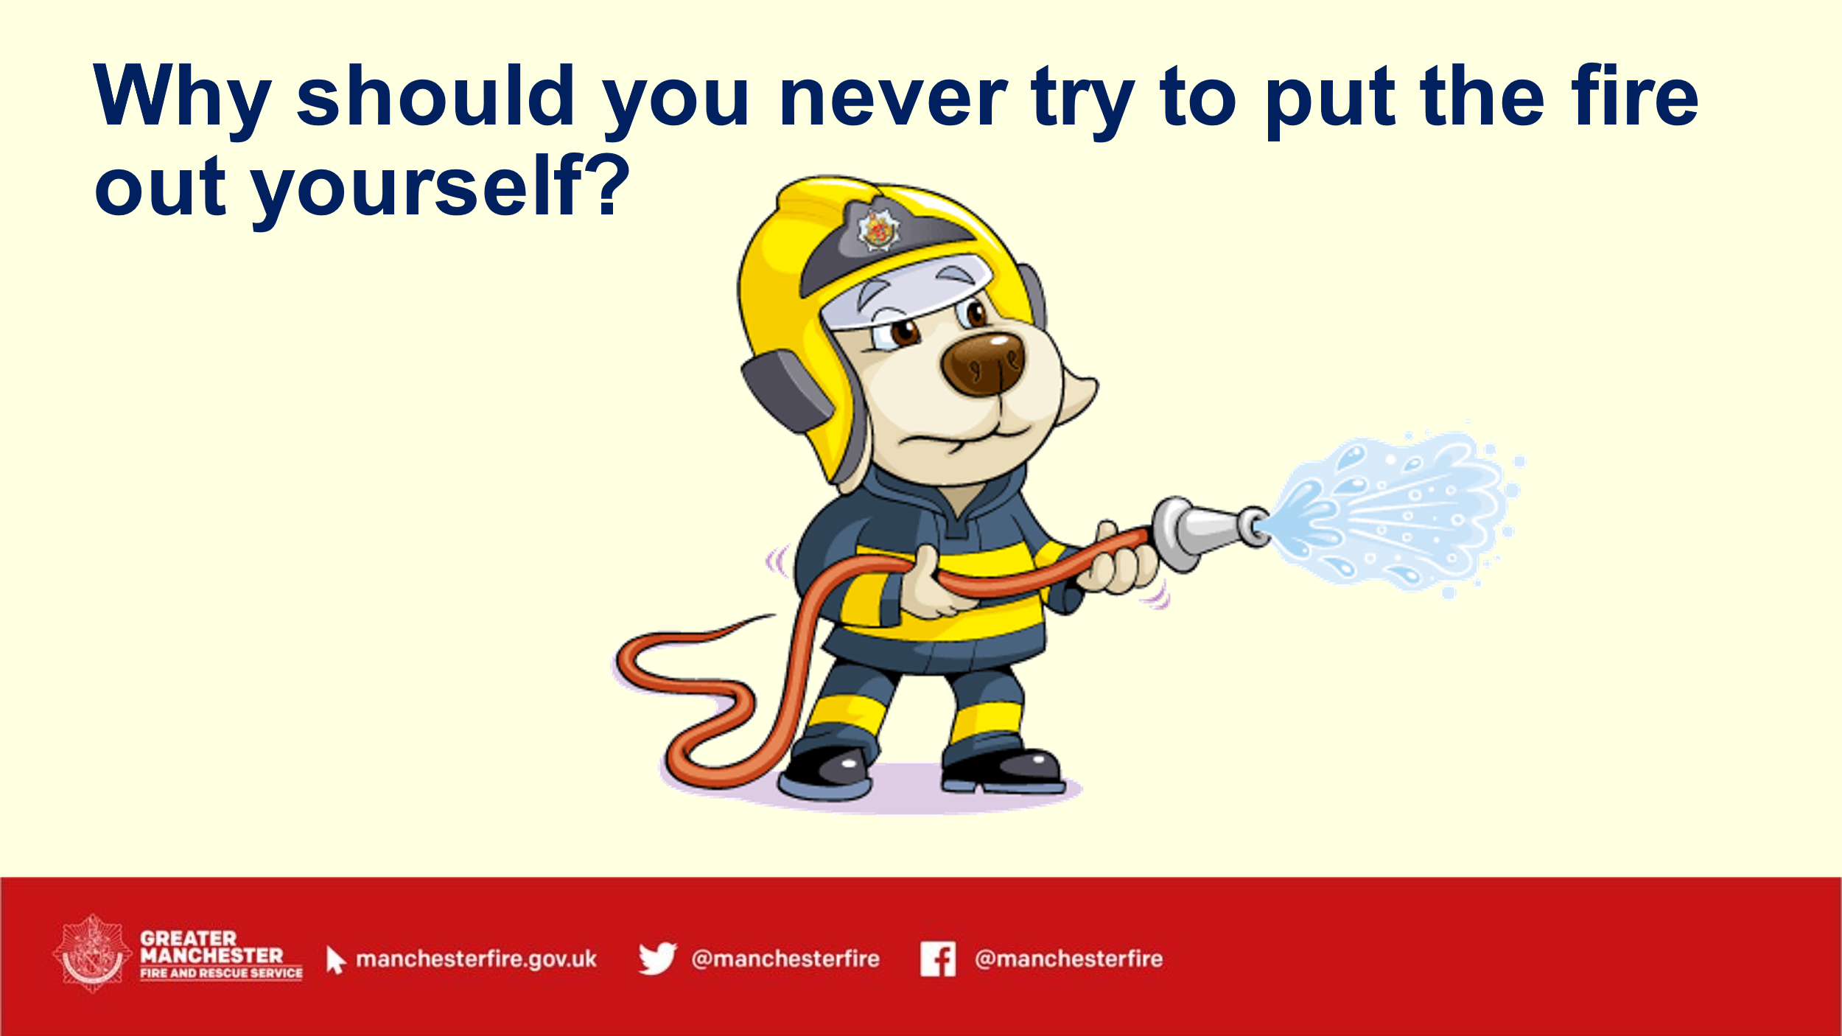 | Slide 15 – Why should you never try to put the fire out yourself  - Reiterate that children or grown up shouldn’t go back into the house for any reason.  - Explain FFs use special equipment and are experts at putting fires out.  - Dress up activity – choose a teacher/pupil (if appropriate) and dress them up in fire gear, explaining what it does. | PowerPoint and fire gear
5 mins  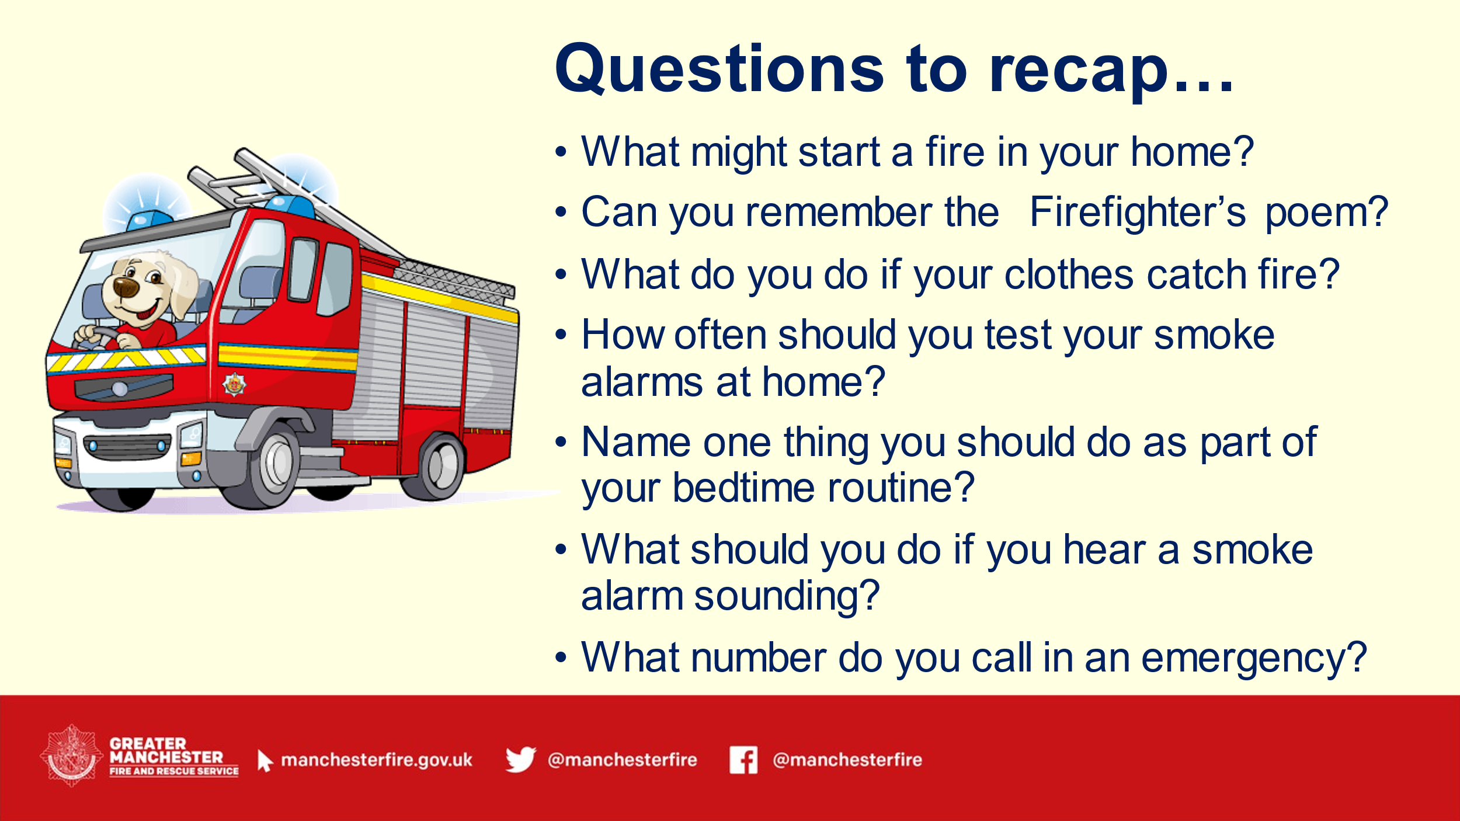 | Slide 16 – questions to recap  Recap what children have learned with revision questions.  - What might start a fire in your home?  - Can you remember the Firefighter’s poem?  - What do you do if your clothes catch fire?  - How often should you test your smoke alarms at home?  - Name one thing you should do as part of your bedtime routine.  - What should you do if you hear a smoke alarm sounding?  - What number do you call in an emergency? | PowerPoint
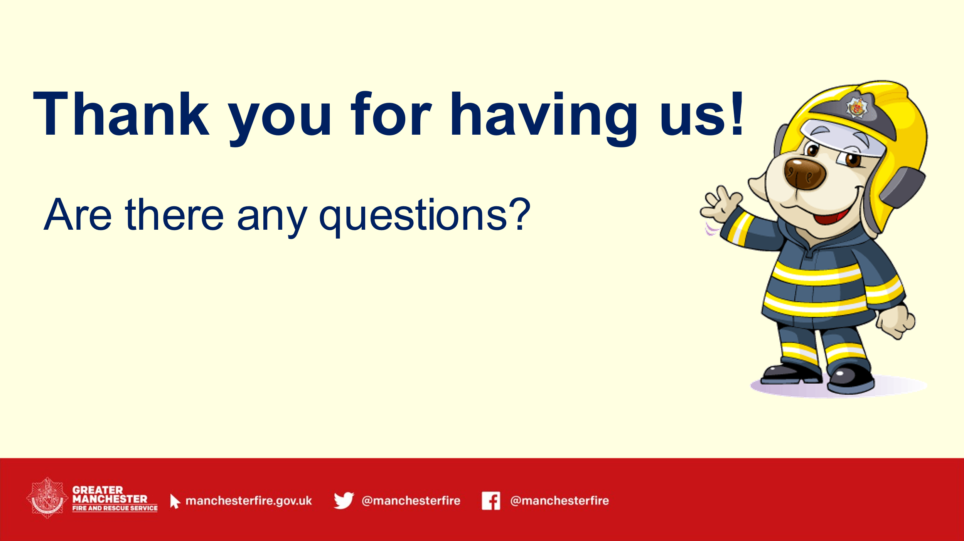 | Slide 17 – thank you  - Thank children and teachers for having you and ask if they have any questions for you

