GMFRS smoke alarm testing and escape route planning campaign
Social media pack 2024
Introduction
We are running a campaign focusing on smoke alarm testing and escape route planning.
A working smoke alarm can be the first alert to a fire and can save lives by providing vital extra seconds to escape a fire in the home. Each level should have at least one working alarm and we suggest testing at least monthly to ensure they are working. Knowing what to do if a smoke alarm sounds is also important – prepare an escape plan to help everyone escape smoothly in case of a fire. Also, make sure everyone living in the same household knows about the plan.
To ensure Greater Manchester residents are aware of these important actions and routines we will be sharing social media posts across all relevant channels and we encourage partners to share where possible, allowing for maximum impact and coverage.
Communication objectives
- Encourage people to fit smoke alarms on each level of their home and a heat alarm in their kitchen - test them at least monthly.
- Encourage people to plan escape routes and review them regularly.
- Educate people on what they should do in case of a fire.
Audience
- Residents in all boroughs of Greater Manchester.
Key messages:
- Ensure you have at least one working smoke alarm fitted on every level of your home and a heat alarm in your kitchen. Test your alarms at least monthly.
- Ensure you have an escape plan, in case of fire, which your whole household understands.
- If there is a fire in your home - get out, stay out, call 999.

Assets can be downloaded here: https://www.manchesterfire.gov.uk/your-safety/campaigns/smoke-alarm-testing-and-escape-planning/
These posts will be shared with the main hashtags #TestItWhileYouWait and #TestingTesting123 on GMFRS’ various channels including Facebook, X and Instagram (@manchesterfire).
Suggested content | Image/Video | Alt text
Facebook and X
When was the last time you tested your smoke alarms?  @manchesterfire advice is to test them at least monthly, by pressing the test button until the alarm sounds.  #TestItWhileYouWait | Test it while you wait animation | N/A (animation)
🔥 It’s hard to notice a fire at the earliest stages when you’re sleeping – that's why you need a working smoke alarm to give you vital extra seconds to escape.  ✅ Test your smoke alarms at least monthly.  #TestItWhileYouWait | Test it while you wait animation | N/A (animation)
Waiting for your kettle to boil? Why not test your smoke alarm while you wait?  It only takes a moment and it could save your life.  #TestItWhileYouWait | Kettle – test it while you wait animation | N/A (animation)
Waiting for your washer/dryer to finish?  Why not test your smoke alarm while you wait? It only takes a moment and it could save your life.  #TestItWhileYouWait | Washer dryer – test it while you wait animation | N/A (animation)
Waiting for the adverts to finish on TV?  Why not test your smoke alarm while you wait? It only takes a moment and it could save your life.  #TestItWhileYouWait | TV adverts – test it while you wait animation | N/A (animation)
On the phone and put on hold?  Why not test your smoke alarm while you wait? It only takes a moment and it could save your life.  #TestItWhileYouWait | Phone on hold – test it while you wait animation | N/A (animation)
🤔 Thinking about smoke alarms and fire safety in your home? 🏠 🔥  Watch @manchesterfire short animation to find out more about their Home Fire Safety Assessments 📽 | Home Fire Safety Assessment animation (short) | N/A (animation)
Would you know what to do if your smoke or heat alarms go off? Plan ahead and practise an escape route.  Make sure door and window keys are accessible to everyone.  #TestingTesting123 | 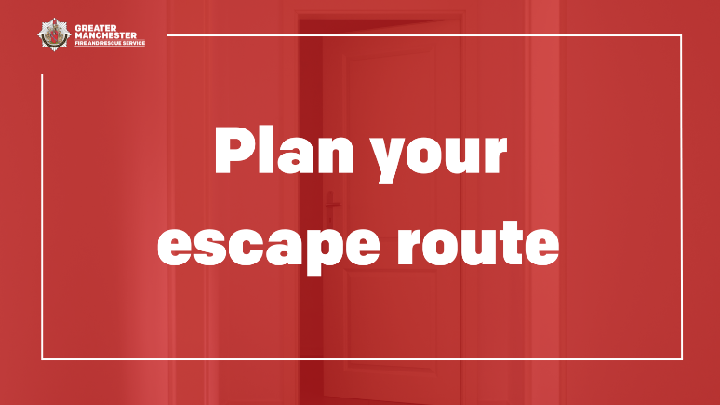 | Door open at the end of a hallway. Graphic text reads ‘Plan your escape route.’
Your normal way out of the house is often your best escape route, so always keep it clear of clutter!  #TestingTesting123 | 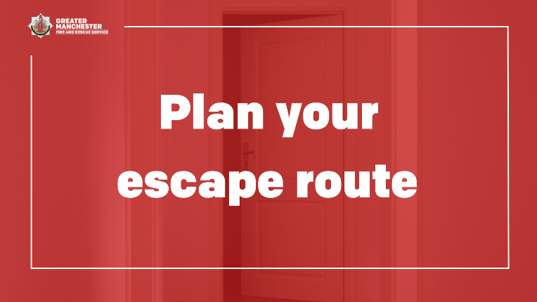 | Door open at the end of a hallway. Graphic text reads ‘Plan your escape route.’
Does your escape plan include a plan B? Plan for a second escape route, in case the first one is blocked.  If you encounter a fire, keep calm and act quickly – get out, stay out, call 999.  #TestingTesting123 | 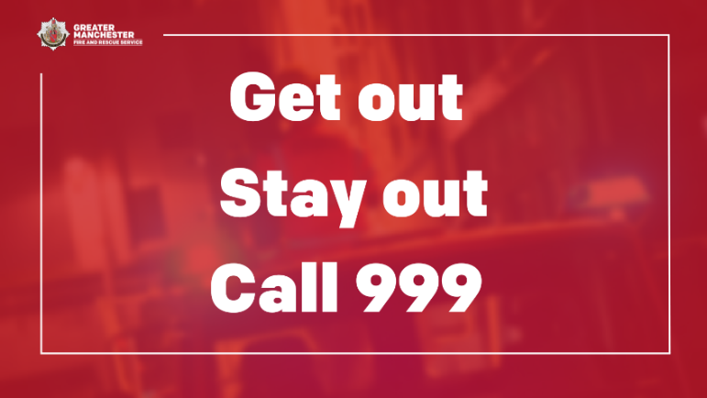 | Firefighter on fire engine with sirens flashing. Graphic text reads ‘Get out. Stay out. Call 999.’
Declutter your home once in a while to keep fire escape routes clear in case of an emergency.  If you’ve made changes to your home, remember to review your escape plan.  Visit @manchesterfire website for more advice and tips.  #TestingTesting123 | 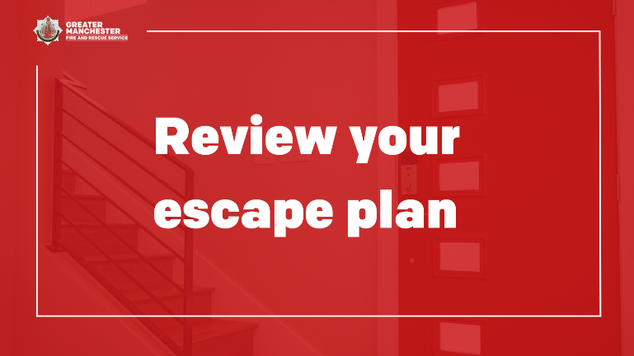 | A staircase inside house next to front door. Graphic text reads ‘Review your escape plan.’
If you encounter a fire, keep calm and act quickly – get out, stay out, call 999.  Use the stairs to get out if you’re escaping from a block of flats.  Learn what to do in a fire 👉 manchesterfire.gov.uk/your-safety/fire-safety/your-home-safety/flat/what-to-do-if-a-fire-is-in-your-building/  #TestingTesting123 | 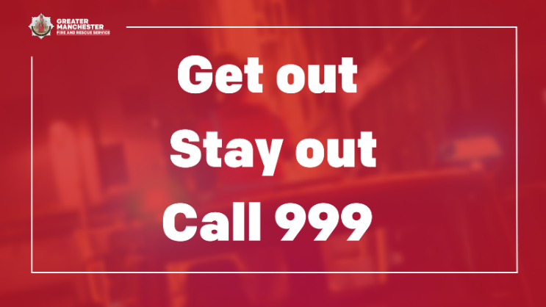 | Firefighter on fire engine with sirens flashing. Graphic text reads ‘Get out. Stay out. Call 999.’
🏠 Complete @manchesterfire free online home fire safety check and get advice on simple changes you can make to reduce the risk of a fire.  manchesterfire.gov.uk/your-safety/hfsa/  #TestingTesting123 | 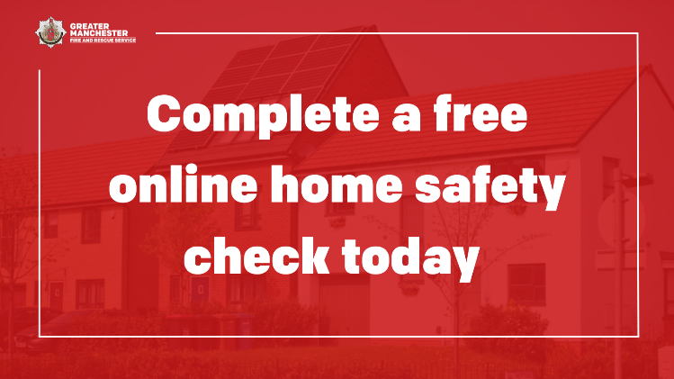 | Row of houses on street. Graphic text reads ‘Complete a free online home safety check today.’
Instagram
When was the last time you tested your smoke alarms?  @manchesterfire advice is to test them at least monthly, by pressing the test button until the alarm sounds.  #TestItWhileYouWait | Test it while you wait animation | N/A (animation)
🔥 It’s hard to notice a fire at the earliest stages when you’re sleeping – that's why you need a working smoke alarm to give you vital extra seconds to escape.  ✅ Test your smoke alarms at least monthly  #TestItWhileYouWait | Test it while you wait animation
Waiting for your kettle to boil? Why not test your smoke alarm while you wait?  It only takes a moment and it could save your life.  #TestItWhileYouWait | Kettle – test it while you wait animation | N/A (animation)
Waiting for your washer/dryer to finish?  Why not test your smoke alarm while you wait? It only takes a moment and it could save your life.  #TestItWhileYouWait | Washer dryer – test it while you wait animation | N/A (animation)
Waiting for the adverts to finish on TV?  Why not test your smoke alarm while you wait? It only takes a moment and it could save your life.  #TestItWhileYouWait | TV adverts – test it while you wait animation | N/A (animation)
On the phone and put on hold?  Why not test your smoke alarm while you wait? It only takes a moment and it could save your life.  #TestItWhileYouWait | Phone on hold – test it while you wait animation | N/A (animation)
🤔 Thinking about smoke alarms and fire safety in your home? 🏠 🔥  Watch @manchesterfire short animation to find out more about their Home Fire Safety Assessments 📽 | Home Fire Safety Assessment animation (short) | N/A (animation)
Would you know what to do if your smoke or heat alarms go off? Plan ahead and practise an escape route.  Make sure door and window keys are accessible to everyone.  #TestingTesting123 | 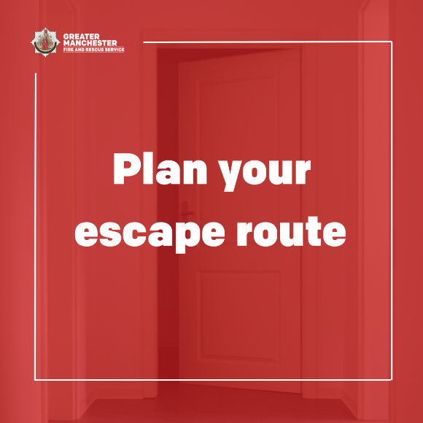 | Door open at the end of a hallway. Graphic text reads ‘Plan your escape route.’
Your normal way out of the house is often your best escape route, so always keep it clear of clutter!  #TestingTesting123 |  | Door open at the end of a hallway. Graphic text reads ‘Plan your escape route.’
Does your escape plan include a plan B? Plan for a second escape route, in case the first one is blocked.  If you encounter a fire, keep calm and act quickly – get out, stay out, call 999.  #TestingTesting123 | 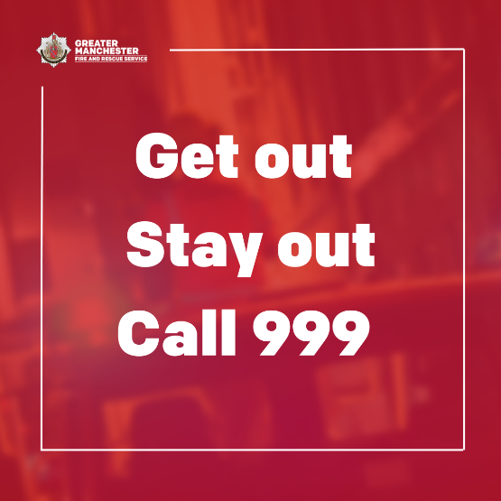 | Firefighter on fire engine with sirens flashing. Graphic text reads ‘Get out. Stay out. Call 999.’
Declutter your home once in a while to keep fire escape routes clear in case of an emergency.  If you’ve made changes to your home, remember to review your escape plan.  Visit @manchesterfire website for more advice and tips.  #TestingTesting123 | 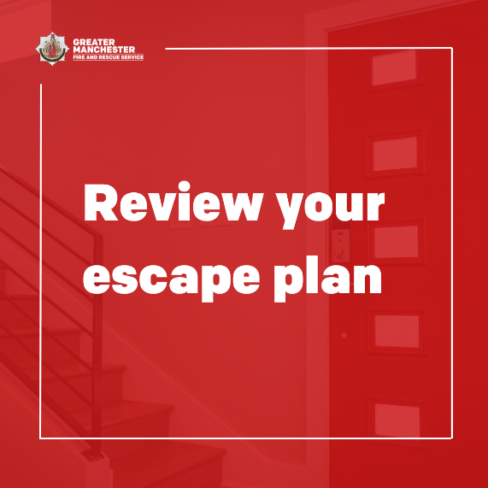 | A staircase inside house next to front door. Graphic text reads ‘Review your escape plan.’
If you encounter a fire, keep calm and act quickly – get out, stay out, call 999.  Use the stairs to get out if you’re escaping from a block of flats.  #TestingTesting123 |  | Firefighter on fire engine with sirens flashing. Graphic text reads ‘Get out. Stay out. Call 999.’
🏠 Complete @manchesterfire free online home fire safety check and get advice on simple changes you can make to reduce the risk of a fire.  #TestingTesting123 | 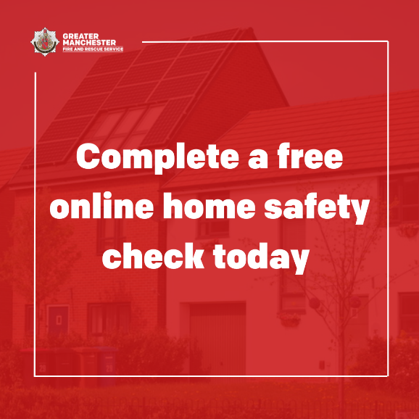 | Row of houses on street. Graphic text reads ‘Complete a free online home safety check today.’

