Lesson Plan
Session  Key Stage 3 (Year 8). | Length  20 Minutes. | Facilities Required  Parking, access and egress.  Computer.  Projector & screen.  Internet access.
Content
- Fire Safety in the Home.
- Smoke alarms.
- Bedtime routines.
- Escape Plans.

Aims  - To understand the 5 main causes of fire in the home.  - To understand the importance of smoke alarms.  - To understand how to complete a bedtime routine.  - To understand the importance of escape plans. | Objectives (delivery Staff)  - Teach the 5 main causes of fire in the home.  - Describe and show a smoke alarm and explain how they work and why they are important.  - Describe how to complete a bedtime routine and encourage them to practice this at home.  - Teach different escape routes and why they are important.

Curriculum links, English, Maths, Science, Design and technology, History, Geography (the area in which they live). Art and design, Physical education, Computing (accessing online resources GMFRS website for example).
Please check the content is suitable for individuals within the audience prior to delivery.

Time | Topic & Activity | Resources
1 min.  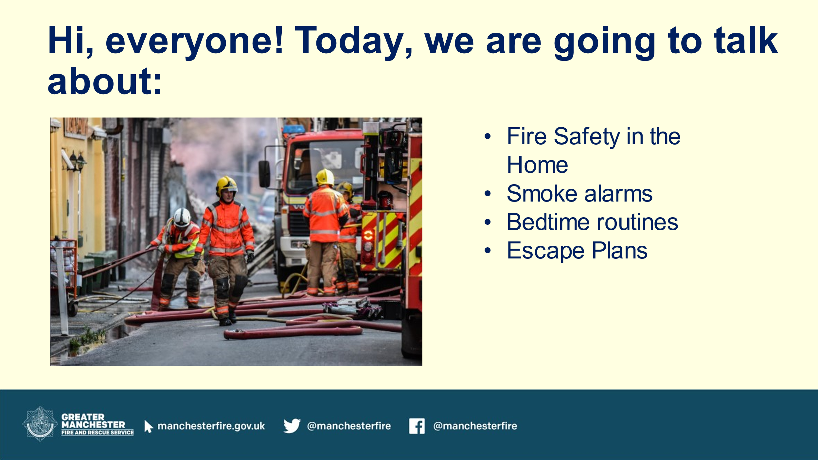 | Slide 2 – Introduction  Introduce yourself and the topics you will be discussing throughout the session (Fire Safety in the Home, smoke alarms, bedtime routines and escape Plans). | PowerPoint.
2 mins.  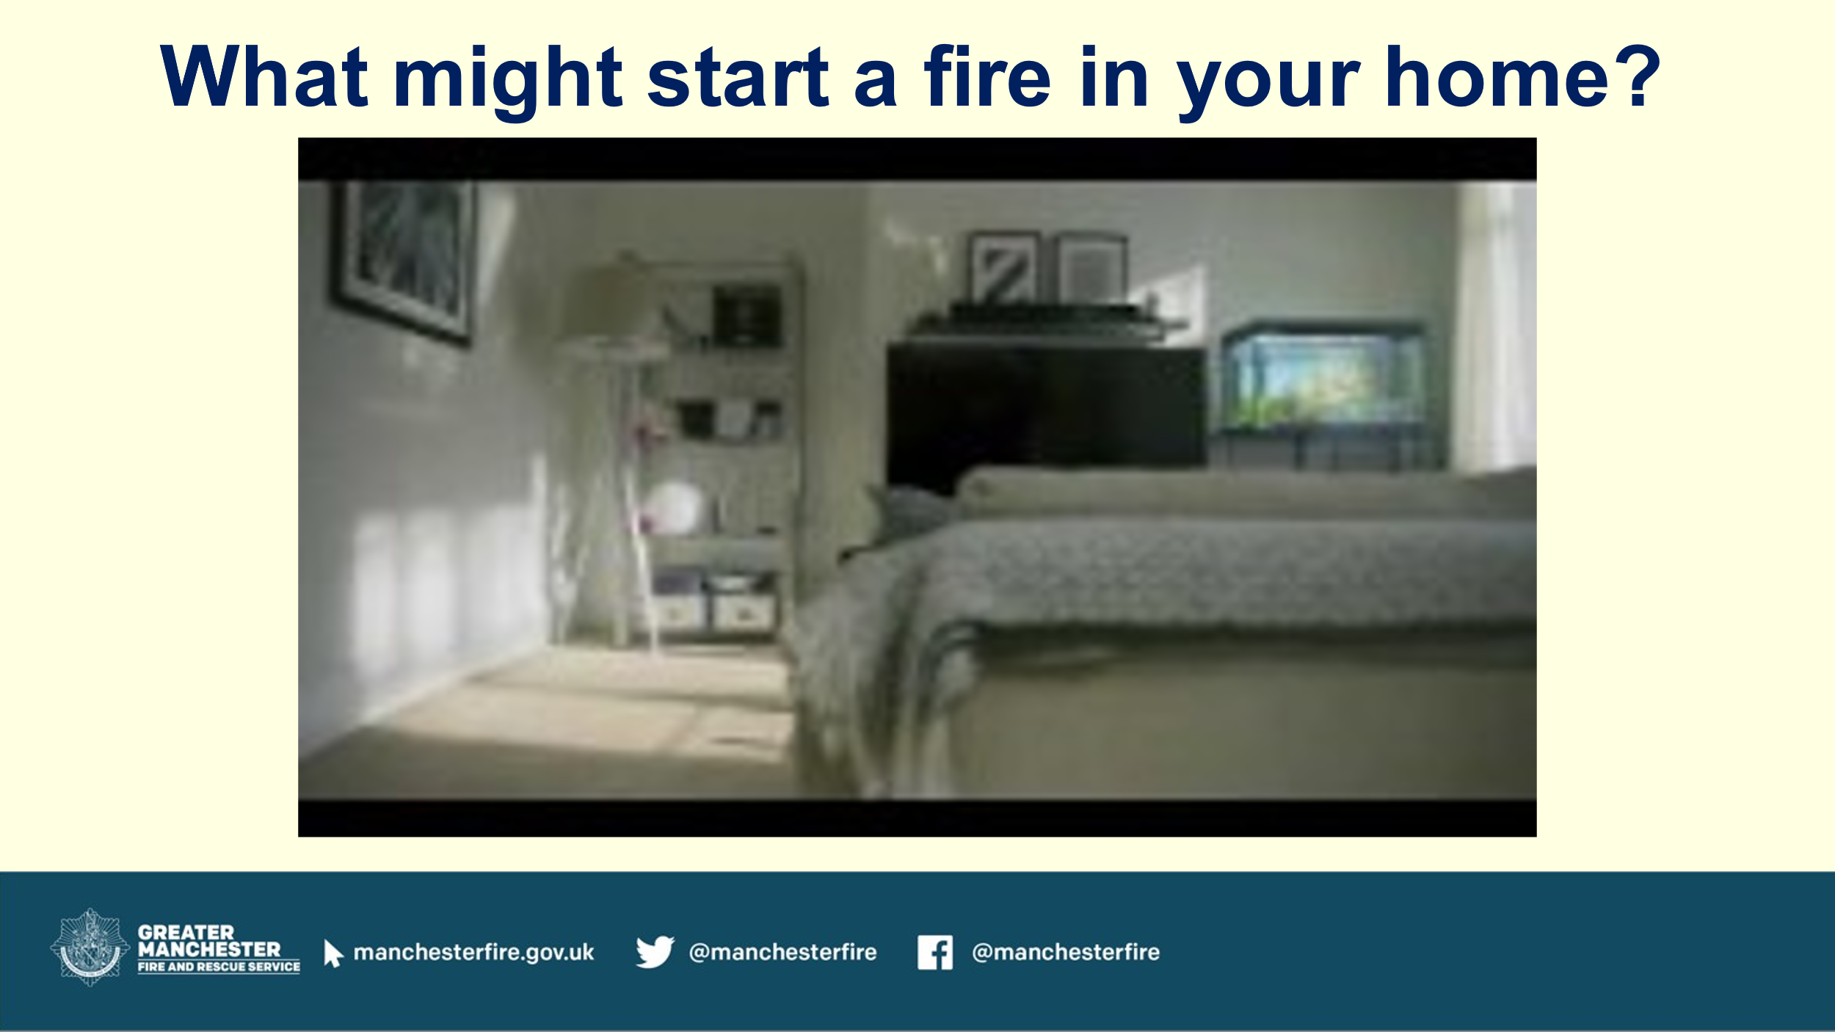 | Slide 3 – What might start a fire in your home?  Use an opening question and ask the children “what might start a fire in your home? Listen to their answers.  - Play the Fire Kills film within the PowerPoint and discuss briefly.  - Ask if there were any surprises in the film at what can cause a fire in the home? | PowerPoint - Fire Kills video – YouTube.  Fire Kills: It only takes one accident_30 sec_with electrical fault scene [captioned] - YouTube
3 min.  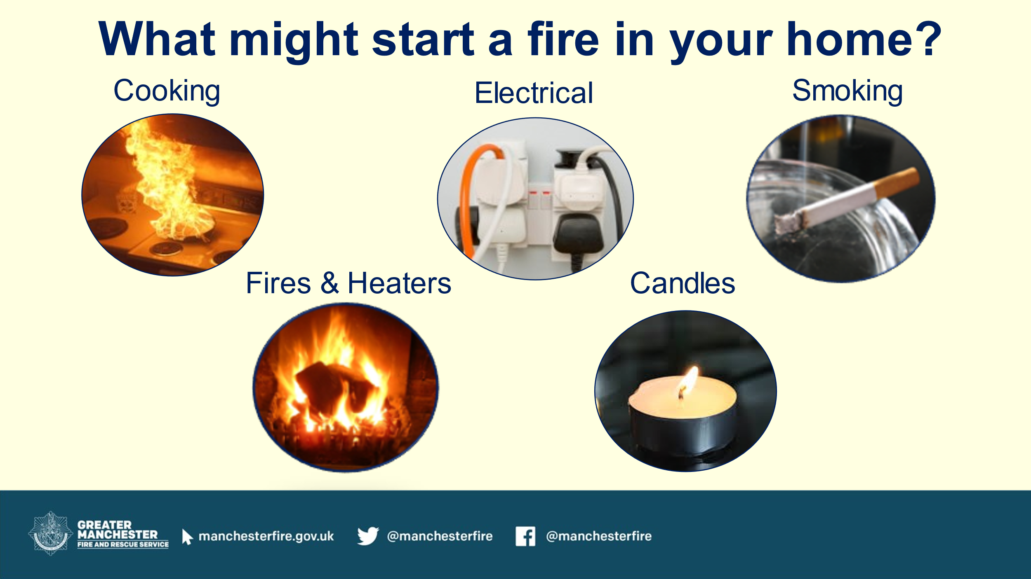 | Slide 4 - What might start a fire in your home?  The 5 main causes of fire in the home are:  - Cooking – is the main cause of fire in the home. We might cook two or three times a day so the likelihood of a fire increases. Advice around cooking – never leave cooking unattended, take care if you’re wearing loose clothing – if clothes catch fire remember to stop, drop and roll. Avoid using chip pans or deep frying – try oven alternatives or takeaway.  - Electrical – keep to one plug per socket, if you need to use an extension – never plug an extension lead into another extension lead and don’t overload it wit devices that add up to more than 13 AMPs of power. Don’t use electrical appliances (tumble dryer, washing machine, dishwasher etc) overnight. Don’t overcharge electrical devices or leave them charging when you go to bed.  - Smoking – quitting smoking or having a smoke free home are the best ways to reduce a smoking related fire at home. Always use an ashtray and make sure cigarettes are fully stubbed out. Remind people to never smoke in bed.  - Fires and heaters – don’t sit too close to a fire or heater (sit at least 1m away), use a fireguard, keep heaters away from curtains and furniture, never use heaters to dry clothes and make sure fires are out and heaters turned off before going to bed or leaving the house.  - Candles – never leave candles unattended, extinguish them properly, use a candleholder on a flat surface and always blow candles out when you leave the room. Keep candles away from children, pets and flammable objects.  Some additional stats from firekills.co.uk you may wish to use.  - Around half of home fires are caused by cooking accidents. (Reasons include distraction, cooking whilst under the influence of alcohol and using chip pans).  - Faulty electrics (appliances, wiring and overloaded sockets) cause around 4,000 fires in the home across the country every year.  - Every six days someone dies from a fire caused by a cigarette.  - About three fires a day are started by heaters.  - Two fires a day are started by candles. | PowerPoint.
2 mins.  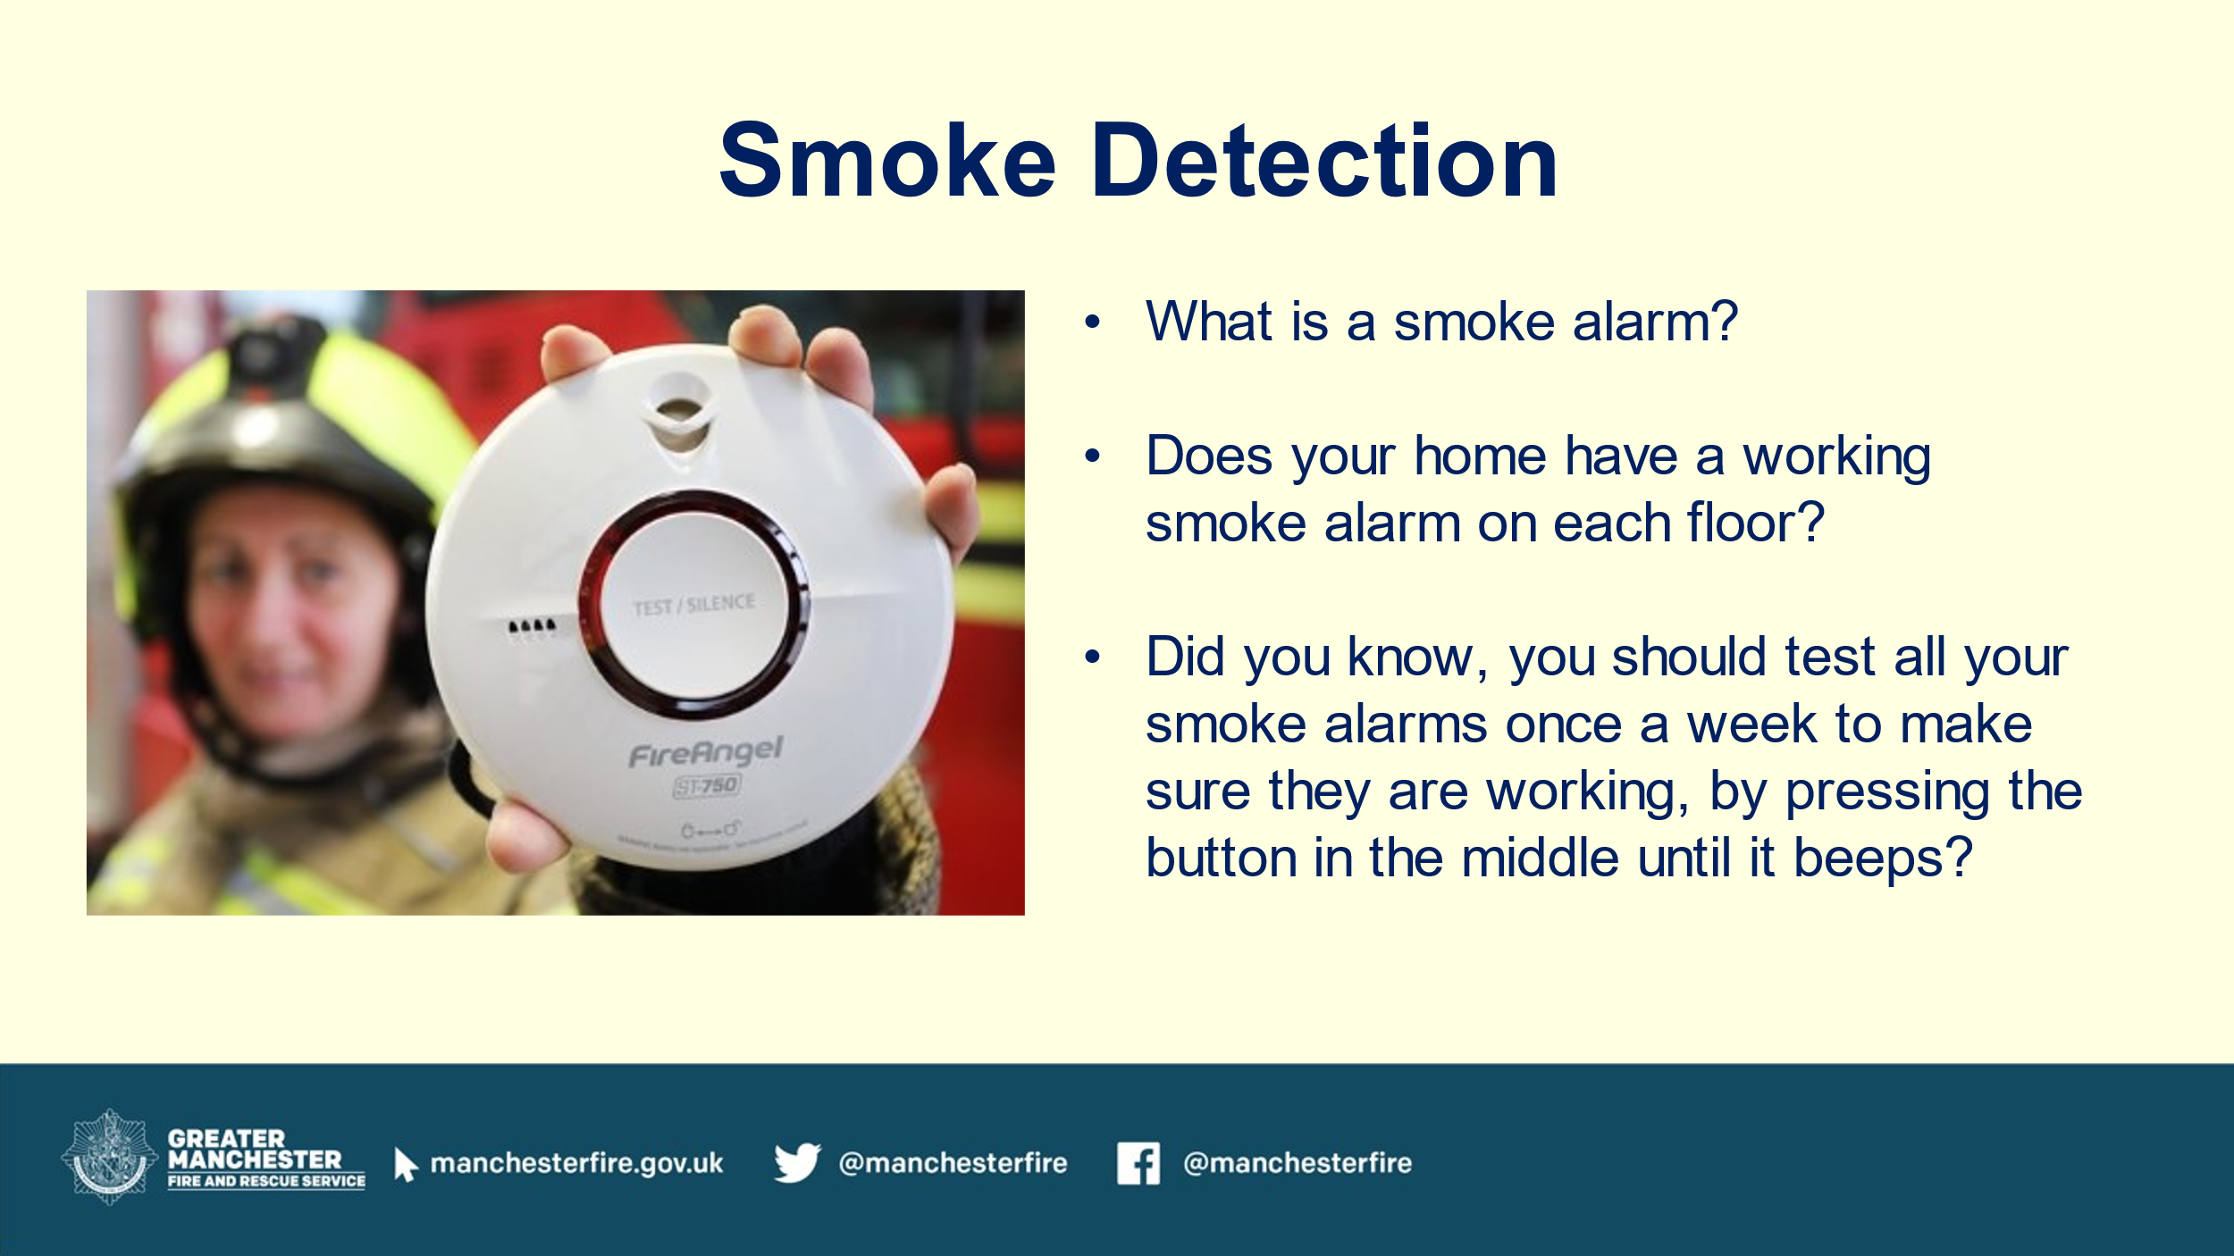 | Slide 5 – Smoke detection  Describe and show a smoke alarm and explain how they work and why they are important.  - What is a smoke alarm?  - Does your home have a working smoke alarm on each floor?  - Did you know, you should test all your smoke alarms once a week to make sure they are working, by pressing the button in the middle until it beeps? | PowerPoint.
3 mins.  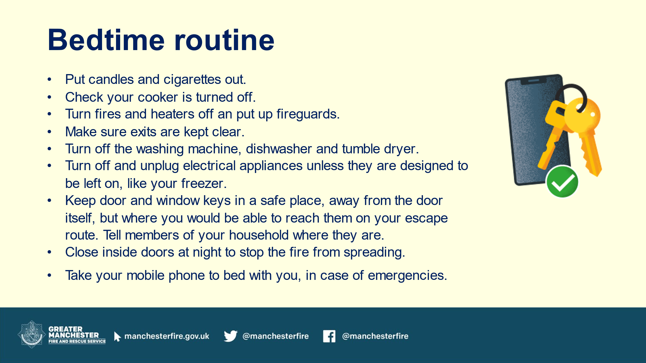 | Slide 6 – Bedtime routines  Describe how to complete a bedtime routine and encourage them to practice this at home.  - Put candles and cigarettes out.  - Check your cooker is turned off.  - Turn fires and heaters off and put up fireguards.  - Make sure exits are kept clear.  - Turn off the washing machine, dishwasher and tumble dryer.  - Turn off and unplug electrical appliances unless they are designed to be left on – like your freezer.  - Keep door and window keys in a safe place, away from the door itself, but where you would be able to reach them on your escape route. Tell members of your household where they are.  - Close inside doors at night to stop the fire from spreading.  - Take your mobile phone to bed with you, in case of emergencies. | PowerPoint.
2 mins.  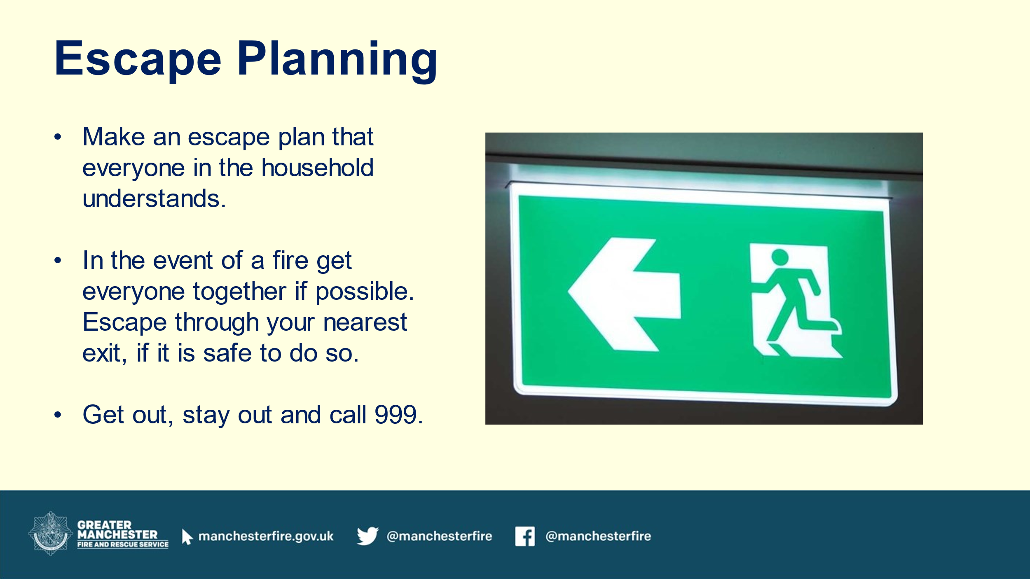 | Slide 7 – Escape plans  Tell them how to plan an escape.  - Make an escape plan that everyone in the household understands  - In the event of a fire get everyone together if possible. Escape through your nearest exit, if safe to do so.  - Get out, stay out and call 999. | PowerPoint.
2 mins.  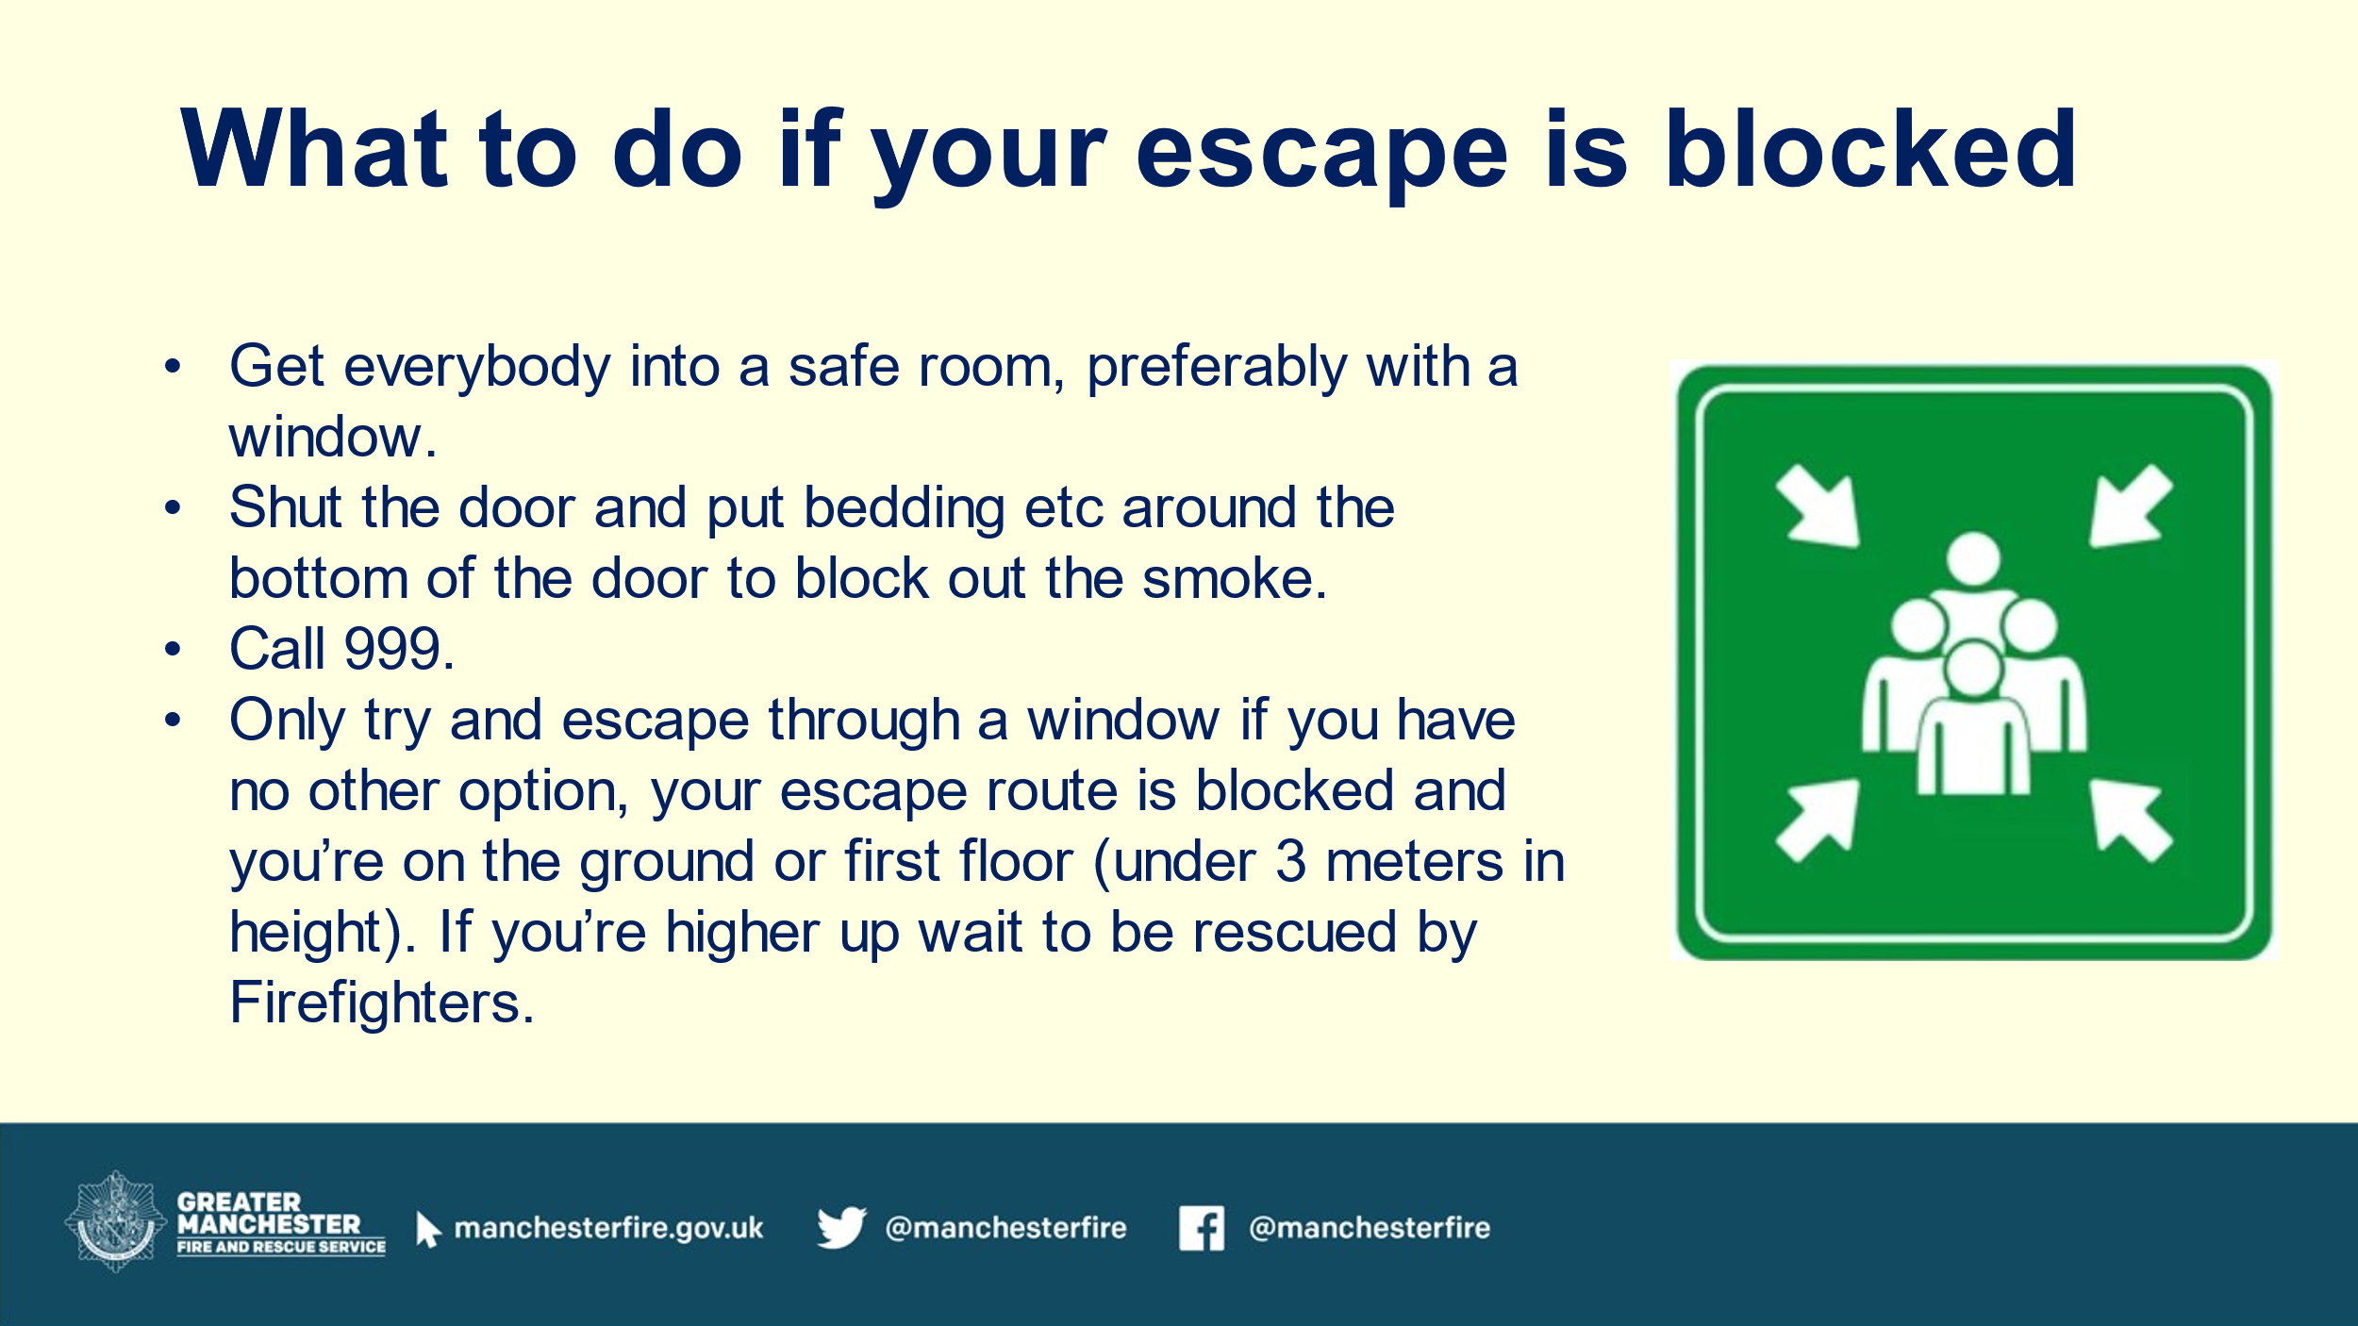 | Slide 8 – Escape plans  Explain what to do if your escape is blocked.  - Get everybody into a safe room, preferably with a window.  - Shut the door and put bedding etc around the bottom of the door to block out the smoke.  - Call 999.  - Only try and escape through a window if you have no other option, your escape route is blocked and you’re on the ground or first floor (under 3 meters in height). If you’re higher up wait to be rescued by Firefighters. | PowerPoint.
2 mins.  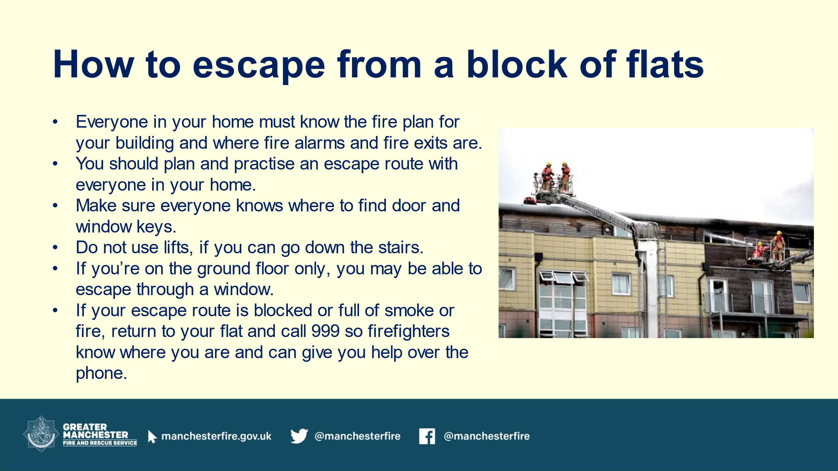 | Slide 9 – How to escape from a block of flats  Tell them how to escape from a block of flats.  - Everyone in your home must know the fire plan for your building and where fire alarms and fire exits are.  - You should plan and practise an escape route with everyone in your home.  - Make sure everyone knows where to find door and window keys  - Do not use lifts, if you can go down the stairs  - If you’re on the ground floor only, you may be able to escape through a window.  - If your escape route is blocked or full of smoke or fire, return to your flat and call 999 so firefighters know where you are and can give you help over the phone | PowerPoint.
3 mins.  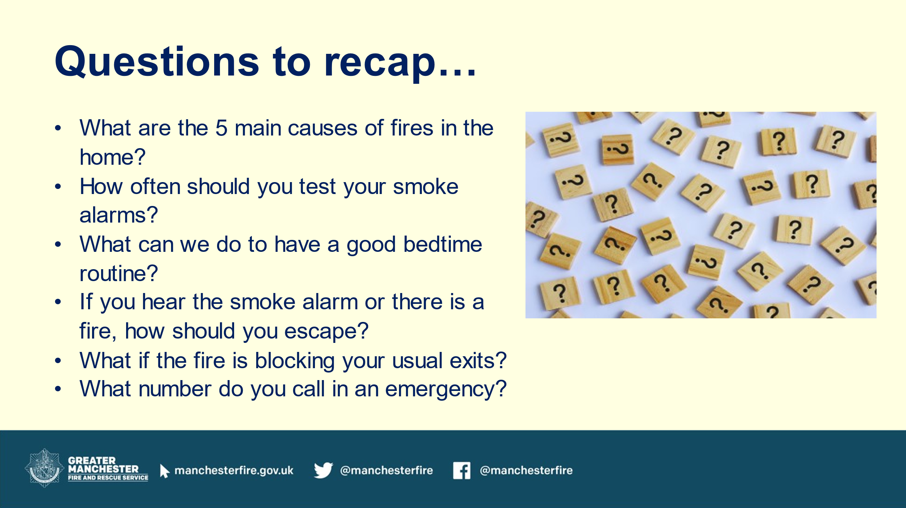 | Slide 10 – Questions to recap  Ask questions to recap…  - What are the 5 main causes of fires in the home?  - How often should you test your smoke alarms?  - What can we do to have a good bedtime routine?  - If you hear the smoke alarm or there is a fire, how should you escape? What if the fire is blocking your usual exits?  - What number do you call in an emergency? | PowerPoint.
2 mins.  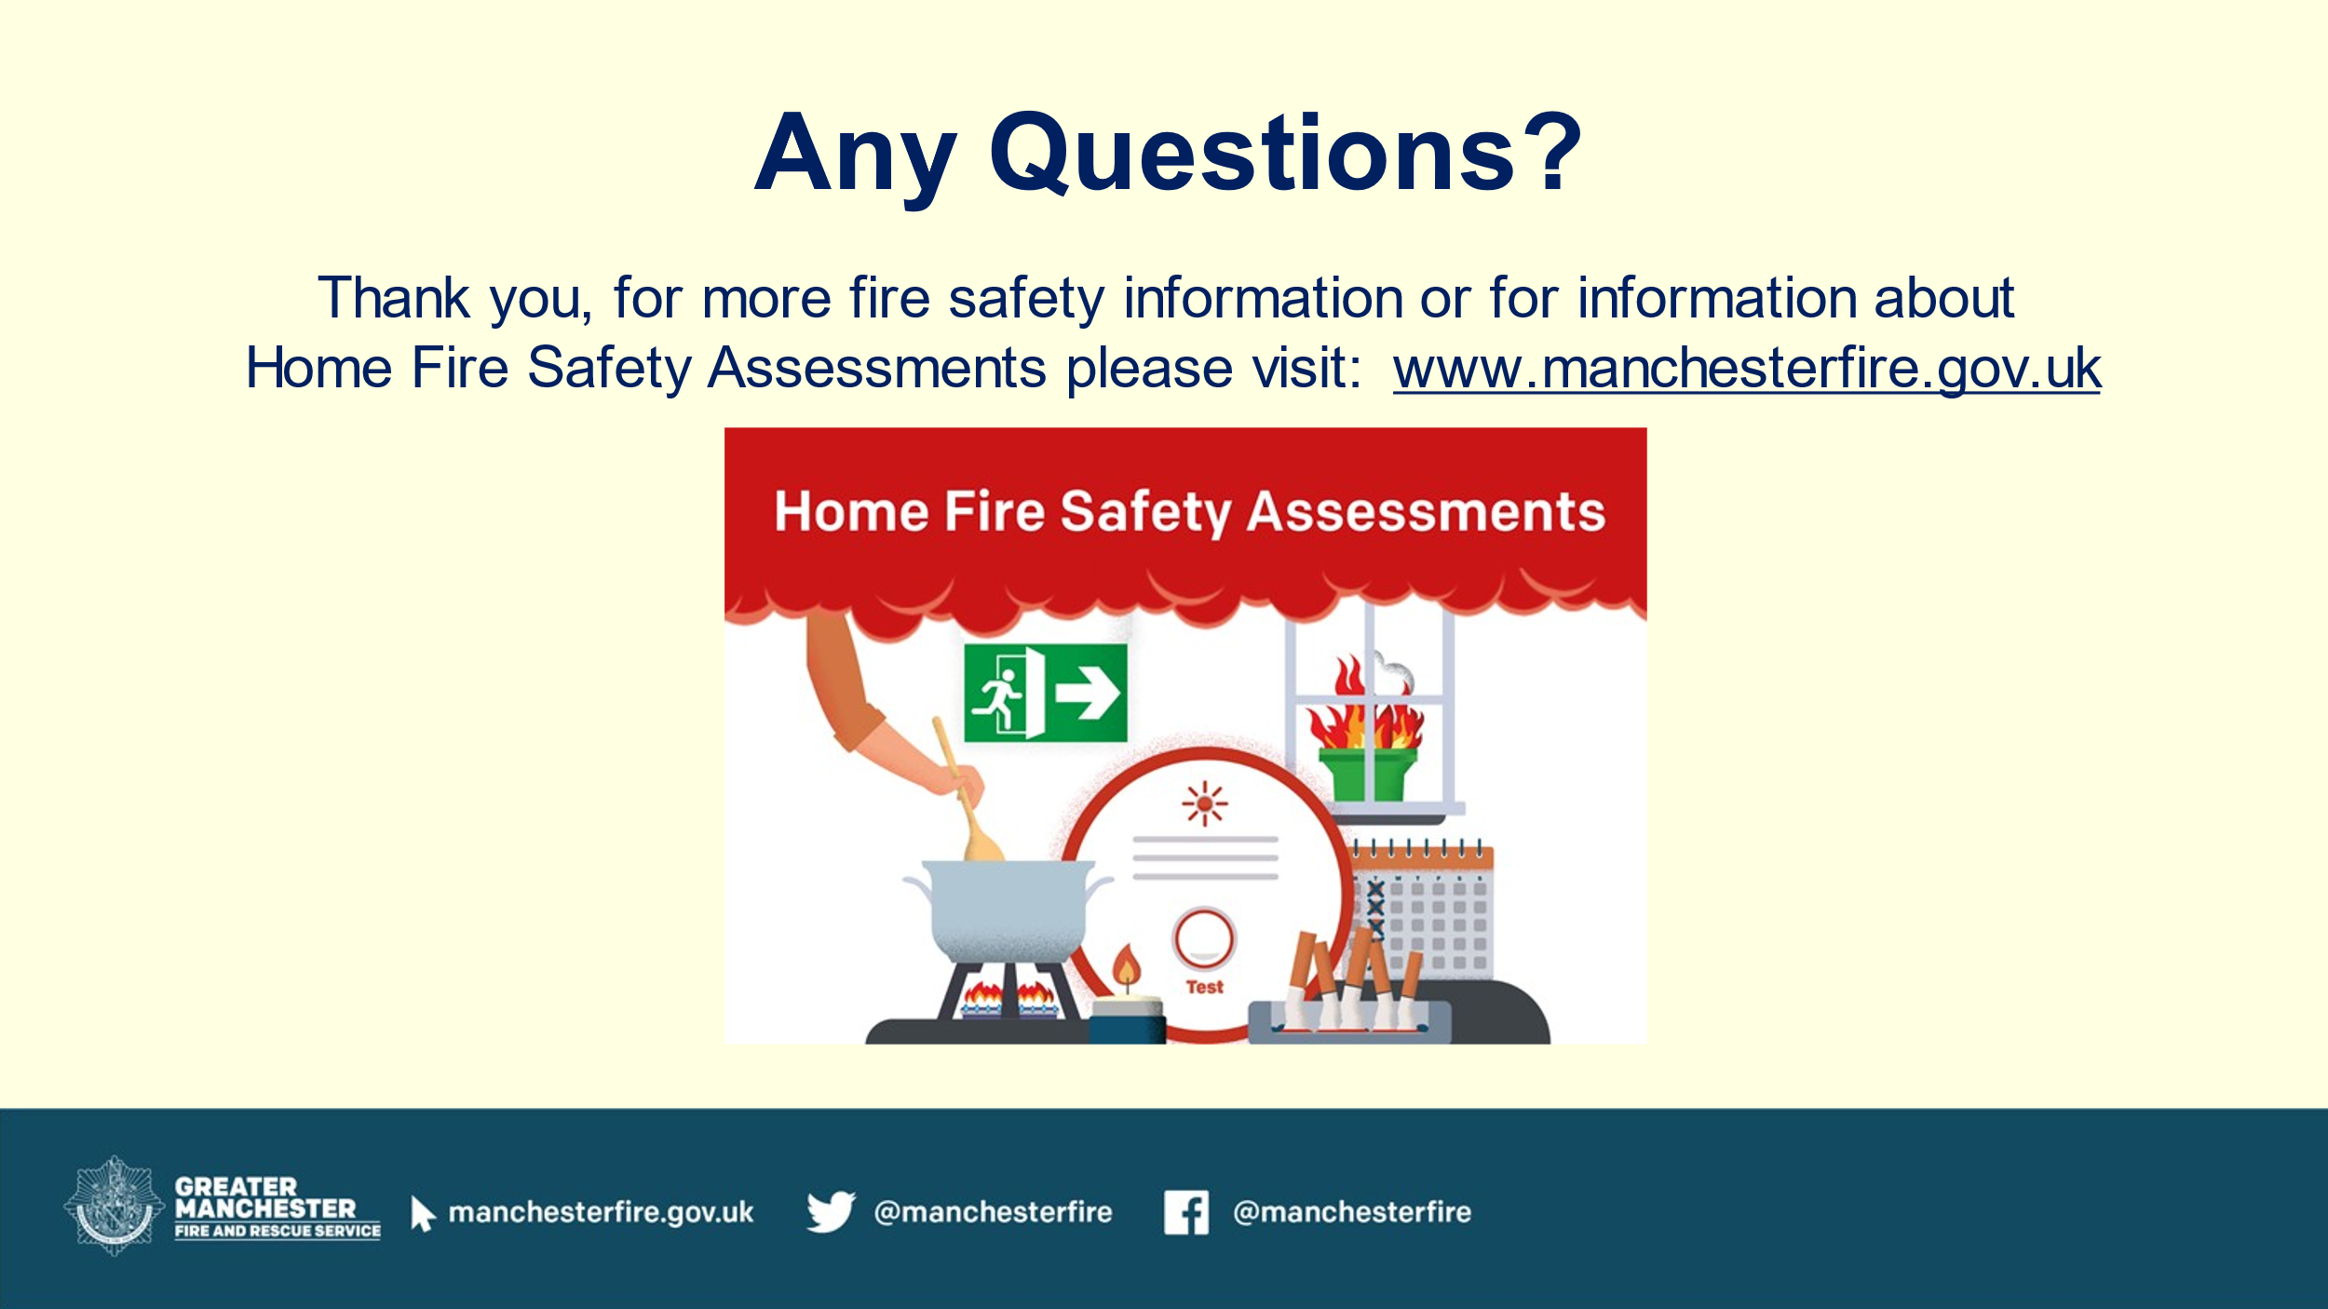 | Any Questions? Provide an opportunity for the audience to ask questions.  Thank you for having us here today!  Direct the audience to our website for further information.  Home Fire Safety Assessments are available on our website.  Home Fire Safety Assessments - Greater Manchester Fire Rescue Service | PowerPoint.

